Lars Jensen

2021-12-06

Mastermind

Innehåll

Project description 2

Class diagram 3

Project plan 4

# Project description

I am going to do a digital adoption of the boardgame Mastermind (<https://en.wikipedia.org/wiki/Mastermind_(board_game)>). I’ve always wanted to do that and now seems to be the perfect time.

I think Mastermind is a great game and can be adopted in quite a few ways. I will start to do an MVP, minimum viable product, which is the base game. The program will randomly choose four colours - only using one colour one time. The player has ten tries to guess the right colour in the right order. After each attempt the player will be informed about number of colours in the right place, number of colours in the wrong place, but not which colour. In the MVP colour representations will be letters, as well as result presentation.

When MVP is reached there are quite a few nice features to add:

* More advanced GUI
  + More advanced playing field with colours
  + Drag and drop of colours
* High scores
  + Based on attempts and time
  + Saved in file
* More game modes
  + Easy mode – Result of each guess will show which colour that is correct and/or correctly placed
  + Hard mode - Allow use of same colour multiple times
  + Choose number of tries (8-12)
* Save game
  + Save your progress mid-game
  + The save file needs to have the answer encrypted.

My children like Mastermind so I will force them to play my creation!

# Class diagram

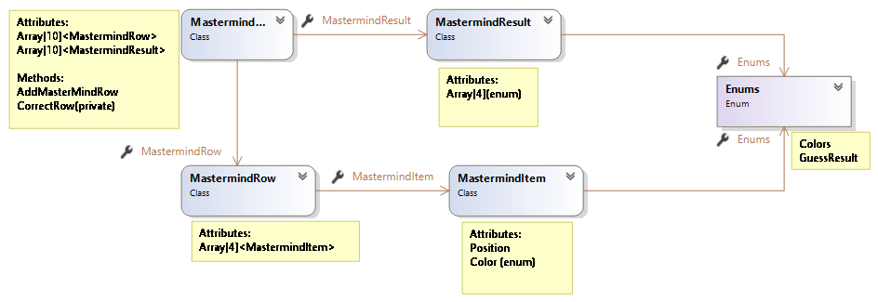

# Project plan

