Assessing Avian-Wind Turbine Collision Risk: An Approach Angle Dependent Model
Lars A. Holmstromª, Jacob P. Verschuyl^{b}, Erin M. Colclazier^{b}, Nathalie Denis^{b}, Thomas E. Hamer^{b,*}.
ªSystems Science Graduate Program, Portland State University, P.O. Box 751, Portland, OR 97207, USA
^{b}Hamer Environmental, P.O. Box 2561, 1510 South 3rd Street, Mt. Vernon, WA 98273, USA

ABSTRACT A site specific model of avian-turbine collision risk is an important component of wind farm impact assessments that will help guide land management decisions. We describe a mathematical model which estimates the probability of a collision between a bird passing through a wind turbine and one of the turbine components. Our model improves significantly upon the reference “Tucker Model” by accounting for different angles of avian approach other than perpendicular or parallel to the turbine rotor plane. We demonstrate, using a case study of fall raptor migration data, that the angle of approach has a significant effect on the collision probability and should be considered when estimating avian-turbine collision risk.

Key words: avian, bird strike, collision risk, mathematical model, probabilistic, raptor, wind turbine.
1. Introduction
Wind power is quickly becoming an attractive renewable energy source across the globe due to its minimal emissions production and increasing efficiency. Wind power is not, however, without environmental impact. Wind turbines have been shown to pose a threat to bird populations resulting from direct collisions with both the rotor blades and turbine towers (Johnson et al., 2002; Johnson et al., 2004). This effect has been documented at numerous installations, including the Altamont Pass Wind Resource Area, where it is estimated that more than 1000 birds are killed annually by about 5000 wind turbines (Thelander et al., 2003). This is an atypically high mortality rate resulting from a combination of local topography, weather, and bird behavior. Nonetheless, wind turbine collisions can have a significant impact on bird populations.
Due to the potential impact on endangered and/or protected bird species, it is becoming common to assess the effect of proposed wind farms on local and migratory bird populations prior to construction. While other factors such as species and habitat displacement may also result from wind farm construction, a key component of the impact assessment is an estimation of the annual bird mortality rate resulting directly from wind turbine collisions.
We propose a model based approach to this mortality estimation problem. The model inputs are based on the characteristics of the wind turbine, characteristics of the bird, wind conditions, and bird flight paths. The output is an estimated probability of collision based upon the kinetics of the moving bird and the rotating wind turbine. We focus on the interaction between a single bird and turbine, but the methodology can easily be expanded to estimate collision probabilities for populations of birds flying across wind farms.
Our proposed model is an extension of the collision model introduced by Tucker (1996a) – an oft cited resource for estimating avian-turbine collision risk (Tucker, 1996b; Desholm and Kahlert, 2005; Chamberlain et al., 2006; Desholm et. al., 2006). Where the Tucker model addresses cases where the bird's flight direction is either parallel or perpendicular to the plane of the turbine rotors, our model analyzes the more general case of oblique angles of approach. This is an important improvement, since birds often follow flight paths that are not dependent on the wind direction, but rather on established migratory routes or geologic features such as valleys or coastlines (Williams et al., 2001). To demonstrate the unique properties of our model we utilize species specific flight speed and direction data from a raptor migration case study in Central Washington. Our raptor case study shows that the angle of approach has a significant effect on the collision probability and should be considered when estimating avian-turbine collision risk.
2. Methods
2.1 Data Collection for Raptor Risk of Collision Case Study in Central Washington
Our field surveys employed a combination of radar and outside observers to correctly identify and capture species specific raptor data during fall migration. The radar sampled in both the horizontal and vertical modes to gather passage rate and flight height data. In the horizontal mode, the modified marine radar (FR 1510, Mark III, Furuno Electric Co., Nishinomiya, Japan) tracked flight speeds, flight directions, and passage rates of birds (events) through the project area. In the vertical mode, the elevation above the radar unit was measured for each event. Radar sampling modes were alternated after 40 minutes of sampling.
The radar cannot reliably differentiate raptor species. As a result, the radar technician was in constant contact with visual observers to assign species to radar events via two-way radios. The radar technician conveyed event locations (height and distance) to the nearest visual observers in an attempt to get species confirmation. Confirmed individuals of two species (Sharp-shinned Hawk [Accipiter striatus] and Golden Eagle [Aquila chrysaetos]) were used in our analysis due to the notable differences in their body size, flight speed and pattern, as well as their abundance in the project area.
The horizontal radar scanning array was operated at 1.5 km radius at a short pulse length (0.07 µs). The radar detected raptors out to 1375 m on each side of the radar for a total diameter of 2750 m. The vertical radar scanning array was also operated at 1.5 km radius at a short pulse length. This range facilitated detection and recording of low altitude birds. The vertical radar was oriented to collect data along an east-west transect that was perpendicular to the main (north-south) direction of raptor migration. Slope distance and bearing above horizontal “ground level” were collected by the radar technician for each confirmed bird allowing for accurate calculation of horizontal distance and height.
2.2 Model Assumptions/Simplifications
To simplify the analysis of avian collision risk, a number of assumptions were made in the design of our model. While some of these simplifications limit the generality and accuracy of the model, they can be justified in that they make the derivation and implementation of the model more tractable while still modeling the salient features of the avian-turbine interactions. Most of the model assumptions were inherited directly from the Tucker model, but the most significant warrant further discussion.
One of the assumptions shared by both the Tucker and our proposed Hamer Model is that birds have a straight flight path which is parallel to the ground. Since birds engaged in other behaviors such as foraging and hunting often use erratic or circular flight patterns which vary in altitude (Thelander et al., 2003), the model would need further adaptations to incorporate the variations specific to those situations. However, the passage of a bird through the rotor plane of a wind turbine is typically a brief event. Therefore, even such complex flight patterns can be modeled using the simplified assumption of straight flight paths that are parallel to the ground while passing through the rotor plane.
Another simplification shared by both the Tucker and our Hamer Model is to model a flying bird as a two dimensional rectangle representing the wingspan and length of the bird. Clearly, a bird has girth as well, may be flapping its wings while traversing the plane of the turbine, and is often more of a ‘T’ shape than a rectangle when viewed from above. The decision to model a bird as a rectangle was made to simplify the mathematical analysis of the problem and to reduce the description of the bird's physical shape down to two parameters. These simplifications, as opposed to a more complete description of the physical dimensions of a bird in flight, can be shown to have only a small effect on the outcome of the model.
The third and most profound assumption in the current model is that there are no behavioral interactions between the birds and the turbine. Since bird species have been shown to avoid turbines and wind farms in existing installations (Kahlert et al., 2003; Chamberlain, 2006), this simplification will clearly bias the model towards over-estimating the collision probabilities. The Tucker model makes an attempt to address this interaction by defining a tangential rotor speed,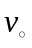, below which a bird can avoid the moving rotor. While the motivation behind this addition to the model is rational, it is not clear how should be estimated for different bird species. Furthermore, it is clearly not a complete or accurate description of the behavioral interaction in question, since there is evidence that birds hit non-moving structures, such as communication towers (Shire, 2000). The model proposed in this paper does not include behavioral interactions. Instead, our Hamer Model provides an upper bound on the collision probabilities when a straight flight path and no behavioral interaction are assumed.
The last significant assumption concerns the collision probabilities that are calculated when a three-dimensional (3-D) rotor blade is considered (one that has a chord length and twist angle along its length). Similar to the Tucker model, the chord length and pitch is assumed to be constant in the region where the bird passes through the rotor plane. The chord and pitch are calculated from the rotor position where the nose of the bird passes through rotor plane, even though the bird may drift to the right or left depending on the angle of flight relative to this point of entry. This simplification can be shown to have an insignificant affect on the outcome and results in a more straight forward collision analysis when a 3-D rotor is considered.
2.3 Model Inputs
Each application of our model will correspond to a specific turbine design and the bird species under consideration. In addition, field survey results will provide critical site dependent information about the distribution of wind conditions and local flight paths. A number of model parameters are specified by the user based on site characteristics (Table 1). The axial induction,, accounts for the fact that air flowing through the turbine has a velocity less than the wind speed (Wilson, 1994). The angle of orientation describes the bird's rotational orientation with respect to the direction downwind (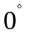). A flight path rotated to the left relative to downwind results in negative angles of orientation, and rotation to the right results in positive angles of orientation. This is not generally equal to the angle that the bird's flight path will intersect the rotor plane (the angle of approach) because flight direction is dependent on both the bird and wind velocity.
2.4 High-Level Algorithm for Calculating Collision Probabilities
When considering a linear flight path through the rotor plane, we used the following algorithm to calculate the probability of a collision with the rotor blades:
- As a bird passes through the rotor plane for a specified flight path, calculate the angular range a single turbine rotor can take on that will result in a collision at some point during this passage.
- Divide this range by 2π radians to calculate the probability of a collision with a single rotor.
- Multiply this by the number of rotors to calculate the probability of a collision with any of the rotors.
2.5 Analysis of Downwind and Upwind Flight Path with One-Dimensional (1-D) Rotor
We used a basic downwind flight path scenario to analyze and provide an introduction into the collision probability calculations described in this paper. Consider a wind turbine as it appears looking downwind (Fig. 1, middle pane). The plane of the rotor blades is perpendicular to the wind direction, as is the case in normal operation. The origin of a left-handed 3-D (xyz) coordinate space is located at the center of the turbine hub. The z-component increases in the upward direction, the y-component increases to the right, and the x-component increases downwind and is negative from the figure viewpoint. The turbine blades rotate counter clockwise when looking downwind. Since the flight path is parallel to the wind direction in this case, there is no component to the bird’s wind velocity 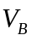 or ground velocity 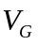. Assuming that the bird’s ground velocity is the quantity measured in a field survey, we can calculate the bird’s ground velocity at the point of entry into the rotor plane:
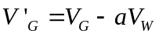
where a is the axial induction factor and 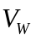 is the wind velocity.
Calculating Collision Points — In the case of downwind flight (flight path perpendicular to the rotor plane), we must calculate the location of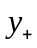, the most advanced position of the rotor on the y-axis that can produce a collision with the bird, and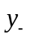, the least advanced position of the rotor on the y-axis that can produce a collision with the bird (Fig. 1, top pane). These two points are given by:
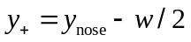
and
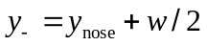
where 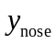 is the y coordinate of the point where the nose of the bird crosses the rotor plane and w is the width of the bird.
Rotor Angle Resulting in Collision — The rotational angles associated with the collision points and are 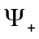 and 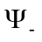, respectively (Fig. 1, bottom pane). These angles are given by:
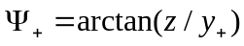
and
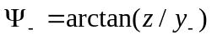
The time the bird spends in the rotor plane is given by 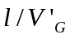, where is the length of the bird. The rotor can rotate
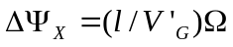
radians in this period of time. The complete angular range, 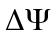, that would result in a collision as the bird passes through the turbine plane is given by:
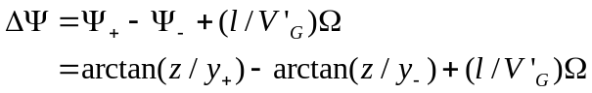
These results agree with those described by Tucker (1996a), with the exception that no small angle approximation is used in the current analysis. These models are therefore equivalent in the case where the flight paths are either upwind or downwind.

Collision Probability Calculation — After specifying the bird, turbine, and wind characteristics (Table 1), and a point 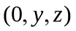 where the nose of the bird intersects the rotor plane, we can calculate the probability of a collision with one of the 1-D blades of the turbine given a downwind flight path and:
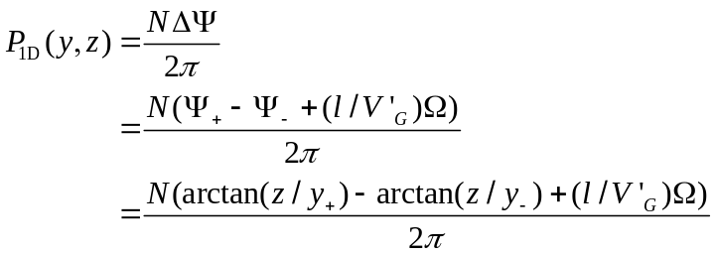 (1)
where  is the number of turbine blades.
Upwind Flight Path Analysis— The analysis of upwind flight is identical to the downwind flight path analysis except that the sign of the bird’s downwind ground velocity 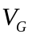 is negative instead of positive.
2.6 Analysis of Oblique Flight Path with 1-D Rotor
Our analysis includes all angles of approach that the bird may take towards the wind turbine – not just the directly downwind, upwind, or perpendicular to the rotor plane scenarios that the Tucker model addresses. Oblique angles of approach require additional analysis in the calculation of the first and last possible collision points between the bird and the rotor. This paper will cover the 4 different collision scenarios based on different angles of approach. Since the bird is no longer traveling parallel to the wind (and perpendicular to the rotor plane), there are now x and y components of the bird’s ground velocity at the point of entry in the rotor plane:
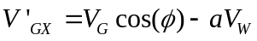
and
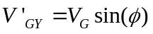
where is the angle of approach of the bird relative to downwind. The angle of orientation of the bird (the direction the bird is pointing) is given by:
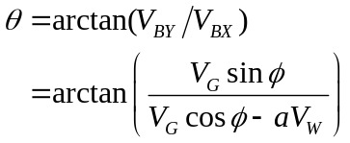
The angle of approach and the angle of orientation are generally not equal, due to the effects of wind.
2.7 Approach in Direction of Turbine Rotation
In this case, the bird moves toward the rotor plane with an approach angle in the direction of the rotor rotation (e.g., if the bird is moving to the left as it enters the rotor plane, the rotor is also rotating to the left at the point of intersection). For downwind flight paths and assuming counter clockwise rotation of the rotor when looking downwind, this is true for negative angles of approach in the top half of the area swept by the rotors (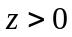,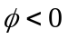) and positive angles of approach in the bottom half (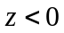,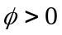). For upwind flight paths, this is true for positive angles of approach in the top half and negative angles in the bottom.
Consider the scenario where and (Figs. 2 and 3). In this case, corner 1 is the first point of contact of the bird with the rotor plane. Looking down from above, the turbine is rotating to the left. The time at which corner 1 intercepts the plane is considered to be zero. The times at which the nose and the other corners intercept the rotor plane are given by:
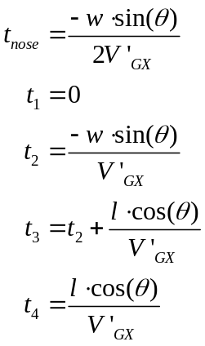 (2)
and the y coordinates of these intercepts are given by:
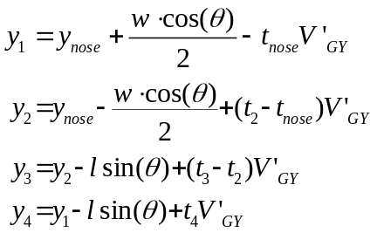 (3)
where 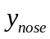 is specified by the flight path through the rotor plane.
Since the angular distance covered by the rotor in the time it takes corner 2 to cross the rotor plane is given by 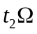, the initial rotor position that will intersect with corner 2 as it passes through the rotor plane is given by:
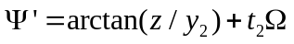
Two cases must be considered to determine the types of collisions possible: 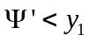 and 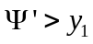. These two scenarios may result in leading edge (1-2) and trailing edge (3-4) collisions, respectively. Right edge (1-4) collisions are possible and left edge (2-3) collisions are impossible in both cases.
Leading Edge Collisions — Even if the rotor is to the left of corner 1 as the bird enters the rotor plane, it is possible for the leading edge of the bird (1-2) to overtake the rotor if , resulting in a collision. In this case, the rotor is traveling to the left at a slower velocity than the point of intersection between the leading edge of the bird and the rotor plane. In this scenario, the bird essentially hits the rotor, rather than the other way around. An example of this situation occurs when =1 m, =0.5 m, =15 m/s, =10 m/s, =72 RPMs, =0.25, 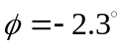 (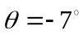), and the point where the bird’s nose intersects the rotor plane is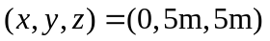 (Fig. 2). In this case,
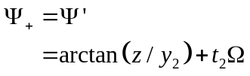
Since the rotor is also traveling to the left at a slower velocity than the point of intersection between the trailing edge of the bird (3-4) and the rotor plane, it is impossible for the rotor to strike the trailing edge (3-4) of the bird. Therefore, the last possible collision with the bird occurs as corner 4 passes through the rotor plane (at the point of the black circle in Fig. 2). This point is given by 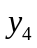 in (3). The rotation angle associated with 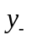 is and is given by:
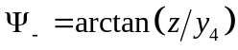
The probability of a collision as the bird passes through the rotor plane is therefore given by:
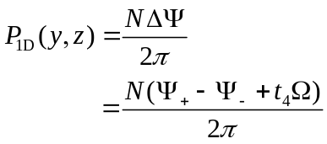
using in (2).
The same analysis applies for , in downwind flight and , in upwind flight except the corner definitions must be swapped to account for the positive angle of approach where corner 2 is the first to intercept the rotor plane.
Trailing Edge Collisions — If the angle of approach in this example is changed to 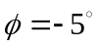(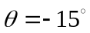), the increased angle of approach decreases the speed at which the leading edge of the bird (1-2) sweeps through the rotor plane, such that (Fig. 3). This makes it impossible for a collision to occur between the rotor and the leading edge of the bird. Therefore, the most advanced position of the rotor as the bird enters the rotor plane that will result in a collision is equal to the point where corner 1 crosses the plane (at the point of the grey circle in Fig. 3). This point is given by 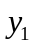 in (3). The rotational angle associated with is and is given by:
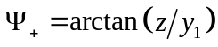
Since the trailing edge of the bird (3-4) also sweeps to the left through the rotor plane slower than the rotor, it is possible for the rotor to clip corner 3 of the bird. Therefore, the last possible collision with the bird occurs as corner 3 passes through the rotor plane (at the point of the black circle in Fig. 3). This point is given by 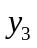 in (3). The rotation angle associated with is and is given by:
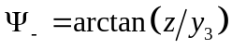
The probability of a collision as the bird passes through the rotor plane is therefore given by:
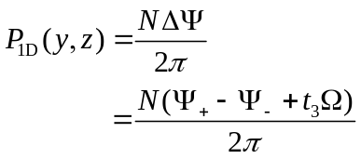
using in (2).
Again, the same analysis applies for, in downwind flight and , in upwind flight except the corner definitions must be swapped to account for the positive angle of approach where corner 2 is the first to intercept the rotor plane.
2.8 Approach Angle in Opposite Direction of Turbine Rotation
In this case, the bird approaches the rotor plane with an approach angle in the opposite direction of the rotor rotation. For downwind flight paths, this is true for positive angles of approach in the top half of the area swept by the rotors (,) and negative angles of approach in the bottom half (, ). For upwind flight paths, this is true for negative angles of approach in the top half and positive angles in the bottom.
Consider the scenario where and (Figs. 4 and 5). In this case, corner 2 is the first point of contact of the bird with the rotor plane. If looking down from above, the turbine is rotating to the right. The time at which corner 2 intercepts the plane is considered to be zero. The time at which the nose and the other corners intercept the rotor plane are given by:
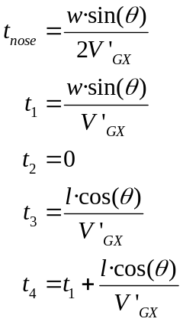 (4)
and the y coordinates of these intercepts are given by:
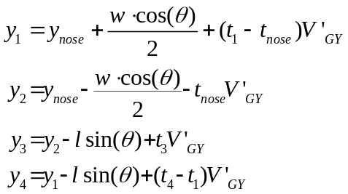 (5)
Since the angular distance covered by the rotor in the time it takes corner 3 to cross the rotor plane is given by 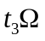, the initial rotor position that will intersect with corner 3 as it passes through the rotor plane is given by:
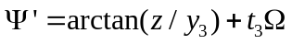
Two cases must be considered to determine the types of collisions possible: 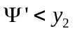 and 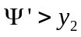. These two scenarios may lead to left edge (2-3) and right edge (1-4) collisions, respectively. Leading edge (1-2) collisions are possible and trailing edge (3-4) collisions are impossible in both cases.
Right Edge Collisions — Consider the case where=1 m, =0.5 m, =15 m/s, =10 m/s, =72 RPMs, =0.25, and the angle of approach is 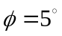(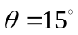) (Fig. 4). In this example, , indicating that if the rotor is to the left of corner 2 as the bird enters the rotor plane, it is impossible for the left edge of the bird (2-3) to overtake the rotor, making a left edge collision impossible. The most advanced position of the rotor as the bird enters the rotor plane that will result in a collision occurs at the point where corner 2 of the bird enters the rotor plane (the grey circle in Fig. 4). The point is given by 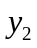 in (5). The rotational angle associated with is and is given by:
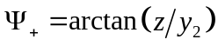
Since the right edge of the bird (1-4) also sweeps through the rotor plane slower than the rotor sweeps to the left, it is possible for the rotor to clip corner 4 of the bird. Therefore, the last possible collision with the bird occurs as corner 4 passes through the rotor plane (the black circle in Fig. 4). This point is given by in (5). The rotation angle associated with is (see bottom pane of Fig. 1) and is given by:
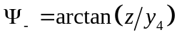
The probability of a collision as the bird passes through the rotor plane is therefore given by:
using in (4).
The same analysis applies for, in downwind flight and, in upwind flight except the corner definitions must be swapped to account for the negative angle of approach where corner 1 is the first to intercept the rotor plane.
Left Edge Collisions — Consider the scenario where the angle of approach is increased to 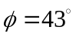(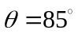) (Fig. 5). In this case, the increased angle of approach increases the speed at which the left edge of the bird (2-3) sweeps through the rotor plane, such that . This makes it possible for a collision to occur between the rotor and the left edge of the bird. The initial position of the rotor (at ) that will clip corner 3 of the bird as the bird passes through the rotor plane (the grey circle in Fig. 5) is given by:
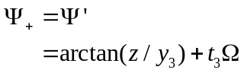
Since the right edge of the bird (1-4) also sweeps to the left through the rotor plane faster than the rotor, it is impossible for the rotor to clip corner 4 of the bird. Therefore, the last possible collision with the bird occurs as corner 1 passes through the rotor plane (the black circle in Fig. 5). This point is given by in (5). The rotation angle associated with is and is given by:
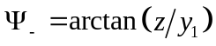
The probability of a collision as the bird passes through the rotor plane is therefore given by:
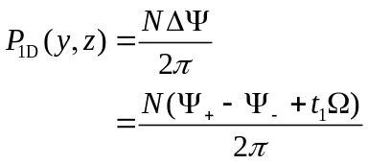
using in (4).
The same analysis applies for, in downwind flight and , in upwind flight except the corner definitions must be swapped to account for the negative angle of approach where corner 1 is the first to intercept the rotor plane.
2.9 Accounting for 3-D Rotor Blades
We adapted existing methods to include the effects of 3-D rotor blades (Tucker 1996a). The chord length and rotation  at each point along the length of the rotor are defined as:
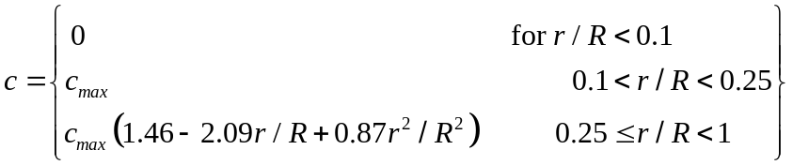
and
While not a precise description of the chord length and angle for all manufacturers’ wind turbines, this formulation provides a reasonable approximation and enables us to calculate the 3-D characteristics at each point along each rotor by specifying only the maximum chord length 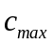 and the radius of the turbine (Fig. 6).
The 3-D collision probability is calculated by adding a correction to the 1-D collision probability calculation described in the previous sections:
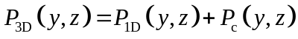
where 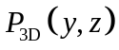 is the 3-D collision probability, 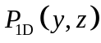 is the 1-D collision probability, and 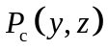 is the additional probability of collision with the 3-D extension of the rotor extending behind the front rotor plane. This additional probability can be calculated using the formula:
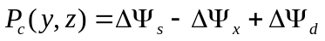
where
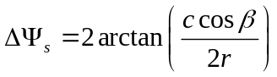
is the angle subtended by the width of the rotor blade,
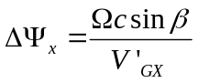
is the angle the blade progresses in the time it takes for the bird to pass from the front to the back of the rotor plane, and
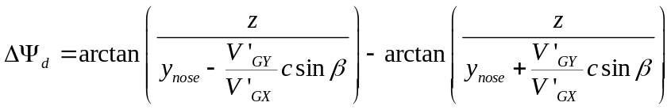
is the angle subtended by the distance the bird drifts in the y-direction in the time it takes for the bird to pass from the front to the back of the rotor plane. If the bird is flying upwind or downwind and 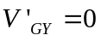, then 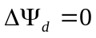 and 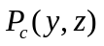 is identical to the formula proposed in Tucker (1996a), with the exception that no small angle approximation is used in the current analysis. For more details on the analysis of the 3-D correction, see (Tucker, 1996a).
3. Results
Unless otherwise noted, we used the following input parameters for the following examples: =1 m, =0.5 m, =15 m/s, =10 m/s, =3 rotors, =10 m, 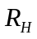=0 m, =72 RPMs, =0.25. We chose these parameters because they are identical to those used by Tucker (1996a), allowing direct comparison of model results. We propose our Hamer Model as an extension to the Tucker model, and want to emphasize that the models produce identical results in the downwind and upwind configurations. Our final result shows the importance of modeling oblique angles of approach, and we use realistic turbine parameters modeled after a common General Electric 1.5 MW (GE 1.5se) design.
3.1 Collision Probability Contours for 1-D Rotors
Upwind and Downwind Turbine Collision Probabilities — A plot of the collision probability contours was generated for downwind flight paths, predicting an increasing probability of collision above and below the center of the turbine (Fig. 7). We expect this result, because the wingspan of the bird subtends a larger angle swept out by the turbine as it enters the rotor plane closer to horizontal center. These results are identical to those published by Tucker (1996a) using the same model parameters.
Oblique Approach Turbine Collision Probabilities — Contour plots of the collision probability contours were generated for the four approach angles described above: 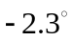, 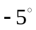, 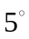, and 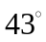 (Figs. 8-11, respectively). These flight path approach angles correspond to bird orientation angles of 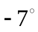, 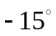, 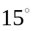, and 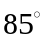due to the effects of the wind. For the orientation, the contours are not symmetric about the horizontal axis (Fig. 8). Since the bird is moving to the left, it is traveling in the direction of the rotors in the top half of the turbine and against the direction of the rotors in the bottom half. As a result, the probability of a collision is higher in the bottom half. For the orientation (Fig. 9), this effect is amplified. The collision probabilities are higher for this case since the oblique angle of approach means that the birds spend more time in the plane of the rotors. For the 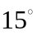 orientation (Fig. 10), the probabilities are identical to a orientation flipped about the horizontal axis of the turbine. This is because the bird is now moving against the direction of the rotor rotation in the top half and with the direction of the rotor rotation in the bottom half. For the orientation (Fig. 11), the highly oblique angle of approach results in a high probability of collision across the entire face of the turbine. The profile of the turbine, as viewed by the bird, is significantly reduced, however, resulting in a more narrow range of flight paths that may result in a collision.
3.2 Collision Probability Contours for 3-D Rotors
A plot of the collision probability contours was generated for a downwind flight path for the case where 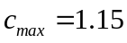 (Fig. 12). Otherwise, the parameters were identical to those used in the 1-D example (Fig. 7). The inclusion of the 3-D rotor characteristics results in a greater probability of collision across the entire turbine. These contours are identical to those predicted by the Tucker model using the same parameters.
A plot of the collision probability contours was generated for the same model parameterization, except an approach angle of was used ( orientation angle) (Fig. 13). Similar to the 1-D case, the probability of collision is elevated across the entire turbine, due to the increased angle of approach.
3.3 The Effect of Approach Angle on Collision Probability Estimates
In constrast to the previous examples which were parameterized in order to compare the results with the reference Tucker Model, this example uses actual turbine parameters and avian flight path data collected in the field (see Data Collection for Raptor Risk of Collision Case Study in Central Washington in Methods). The turbine parameters chosen for this example correspond to a modern GE 1.5se turbine: =3 rotors, =35.25 m, 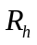=5 m, =16.6 RPMs, =0, =1.5 m.
We recorded 89 flight speeds for the Sharp-shinned Hawk. These were normally distributed with a mean of 16.1 m/s and a standard deviation of 3.4 m/s. We recorded 69 flight speeds for the Golden Eagle. These were also normally distributed and had a mean of 19.3 m/s and a standard deviation of 3.3 m/s. For the Sharp-shinned Hawk we used a body length of 0.29 m and a wingspan of 0.59 m, which are the mean values of the full range reported for males of the species (Dunn and Alderfer 2006). For the Golden Eagle we used a body length of 0.77 m and a wingspan of 2.03 m, which are the mean values of the full size range for both males and females of the species (Dunn and Alderfer 2006).
The scenario illustrated in this example is one in which the ground velocity of the bird is a known quantity (as a result of field surveys), but the wind speed and direction are not. The question being addressed is what effect does the wind speed and direction, and therefore the turbine orientation, have on the estimated collision probabilities for a bird moving at a fixed ground speed.
We calculated a comparison of average collision probabilities across a single GE 1.5se wind turbine for different Sharp-shinned Hawk flight path approach angles relative to downwind using the mean recorded ground velocity of 16.1 m/s measured in the field study (Fig. 14). To generate the collision probabilities for each wind direction, a uniform sampling of flight paths intersecting with the rotor plane was used across the entire surface of the area swept out by the turbine rotors. Each average collision probability was then adjusted to account for the reduced area that may result in a collision when the rotor is rotated with respect to the flight path. First, probabilities were calculated for downwind flight (the dashed, flat line at the bottom of Fig. 14), which produces the same result that would be obtained from an application of the Tucker Model.
Probabilities were also calculated for a number of different wind directions assuming that the wind speed was equal to either the cut-in wind speed of 4 m/s (the dot-dashed line in Fig. 14) or the rated wind speed of 12 m/s for the GE 1.5se wind turbine (the solid line in Fig. 14). The cut-out wind speed of 28 m/s for the GE 1.5se wind turbine was not used, because it would require that the bird was flying backwards. Due to the effects of wind, the orientation of the bird and the flight path direction are not, in general, the same (see top and bottom axes of Fig. 14). Our results show that even though the area that may result in a collision is reduced when the bird is not flying downwind, the increased possibility of collision across this area results in a net increase in collision risk. For this example, at angles of approach of 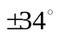 and a wind speed of 4 m/s, the probability of collision is at a maximum and results in a 10% increase over a downwind flight path. At angles of approach of 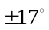 and a wind speed of 12 m/s, the probability of collision is at a maximum and results in a 20% increase over a downwind flight path. At angles of approach of 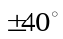 and a wind speed of 12 m/s, the bird's orientation angle is almost perpendicular to the plane of the rotor. Angles greater than this were not used because they resulted in scenarios where the angle of orientation is greater than 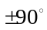, indicating that the bird is being pushed backwards by the wind and not considered a likely scenario.
Next, we used the same approach to calculate a comparison of average collision probabilities across a single GE 1.5se wind turbine for different Golden Eagle flight path approach angles relative to downwind, using the mean recorded ground velocity of 19.3 m/s measured in the field study (Fig. 15). For this example, at angles of approach of 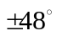 and a wind speed of 4 m/s, the probability of collision is at a maximum and results in a 25% increase over a downwind flight path. At angles of approach of 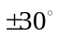 and a wind speed of 12 m/s, the probability of collision is at a maximum and results in a 31% increase over a downwind flight path.
4. Discussion
The modeling of avian collision risk is an important step for responsible planning and installation of wind farms (Huppop et al., 2006). The mortality rate resulting from collisions between birds and wind turbines is highly dependent on the topography, turbine construction, and local bird species and behaviors. A model which can take into account all of these factors can provide useful information for the planning of these installations and can significantly reduce the impact on the affected bird populations.
This paper proposes a kinematic model for calculating collision probabilities between birds and wind turbine rotors. This model improves upon the model proposed by Tucker (1996a) by accounting for different flight path angles of approach relative to the turbine rotor plane. Our raptor case study exemplified in this paper uses parameters from a modern wind turbine and flight speed data collected from field surveys of Sharp-shinned Hawks and Golden Eagles. Using the mean ground velocities measured in our case study, the estimated collision probability was as much as 31% higher than downwind flight for wind speeds equal to the rated wind speed for the turbines (12 m/s). Assuming a fixed ground speed and approach angle, higher wind speeds resulted in higher collision probabilities due to the increased bird orientation angle relative to the rotor plane. This results in the bird spending more time in the rotor plane due to the increased effect of the dominant dimension of the bird – the wingspan. Although this experiment accounted for the reduced area swept out by the turbine rotors (from the bird's perspective, resulting from a rotated turbine with respect to the angle of approach) this effect was overcome by the increased probability of collision within this area.
This model is intended as a primary building block of a larger model which may account for behavioral interactions, populations of birds, and arrays of turbines in a wind farm. Any accurate inclusion of the complex behavior interactions in play would be a non-trivial task. Avoidance behaviors vary by species, activity (e.g., foraging or migration), light and weather conditions, and perhaps by individual. These behaviors may be arbitrarily complex, ranging from long distance avoidance of the wind farm, to short distance avoidance of an approaching rotor blade. Due to this complexity, it is common to use a global estimated avoidance rate to calculate the collision probabilities (Cooper and Day, 2004; Podolsky, 2005; Chamberlain, 2006). These avoidance rates are often estimated to be from 95% - 99.9%, meaning that, at most, 5 of every 100 birds that are predicted to be hit by the model will actually be hit. The designation of avoidance rates is somewhat arbitrary and does not account for site or species specific variation. While utilizing a range of avoidance rates will generate a corresponding range of mortality estimates, the direct output of collision risk probabilities provided by the described model provides a solid foundation for comparative impact assessment, without the use of untested adjustment factors.
Alternately, a better estimate of these avoidance rates may be discernible by studying the species in question at a similar wind farm. Suitable techniques for such studies include carcass searches (Johnson et al., 2002; Johnson et al., 2004) and the use of surveillance azimuth radar and thermal infra-red imagery (Desholm et al., 2006). How or whether results obtained from these techniques utilized at existing wind farms will transfer to surveys of proposed wind farm sites remains undetermined.
4.1 Management Implications
Our results show that wind speed and direction are important and significant factors when estimating avian collision mortality rates at proposed wind farm sites. Not only should we measure bird and wind velocities at these sites, but we need to employ an avian collision model which accurately accounts for these variables to improve the quality of an impact assessment. The proposed Hamer model offers a more accurate tool to aid in educated land management decisions for renewable energy development.
REFERENCES
Chamberlain, D. E., Rehfisch, M. R., Fox, A. D., Desholm, M., Anthony, S. J., 2006. The effect of avoidance rates on bird mortality predictions made by wind turbine collision risk models. The International Journal of Avian Science 148, 198–202.
Cooper, B. A., Day, R. H., 2004. Modeling annual seabird use and fatality at the proposed Kaheawa pastures wind energy facility, Maui Island, Hawaii. Kaheawa Windpower LLC, Tech. Rep.
Desholm, M., Kahlert, J. 2005. Avian collision risk at an offshore wind farm. Biology Letters 1, 296–298.
Desholm, M, Fox, A. D., Beasley, P. D. L, Kahlert, J., 2006. Remote techniques for counting and estimating the number of bird-wind turbine collisions at sea: a review. Ibis 148, 76-89.
Dunn, J.L., Alderfer, J., 2006. National Geographic Field Guide to the Birds of North America, Fifth Edition. National Geographic Society, Washington, D.C., USA, 504 pp.
Huppop, O., J. Dierschke, Exo, K. M., Fredrich, E., Hill, R., 2006. Bird migration studies and potential collision risk with offshore wind turbines. Ibis 148, 90-109.
Kahlert, J., Petersen, I. K., Fox, A. D., Desholm, M., Clausager, I., 2003. Investigations of birds during construction and operation of Nysted offshore wind farm at Rodsand. National Environmental Research Institute, Ministry of the Environment, Tech. Rep. Copenhagen, Denmark.
Johnson, G. D., Erickson, W. P., Strickland, M. D., Shepherd, M. F., Shepherd, D. A. Sarappo, S. A., 2002. Collision mortality of local and migrant birds at a large-scale wind-power development on Buffalo Ridge, Minnesota. Wildlife Society Bulletin 30, 879–887.
Johnson, G. D., Perlik, M. K., Erickson, W. P., Strickland, M. D., 2004. Bat activity, composition, and collision mortality at a large wind plant in Minnesota. Wildlife Society Bulletin 32, 1278–1288.
Madders, M., D. P., Whitfield, M. D., 2006. Upland raptors and the assessment of wind farm impacts. The International Journal of Avian Science 148, 43–56.
Podolsky, R. 2005. Peer Review and Avian Risk of Collision model, Kaheawa Pastures wind farm, Maui, HI. Technical report, UPC Wind Management, LLC.
Shire, G.G., Brown, K., Winegrad, K., 2000. Communication towers: a deadly hazard to birds. American Bird Conservancy, Washington, DC, USA.
Smith, J. P., Neal, M. C., 2008. Fall 2007 raptor migration studies at Chelan Ridge, Washington. HawkWatch International, Inc., Salt Lake City, Utah, USA, 34 pp.
Thelander, C., Smalwood, K., Rugge, L., 2003. Bird risk behaviors and fatalities at the Altamont Pass Wind Resource Area. National Renewable Energy Laboratory, Tech. Rep.
Tucker, V. A. 1996a. A mathematical model of bird collisions with wind turbine rotors. ASME Journal of Solar Energy Engineering. 118, 253–262.
Tucker, V. A. 1996b. Using a collision model to design safer wind turbine rotors for birds. ASME Journal of Solar Energy Engineering. 118, 263–270.
Williams, T. C., Williams, J. M., Williams, P. G., Stokstad, P., 2001. Bird migration through a mountain pass studied with high resolution radar, ceilometers, and census. The Auk 118, 389-403.
Wilson, R. E. 1994. Aerodynamic Behavior of Wind Turbines. ASME Press, New York, NY, USA, pp. 215–282.

Table 1. Variable Definitions
Parameter | Description
 | Wing span (m)
 | Length of nird (m)
 | Bird’s groundspeed (m/s)
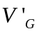 | Bird’s groundspeed, after accounting for the axial induction factor (m/s)
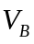 | Bird’s Air Speed (m/s)
 | Angle of approach (radians)
 | Angle of orientation (radians)
 | Number of rotors in turbine
 | Radius of Turbine (m)
 | Radius of hub (m)
 | Angular velocity (radians/s)
 | Wind velocity (m/s)
 | Axial induction factor

