Social Capital and Crime in Germany

Daniel Salgado Moreno and Lars Mehwald

11 December 2015

**Abstract:** The current research project studies the relation between social capital and crime. Relevance, Reearch Question, Main Findings

# Introduction

Most of crime studies are based on the rational choice assumptions of legal and criminal returns and the importance of deterrence to reduce criminal behaviours (Becker 1968). However, less has been written about the relevance of social interactions explaining criminal behaviours. This work draws on new data in Germany and investigates this relationship with different measurements for social capital and various statistical analyses. Though several methodological problems persist throughout the research, a preliminary conclusion can be drawn: higher voter turnout in federal elections (civic participation) is highly correlated with lower murder rates. Further theoretical and empirical research is required to assess the causal relationship between social capital and homicides.

# Theory

Social capital can be summarised as the links, shared values, and understandings in society that enable individuals and groups to trust each other and so work as a group to overcome collective action problems (OECD 2012). The concept of social capital gained importance after Robert Putnam used it to describe the anomic state of the American society at the beginning of the 21st century (Putnam 2001). He argued that a decrease in community linkages that once held societies together, translates into a loss of social capital (Putnam 2001). Social capital is commonly defined using a five dimensional analysis framework, which includes: social participation, civi participation, reciprocity and trust, social networks, and social support and views of the local areas (Whiting and Harper 2003). Putnam (2001) subdivides the engagement component of social capital into social and civic participation, reclassifying participation into a subset of different participation spheres that contain political, civic and religious participation, workplace connections, informal social ties, and philanthropy, altruism, and volunteering (Messner, Baumer, and Rosenfeld 2004).

     Furthermore, among other forms of political participation, he describes voting, political knowledge and interest, party identification, and involvements in political campaigns as subcategories of civic participation. Others types of participation include membership and attendance, as well as involvement in charity, religious and community associations. However, Putnam also recognises that not all forms of social capital produce positive outcomes, due to strong association between some forms of bounding social capital with hostility against minorities or community outsiders, and the possibility of information flow disruptions (Messner, Baumer, and Rosenfeld 2004). Moreover, according to Putnam the most harmful effect of a diminishing social capital in the United States is the increase in crime rates. Thus, his most important conclusion is the direct link between social capital and crime (Putnam 2001). The underlining argument is that criminal behaviour takes place not because people are poor, but because networks and institutions are dysfunctional.

     The causal link between social capital and crime follows the logic of social disorganisation theory (Messner, Baumer, and Rosenfeld 2004). Hence, disorganised communities present high levels of economic deprivation, residential instability, and population heterogeneity, making harder the development of primary and secondary social networks among individuals and between communities. Thus, the given community suffers from a chronic incapacity to exert social control, specially over criminal behaviour of young adult populations (Messner, Baumer, and Rosenfeld 2004). Furthermore, social networks serve as the information infrastructure of social capital, allowing for reinforcement of positive or negative individual behaviour. Disrupted social ties tend to favour destructive forms of bounding social capital, like criminal organisations, that may emerge in response to absent of other forms of linking social capital.

     Crime and the disruption it brings to the communities are one of the main determinants of individual well-being. Therefore, we are interested in responding to the question: how does social capital in a given community determine the level of violent crime? Our main hypothesis is that the more social capital a community has, the less crime there would be observed as a result of its collective action mechanisms. Thus, we expect to observe that communities with anomic symptoms will tend to have more crime.

     Ever since Robert Putnam coined the term social capital in the late nineties, a vast literature has focused on the relationship between violent crimes and social capital. Lederman (Lederman, Loayza, and Menedez 2002) identified that the prevalence of trust on community members has an effect on violent crimes and that the social cohesion through participation and membership in community organisations only impact violent crime levels depending on the type of religious and social organisation engaged. Additionally, Hanslaimer (Hanslmaier 2015) showed that altruism has a general negative effect on violent crimes, but other indicators of social capital only proved to be related to other types of high impact crime and not to violent crime.

     In our analysis we expect to observe that in societies with anomic and disorganisation symptoms there are lower levels of social capital. Within these societies, groups and member interactions find themselves in a disruptive phase, damaging social bonds, norms, values, understandings and commitment. Environments where people lack a strong moral order lead to individual members to behave more egoistically therefore diminishing social capital (Hanslmaier 2015). Disintegration of members of the community weakens social cohesion and promotes individualism that end in disruptive competition, fostering feelings of status insecurity. Moreover, certain social milieus tend to be more vulnerable and respond therefore with violence, e.g. young male adults are more prone to commit violent crimes. In addition, social capital provides means for informal punishment within a given community. Therefore more social capital leads to more abiding to social norms. In contrast communities that lack of social capital can merely punish norm diverging behaviour informally to a lesser extent and therefore are expected to have higher crime (Lederman, Loayza, and Menedez 2002).

     Social Capital is, as mentioned above, a multi-dimensional concept that consist of "varios social elements that promote individual and collective action" (Lederman, Loayza, and Menedez 2002). As a consequence of its high complexity, measuring social capital carries some difficulties. However, researchers have shown consistent results when using indicators for social capital based on participation in community organisations, attitudes of civil action, and the sense of membership to the community (Lederman, Loayza, and Menedez 2002). This proves that there is no single indicator comprehensive enough to capture the bast spectrum of social capital, but jointly they are able to come near this complex concept. Even more complex is the relation between social capital and crime, since the causal connection between the two may go in both directions, meaning that crime also can impact social capital. Higher crime could alter community ties and decrease social capital, it could also facilitate the creation of social capital by promoting community engagement in tackling crime. Moreover, the presence of crime, specially, violent crime like homicides, might reduce social capital disrupting trust among members of the community and might create more it by brining people together to fight crime (Lederman, Loayza, and Menedez 2002).

     Besides studying the relation between crime and social capital has shown some empirical and methodological difficulties. Bunonanno and Montolio (2009) state that among the most recurrent methodological problems when studying this relationship are omitted variables bias, measurement errors, endogeneity, and spatial correlation. Furthermore, crimes counts and rates depend mostly on crimes reported by police, which has a high variance across types of crimes and space and also might be positively correlated with social capital (Buonanno and Montolio 2009).

     With new data available for crime statistics for the years 2013 at the districts' level in Germany it is relevant to study the incidence of high impact crimes and its relation to social capital formation. Results might be meaningful as rational for public intervention using crime reduction strategies that help build-up social capital at the community level (e.g. funding of sport clubs, gathering community, subsidies for staying in a community), instead of more aggressive interventionist policing strategies. Strategies that are less police intensive might have higher public support and might be seen as more legitimate. Social engagement at the local level might also help increase trust levels across community members and encourage more altruistic behaviours among them. Furthermore, social capital investment might be more cost-efficient compared to more aggressive policing tactics, which effects tend to be perceived only in the more immediate time, whereas social capital investments and their effects might stretch out for longer time.

# Data

## Data sources:

We have data from three main sources:

1. German Federal Police's crime statistic ("Polizeiliche Kriminalstatistik" [PKS])
2. The Regional Database Germany published by the Federal Statistical Office and the statistical Offices of the Laender.
3. German Federal Foundations Association ("Bundesverband Deutscher Stiftungen")

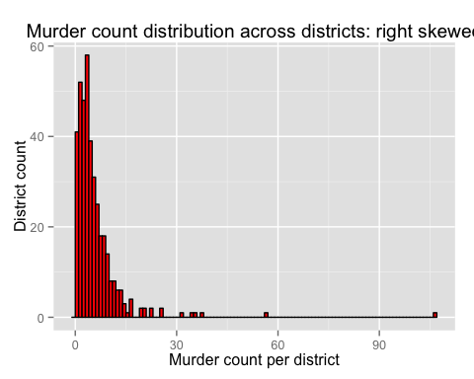

## Data gathering process

It is best practice in reproducible research to gather the data dynamically from the respective web pages. This way the research remains up-to-date as data is being updated. To perform this task transparently, it is necessary to evaluate if a data source has been updated in the meantime - which can be performed by assigning a unique SHA1 hash to data sets.

      Crime data was compile through a stable link for the PKS statistics directly from their website. The required socio economic data for all 402 German districts is publicly available through the Regional Database Germany and it is published by the Federal Statistical Office and the statistical Offices of the Federal States (*Länder*). However, it is not posible to source the application programming interface (API) from the website, since it is only reserved for registered users. The API required a session IDs to be included into the link to the respective data tables. This prevented us from gathering the data dynamically. Therefore all socio economic data was downloaded manually and store into csv files, then consequentially used for the statistical analyses without any prior manipulation.

     The data provided by the German Federal Foundations Association is contained in a pdf file available in their web page. First, we needed to download the pdf file, then extract the data manually to an excel spreadsheet and finally process it into the statistical analysis.

## Dependent Variable

Crime statistics were obtained from the German Federal Police's crime statistic ("Polizeiliche Kriminalstatistik" PKS) for only one year 2013 on a district level ("Kreis"). The first limitation we encounter was that the PKS is not providing time series for district level crime for more years than 2013 and 2014. However, we were not able to use the most recent data for the year 2014, because socio economic data at the district level in the Regional Database Germany is mostly available only before 2013 and in some cases only before 2012 for all districts. The last census took place in Germany in the year 2011, since then few estimations regarding socio economic indicators at the regional level (districts) have been updated.

     Crime data is also disaggregated regarding the type of offence. One limitation to this statistics, however, is that they fail to account for the dark figure of crime --the unreported number of crime in this area. Different methods exist to assess the dark figure of crime, but it is difficult to assess their reliability. Hence, depending on the type of crime, the reported numbers might contain a structural bias, i.e. some types of crime are reported at a different rate than others (e.g. when insurance companies require individual reporting). Focusing mainly on crimes that disrupt communities the most, we expect a high level of reporting and this reporting to be consistently high across different types of the most disruptive crimes like murders.

     It is possible to focus only on one type of crime as our variable of interest, but also to aggregate different types of crime into one single category First we are considering only two categories of crime: violent and non-violent crime. These two measures of crime follow a simple addition method, including in each of them their respective fitting crimes.

     Furthermore, given the limitations of our data we have to assume that this cross-sectional data for district crime are a simple count of independent events. In addition, we are more interested in those types of crimes that disrupt a community the most. Thus, our main variable of interest is murder. There are two ways to see and analyse the occurrence of murders. In terms of its frequency, e.g. count of occurrences per district in a year, or, for easier comparison purposes, in terms of murders per population by district.

## Independent Variables

As mentioned above, all socio economic data is provided by the Federal Statistical Office and the statistical Offices of the Laender. The multi-dimensional characteristic of social capital allows us to use a wide range of indicators to operasionalise the effect of this complex concept. Due to data availablility restrictions we use only three indicators to measure social capital as an indepdendent variable in our analysis.

     First, we used the data on foundations density in per district as an indicator of community engagement. Foundation density is an indicator of the total number of foundations in each German district devided by 100 thousand inhabitants. The underlining assumption behind engagment in the community and its implication for crime lies in its potential negative relation. Thus, the higher the foundation density per inhabitants in a district, the lower the level of repoerted crime.

     A second indicator for social capital we used was the total flow of migrants coming in and out of each district during 2013. This indicator served as an approximation to the concept of community membership. The assumption behind this indicator is that the more people moving in and out of a district, the less a person leaving in that district feels part of the community, which is might be also true for people moving. Since social capital requires time to build up, we expect higher crime rates in areas with high fluctuations.

     The third dimension of social capital we tried to measure was the civil participation within a community. We then looked at the voting turnout during the federal elections of 2013 in Germany to estimate the effect of social capital on crime through the participation of community members in policy decisions when deciding on their next government. We therefore assume a negative relation between crime and voting turnout. Hence, when voting turnout increases, reported crime levels decrease in a district.

     Moreover, we need district level data for other variables to control for local heterogeneity of the population. We want to control for factors that potentially influence the probability of committing a crime. First, unemployment changes the opportunity costs of punishment, i.e. imprisonment. In addition, we want to control for a district's population composition regarding age (younger people have a higher probability of being involved in crimes) and gender (male people are found to be more prone to perpetrate crimes).

     Additional to the gender and age variables included, when accounting for community heterogeneity we included the total count of foreigners living in a dsitrict. The data containing this information was also gther from the Federal Statistical Office for the year 2013.

     Then, we also control for number of marriages based on the information available from the census in 2011 described as registered partnerships in a district. There are reasons to belive that communities with higher marriages rates frequently show higher levels of social capital. Including this control indicator allow us to control for the structure of a given community.

     Furthermore, we take into consideration the size of the population in a district. Including such a control variable, allows to capture the effect of the population size of a district, making it easier to compare accross secctions. In terms of the estimated coefficients related to this control variable, a positive sign indicates that more crimes are perpetrated in districts with more population.

     In addition we included a dummy variable for districts of former East and West Germany. This distinction might prove useful to control for different socialisation processes of citizens under different institutional regimes during longer periods of time: it might be the case that specific institutional factors have shaped the process of social capital formation. Former West Germany is coded as 1 and former East Germany is coded as 2. Berlin is coded as 2 for two reasons. First it was not officially listed as one of the German Laender ("Berlin Frage"). Second it is deemed to be distinct from former West Germany.

## Optimal data set

Throughout the analysis we face severe data constraints that inhibit an in depth analysis of the theoretical relationship. An optimal data set, however, would have the following characteristics.  
It would contain time series data for every unit of observation ("Kreis"). This would enable us to use a fixed effects model (since we already have cross-sectional data) and thereby controlling for unobserved heterogeneity between the observations. This data would also enable us to address the most severe challenge to this analysis: reverse causality. People are deemed to respond to a criminal environment and it is likely that this response is correlated with our independent variables (i.e. people with higher social capital tend to move out of areas with high crime rates).  
On optimal dataset would also contain more detailed data. First, this would allow more elaborate control variables. This is important, because so far it is not possible to use a fixed-effects model that would at least control of unobserved heterogeneity. Second, this would yield the possibility to use better measurements and further dimensions of social capital.  
In addition individual level data would improve the analysis by allowing for a multi-level analysis controlling for individuals characteristics. This could also address the main challenge of reversed causality since migration between different districts could be explicitly modelled. This would also reduce the interpretative challenge of ecological fallacy due to the high level of aggregation (currently at the "Kreis" level).

# Methodology and analysis

For this research, we have conducted a cross-district study to estimate the relation of different indicators of social capital --engagement in the community, political participation and community stability-- and the incidence of violent and non-violent crime, with specific focus on murders.

     When considering the frequency of occurrences of crimes, as in the case of our analysis with murders, we are interested in the distribution of observations per unit. However, some crimes like homicide are very rare, and when the average counts are small, the distribution of outcomes is skewed to the right. Such a skewed distribution might cause that an ordinary least square (OLS) regression analysis that assumes a norma distribution in the error terms around the expected average is simply not appropriate (Macdonald and Lattimore 2011). Thus, our analysis requires a different method, based on another type of distribution. The appropriate distribution is the Poisson distribution, which is unimodal and skewed to the right. It is represented by a single parameter , meaning that its mean and variance are identical: . The more simple Poisson formulation is:

for Y=0,1,2,3,4,5,... Where Y is the outcome represented by a count and is the parameter representing the expected probability of the count (e.g. count of crimes) according to a Poisson distribution. For crime analysis we are interested to know what is that predicts the number of crime counts taking into consideration the probability of outcome occurrences through a Poisson distribution (Macdonald and Lattimore 2011).

     Nevertheless, if we include additional predictors then we have to use the approach proposed by econometricians who expanded the Poission probability distribution into a set of generalised linear models (GLM). Hence, this method is particularly useful when explaining the expected response variable as counts () by a set of independent variables () and when assuming a linear relationship between outcomes and predictors (). The GLM formulation is:

where the parameter captures the distribution of observed outcomes (Y) that are still Poisson (Macdonald and Lattimore 2011).

     The basic assumptions of count models, specifically in our case the Poisson regression and its different variations estimate the expected rate, of observed crime outcomes *(Y)* according to a Poisson distribution. Due to its intrinsict right skewed characteristic, the logarithm of the Poisson probability distribution should be approximatly linear. To achieve this the Poisson regression model relies on assumptions related to a log-linear model (Macdonald and Lattimore 2011).

     The Poisson regression model can be expressed as in the following equation:

Where the model is expressed as the logarithm of the expected count outcome, and the is the intercept and *(X')* a set of predictor variables. The singularity of the Poisson model compared to the OLS regression is that the latter assumes a normal distribution of expected values and variance, while the first with a single parameter assumes that the . Therefore, when analysing the regression outputs for a Poisson model we are intereseted in assessing whether the estimated mean equals the variance of the model (Macdonald and Lattimore 2011).

     Nontheless, this last asssumption of mean equals variance of the model, rarely is met with data available for crime according to MacDonald and Lattimore (2011). It is more common to observe that the variance is greater or less than the mean. In the first case, we refere to a case of overdispersion, the latter to underdispersion. The basic interpretation tells us that the model fit shows less or more variation than expected according to the Poisson model (Macdonald and Lattimore 2011).

     In other words, underdispersion occures when the observed average count of the outcome is zero and there are very few observations with high counts. On the other hand, overdispersion occurs when a high number of observations have very large counts. To test for overdispersion we run a dispersion test command includede in the AER (Kleiber and Zeileis 2015) R-package. In the overdispersion test the null hypothesis states *Ho:* and the alternative hypothesis is that the true dispersion is greater than 1. In our data the z-statistic is , the p-values are small enough so we can say that they are statistically significant, and the estimated dispersion is therefore we can assume overdispersion in our counting data.

     The most commonly used correction for overdispersion is to use a negative binomial model istead. This model assumes that at different values of the observed outcome *(Y=crime counts)* we get a mixture of Poisson and gamma distributed estimations. The expected value follows a Poisson distribution () but with a variance with a gamma distribution (). The negative binomial distribution includes both such as:

and

For which the parameter describes the gamma distribution with the skwede distribution to the right. Thus, when , the formula comes back to the original Poisson formulation and the expected mean and the variance will be equal. The higher the value of , the higher the amount of overdispersion (Macdonald and Lattimore 2011).

     Furtheremore, the Poisson models are based on log-link function to estimated the linear relation between the predictor variables and the expected count of crimes. We can compute the expected count by exponentiating both sides of

One obtains then the expected average count:

The importance of the exponential values for the parameters lies upon the fact that we can interpretated them as incidence ratios, because they are a multiplication of the expected count or incidence of the outcome by a function of the predictor variable (). Thus, what it is of most interest to us for our analysis are the exponential values of the parameters times the predictors (). This term of the equation will tell us how much a predictor variable increases the expected count or incidence of crime (Macdonald and Lattimore 2011). We could then interpret the incidence rates as percentages, for example a value higher than 1 like 1.7, means an increase in the depdentent variable of 70 percent for every one unit change in the predictor (). It is also true, that a vlaue of 0.6 yields a reduction of 40 percent in the crime count for each increasing unit in the explanatory variable.

{{{{{Since crime events are discrete events, the possible crime rates for any given populations size are those corresponding to integer counts of crimes. Change in populations sizes will lead to violating the assumption of homogeneity of error variance. Second, normal or symmetrical error distributions of crime rates cannot be assumed. So the error distribution is skewed to the lower bound (to the left). Thus, a more formal way to accommodate over-dispersion in a count data regression model is to use a negative binomial model as tables 2 to 5 show.}}}}}}

# Regression analysis

## OLS regression analysis

## Poisson, quasi-poisson and negative binomial regression analysis

# Predicted probabilities

Predicted probabilities yield the possibility to visualise the statistical and substantial effect of the different variables. In the following predicted probabilities are shown conditional on the dichotomous variable EastWest.

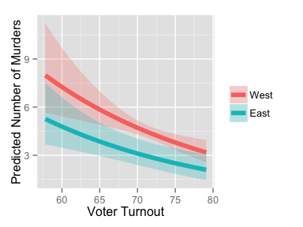

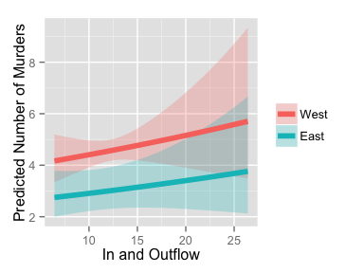

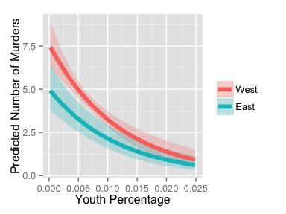

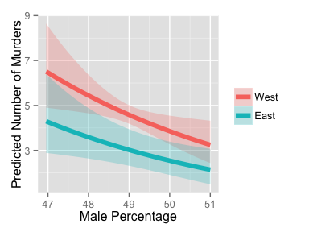

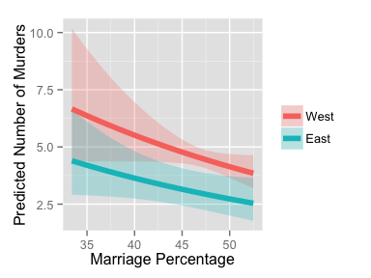

# Conclusion

A preliminary analysis of the model specification shows that the negative binomial model does not change the statistical significance of the main explanatory variables.  
Moreover, only some independent variables attain statistical significance for violent crimes.  
Further model specifications are require in order to improve the reliability of these findings.  
However, further estimations are needed to improve the interpretations of the coefficients, since the estimated coefficients are log likelihoods.

# References

Becker, Gary S. 1968. “Crime and Punishment: An Economic Approach, 76 J. Pol. Econ. 169 (1968).” *Journal of Political Economy*.

Buonanno, Paolo, and Daniel Montolio. 2009. *Jourrnal of Law and Economics* vol. 52.

Hanslmaier, Michael. 2015. “Mehr Sozialkapital–weniger Kriminalität? Eine Makrosoziologische Längsschnittanalyse Bayerischer Landkreise.” In *Empirische Forschung über Kriminalität*, pp. 361–404. Springer.

Kleiber, Christian, and Achim Zeileis. 2015. *AER: Applied Econometrics with R*. <http://CRAN.R-project.org/package=AER>.

Lederman, Daniel, Norman Loayza, and Maria Menedez. 2002. “Violent Crime: Does Social Captal Matter?” *Economic Development and Cultural Change* vol. 50 (no. 3): pp. 509–39.

Macdonald, John M., and Pamela K. Lattimore. 2011. In, edited by Alex R. Piquero and David Weisburd, pp. 683–98. Springer.

Messner, Steven F., Eric P. Baumer, and Richard Rosenfeld. 2004. *American Sociological Review* vol. 69: pp.882–p903).

OECD. 2012. [doi:http://www.oecd.org/insights/37966934.pdf](http://doi.org/http://www.oecd.org/insights/37966934.pdf).

Putnam, Robert D. 2001. *Bowling Alone: The Collapse and Revival of American Community*. Simon; Schuster.

Whiting, Elizabeth, and Rosalyn Harper. 2003. “Young People and Social Capital.” Office for National Statistics, United Kindom.