

CST363 Introduction to Database Design  
**Team Project**

Image_5

California State University Monterey Bay (CSUMB)

Computer Science and Information Technology (CSIT)

Dr. Wang

April 14, 2015

Team Members

Image_3

Team Clarus Solutions consist of the following members:

**Gracie Alderete-Fisher**

**Nigel DeVaughn**

**Clarence Mitchell**

.

Project Summary

Image_6

Every company needs a way to track employee’s reported work time, the employee timesheet is the most widely used method of tracking the time an employee has spent working. The scope of this project is to provide simple database for a basic employee timesheet system.

The basic system functions should include (and scope are as follows):

* Provide a weekly timesheet for capturing employee time
* Provide employee information (such as name, address, etc.)
* Provide department and office information for employees
* Provide a method of tracking which projects an employee is assigned
* Provide a method for tracking and reporting total hours worked or spent on a specific job/project (or task).
* Provide a method for capturing when employee timesheets have been approved
* Allow time entry as little as 3 minute increments

Image_4Entity Relationship Diagram

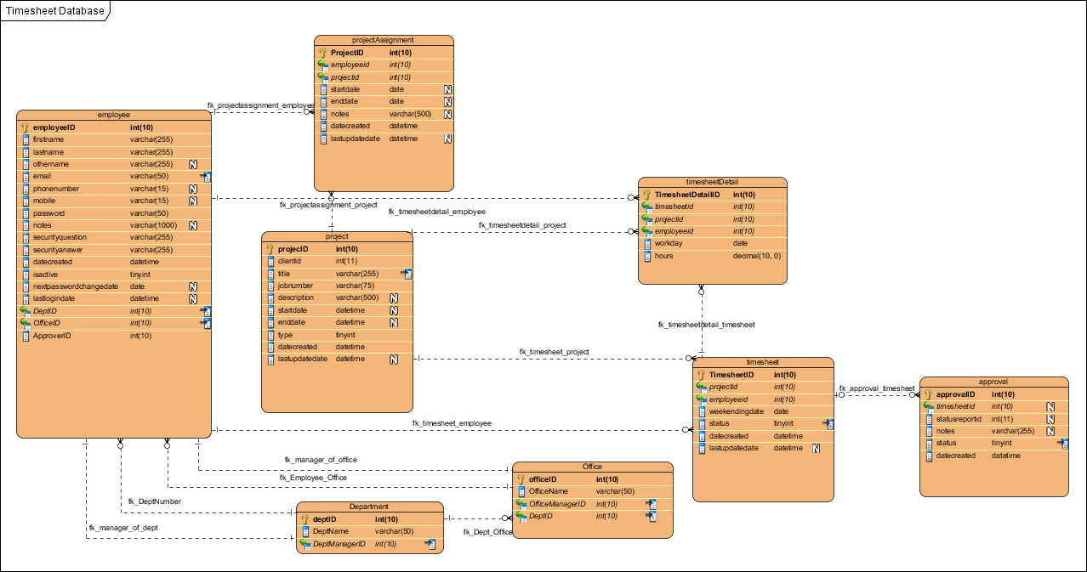

Tables in 3rd Normal Form (3NF)

Image_1

|  |  |
| --- | --- |
| Name | Description |
| Approval | Table used to track timesheet approval |
| Department | Used to list all departments and department managers |
| Employee | Used to list all employees |
| Office | Used to list all offices within departments and office mangers |
| Project | Used to list all projects |
| ProjectAssignment | Used to track employee to project assignments |
| Timesheet | Weekly timesheet for employee |
| TimesheetDetail | Contains timesheet details |

## Approval

|  |  |  |  |
| --- | --- | --- | --- |
| Name | DataType | Constraints | Nullable |
| **approvalID** | **int(10)** | **PK** | **No** |
| **timesheetid** | **int(10)** | **FK (timesheet.TimesheetID)** | **Yes** |
| statusreportid | int(11) |  | Yes |
| notes | varchar(255) |  | Yes |
| status | tinyint |  | No |
| datecreated | datetime |  | No |

## Department

|  |  |  |  |
| --- | --- | --- | --- |
| **Name** | **DataType** | **Constraints** | **Nullable** |
| **deptID** | **int(10)** | **PK** | **No** |
| DeptName | varchar(50) |  | No |
| **DeptManagerID** | **int(10)** | **FK (employee.employeeID)** | **No** |

## Employee

|  |  |  |  |
| --- | --- | --- | --- |
| **Name** | **DataType** | **Constraints** | **Nullable** |
| **employeeID** | **int(10)** | **PK** | **No** |
| firstname | varchar(255) |  | No |
| lastname | varchar(255) |  | No |
| othername | varchar(255) |  | Yes |
| email | varchar(50) |  | No |
| phonenumber | varchar(15) |  | Yes |
| mobile | varchar(15) |  | Yes |
| password | varchar(50) |  | No |
| notes | varchar(1000) |  | Yes |
| securityquestion | varchar(255) |  | No |
| securityanswer | varchar(255) |  | No |
| datecreated | datetime |  | No |
| isactive | tinyint |  | No |
| nextpasswordchangedate | date |  | Yes |
| lastlogindate | datetime |  | Yes |
| **DeptID** | **int(10)** | **FK (Department.deptID)** | **No** |
| **OfficeID** | **int(10)** | **FK (Office.officeID)** | **No** |
| **ApproverID** | **int(10)** |  | **No** |

## Office

|  |  |  |  |
| --- | --- | --- | --- |
| Name | DataType | Constraints | Nullable |
| **officeID** | **int(10)** | **PK** | **No** |
| OfficeName | varchar(50) |  | No |
| **OfficeManagerID** | **int(10)** | **FK ([employee.employeeID](file:///C:\\Users\\LN\\Documents\\7.%20Education\\Classess\\Current\\CST363\\8.%20Projects\\Team%20Projects\\Part%201\\project_vpp.docx" \l "_WH43TKAUICy0gOj))** | **No** |
| **DeptID** | **int(10)** | **FK ([Department.deptID](file:///C:\\Users\\LN\\Documents\\7.%20Education\\Classess\\Current\\CST363\\8.%20Projects\\Team%20Projects\\Part%201\\project_vpp.docx" \l "vMEB3TKAUICy0gsl))** | **No** |

## Project

|  |  |  |  |
| --- | --- | --- | --- |
| Name | DataType | Constraints | Nullable |
| **projectID** | **int(10)** | **PK** | **No** |
| **clientid** | **int(11)** |  | **No** |
| title | varchar(255) |  | No |
| jobnumber | varchar(75) |  | No |
| description | varchar(500) |  | Yes |
| startdate | datetime |  | Yes |
| enddate | datetime |  | Yes |
| type | tinyint |  | No |
| datecreated | datetime |  | No |
| lastupdatedate | datetime |  | Yes |

## ProjectAssignment

|  |  |  |  |
| --- | --- | --- | --- |
| Name | DataType | Constraints | Nullable |
| **ProjectID** | **int(10)** | **PK** | **No** |
| **employeeid** | **int(10)** | **FK ([employee.employeeID](#_WH43TKAUICy0gOj))** | **No** |
| **projectid** | **int(10)** | **FK ([project.projecID](#DWH43TKAUICy0gOH))** | **No** |
| startdate | date |  | Yes |
| enddate | date |  | Yes |
| notes | varchar(500) |  | Yes |
| datecreated | datetime |  | No |
| lastupdatedate | datetime |  | Yes |

## Timesheet

|  |  |  |  |
| --- | --- | --- | --- |
| Name | DataType | Constraints | Nullable |
| **TimesheetID** | **int(10)** | **PK** | **No** |
| **projectid** | **int(10)** | **FK ([project.projecID](file:///C:\\Users\\LN\\Documents\\7.%20Education\\Classess\\Current\\CST363\\8.%20Projects\\Team%20Projects\\Part%201\\project_vpp.docx" \l "DWH43TKAUICy0gOH))** | **No** |
| **employeeid** | **int(10)** | **FK ([employee.employeeID](file:///C:\\Users\\LN\\Documents\\7.%20Education\\Classess\\Current\\CST363\\8.%20Projects\\Team%20Projects\\Part%201\\project_vpp.docx" \l "_WH43TKAUICy0gOj))** | **No** |
| weekendingdate | date |  | No |
| status | tinyint |  | No |
| datecreated | datetime |  | No |
| lastupdatedate | datetime |  | Yes |

## TimesheetDetail

|  |  |  |  |
| --- | --- | --- | --- |
| Name | DataType | Constraints | Nullable |
| **TimesheetDetailID** | **int(10)** | **PK** | **No** |
| **timesheetid** | **int(10)** | **FK ([timesheet.TimesheetID](file:///C:\\Users\\LN\\Documents\\7.%20Education\\Classess\\Current\\CST363\\8.%20Projects\\Team%20Projects\\Part%201\\project_vpp.docx" \l "nWH43TKAUICy0gOZ))** | **No** |
| **projectid** | **int(10)** | **FK ([project.projecID](file:///C:\\Users\\LN\\Documents\\7.%20Education\\Classess\\Current\\CST363\\8.%20Projects\\Team%20Projects\\Part%201\\project_vpp.docx" \l "DWH43TKAUICy0gOH))** | **No** |
| **employeeid** | **int(10)** | **FK ([employee.employeeID](file:///C:\\Users\\LN\\Documents\\7.%20Education\\Classess\\Current\\CST363\\8.%20Projects\\Team%20Projects\\Part%201\\project_vpp.docx" \l "_WH43TKAUICy0gOj))** | **No** |
| workday | date |  | No |
| hours | decimal(10) |  | No |