**Originele User stories / Actoren**

Actoren: leerkracht, leerling

| **As a...** | **I want to...** | **So that...** |  |
| --- | --- | --- | --- |
| Pupil | Register with Gmail | I am able to log in | Vonden dit uiteindelijke onnodig om in te loggen als student |
| Pupil | Login with Gmail | I can participate in presentations | “ |
| Pupil | Fill in access code | I can access presentation | √ |
| Pupil | Answer questions in my browser (mobile or pc) | The teacher can see my answers | √ |
| Teacher | Register with Gmail | To get started | √ |
| Teacher | Login with Gmail | To access the control pane | √ |
| Teacher | Edit presentation | I can change my presentation later on | √ |
| Teacher | Edit question | I can change my questions later on |  |
| Teacher | Create presentation | I can assign questions | √ |
| Teacher | Create question | It can be assigned to a presentation | √ |
| Teacher | Remove questions | I can remove questions that I don’t need anymore | √ |
| Teacher | Show the presentation in real-time, question by question | The pupil can follow and answer the presentation in real-time. | √ |
| Teacher | Set the type of a question | It can be set to multiple choice or open question | √ |
| Teacher | Show access code | Pupils can enter the code and access the presentation | √ |
| Teacher | See answers in a bar chart | I have a good overview of the answers | tijdsnood |
| Pupil | See history of my answers | I can see my wrong answers and correct ones | tijdsnood |
| Teacher | Be able to see the history of all answers | I can review them later on | tijdsnood |
| Teacher | Export data in a .csv file | I can use it in Excel/other programs | tijdsnood |

**Toegevoegde Stories:**

|  |  |  |  |
| --- | --- | --- | --- |
| **As a...** | **I want to…** | **So that…** |  |
| Teacher | View answers the pupils have filled in | Can review them. | √ |
| User | Choose whether i'm a student or teacher | I can acces the correct page | √ |

**Mockups**

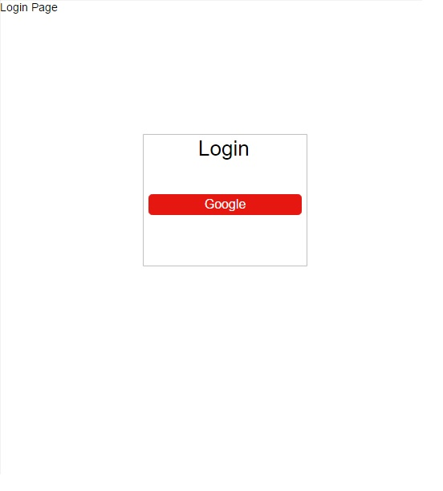

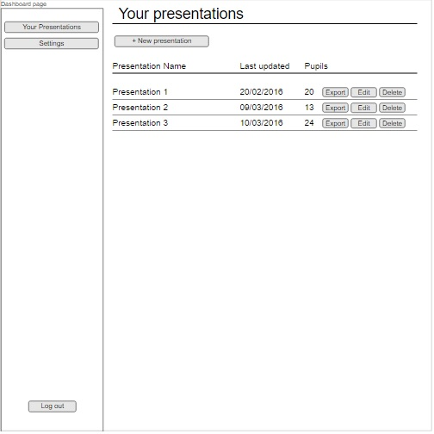

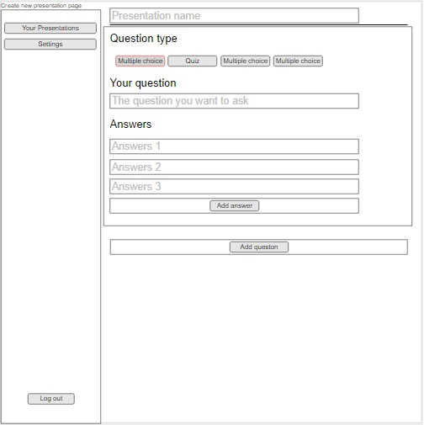

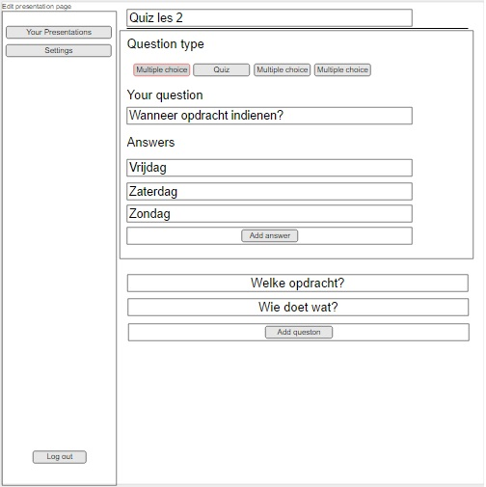

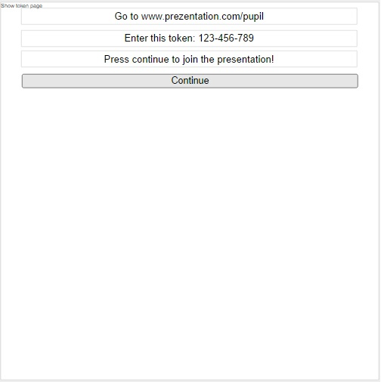

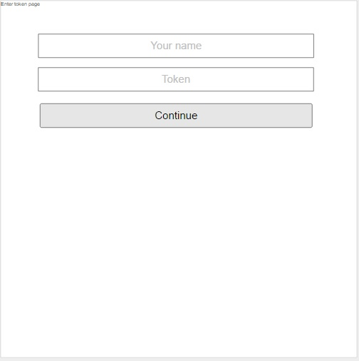

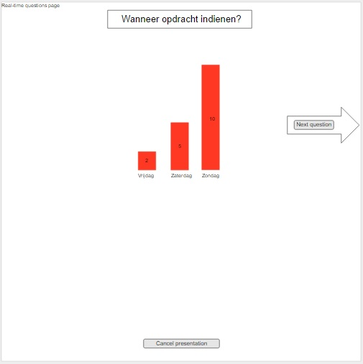

­­­­­­­­­

**Diagram Meteor**

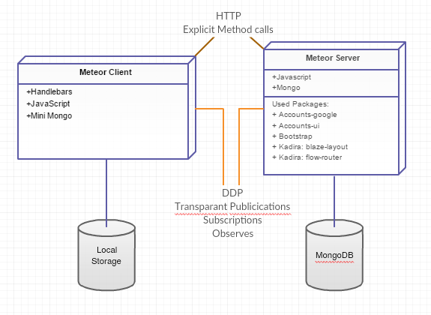

**Schema Meteor**

