System Verilog 32 Bit CPU and RISK-V Standard
Musiaev Konstantin 2026
Structure:
1) Introduction
1.1 Project branch introduction
1.2 About the plans
2) Hardware modernization
2.1 Register File (Registers read/write control)
2.2 ALU (Mathematical & Logical commands/calculations)
2.3 Data Memory (Read/write constants & variables)
2.4 Instruction Memory (Read/write instructions)
2.5 Program Counter (Instruction address tracking & flow control)
2.6 Control Unit (Instructions decoding & distribution)
2.7 TOP Unit (Unite all parts & data transfer)
3) Hardware modernization conclusion
4) QEMA and simulation settings
5) C-development
6) Project branch conclusion
7) Appendices

Introduction
1.1 Project Branch Introduction
This branch, RISC-V-Standard-Modernization, marks a major milestone in the step-by-step development of a fully compliant RV32I (32-bit RISC-V Base Integer Instruction Set) soft-core processor implemented in SystemVerilog.
By utilizing a structured Git branching workflow, each key architectural component from register files and arithmetic logic units to control logic and memory interfaces is developed, parameterized, and thoroughly verified via simulation testbenches before being merged into the main development branch.
1.2 About the Plans
The roadmap for this modernization phase is divided into four key milestones: 1. RTL Design & Hardware Implementation: Complete core hardware blocks. Assemble all individual modules into a unified TOP entity with well-defined bus structures.
2. Verification & Simulation: Develop comprehensive SystemVerilog testbenches for unit-level and system-level verification. Resolve timing issues, race conditions, and validate branch/comparison logic in Vivado Simulator.
3. Environment & Toolchain Setup: Configure QEMU for functional simulation and behavior comparison against reference RISC-V models.
4. Software Execution (C-Development): Write, compile, and load C programs onto the core to confirm correct hardware execution of real-world binaries.

Hardware modernization
2.1 ALU
The ALU module is not only calculator for mathematical operations in the RV32I processor architecture, it also takes significant part in the other operations types (address, etc.) The main core idea and combinational logic has remained unchangeable, although commands codes, data types and their quantity were modified.
The following commands are R-block RISC-V standard:
- ADD
- SUB
- SLL
- STL
- STLU
- XOR
- SRL
- SRA
- OR
- END
Commands, which weren’t written above (NOT, *, /, etc.) are executable using operators above (full information can be found in “RISC-V Green Card”). All commands implementations and simulation verification results can be seen in ALU_tb.sv and in the simulation graph (Appendices).

2.2 Register File
The Register File is one of the fundamental blocks of the RV32I processor core, operating as a high-speed internal storage unit. It holds intermediate data, memory addresses, and calculation results required by the processor during instruction execution. Because accessing external memory is significantly slower, the Register File provides the ALU and control unit with zero-wait-state access to active variables.
In compliance with the RV32I RISC-V base integer specification, the Register File consists of 32 general-purpose registers (designated as x0 through x31), where each register is 32 bits wide. Register read operation became synchronous and also is executed for 2 clk signals. All modernizations can be seen in Register_File.sv and in the simulation graph (Appendices).

3.3 Data Memory
The Data Memory is a critical component of the RV32I processor core, responsible for handling persistent data storage and load/store operations during program execution. Acting as the primary interface between the processor datapath and the memory subsystem, it supports flexible word and sub-word data manipulation required for executing complex software instructions and bytes operations.
In compliance with the RV32I RISC-V base architecture, the memory is structured as a word-addressable array of 32-bit words, where the upper address bits define the row index and the lower bits ([1:0]) represent the byte offset. To support fine-grained memory access, a dedicated 4-bit write-enable mask enables selective byte and half-word updates, ensuring the integrity of surrounding data within the same word. All implementation details and simulation verification results can be seen in Data_Memory.sv and in the simulation graph (Appendices).
Memory size is restricted by 16 Kbytes at this moment to load it in FPGA without extra REM connection.
! Read and write data values can be different in some parts due to implementation, namely, read operation gives full 32-bit value, while write data can be written and checked only in some part of the full line!

3.4 Instruction Memory
The Instruction Memory is a critical component of the RV32I processor core, responsible for handling CPU instructions. Acting as instructions source for the processor, it supports only reading operation and data manipulation with the whole 32-bit words. The memory is also separated by bytes according to RISC-V standard, which initially was based on von-Neumann architecture, but in this project the Harvard architecture is used.
Memory size is restricted by 16 Kbytes at this moment to load it in FPGA without extra REM connection.
All implementation details and simulation verification results can be seen in Instruction_Memory.sv and in the simulation graph (Appendices).

3.5 Program Counter
The program Counter is an “engine”, which moves instructions execution forward. This module is able to implement direct displacement to 4 bits forward and also make “jumps” to some concrete instructions using commands:
1) SB block
- BEQ
- BNE
- BLT
- BGE
- BLTU
- BGEU
2) I block
- JALR
3) UJ block
- JAL
AUIPC is also can be executed, but its output address is calculated in dataflow way (in behavior block it just implements 4-bit shift forward like default statement).
All implementation details and simulation verification results can be seen in Program_Counter.sv and in the simulation graph (Appendices).

Appendices
ALU:
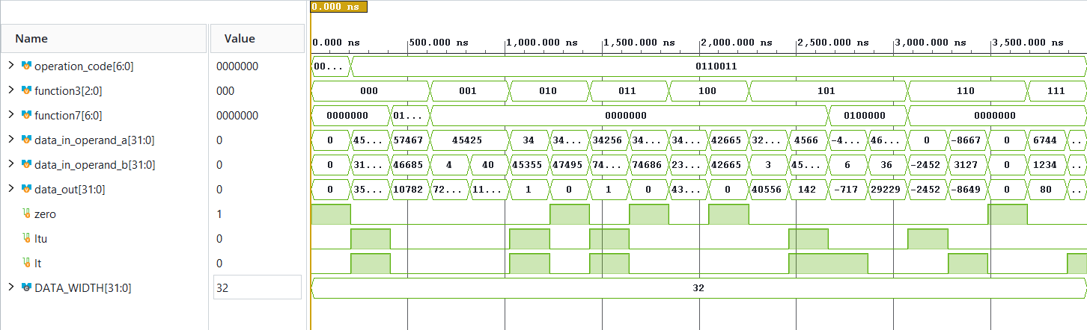
SUCCESS DEFAULT: 0 was got correctly
SUCCESS ADD: Expected result ( 3598304) was received correctly
SUCCESS SUB: Expected result ( 10782) was received correctly
SUCCESS SLL: Expected result ( 726800) was received correctly
SUCCESS SLL: Expected result ( 11628800) was received correctly
SUCCESS STL: Expected result ( 1) was received correctly
SUCCESS STL: Expected result ( 0) was received correctly
SUCCESS STLU: Expected result ( 1) was received correctly
SUCCESS STLU: Expected result ( 0) was received correctly
SUCCESS XOR: Expected result ( 438779) was received correctly
SUCCESS XOR: Expected result ( 0) was received correctly
SUCCESS SRL: Expected result ( 40556) was received correctly
SUCCESS SRL: Expected result ( 142) was received correctly
SUCCESS SRA: Expected result (4294966579) was received correctly
SUCCESS SRA: Expected result ( 29229) was received correctly
SUCCESS OR: Expected result (4294964844) was received correctly
SUCCESS OR: Expected result (4294958647) was received correctly
SUCCESS OR: Expected result ( 0) was received correctly
SUCCESS AND: Expected result ( 80) was received correctly
SUCCESS AND: Expected result ( 3109) was received correctly

Register File:
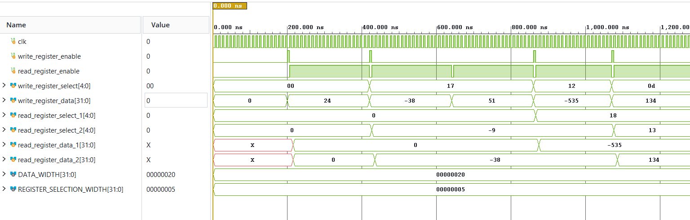
SUCCESS: Register 0 was keeped unchanged
SUCCESS: Number -38 was written in register 23
SUCCESS: Register 23 was keeped unchanged
SUCCESS: Both registors got and gave rigth data

Data Memory:
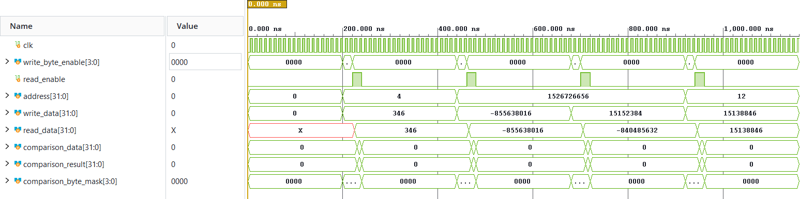
SUCCESS: Expected data ( 346) was written to the address word cell 1
SUCCESS: Expected data (205) was written to the address byte cell 3
SUCCESS: Expected data (59189) was written to the address byte cell 2 and 1
SUCCESS: Expected data (59166) was written to the address byte cell 2 and 0
Instruction Memory:
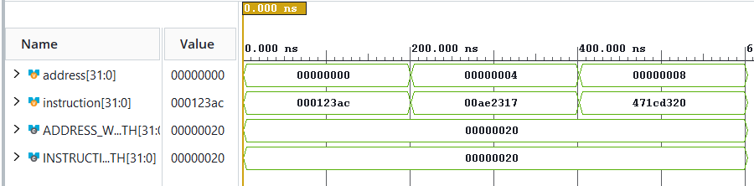
SUCCESS: Expected data ( 74668) is located in the address cell 0
SUCCESS: Expected data ( 11412247) is located in the address cell 4
SUCCESS: Expected data (1193071392) is located in the address cell 8

Program Counter:
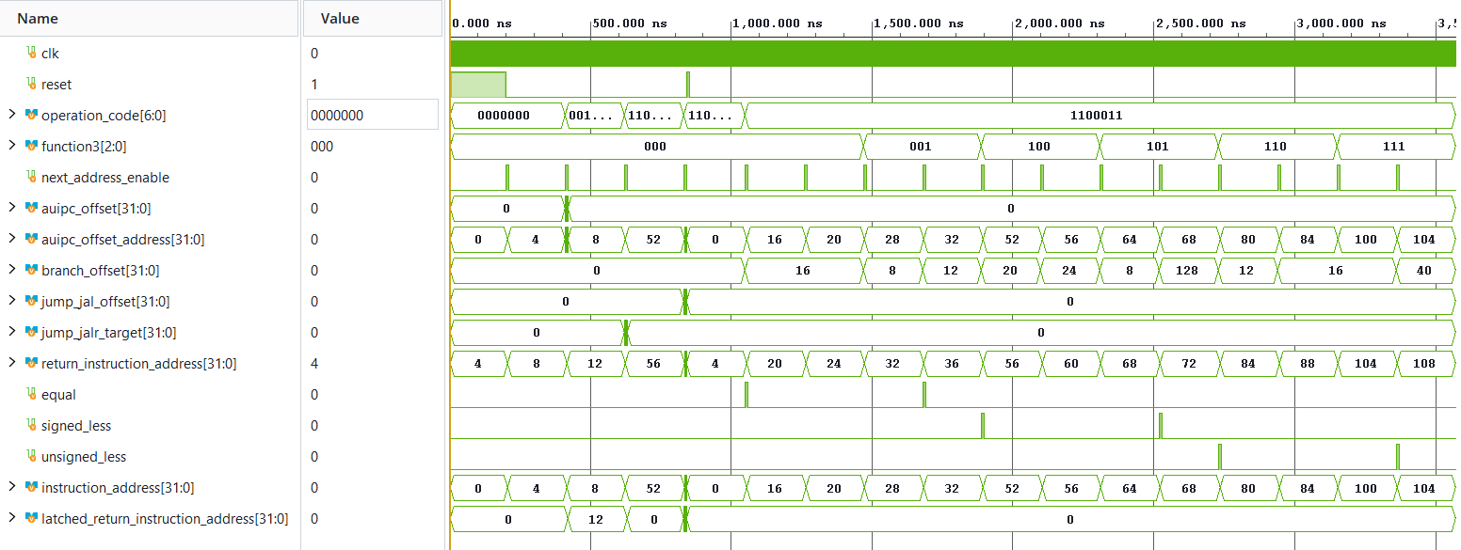
SUCCESS: Expected instruction address ( 4) was received correctly.
SUCCESS: Expected instruction address, latched_return_instruction_address, auipc_offset_address ( 8, 12, 408) were received correctly.
SUCCESS: Expected instruction address, latched_return_instruction_address ( 52, 12) were received correctly.
SUCCESS: Expected instruction address, latched_return_instruction_address ( 244, 56) were received correctly.
SUCCESS: Expected instruction address ( 16) were received correctly.
SUCCESS: Expected instruction address ( 20) were received correctly.
SUCCESS: Expected instruction address ( 28) were received correctly.
SUCCESS: Expected instruction address ( 32) were received correctly.
SUCCESS: Expected instruction address ( 52) were received correctly.
SUCCESS: Expected instruction address ( 56) were received correctly.
SUCCESS: Expected instruction address ( 64) were received correctly.
SUCCESS: Expected instruction address ( 68) were received correctly.
SUCCESS: Expected instruction address ( 80) were received correctly.
SUCCESS: Expected instruction address ( 84) were received correctly.
SUCCESS: Expected instruction address ( 100) were received correctly.
SUCCESS: Expected instruction address ( 104) were received correctly.

