SystemVerilog 8-bit CPU
Musiaev Konstantin 2026
Structure:
- Introduction
1.1 Project aim
1.2 Short Description
- CPU architecture
- Hardware description (SystemVerilog & Simulation)
3.1 ALU (Mathematical & Logical commands/calculations)
3.2 Register File (Registers read/write control)
3.3 Flag Register (Carry out, zero, overflow).
3.4 Data Memory (Read/write constants & variables)
3.5 Instruction Memory (Read/write instructions)
3.6 Program Counter (Instruction address tracking & flow control)
3.7 Control Unit (Instructions decoding & distribution)
3.8 CPU Top (Unite all parts & data transfer)
- Architecture conclusion
- Python “Assembler imitation”
4.1 Creating Python script for translation commands into machine code
4.2 Workability tests
- Python conclusion
- C compiler connection
5.1 This stage is in development
- Software conclusion
- Total conclusion
10) Appendices

Introduction
  - Project aim
The primary goal of this project is the design, SystemVerilog implementation, and functional verification of an 8-bit Central Processing Unit (CPU). Following the hardware realization, a custom software ecosystem-including a Python-based instruction encoder (assembler emulator) and C compiler support-will be integrated to demonstrate full-stack execution capability.

  - Project Overview
The designed 8-bit CPU is capable of executing a core set of arithmetic, classic “Harvard Architecture”, featuring completely separate memory spaces and buses for instructions and data. This separation allows concurrent instruction fetching and data access, optimizing execution throughput.

CPU architecture
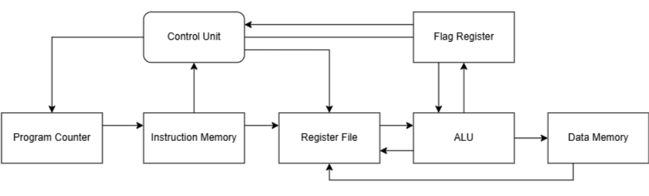
The structural block diagram below illustrates the complete data path and control pathways connecting all functional modules within the CPU.

Hardware description (SystemVerilog & Simulation)
All simulation graphs and logs are available in the appendices
This chapter consists of general description of realization, examples and code are located in this repository.

- ALU
ALU module is mathematical and logical controller implementing such commands. This part of CPU is built asynchronously (there is no clk / reset signal control), due to its purpose, namely, immediate commands execution of input data and output signals sending.
The following commands are realized:
- ADD – 0000
- SUB - 0001
- ADC – 0110
- SBB -1001
- AND – 0010
- OR – 0100
- NEG – 1000
- >>> - 0011
- <<< - 0111
- NOT – 1111

- Register File
Register file controls register are used in ALU module for calculations. Read / Write commands are realized in 2 different ways. Reading is executed asynchronously using “assign” operator allows get located data immediately, whereas writing depends on clk signal to avoid raсыe condition. Reset command for setting 0 for all registers (currently configured with 2 registers).

- Flag Register
Flag register is created for keeping flags (Zero, Carry bit, Sign, Overflow) for operations requires them. The structure is similar to Register File, but only one register is realized.

- Memory Data
This module executes read / write operations for variables and constants. Execution is different from register, namely, reading is also synchronous. The read command does not simply access a specific cell directly but first reaches it using a specific address, therefore, synchronous reading is used to avoid “zero intervals”, where new address is received, but write command has not set new data yet, while read command has already started checking the memory cell and return 0 (All cells are set to 0 before execution, to avoid x state).

Appendices
ALU (Simulation picture & Logs)
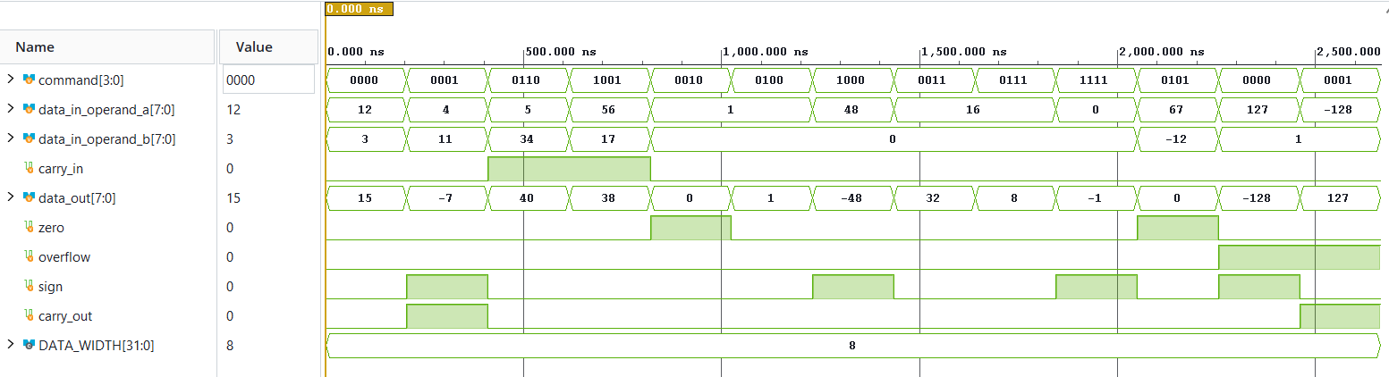
SUCCESS ADD: Expected result ( 15) was received correctly
SUCCESS SUB: Expected result ( -7) was received correctly
SUCCESS ADC: Expected result ( 40) was received correctly
SUCCESS SUC: Expected result ( 38) was received correctly
SUCCESS AND: Expected result ( 0) was received correctly
SUCCESS OR: Expected result ( 1) was received correctly
SUCCESS NEG: Expected result ( -48) was received correctly
SUCCESS >>>: Expected result ( 32) was received correctly
SUCCESS <<<: Expected result ( 8) was received correctly
SUCCESS NOT: Expected result ( -1) was received correctly
SUCCESS: Default value was set
SUCCESS: (+) Overflow was set
SUCCESS: (-) Overflow was set

Register File (Simulation picture & Logs)
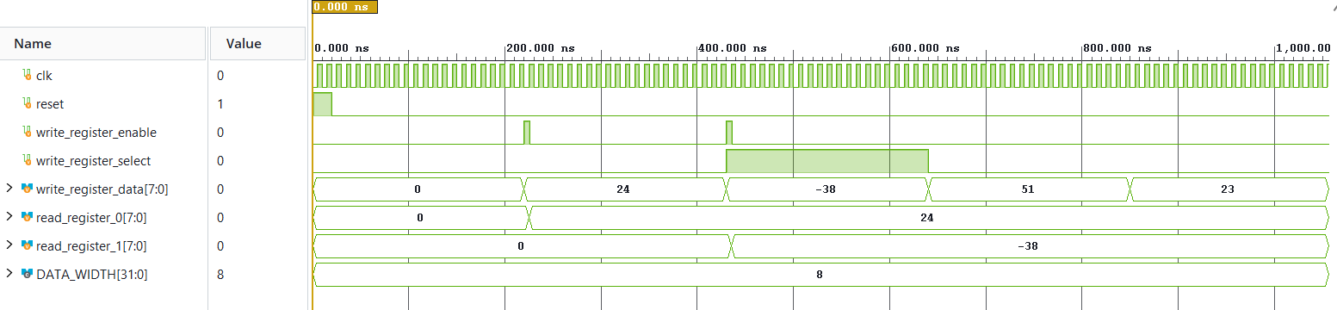
SUCCESS: Number 24 was written in register_0
SUCCESS: Number -38 was written in register_1
SUCCESS: register_0 is unchanged
SUCCESS: register_1 is unchanged

Flag Register (Simulation picture & Logs)
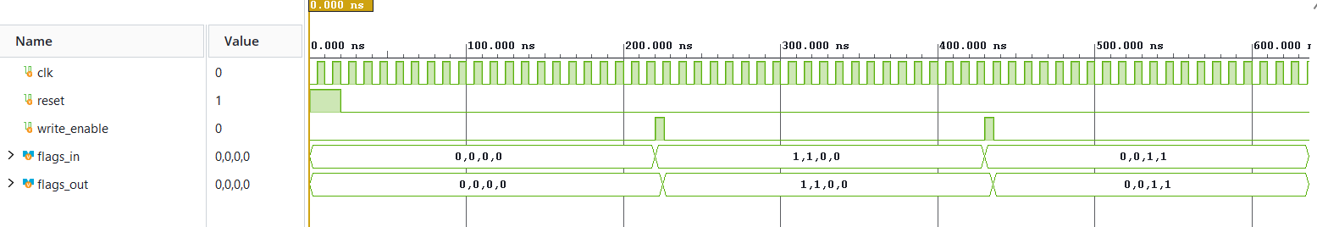
SUCCESS: zero flag was set correctly (1)
SUCCESS: carry_out flag was set correctly (1)
SUCCESS: sign flag was set correctly (0)
SUCCESS: overflow flag was set correctly (0)
SUCCESS: zero flag was set correctly (0)
SUCCESS: carry_out flag was set correctly (0)
SUCCESS: sign flag was set correctly (1)
SUCCESS: overflow flag was set correctly (1)

Data Memory (Simulation picture & Logs)
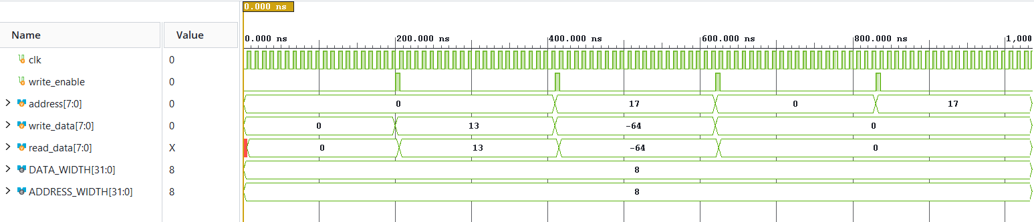
SUCCESS: Expected data ( 13) was written to the address cell 0
SUCCESS: Expected data ( -64) was written to the address cell 17
SUCCESS: Address cell 0 was reset to zero
SUCCESS: Address cell 17 was reset to zero

