SystemVerilog 8-bit CPU
Musiaev Konstantin 2026
Structure:
- Introduction
1.1 Project aim
1.2 Short Description
- CPU architecture
- Hardware description (SystemVerilog & Simulation)
3.1 ALU (Mathematical & Logical commands/calculations)
3.2 Register File (Registers read/write control)
3.3 Flag Register (Carry out, zero, overflow).
3.4 Data Memory (Read/write constants & variables)
3.5 Instruction Memory (Read/write instructions)
3.6 Program Counter (Instruction address tracking & flow control)
3.7 Control Unit (Instructions decoding & distribution)
3.8 TOP Unit (Unite all parts & data transfer)
- Architecture conclusion

Introduction
  - Project aim
The primary goal of this project is the design, SystemVerilog implementation, and functional verification of an 8-bit Central Processing Unit (CPU). Following the hardware realization, a custom software ecosystem-including a Python-based instruction encoder (assembler emulator) and C compiler support-will be integrated to demonstrate full-stack execution capability.

  - Project Overview
The designed 8-bit CPU is capable of executing a core set of arithmetic, classic “Harvard Architecture”, featuring completely separate memory spaces and buses for instructions and data. This separation allows concurrent instruction fetching and data access, optimizing execution throughput.

CPU architecture
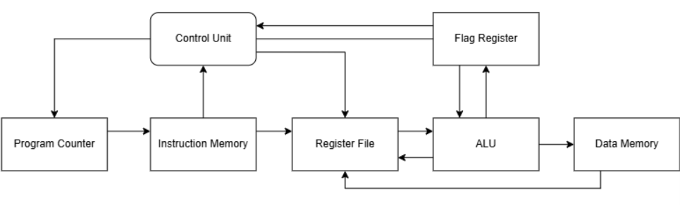
The structural block diagram below illustrates the complete data path and control pathways connecting all functional modules within the CPU.

Hardware description (SystemVerilog & Simulation)
All simulation graphs and logs are available in the appendices
This chapter consists of general description of realization, examples and code are located in this repository.

- ALU
ALU module is mathematical and logical controller implementing such commands. This part of CPU is built asynchronously (there is no CLK / reset signal control), due to its purpose, namely, immediate commands execution of input data and output signals sending.
The following commands are realized:
- ADD - 0001
- SUB - 0011
- ADC - 0111
- SBB - 1111
- AND - 1000
- OR - 1100
- NEG - 1110
- >>> - 0101
- <<< - 1010
- NOT - 0110

Bits Distribution [15-0]:
15:12 - Operation
11 - Set result register selection
10 - Operand 1 (register)
9 - Operand 2 (register)
8:0 - Reserved

- Register File
Register file controls register are used in ALU module for calculations. Read / Write commands are realized in 2 different ways. Reading is executed asynchronously using “assign” operator allows get located data immediately, whereas writing depends on CLK signal to avoid raсe condition. Reset command for setting 0 for all registers (currently configured with 2 registers).

- Flag Register
Flag register is created for keeping flags (Zero, Carry bit, Sign, Overflow) for operations requires them. The structure is similar to Register File, but only one register is realized.

- Data Memory
This module executes read / write operations for variables and constants. Execution is different from register, namely, reading is also synchronous. The read command does not simply access a specific cell directly but first reaches it using a specific address, therefore, synchronous reading is used to avoid “zero intervals”, where new address is received, but write command has not set new data yet, while read command has already started checking the memory cell and return 0 (All cells are set to 0 before execution, to avoid x state).

- Instruction memory
This processor part is similar to the previous, namely, it is responsible for data storage. The main difference is instructions in place of variables and constants. Instructions can be read during the execution asynchronously, due to the lack of write operations (instructions are preloaded prior to execution time).

- Control Unit
Control unit is logical decoder, namely, it transfers instruction parts to control bits for other parts. It receives the current 16-bit instruction word, extracts the 4-bit opcode, and generates a set of combinational control signals, that determine the operating mode of the data path for a single clock cycle.

Essential Update:
Synchronous modulus, CLK & reset signals and FSM were added to control LOAD command execution, namely, it is implemented in clk cycles due to synchronous data memory write / read structure.

The following control commands are realized:
- LOADI (Load constant in register) 1101
- LOAD (Load value form data memory in register) 1011
- STORE (Load value from register in data memory) 0100
- JMP (Move to concrete address) 0010
- JZ (Move to concrete address if zero) 1001

Bits Distribution [15-0] (LOADI):
15:12 - Operation
11 - Register selection
10:3 - Number
2:0 - Reserved

Bits Distribution [15-0] (LOAD, STORE):
15:12 -Operation
11- Register selection
10:3 - Memory address
2:0 - Reserved

Bits Distribution [15-0] (JMP,):
15:12 - Operation
11 - Reserved
10:3 - Address
2:0 - Reserved

Bits Distribution [15-0] (JZ):
15:12 - Operation
11 - Flag
10:3 - Address
2:0 - Reserved

- Program Counter
Program counter executes instructions address control. Instructions can be executed in series, transfer to concrete address is available.

- TOP Unit
TOP unit is main connection uniting all other modulus in one system according to the schematic above. All signals circulate within the system except of CLK and reset signals.

First test was executed and successfully verified. The following programs were implemented and translated in hexadecimal system:
LOADI R0 79 = 1101 0 01001111 xxx
LOADI R1 -23 = 1101 1 10010111 xxx
ADD R0 R0 R1 = 0001 0 0 1 xxxxxxxxx
STORE R0 0 = 0100 0 00000000 xxx
LOADI R0 66 = 1101 0 01000010 xxx
LOAD R1 0 = 1011 1 00000000 xxx
SBB R0 R0 R1 = 1111 0 0 1 xxxxxxxxx
STORE R0 1 = 0100 0 00000001 xxx
JMP Itself (infinite cycle) = 0010 x 00001000 xx
X – not used (can be 0 or 1)

Architecture conclusion
The development of this custom 8-bit CPU core successfully validates a modular and robust SystemVerilog architecture. By transitioning the Control Unit to a two-state Finite State Machine (FETCH and WRITE), the core reliably mitigates timing hazards associated with synchronous memory latency, ensuring stable Program Counter behavior and race-free register updates (Described at the previous chapter).
Furthermore, the ALU natively handles signed arithmetic through standard two’s complement representation, supporting seamless operation over the unified data path. Comprehensive simulation results confirm clean signal execution across all instruction cycles, proving the architecture fully functional and ready for further system-level integration or expansion.

Appendices
ALU (Simulation picture & Logs)
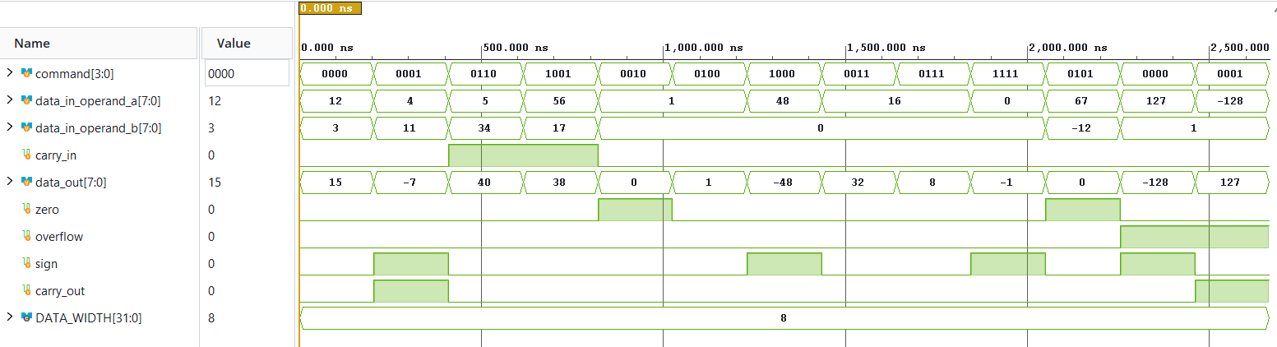
SUCCESS ADD: Expected result ( 15) was received correctly
SUCCESS SUB: Expected result ( -7) was received correctly
SUCCESS ADC: Expected result ( 40) was received correctly
SUCCESS SUC: Expected result ( 38) was received correctly
SUCCESS AND: Expected result ( 0) was received correctly
SUCCESS OR: Expected result ( 1) was received correctly
SUCCESS NEG: Expected result ( -48) was received correctly
SUCCESS >>>: Expected result ( 32) was received correctly
SUCCESS <<<: Expected result ( 8) was received correctly
SUCCESS NOT: Expected result ( -1) was received correctly
SUCCESS: Default value was set
SUCCESS: (+) Overflow was set
SUCCESS: (-) Overflow was set

Register File (Simulation picture & Logs)
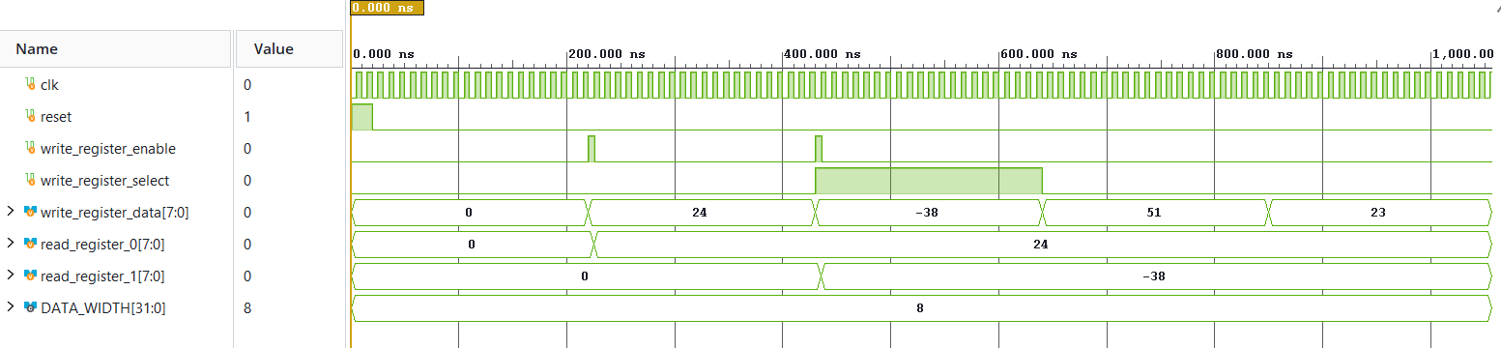
SUCCESS: Number 24 was written in register_0
SUCCESS: Number -38 was written in register_1
SUCCESS: register_0 is unchanged
SUCCESS: register_1 is unchanged

Flag Register (Simulation picture & Logs)
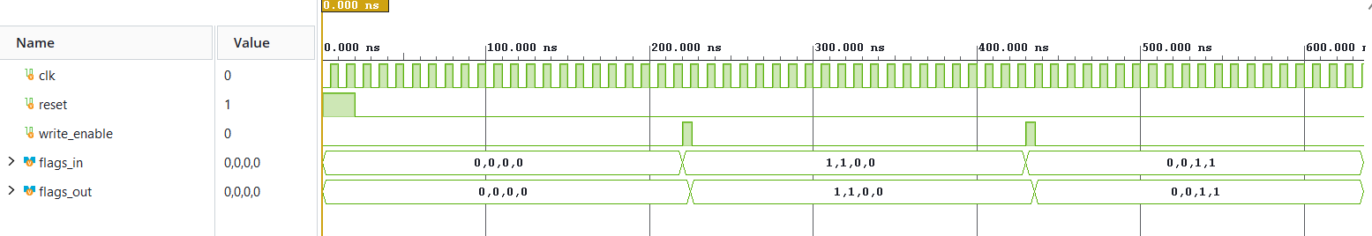
SUCCESS: zero flag was set correctly (1)
SUCCESS: carry_out flag was set correctly (1)
SUCCESS: sign flag was set correctly (0)
SUCCESS: overflow flag was set correctly (0)
SUCCESS: zero flag was set correctly (0)
SUCCESS: carry out flag was set correctly (0)
SUCCESS: sign flag was set correctly (1)
SUCCESS: overflow flag was set correctly (1)

Data Memory (Simulation picture & Logs)
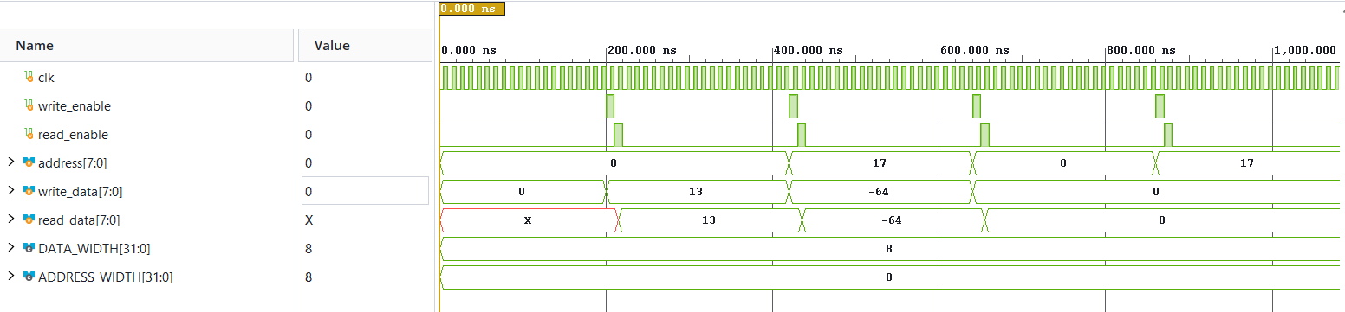
SUCCESS: Expected data ( 13) was written to the address cell 0
SUCCESS: Expected data ( -64) was written to the address cell 17
SUCCESS: Address cell 0 was reset to zero
SUCCESS: Address cell 17 was reset to zero

Instruction Memory (Simulation picture & Logs)
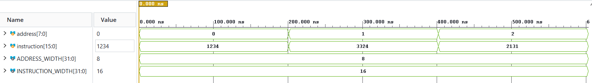
SUCCESS: Expected data ( 4660) is located in the address cell 0
SUCCESS: Expected data (13092) is located in the address cell 1
SUCCESS: Expected data ( 8497) is located in the address cell 2

Control Unit (Simulation picture & Logs)
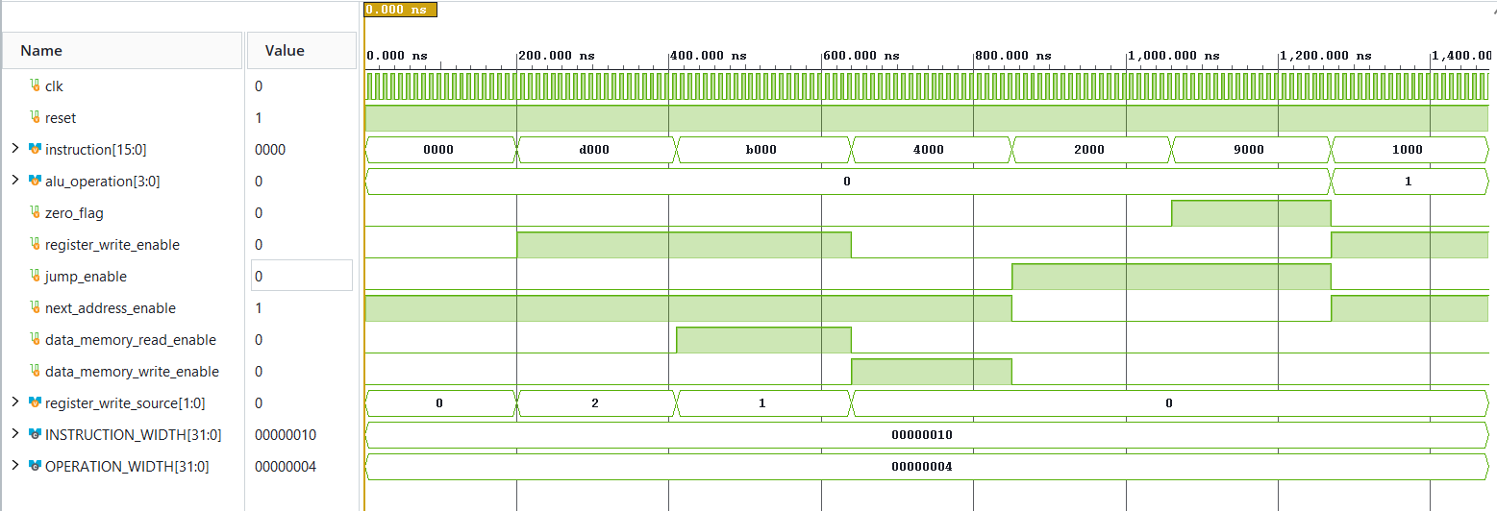 SUCCESS LOADI: Expected result (1) was received correctly
SUCCESS LOADI: Expected result (2) was received correctly
SUCCESS LOAD: Expected result (1) was received correctly
SUCCESS LOAD: Expected result (1) was received correctly
SUCCESS LOAD: Expected result (1) was received correctly
SUCCESS STORE: Expected result (1) was received correctly
SUCCESS STORE: Expected result (0) was received correctly
SUCCESS JMP: Expected result (1) was received correctly
SUCCESS JZ: Expected result (1) was received correctly
SUCCESS ALU: Expected result (1) was received correctly
SUCCESS ALU: Expected result (0) was received correctly

TOP Unit (Simulation picture & Logs)
