Simulation pictures and logs
1) ALU:
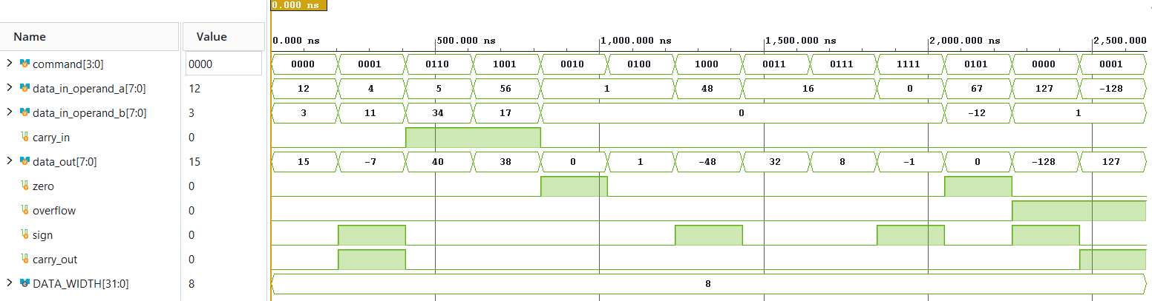
Loggs:
SUCCESS ADD: Expected result ( 15) was received correctly
SUCCESS SUB: Expected result ( -7) was received correctly
SUCCESS ADC: Expected result ( 40) was received correctly
SUCCESS SUC: Expected result ( 38) was received correctly
SUCCESS AND: Expected result ( 0) was received correctly
SUCCESS OR: Expected result ( 1) was received correctly
SUCCESS NEG: Expected result ( -48) was received correctly
SUCCESS >>>: Expected result ( 32) was received correctly
SUCCESS <<<: Expected result ( 8) was received correctly
SUCCESS NOT: Expected result ( -1) was received correctly
SUCCESS: Default value was set
SUCCESS: (+) Overflow was set
SUCCESS: (-) Overflow was set

2) Register_File:
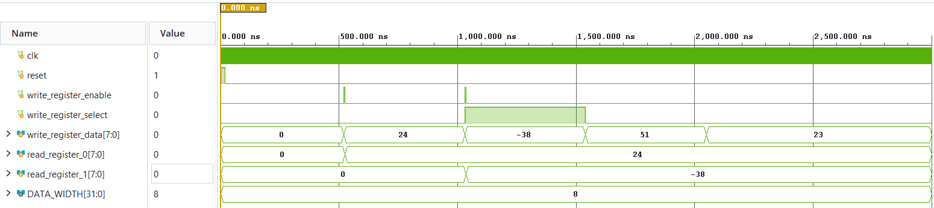
Loggs:
SUCCESS: Number 24 was written in register_0
SUCCESS: Number -38 was written in register_1
SUCCESS: register_0 is unchanged
SUCCESS: register_1 is unchanged

