System Verilog 32 Bit CPU and RISK-V Standard
Musiaev Konstantin 2026
Structure:
1) Introduction
1.1 Project branch introduction
1.2 About the plans
2) Hardware modernization
2.1 Register File (Registers read/write control)
2.2 ALU (Mathematical & Logical commands/calculations)
2.3 Data Memory (Read/write constants & variables)
2.4 Instruction Memory (Read/write instructions)
2.5 Program Counter (Instruction address tracking & flow control)
2.6 Control Unit (Instructions decoding & distribution)
2.7 TOP Unit (Unite all parts & data transfer)
3) Hardware modernization conclusion
4) QEMA and simulation settings
5) C-development
6) Project branch conclusion
7) Appendices

Introduction
1.1 Project Branch Introduction
This branch, RISC-V-Standard-Modernization, marks a major milestone in the step-by-step development of a fully compliant RV32I (32-bit RISC-V Base Integer Instruction Set) soft-core processor implemented in SystemVerilog.
By utilizing a structured Git branching workflow, each key architectural component from register files and arithmetic logic units to control logic and memory interfaces is developed, parameterized, and thoroughly verified via simulation testbenches before being merged into the main development branch.
1.2 About the Plans
The roadmap for this modernization phase is divided into four key milestones: 1. RTL Design & Hardware Implementation: Complete core hardware blocks. Assemble all individual modules into a unified TOP entity with well-defined bus structures.
2. Verification & Simulation: Develop comprehensive SystemVerilog testbenches for unit-level and system-level verification. Resolve timing issues, race conditions, and validate branch/comparison logic in Vivado Simulator.
3. Environment & Toolchain Setup: Configure QEMU for functional simulation and behavior comparison against reference RISC-V models.
4. Software Execution (C-Development): Write, compile, and load C programs onto the core to confirm correct hardware execution of real-world binaries.

Hardware modernization
2.1 Register File
The Register File is a fundamental block of the RV32I processor core, operating as a high-speed internal storage unit. It holds intermediate data, memory addresses, and calculation results required by the processor during instruction execution. Because accessing external memory is significantly slower, the Register File provides the ALU and control unit with zero-wait-state access to active variables.
In compliance with the RV32I RISC-V base integer specification, the Register File consists of 32 general-purpose registers (designated as x0 through x31), where each register is 32 bits wide. All modernizations can be seen in Register_File.sv and in the simulation graph (Appendices).

Appendices
Register File:
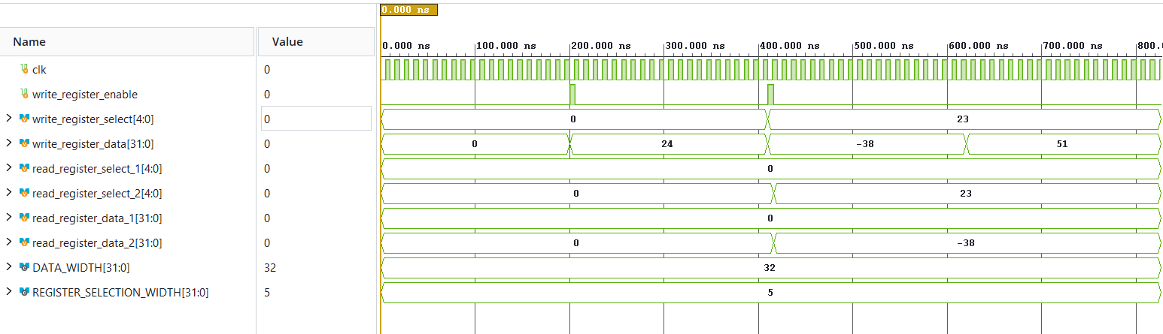
SUCCESS: Register 0 was keeped unchanged
SUCCESS: Number -38 was written in register 23
SUCCESS: Register 23 was keeped unchanged

