

|  |  |
| --- | --- |
| Assessment Module | RGU CM1603 Database Systems |
| Module Leader | Mrs.Theja Perera |
| Student Name | Lasal Chathranjey Jayawardena |
| RGU Id | 2016279 |
| IIT Id | 20200344 |
| Submission Type | Database Coursework |
| Submission Date | 4th  January 2020 |
| Tools Used | XAMP |

Course Work Report

Summary

The coursework is based on a complete step by step implementation of a simplified Database used for the Amazon's transactional A.I . First we created a Conceptual Entity-Relationship Diagram. Then we moved onto developing a Logical Schema Diagram. Then we applied all Normalization Rules before finally implementing the Database. The Implementation section will include all SQL queries and corresponding images of the result.

I used XAMP to develop and maintain the Database. Used the Phpmyadmin for writing and executing the queries.

**Conceptual Entity-Relationship Diagram**

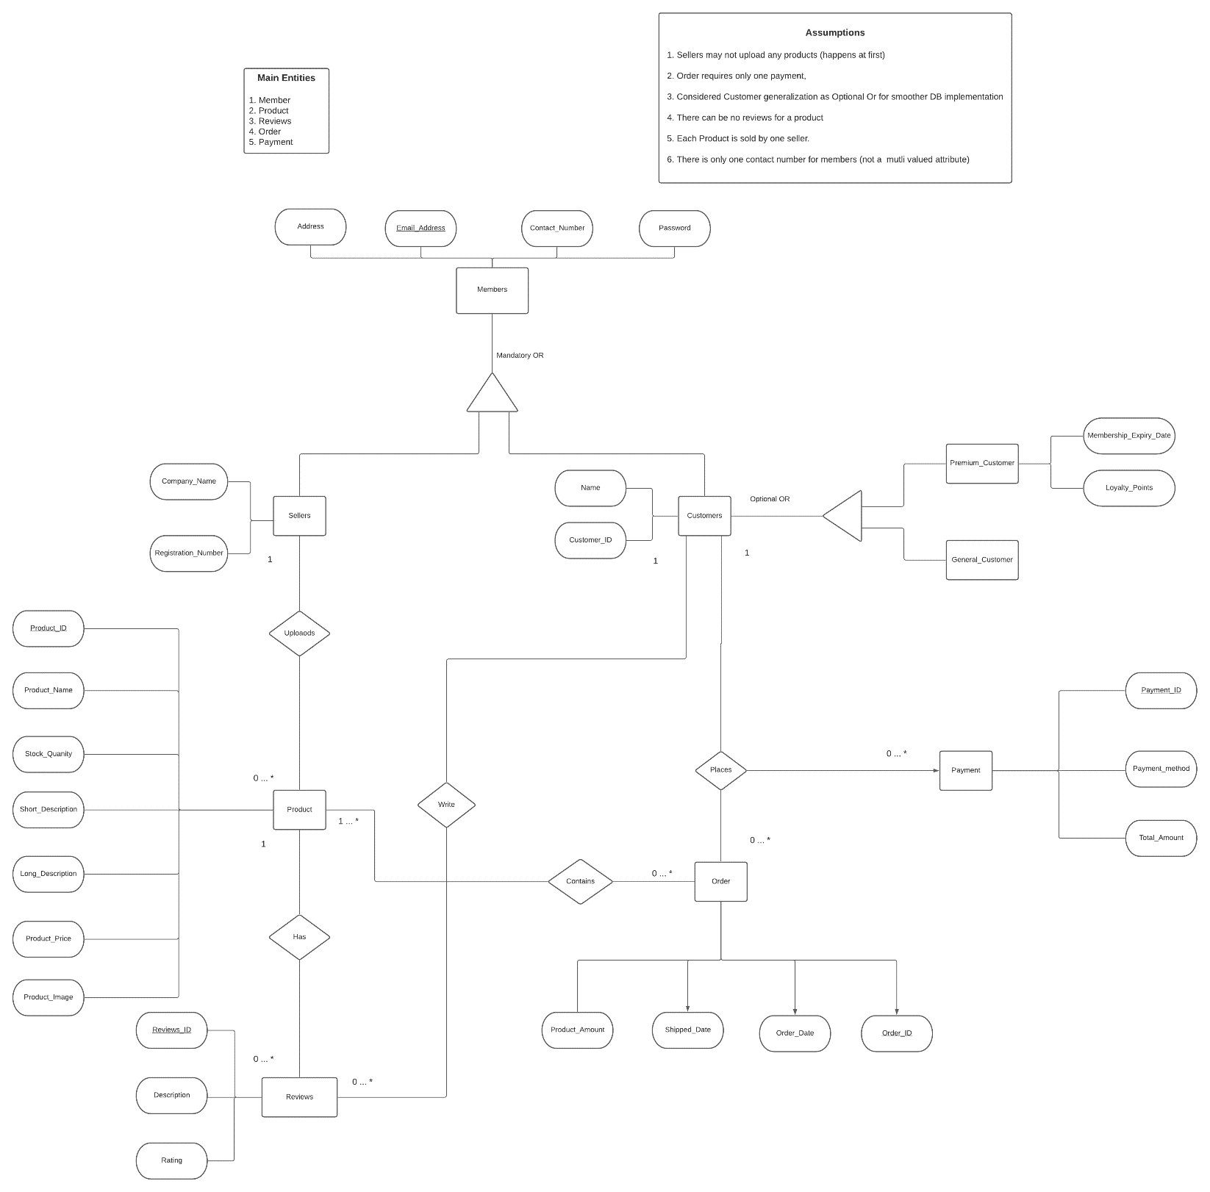

**Logical Schema Diagram**

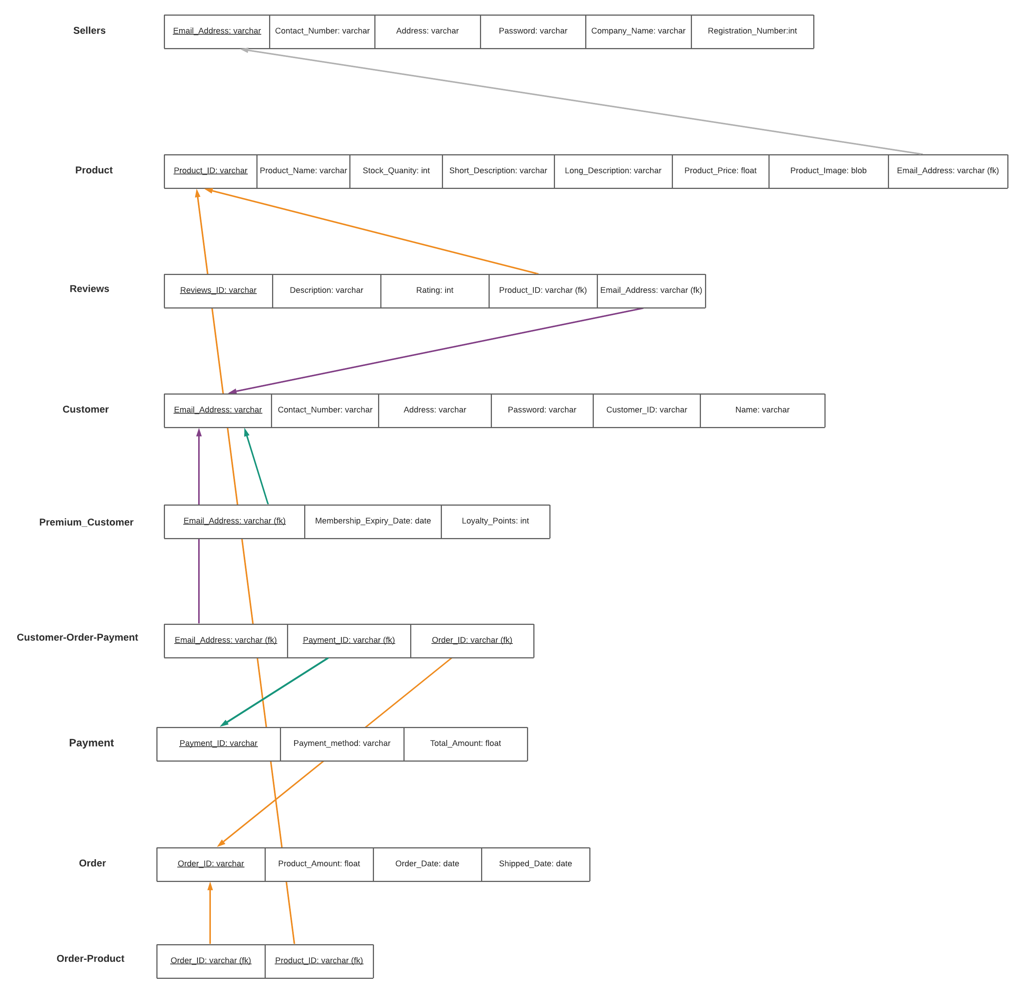

**Normalization Phase**

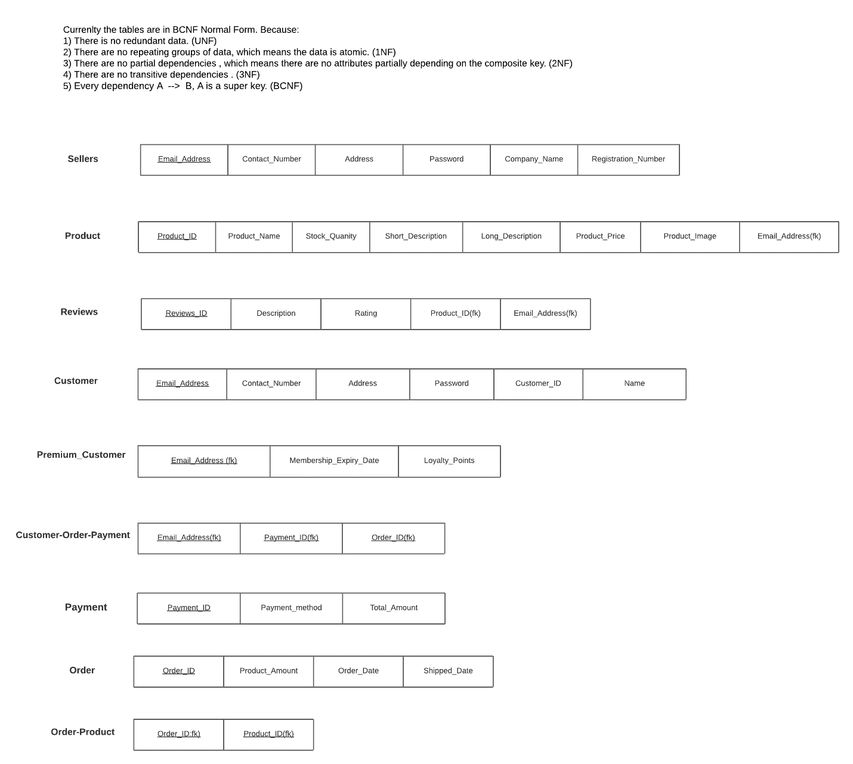

**All SQL Commands**

Table Creation

1. customer Table  
     
   SQL  
   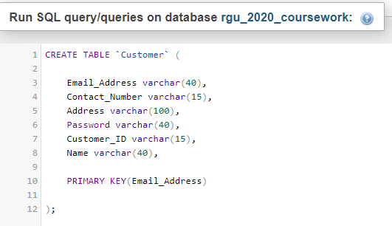

Table Structure

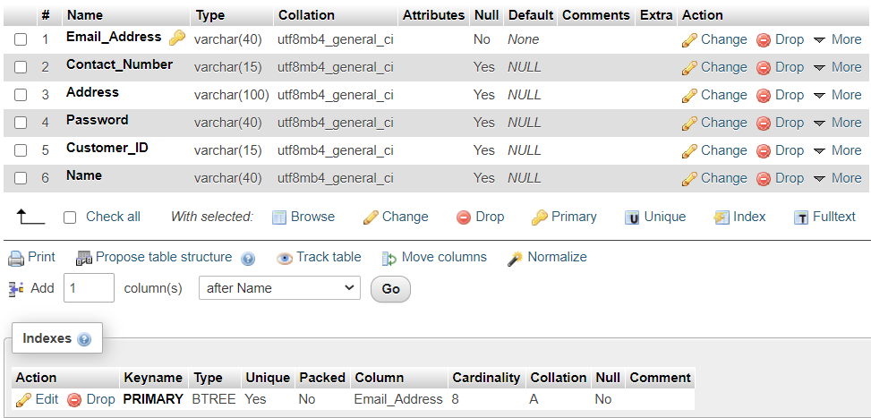

1. customer-order-payment Table  
     
     
   SQL  
     
   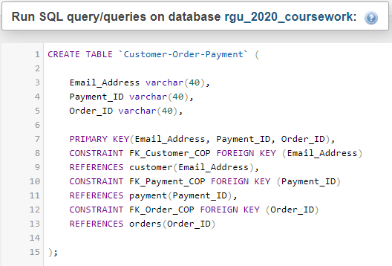  
     
     
   Table Structure  
     
   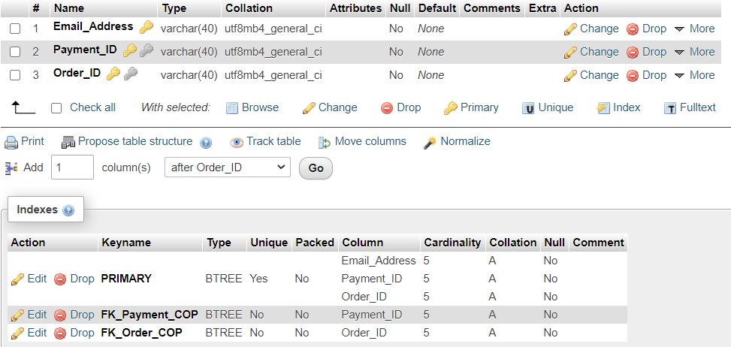
2. order-product Table  
     
     
     
   SQL  
     
   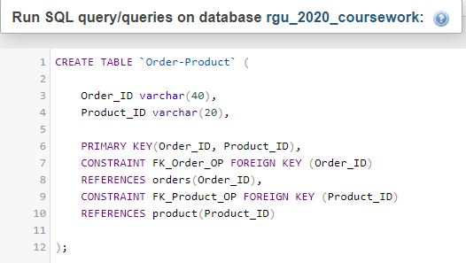

Table Structure  
  
  
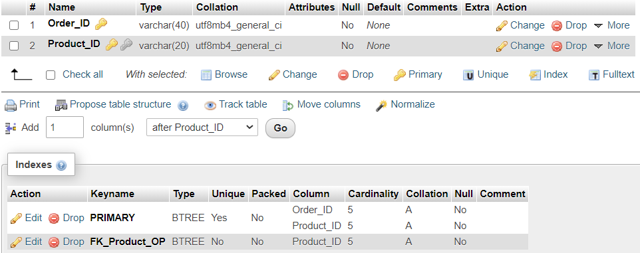

1. orders Table  
     
     
   SQL  
     
   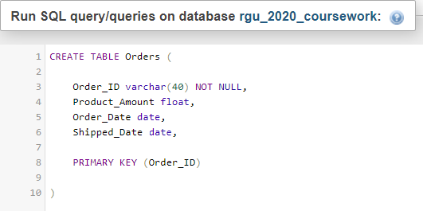  
     
     
   Table Structure  
     
   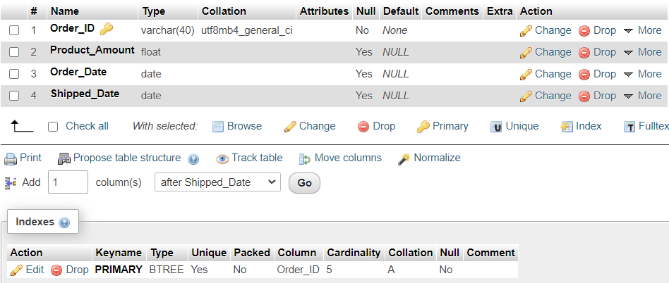
2. payment Table  
     
     
   SQL  
     
   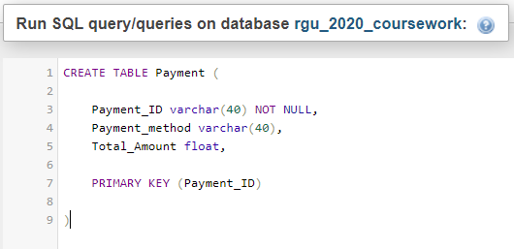  
     
     
     
   Table Structure  
     
   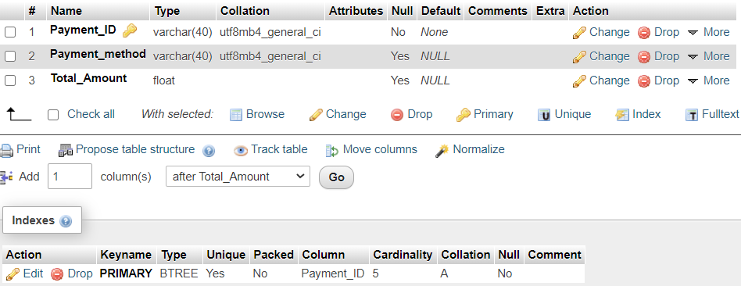
3. premium_customer Table  
     
     
   SQL  
     
   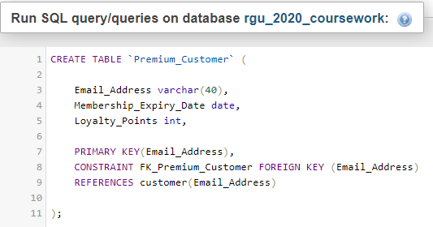  
     
     
     
   Table Structure  
     
   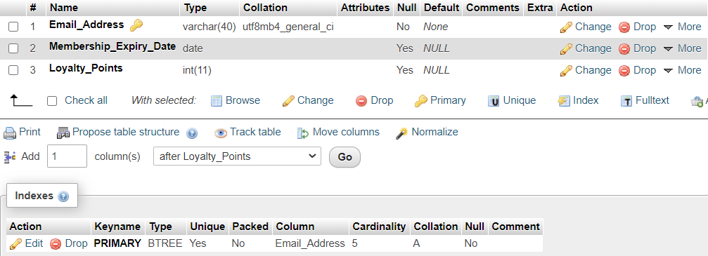
4. product Table  
     
     
   SQL  
     
   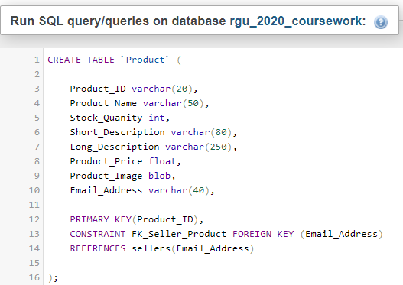  
     
     
   Table Structure  
     
   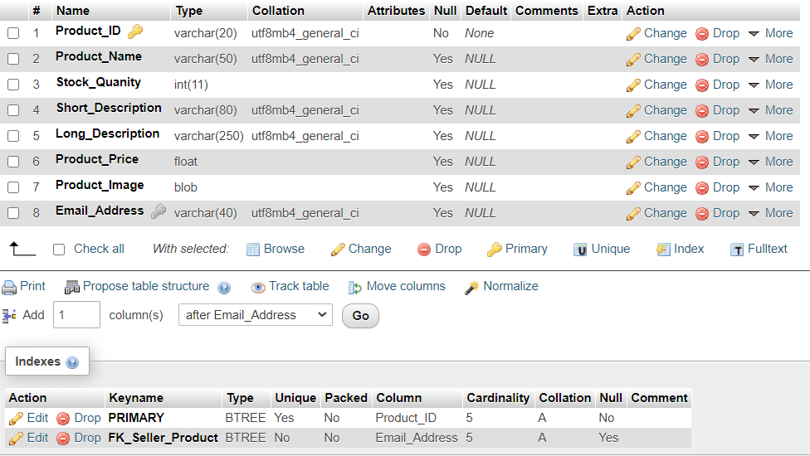
5. reviews Table  
     
   SQL  
     
   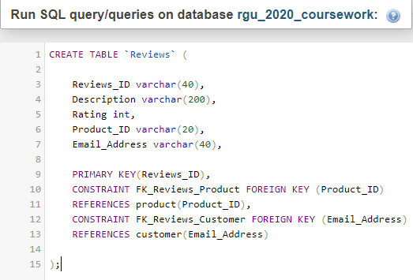  
     
     
     
   Table Structure  
     
   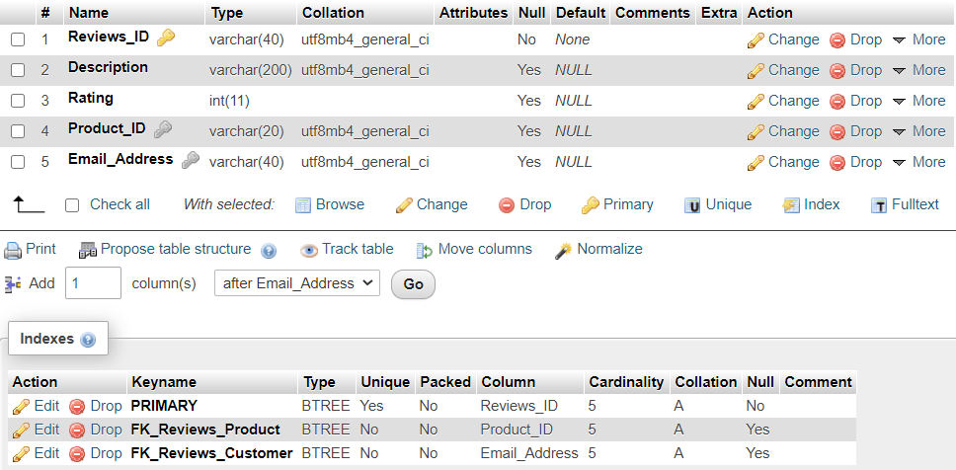

sellers Table  
  
  
SQL  
  
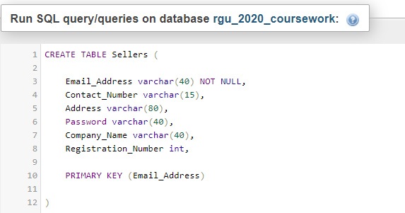  
  
  
Table Structure  
  
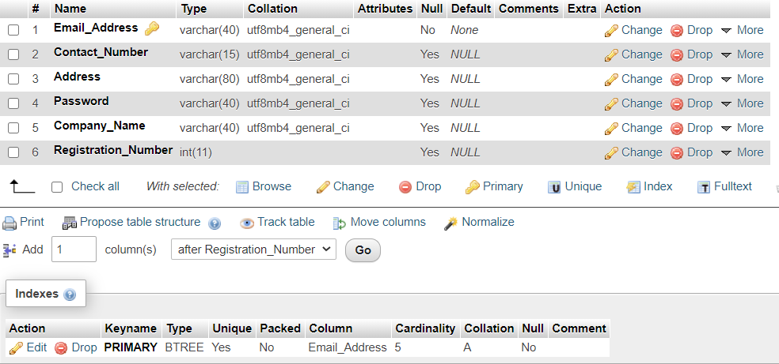  
  
  
  
  
  
Sample Data Insertion

1. 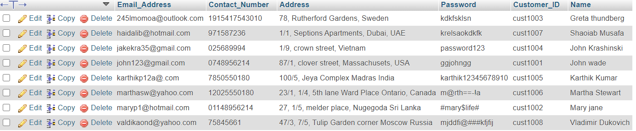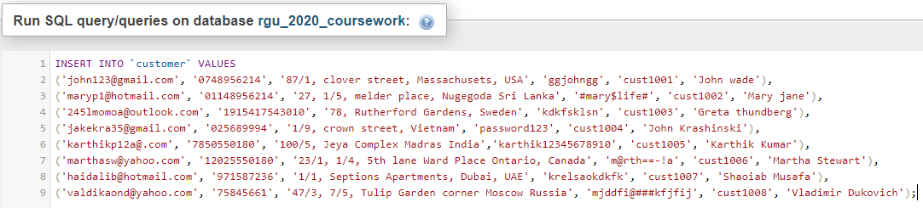customer Table  
     
   SQL  
     
     
     
     
   Table Content
2. customer-order-payment Table  
     
     
   SQL  
     
   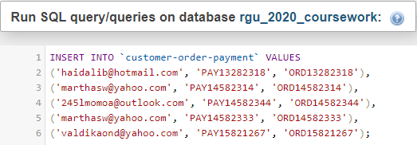  
     
     
     
   Table Content  
     
   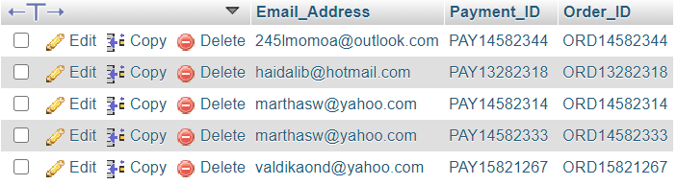

1. order-product Table  
     
     
   SQL  
     
   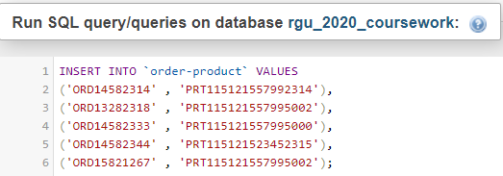  
     
     
   Table Content  
     
   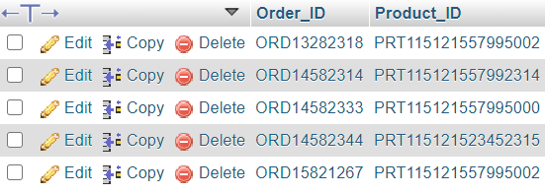
2. 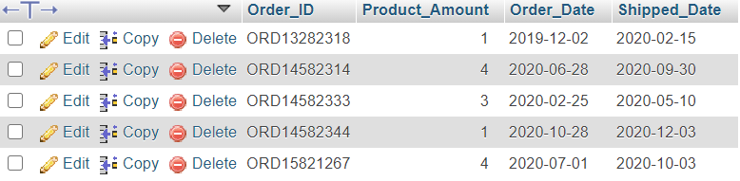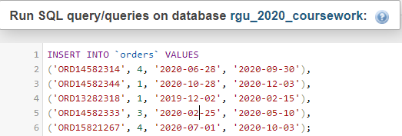order Table  
     
     
   SQL  
     
     
     
     
     
     
     
     
     
     
     
     
     
     
     
   Table Content
3. 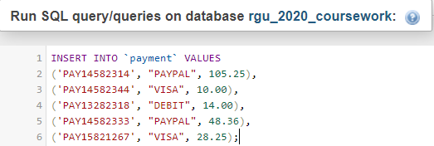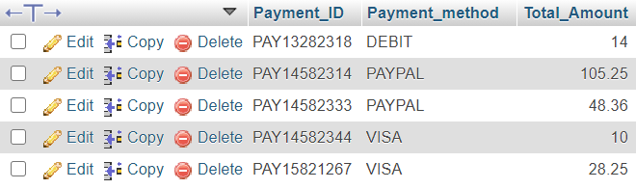payment Table  
     
     
     
   SQL  
     
     
     
     
     
     
     
     
     
     
     
     
   Table Content

1. 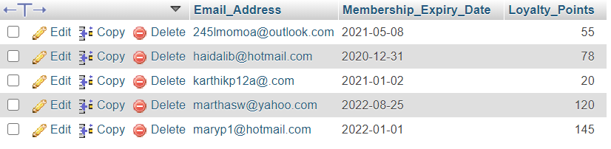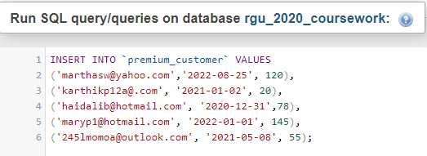premium_customer Table  
     
     
   SQL  
     
     
     
     
     
     
     
     
     
     
     
     
     
     
     
   Table Content
2. 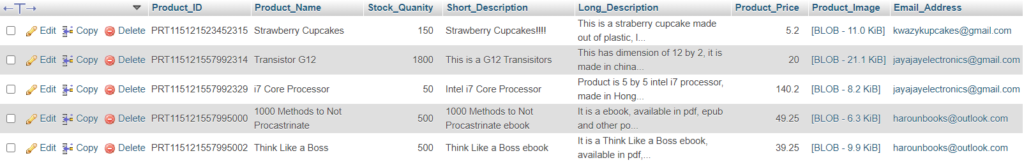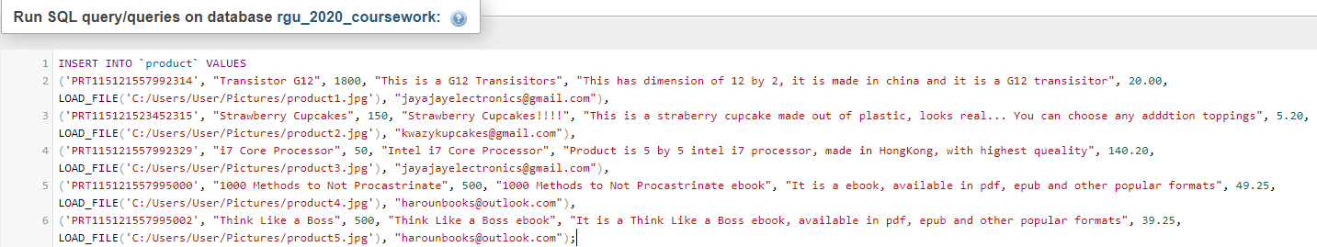Product Table  
     
     
   SQL  
     
     
     
     
   Table Content
3. 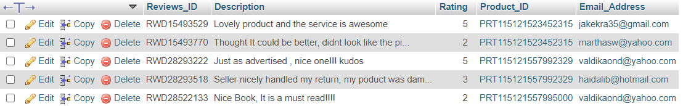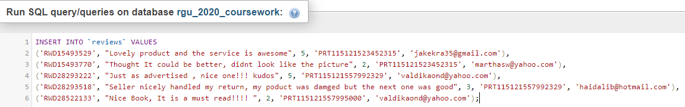Reviews Table  
     
     
   SQL  
     
     
     
     
   Table Content

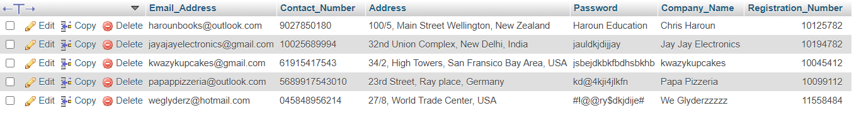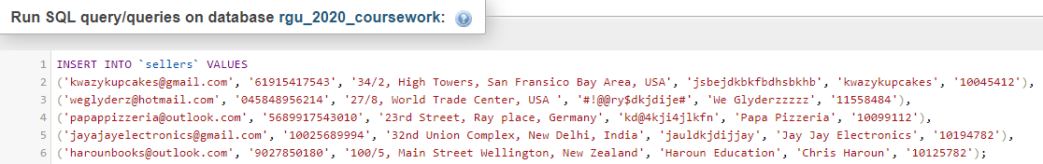Sellers Table  
  
  
  
SQL  
  
  
  
Table Content  
  
  
  
  
  
  
  
  
  
  
  
  
  
  
  
  
  
  
SQL Queries  
  
  
1. Select query to find out product details where price is less than or equal to 15$.  
  
  
SQL  
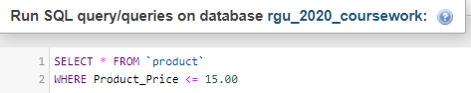   
  
  
Result  
  
  
  
  
2. Select query to find out customer details who belongs to premium customers.  
  
  
SQL  
  
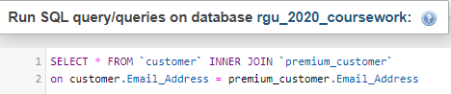  
  
  
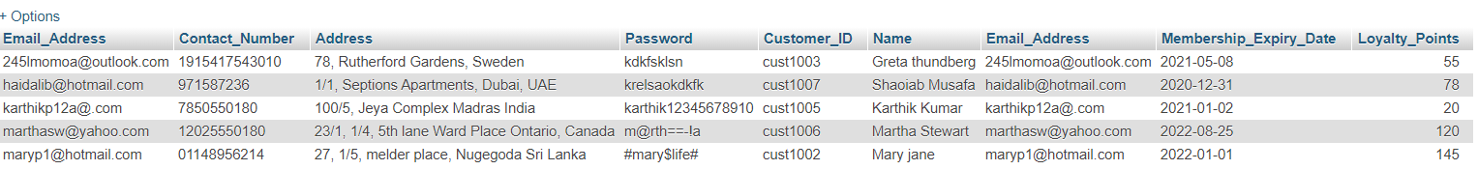Result  
  
  
3. Query for left outer join and right outer join for customer-order-payment with customer table.  
  
First is Right join -  
  
SQL  
  
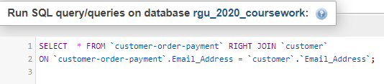  
  
  
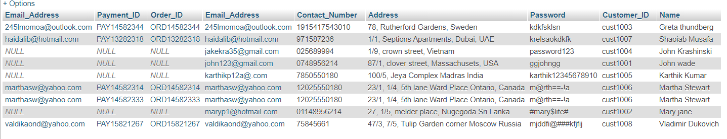Result  
  
  
Second is Left join -  
  
SQL  
  
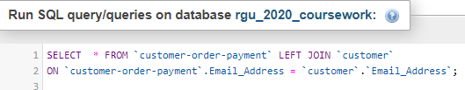  
  
  
Result   
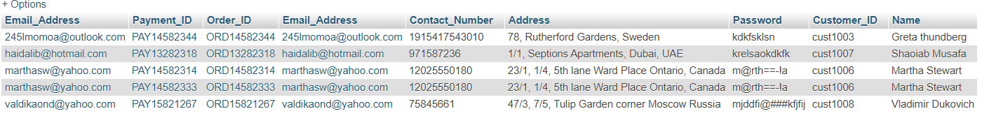  
  
  
  
4. Query to make all products in descending and ascending order according to product Price.  
  
First is Ascending Order-  
  
SQL  
  
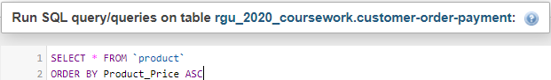  
  
Result   
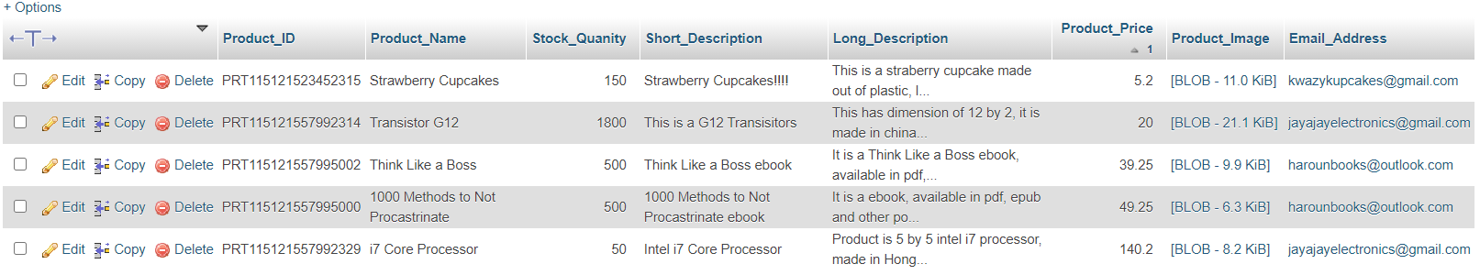  
  
  
Second is Descending Order -  
  
SQL  
  
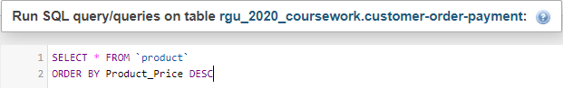  
  
  
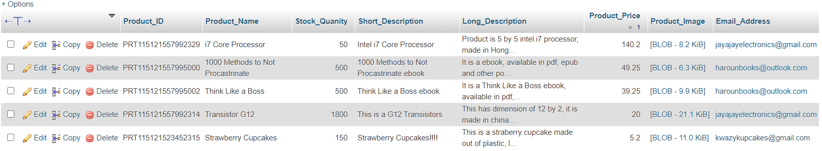Result