**CDA Computer Logic Design**

**Homework 2**

Points: 100

Questions 1 to 6: 15 points each

Question 7: 10 points

1. Draw the schematic for the following functions using NOR gates only:
   1. 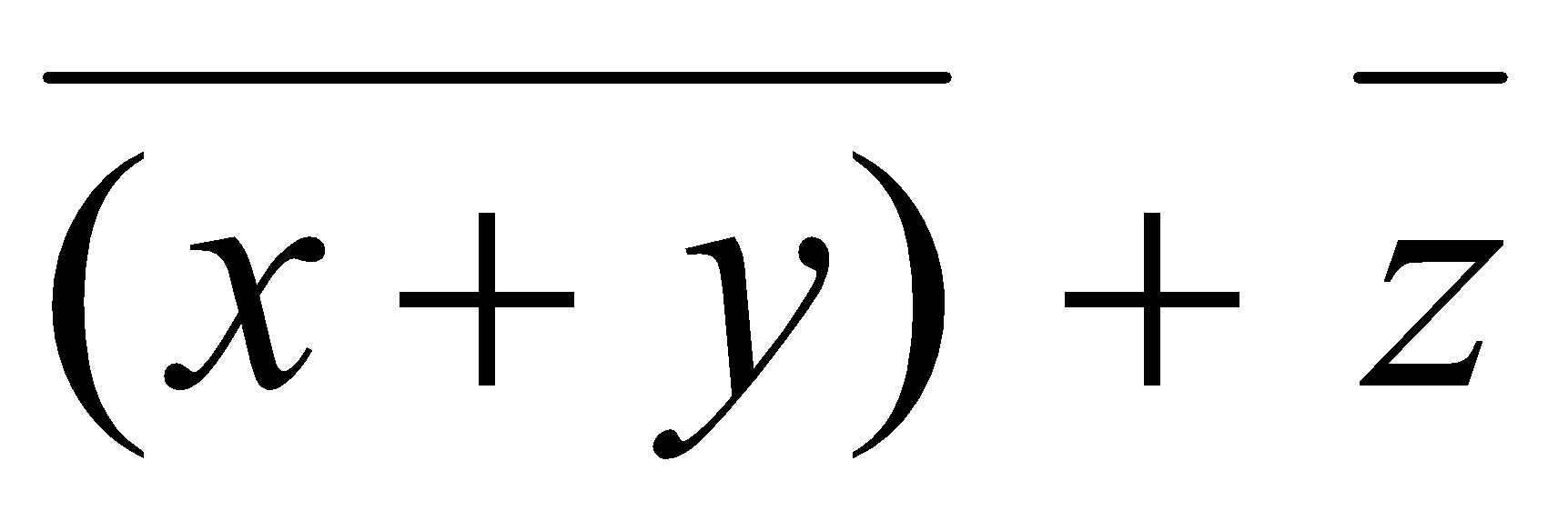

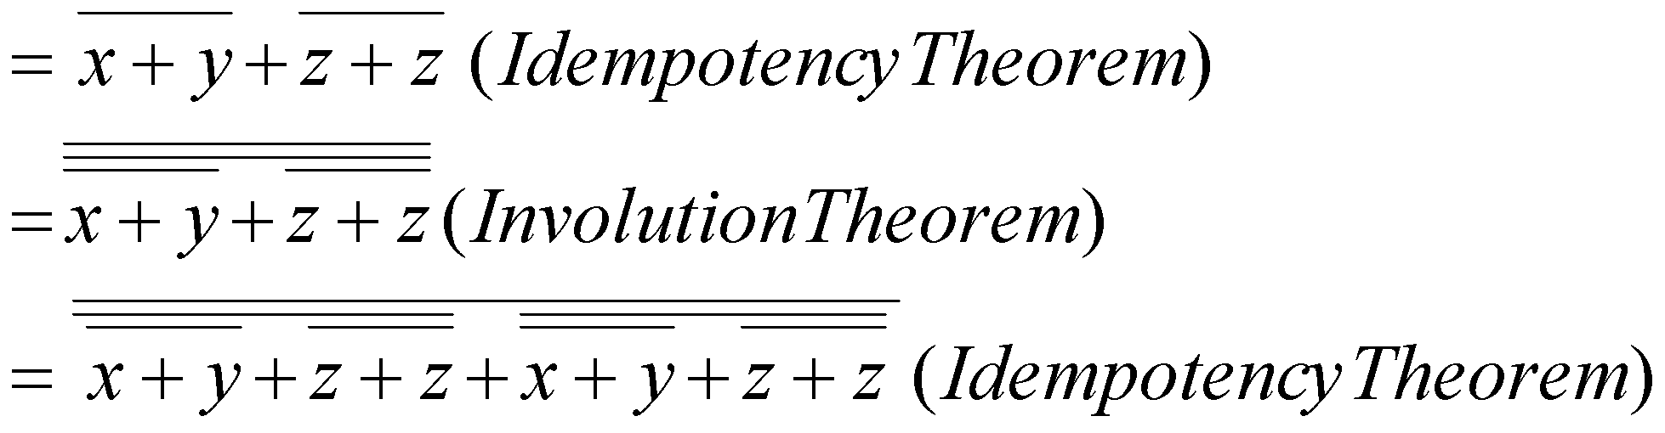

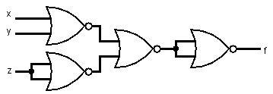

* 1. 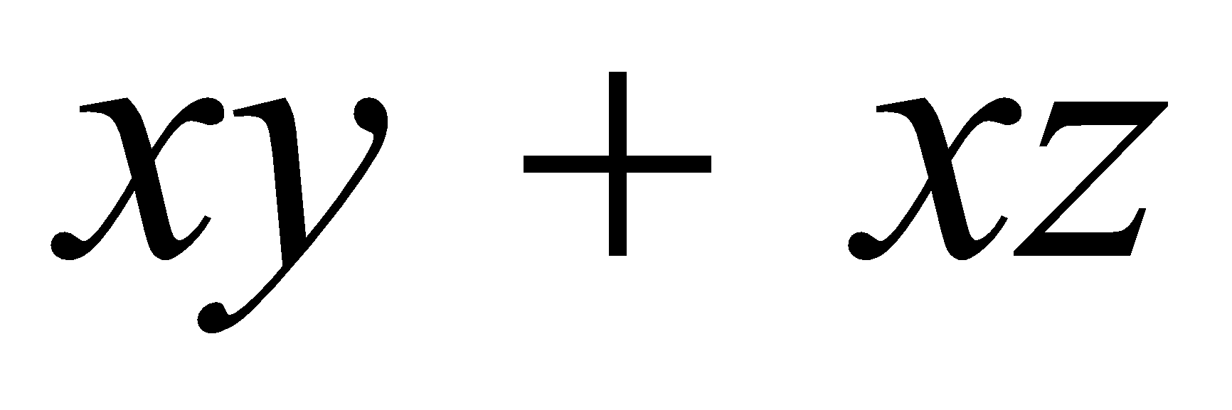

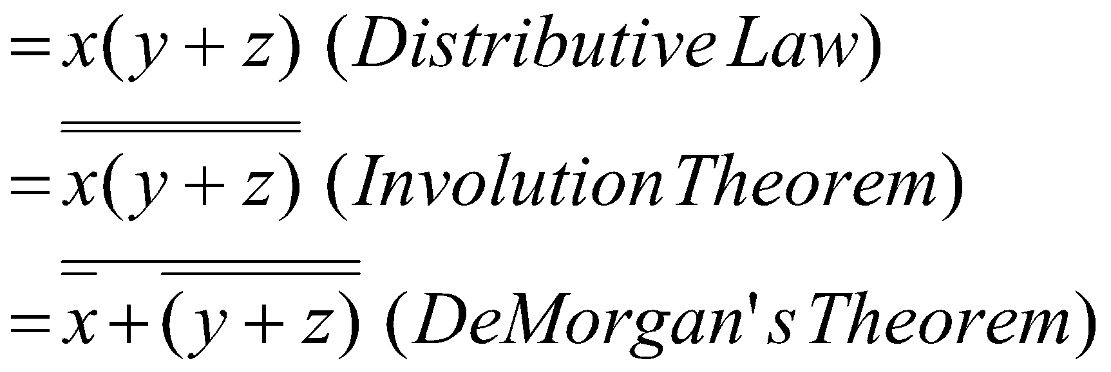

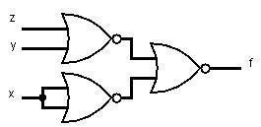

1. Draw the schematic for the following function using NAND gate only:
   1. 

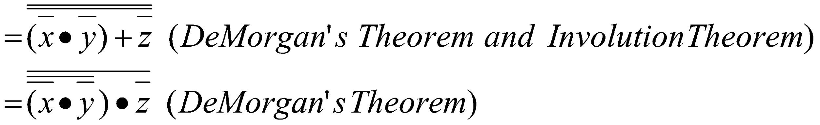

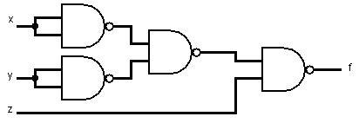

* 1. 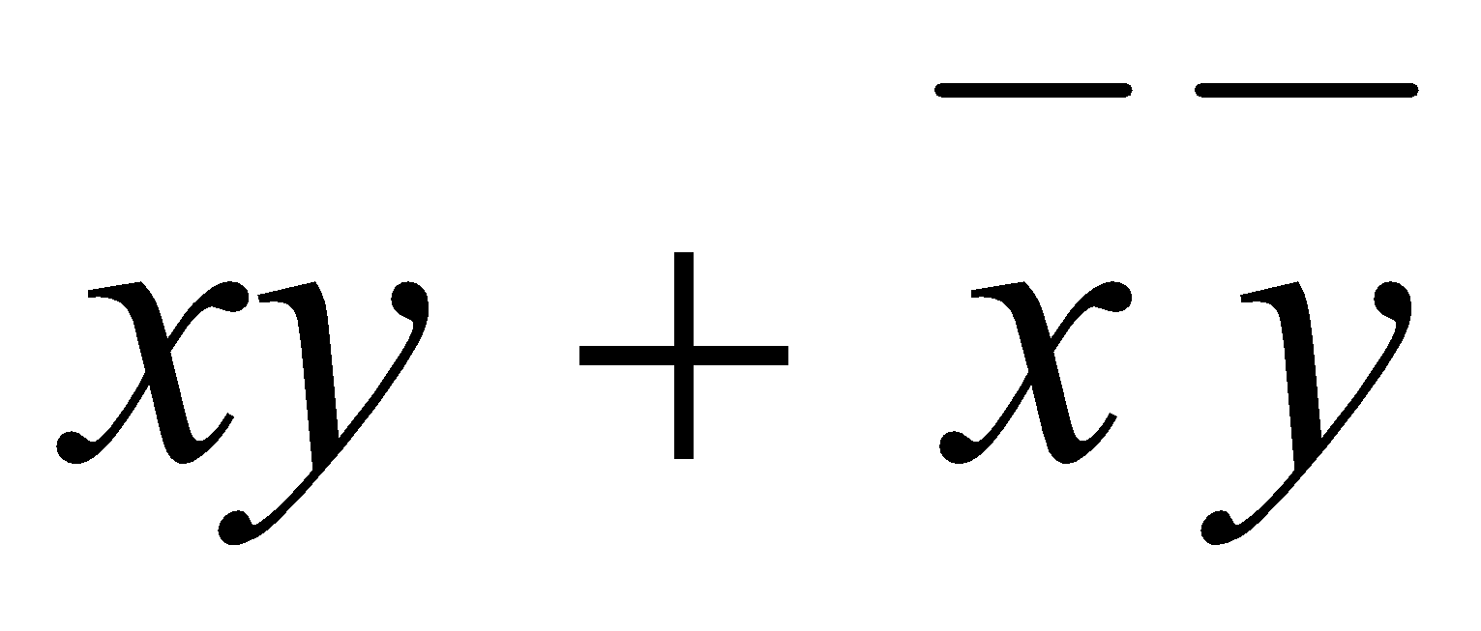



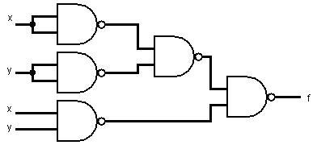

1. Determine the minimized realization of the following functions in the sum-of-products form:
   1. 

|  |  |  |  |  |
| --- | --- | --- | --- | --- |
|  | A'b' | A'b | Ab | ab' |
| c'd' | 0 | 0 | 0 | 0 |
| c'd | 1 | X | 1 | 0 |
| cd | 0 | 1 | X | 1 |
| cd' | X | 0 | X | 0 |

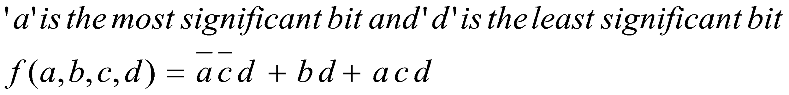

* 1. 

|  |  |  |  |  |
| --- | --- | --- | --- | --- |
|  | A'b' | A'b | Ab | ab' |
| c'd' | 1 | 1 | 1 | 1 |
| c'd | 0 | 1 | 0 | 1 |
| cd | 1 | X | 0 | 0 |
| cd' | 0 | X | 0 | X |

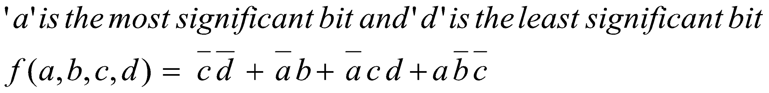

1. (a) F = A + E + BCD (one AND gate and one OR gate with three inputs)

(b) Y = A + B

1. Derive the Boolean expressions for 2-bit multiplier. Each output bit should be represented by a different Boolean expression.

The two numbers are represented as A1 B1 and A2 B2.

The product A1 B1 x A2 B2 is represented as F1 F2 F3 F4

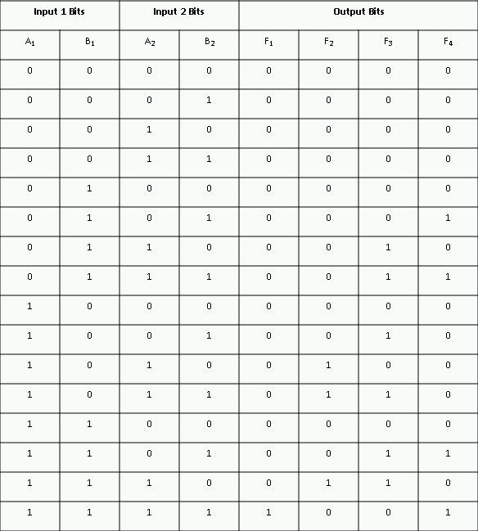

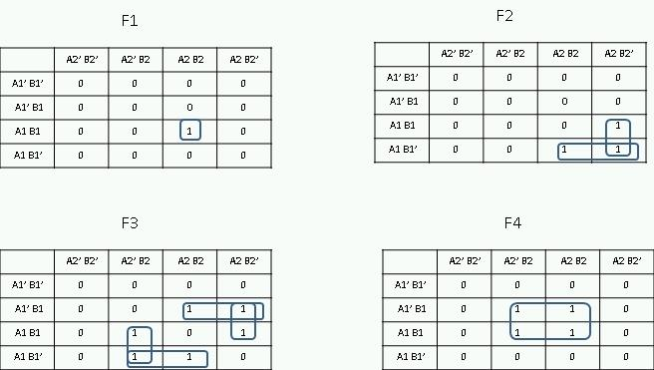

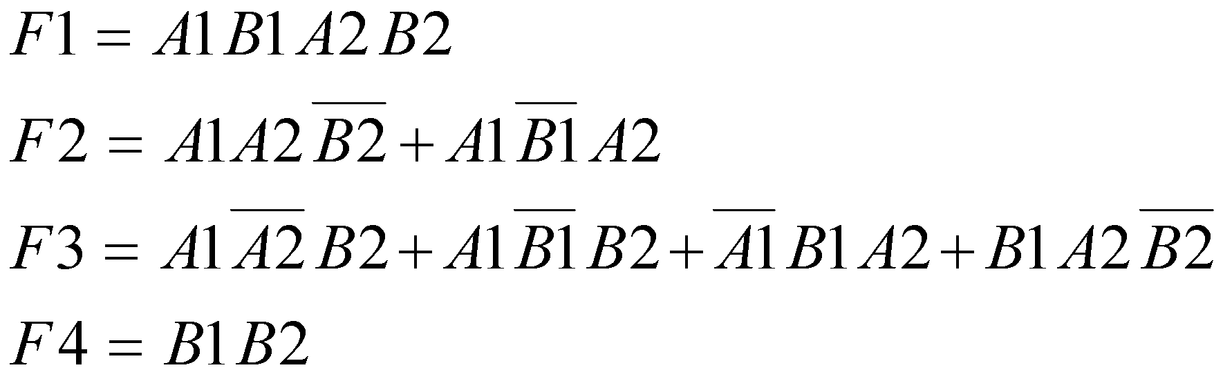

1. The minterms can easily be found from Karnaugh Map where addresses of 2, 3, or 5 numbers of 1's. This is shown in figure 1.

Table 1. Truth table

|  |  |  |  |
| --- | --- | --- | --- |
| Decimal | Binary | # of 1’s | Function |
| 0 | 00000 | 0 | 0 |
| 1 | 00001 | 1 | 0 |
| 2 | 00010 | 1 | 0 |
| 3 | 00011 | 2 | 1 |
| 4 | 00100 | 1 | 0 |
| 5 | 00101 | 2 | 1 |
| 6 | 00110 | 2 | 1 |
| 7 | 00111 | 3 | 1 |
| 8 | 01000 | 1 | 0 |
| 9 | 01001 | 2 | 1 |
| 10 | 01010 | 2 | 1 |
| 11 | 01011 | 3 | 1 |
| 12 | 01100 | 2 | 1 |
| 13 | 01101 | 3 | 1 |
| 14 | 01110 | 3 | 1 |
| 15 | 01111 | 4 | 0 |
| 16 | 10000 | 1 | 0 |
| 17 | 10001 | 2 | 1 |
| 18 | 10010 | 2 | 1 |
| 19 | 10011 | 3 | 1 |
| 20 | 10100 | 2 | 1 |
| 21 | 10101 | 3 | 1 |
| 22 | 10110 | 3 | 1 |
| 23 | 10111 | 4 | 0 |
| 24 | 11000 | 2 | 1 |
| 25 | 11001 | 3 | 1 |
| 26 | 11010 | 3 | 1 |
| 27 | 11011 | 4 | 0 |
| 28 | 11100 | 3 | 1 |
| 29 | 11101 | 4 | 0 |
| 30 | 11110 | 4 | 0 |
| 31 | 11111 | 5 | 1 |



Figure 1. Truth table in overlap map

In the overlay mode, the maps are laid one above the other just as shown in figure 2 instead of folding it about the center and then the grouping is done.



Figure 2. Solution for question 6

Then, the simplified expression becomes

Y = BC'D'E + A'BC'D + AC'DE' + AB'C'D + A'B'CE + A'CDE' + A'BCD + AB'CD' + ABD'E + AB'DE' + A'B'DE + ABCDE

1. Step 1: list all minterms

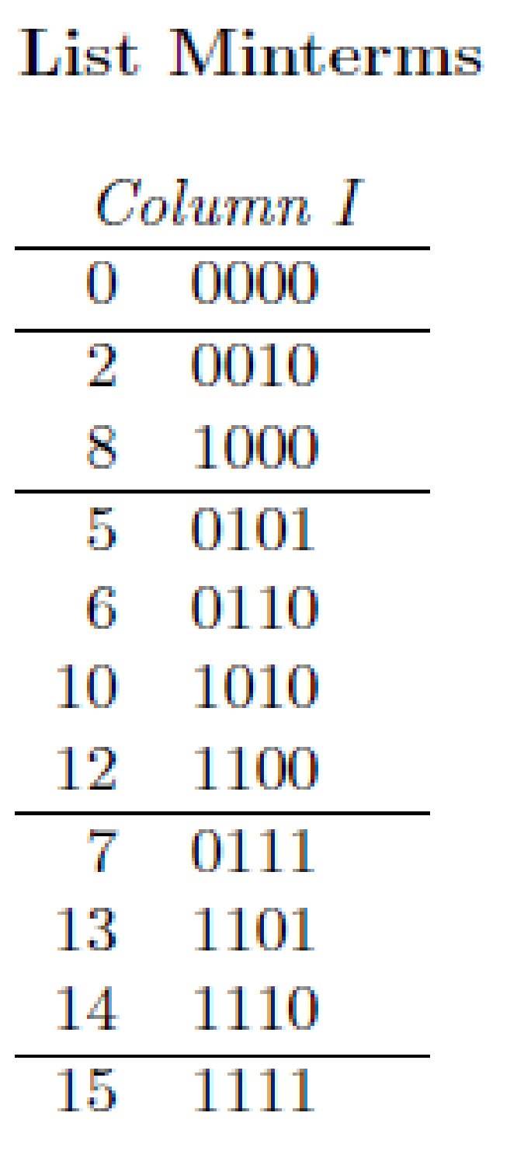

Combine Pairs of Minterms from Column I A check (√ ) is written next to every minterm which can combined with another minterm

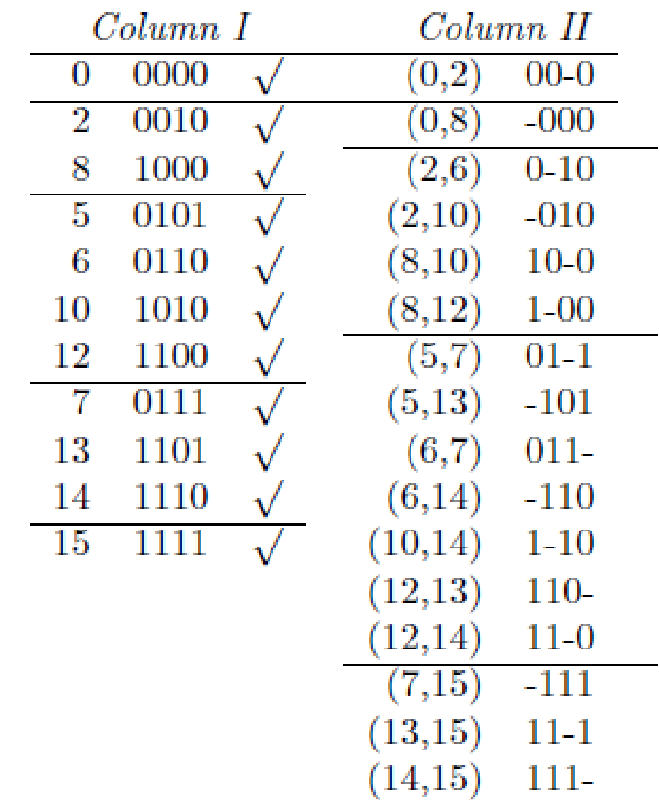

**Combine Pairs of Products from Column II**

A check (√ ) is written next to every product which can combined with another product.

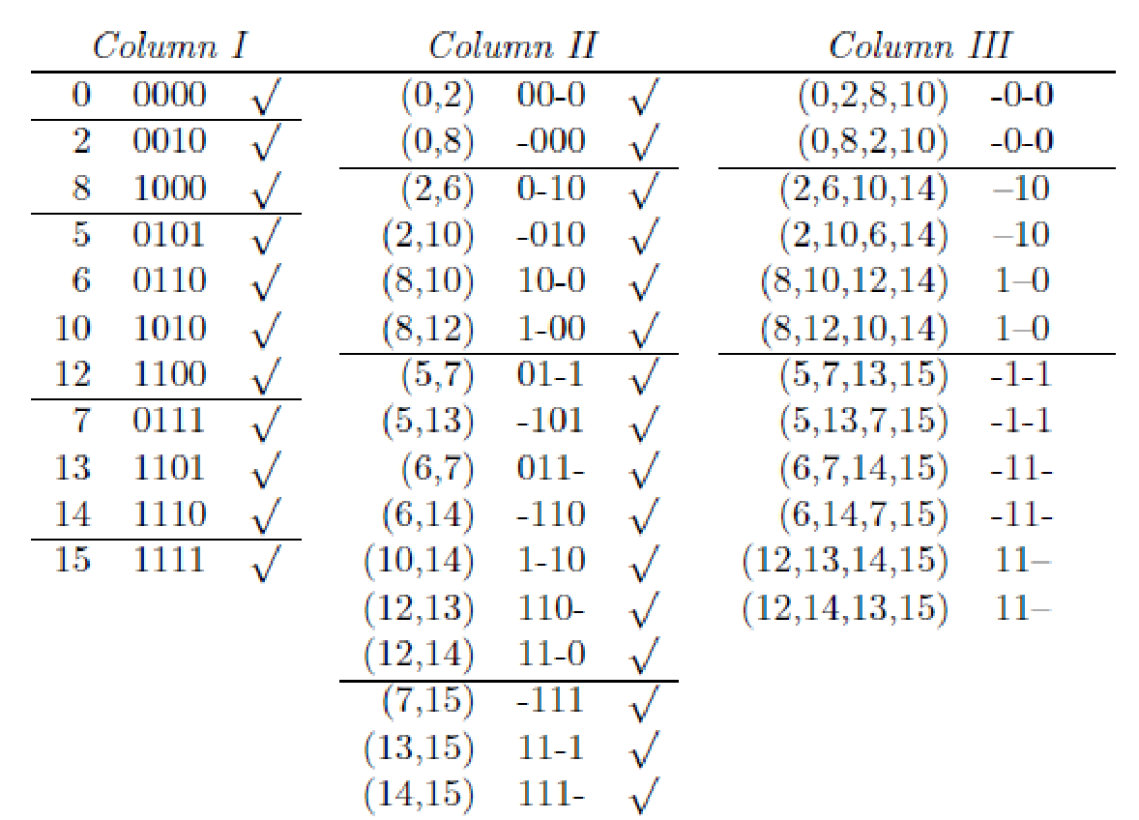

Column III contains a number of duplicate entries, e.g. (0,2,8,10) and (0,8,2,10). Duplicate entries appear because a product in Column III can be formed in several ways. For example, (0,2,8,10) is formed by combining products (0,2) and (8,10) from Column II, and (0,8,2,10) (the same product) is formed by combining products (0,8) and (2,10). Duplicate entries should be crossed out. The remaining unchecked products cannot be combined with other products. These are the prime implicants: (0,2,8,10), (2,6,10,14), (5,7,13,15), (6,7,14,15), (8,10,12,14) and (12,13,14,15); or, using the usual product notation: B0D0 , CD0 , BD, BC, AD0 and AB.

Step 2: Construct Prime Implicant Table.

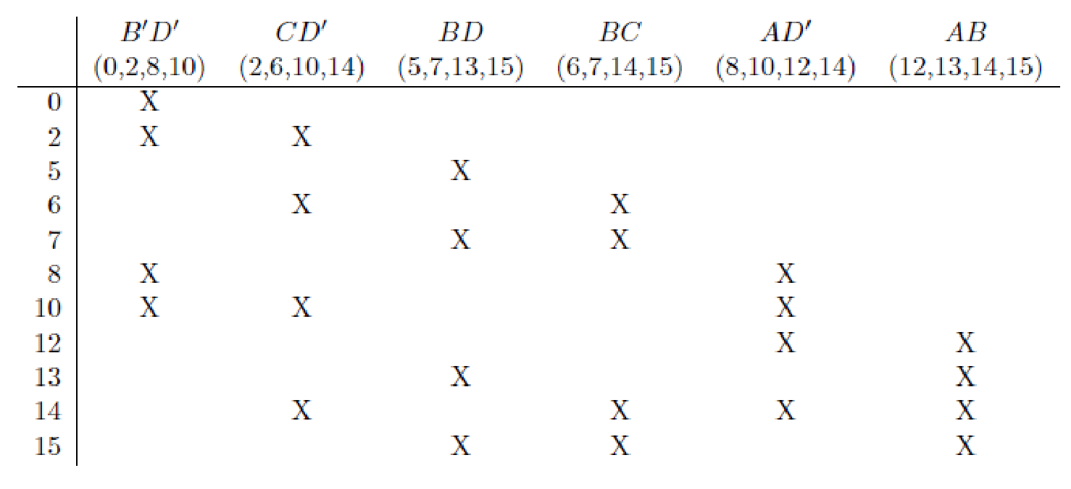

Step 3: Reduce Prime Implicant Table.

Iteration #1.

1. Remove Primary Essential Prime Implicants

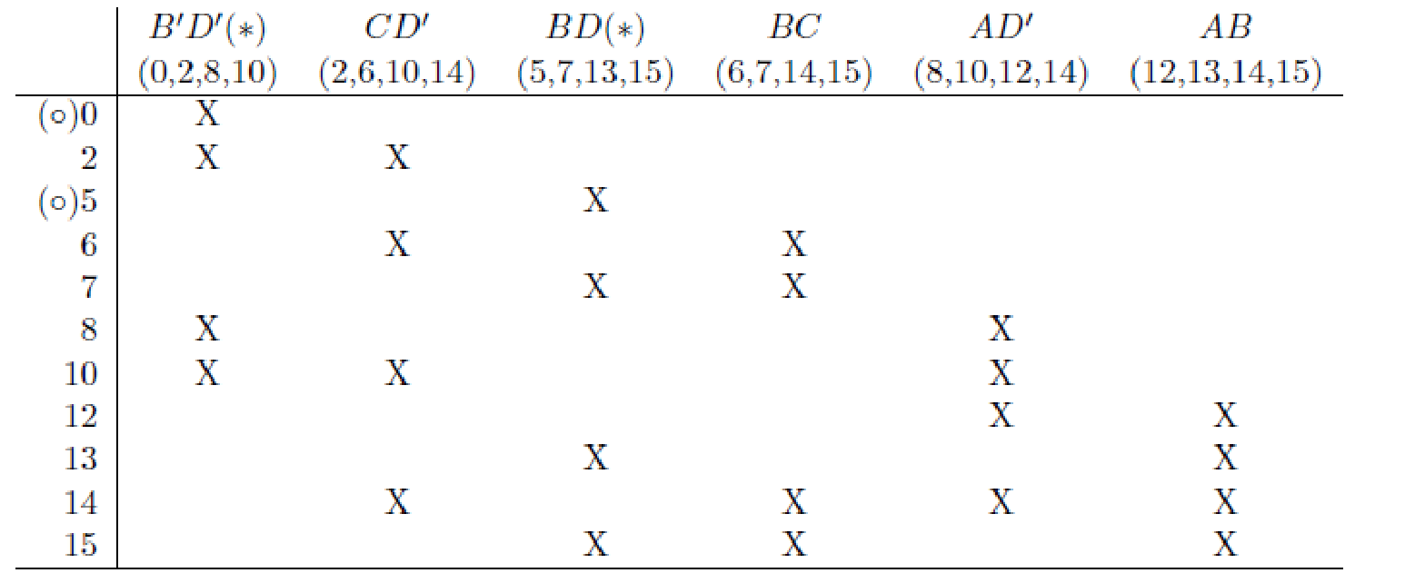

* indicates a distinguished row, i.e. a row covered by only 1 prime implicant In step #1, primary essential prime implicants are identified. These are implicants which will appear in any solution. A row which is covered by only 1 prime implicant is called a distinguished row. The prime implicant which covers it is an essential prime implicant. In this step, essential prime implicants are identified and removed. The corresponding column is crossed out. Also, each row where the column contains an X is completely crossed out, since these minterms are now covered. These essential implicants will be added to the final solution. In this example, B0D0 and BD are both primary essentials.

1. Row Dominance The table is simplified by removing rows and columns which were crossed out in step (i). (Note: you do not need to do this, but it makes the table easier to read. Instead, you can continue to mark up the original table.)

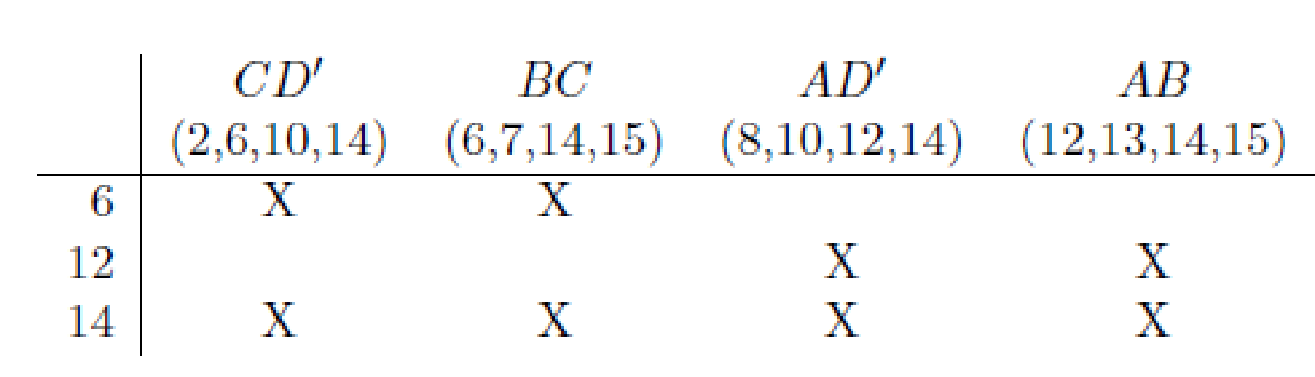

Row 14 dominates both row 6 and row 12. That is, row 14 has an “X” in every column where row 6 has an “X” (and, in fact, row 14 has “X”’s in other columns as well). Similarly, row 14 has in “X” in every column where row 12 has an “X”. Rows 6 and 12 are said to be dominated by row 14. A dominating row can always be eliminated. To see this, note that every product which covers row 6 also covers row 14. That is, if some product covers row 6, row 14 is guaranteed to be covered. Similarly, any product which covers row 12 will also cover row 14. Therefore, row 14 can be crossed out.

1. Column Dominance

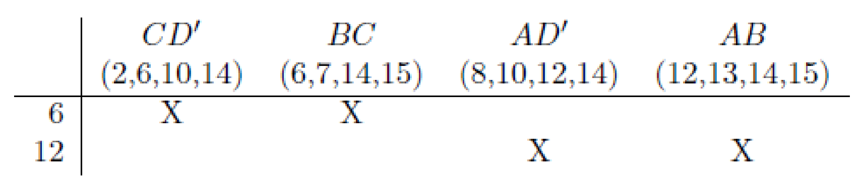

Column CD0 dominates column BC. That is, column CD0 has an “X” in every row where column BC has an “X”. In fact, in this example, column BC also dominates column CD0 , so each is dominated by the other. (Such columns are said to co-dominate each other.) Similarly, columns AD0 and AB dominate each other, and each is dominated by the other. A dominated column can always be eliminated. To see this, note that every row covered by the dominated column is also covered by the dominating column. For example, C 0D covers every row which BC covers. Therefore, the dominating column can always replace the dominated column, so the dominated column is crossed out. In this example, CD0 and BC dominate each other, so either column can be crossed out (but not both). Similarly, AD0 and AB dominate each other, so either column can be crossed out.

Iteration #2.

1. Remove Secondary Essential Prime Implicants

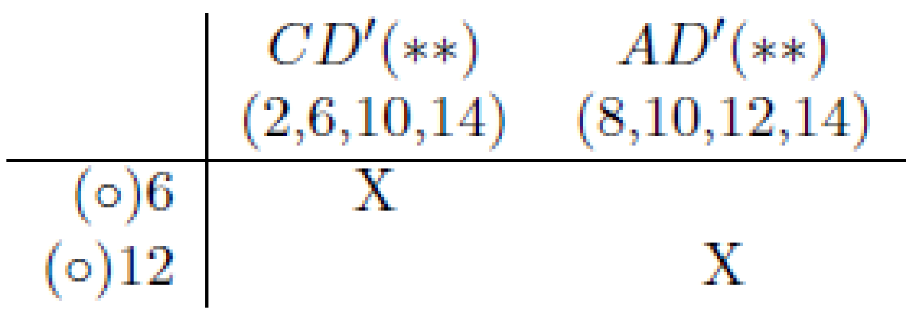

** indicates a secondary essential prime implicant

◦ indicates a distinguished row

In iteration #2 and beyond, secondary essential prime implicants are identified. These are implicants which will appear in any solution, given the choice of column-dominance used in the previous steps (if 2 columns co-dominated each other in a previous step, the choice of which was deleted can affect what is an “essential” at this step). As before, a row which is covered by only 1 prime implicant is called a distinguished row. The prime implicant which covers it is a (secondary) essential prime implicant. Secondary essential prime implicants are identified and removed. The corresponding columns are crossed out. Also, each row where the column contains an X is completely crossed out, since these minterms are now covered. These essential implicants will be added to the final solution. In this example, both CD0 and AD0 are secondary essentials.

Step 4: Solve Prime Implicant Table.

No other rows remain to be covered, so no further steps are required. Therefore, the minimum-cost solution consists of the primary and secondary essential prime implicants B0D0 , BD, CD0 and AD0 :

F = B0D0 + BD + CD0 + AD0