Solution to Example Assignment

Problem #1: Write a C program that outputs “Hello World!” Paste a screenshot of a successful build and execution. Show the source code.

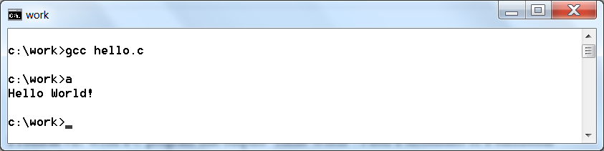

int main()
{
printf("Hello World! \n");

return(0);
}

Problem #2: The below program contains serious errors. Correct the errors. Show the corrections in the source code below. Note which errors are compile time and which are run time. The comments are correct (that is, they describe the intended functionality).
Need to add #include <stdlib.h>. Compile time.
#include <stdio.h>

#define SIZE 10
Should be ==. Run time.

int main(void)
Should be int. Run time.
{
int i;
int *p;
Hint: For the assignments you can copy-paste the code into a source file and then compile and run to find errors. On an exam you will not be able to do this.

p = (int *) malloc(SIZE * sizeof(char));
if (p = NULL)
{
printf("*** ERROR *** out of memory \n");
exit(1);
Should be SIZE. Run time.
}

// Initialize SIZE element of p
for (i=0; i<100; i++)
Should be for (i=(SIZE-1); i>=0; i--). Run time.
*(p+i) = i;

// Output the values of SIZE elements in reverse order
for (i=100; i<SIZE; i--)
printf("*p[%d] = %d \n", i, *(p+i));

return(0);
Need to add free(p);
}

