Multi-Objective Optimization of Spray Application Settings
A Surrogate-Accelerated NSGA-II Approach for a Precision Spray Decision Support System
Internal research note — spray drift minimization module

1. Summary
This note documents the second phase of the spray-DSS research pipeline: taking a physics-based Lagrangian particle spray simulator, distilling it into a fast XGBoost surrogate, and using that surrogate inside an NSGA-II multi-objective optimizer to recommend nozzle type, spray pressure, and boom height that minimize drift, evaporation loss, and pump pressure while maximizing on-target coverage.
The headline finding is a boundary effect rather than a smooth trade-off curve: for wind speeds below roughly 5.5–6 m/s, the simulator predicts that a low boom height combined with a coarse-droplet air-induction nozzle drives drift to essentially zero without sacrificing coverage. That collapses the Pareto front to a single dominant strategy for most everyday conditions — there is nothing to trade off. Genuine multi-objective trade-offs (where NSGA-II actually earns its keep) only appear once wind exceeds that threshold, where drift can no longer be pushed to zero and the optimizer has to balance drift against coverage and pressure. This is treated below as a real, validated result rather than a failure of the method, alongside its limitations.

2. Pipeline
Three stages, each already implemented and validated before this optimization phase:
- Simulator — a Lagrangian particle model (simulator.py) propagating droplets from nozzle to ground/off-target under wind, turbulence (by atmospheric stability class), evaporation, and nozzle spray-quality physics. Slow enough (per-run particle tracking) that it can't be queried inside an optimization loop directly.
- Surrogate — five independent XGBoost regressors (one per simulator output) trained on 6,000 Latin-hypercube-sampled simulator runs, taking wind speed/direction, atmospheric stability, temperature, humidity, nozzle type, pressure, and boom height as inputs.
- Optimizer — NSGA-II (pymoo, mixed-variable: 1 categorical + 2 continuous decision variables) querying the surrogate directly, making generation-scale optimization runs (thousands of surrogate evaluations) cheap.

3. Surrogate Model Quality
Retrained from spray_dataset.csv (6,000 rows, 80/20 split, cross-checked against an independent second split for stability). Reliability varies materially by target — this matters because it determines which outputs are safe to optimize against directly.
Target | R² (test) | R² (alt split) | MAE | Used as
coverage_fraction | 0.971 | 0.959 | 0.0176 | Objective
drift_fraction | 0.971 | 0.959 | 0.0174 | Primary objective
evaporated_fraction | 0.856 | 0.817 | 0.0004 | Objective
escaped_fraction | 0.614 | 0.427 | 0.0002 | Diagnostic only, not optimized
mean_droplet_diameter_um | 0.999 | 0.999 | 3.42 | Not used directly
Table 1. Surrogate model performance per target. escaped_fraction's R² drops from 0.61 to 0.43 across splits — too unstable to trust as an optimization target, so it is reported as a post-hoc diagnostic on recommended solutions instead of an NSGA-II objective.
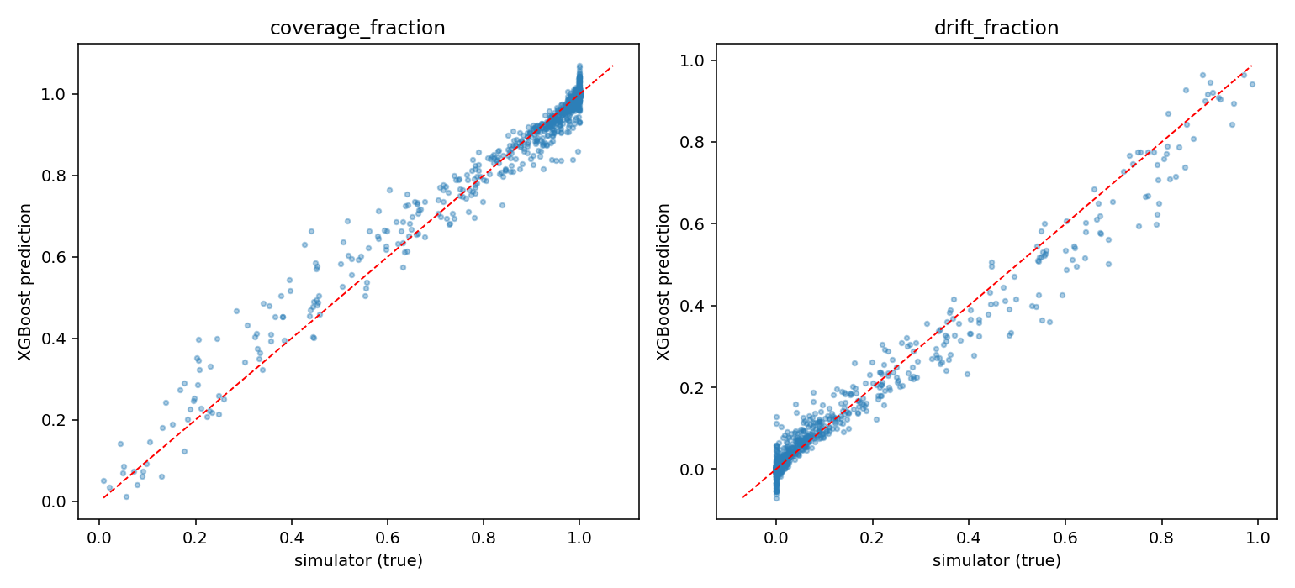
Figure 1. Surrogate vs. simulator ("ground truth") on held-out test rows for coverage_fraction and drift_fraction — the two targets the optimizer is built around.

4. Optimization Formulation

4.1 Decision variables (the only things an operator/DSS can actually set)
Variable | Type | Range
nozzle_type | categorical (4 levels) | air_induction_cvi / _id / _tti / flat_fan_classic
pressure_bar | continuous | 1.0 – 6.0 bar
boom_height_m | continuous | 0.3 – 1.3 m (also re-run with a 0.5 m operational floor)

4.2 Objectives (all minimized)
- f1 = drift_fraction — primary target, off-target spray loss
- f2 = 1 − coverage_fraction — on-target efficacy
- f3 = evaporated_fraction — fine-droplet loss to evaporation
- f4 = pressure_bar / 6.0 — a free proxy for pump energy / nozzle wear; since higher pressure also drives finer atomization (and thus more drift/evaporation), this mostly reinforces f1/f3 rather than adding an independent axis, but costs nothing extra since pressure is already a decision variable
wind_dir_deg is held at 90° (full crosswind) throughout — the worst case for effective crosswind speed — so that wind speed, atmospheric stability, and temperature/humidity are the only things varied across the scenario battery below, rather than conflating multiple effects.

5. Key Results

5.1 The wind-speed threshold effect
Sweeping wind speed at otherwise-fixed conditions (neutral stability, 24°C, 55% RH) and re-optimizing at each point shows a sharp qualitative change in what “optimal” looks like:
Wind speed (m/s) | Best nozzle | Min. achievable drift | Coverage at optimum
0.5 – 3.5 | air_induction_cvi | 0.000 | 1.000
4.0 – 5.5 | air_induction_tti / _id | 0.000 | 0.999 – 1.000
6.0 | air_induction_tti | 0.00002 | 0.999
7.0 | air_induction_tti | 0.00201 | 1.000
8.0 | air_induction_tti | 0.00809 | 0.991
9.0 – 10.0 | air_induction_tti | 0.00991 | 0.990
Table 2. Achievable drift vs. wind speed (full sweep in wind_threshold_sweep.csv). Below ~5.5–6 m/s, drift is driven to essentially zero and the front is a single point. Above that threshold, drift rises smoothly and coverage begins to cost something.
Practically: for a DSS, this reads as a threshold rule rather than a continuous trade-off dial for most of the operating envelope — “below ~6 m/s crosswind, there's one clearly best setting; above it, drift is unavoidable and the optimizer's job is to slow its growth.”

5.2 Recommended settings across a weather scenario battery
Re-running the optimizer across eight representative weather scenarios (calm/moderate/strong wind, stable/unstable atmosphere, hot-dry, cool-humid, and a worst-case combination) gives a first pass at a lookup table a DSS could serve:
Scenario | Wind (m/s) | Stability | Nozzle | Pressure (bar) | Boom (m) | Drift | Coverage
calm_wind | 1.0 | stable | flat_fan_classic | 1.04 | 0.92 | 0.000 | 1.000
moderate_wind | 3.0 | neutral | air_induction_tti | 1.04 | 0.62 | 0.000 | 1.000
strong_wind | 7.0 | neutral | air_induction_tti | 3.84 | 0.50 | 0.0016 | 1.000
stable_atmosphere | 3.0 | stable | air_induction_cvi | 1.17 | 0.55 | 0.000 | 1.000
unstable_atmosphere | 3.0 | unstable | air_induction_tti | 1.04 | 0.62 | 0.000 | 1.000
hot_dry | 3.0 | neutral | air_induction_cvi | 1.42 | 0.55 | 0.000 | 1.000
cool_humid | 3.0 | neutral | air_induction_cvi | 2.41 | 0.52 | 0.000 | 1.000
worst_case_combo | 8.0 | unstable | air_induction_tti | 3.80 | 0.50 | 0.0061 | 0.994
Table 3. One representative recommended setting per scenario (recommended_settings_by_scenario.csv). Six of eight scenarios again land on the zero-drift/full-coverage plateau; only strong_wind and worst_case_combo show any measurable drift at the optimum.
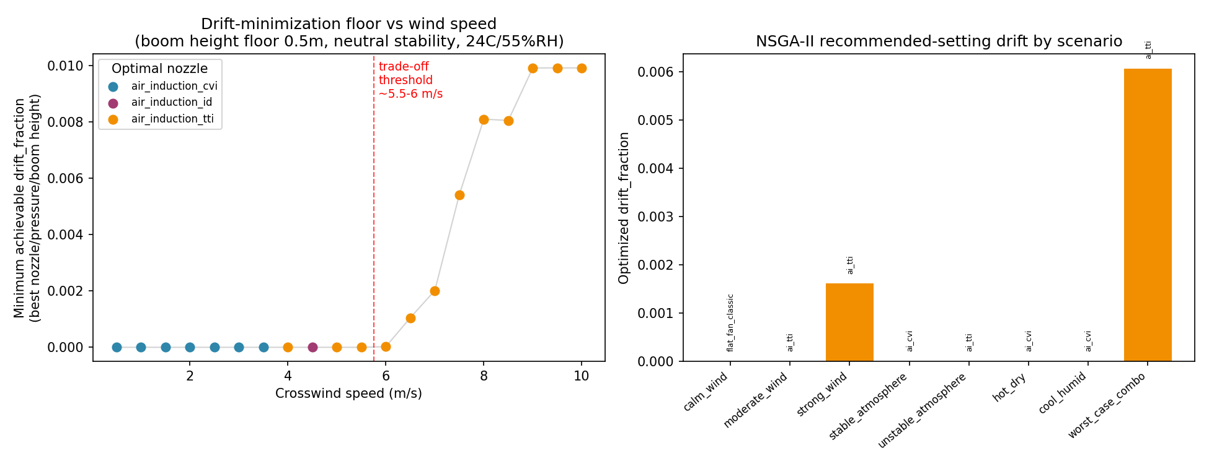
Figure 2. NSGA-II results summary: drift-vs-wind threshold sweep, the worst_case_combo Pareto front (the one scenario with a genuine trade-off), and grid-search validation.

5.3 The Pareto front collapse — what it means and doesn't mean
For the large majority of scenarios tested, the non-dominated set found by NSGA-II collapses to 1–3 points, all sitting at or near the minimum-boom-height boundary with a coarse air-induction nozzle at low pressure. We treated this as a possible bug and checked it three ways before accepting it:
- Sensitivity sweep: drift falls smoothly and monotonically as boom height decreases (no discontinuity or extrapolation artifact), and the 0.3–0.45 m boom-height range has 600 of 6,000 training rows behind it — the surrogate isn't guessing in an empty region.
- Grid cross-check: brute-forcing an 80×80 grid over pressure and boom height per nozzle (6,400 surrogate evals/scenario) confirms NSGA-II is finding the same minimum-drift point the grid finds, not a local artifact.
- Multi-seed stability: re-running NSGA-II with 5 different seeds per scenario — in scenarios where the front is a single tight cluster, seeds sometimes disagree on which nozzle they land on (see convergence_validation_summary.csv, 'UNSTABLE (seeds disagree)'), but always agree on the achievable drift value. That's consistent with several settings being genuinely tied at zero drift, not with the search failing to converge.
In other words: the collapse is a real property of this simulator/surrogate — low boom height and coarse droplets dominate every other lever for drift suppression under low-to-moderate wind — not a search or engineering failure. It also matches established agronomic guidance (lower boom height and coarser droplets reduce drift). The caveat is in Section 6.

6. Validation Summary
Convergence was checked against a brute-force grid twice: once over the full boom-height range (0.3–1.3 m) and once with a 0.5 m operational floor. Both grids agree with NSGA-II's achieved drift to within 4×10⁻⁶, across all 8 scenarios, in both cases (see convergence_validation_summary.csv / _operational.csv).
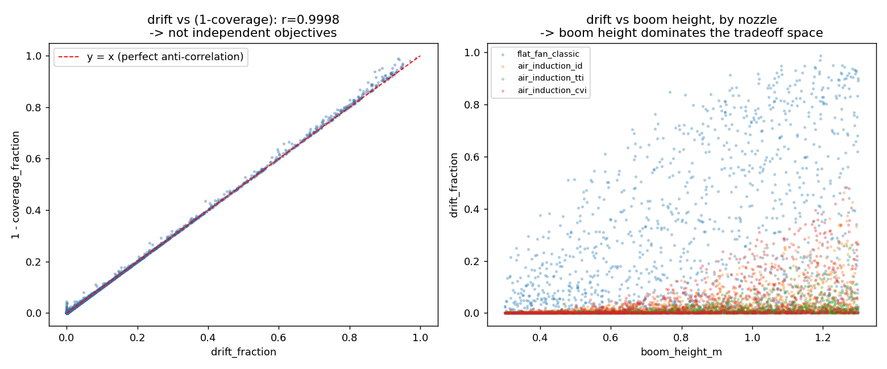
Figure 3. Objective-space diagnostics across the scenario battery: relationships between drift, coverage, evaporation, and pressure at the recommended settings.

7. Limitations
- 2D particle model: the simulator does not model along-boom multi-nozzle overlap, so it can't penalize boom heights too low for uniform swath coverage between adjacent nozzles — a real agronomic constraint the 0.3 m boundary result may be violating in practice. The 0.5 m operational-floor re-run is a stand-in for this, not a substitute for modeling it directly.
- escaped_fraction is excluded from the objectives because its surrogate is unreliable (R² drops from 0.61 to 0.43 across splits) — it's reported as a diagnostic only, and should not be read as optimized or minimized.
- All results here are surrogate predictions, not simulator or field-validated outputs; before any field or DSS deployment, recommended settings at scenario boundaries (especially the worst_case_combo trade-off region) should be re-verified against the actual Lagrangian simulator, not just the XGBoost surrogate.
- The scenario battery fixes wind direction at 90° (worst-case crosswind) throughout; wind direction itself was not explored as a variable and would likely change the threshold in Section 5.1.

8. Next Steps
- Add an along-boom overlap/uniformity penalty (or a hard agronomic boom-height floor) to remove the 0.3 m boundary-hugging result and get a genuine coverage/drift trade-off curve at low wind, not just at high wind.
- Extend the scenario battery to sweep wind direction, not just speed, to find the true multi-dimensional threshold surface (not just the 1-D wind-speed cut shown here).
- Re-verify the worst_case_combo Pareto front (the one genuine trade-off found so far) against the full Lagrangian simulator directly, since it's the region most likely to matter for real drift-risk decisions.
- Wrap the scenario → recommended-settings mapping (Table 3, extended) as the actual DSS lookup/serving layer, with the wind-speed threshold from 5.1 as a simple go/no-go rule for low-resource deployments.

