# Student Database

Description

This application connected to the database registrar.mbd is an application that allows you to calculate various features such as the students grade average, maximum or minimum mark obtained by a student, the standard deviation and more.

Welcome page

Contains student data button that has the following view. The user will chose to import one of the choices given as option buttons and make a choice from the available calculations given. Then click on continue to display the calculation on the welcome page.

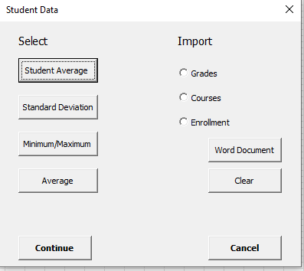

Data page

The data page allows the user to make a choice between any of the subjects given.

