**ACS 54500 Cryptography and Network Security**

**Lab 7: Crypto Lab: Secret-Key Encryption**

Task 1: Frequency Analysis

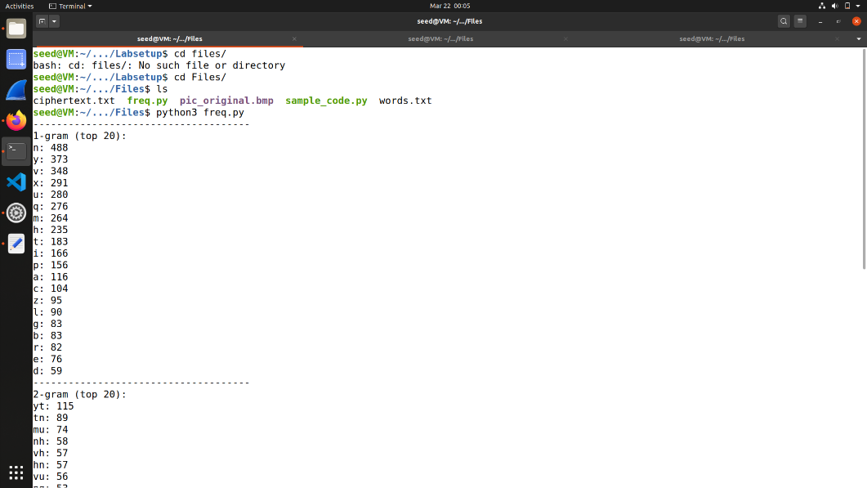Opening the freq.py file.

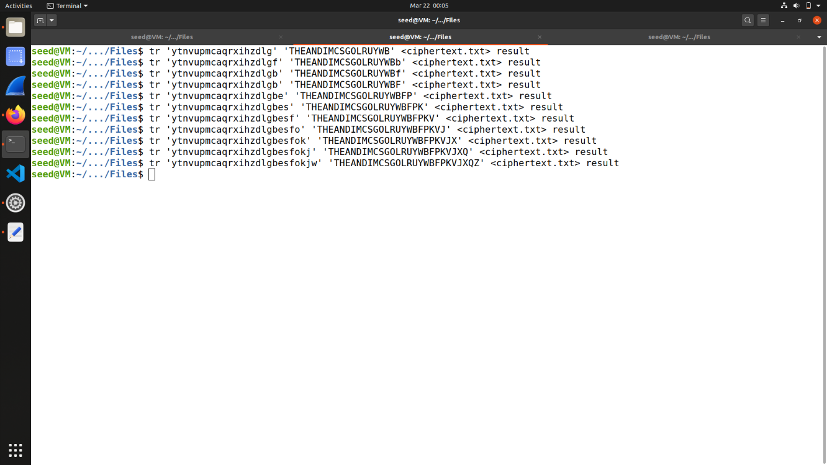

Cipher text:

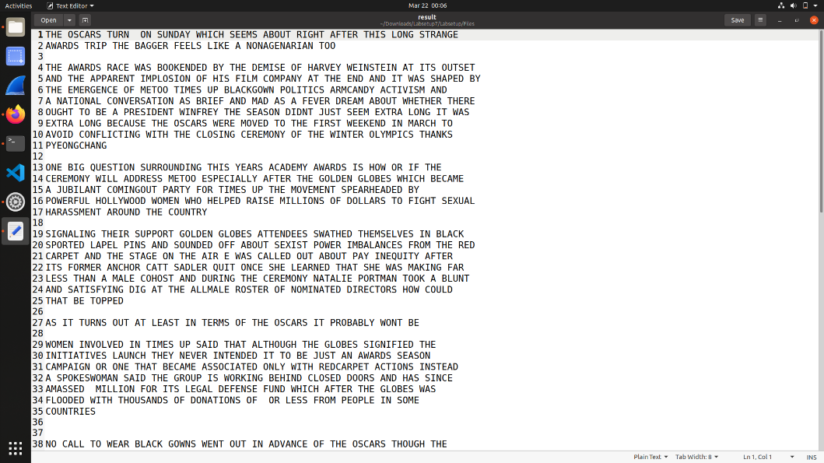

Output:

Task 2: Encryption using Different Ciphers and Modes

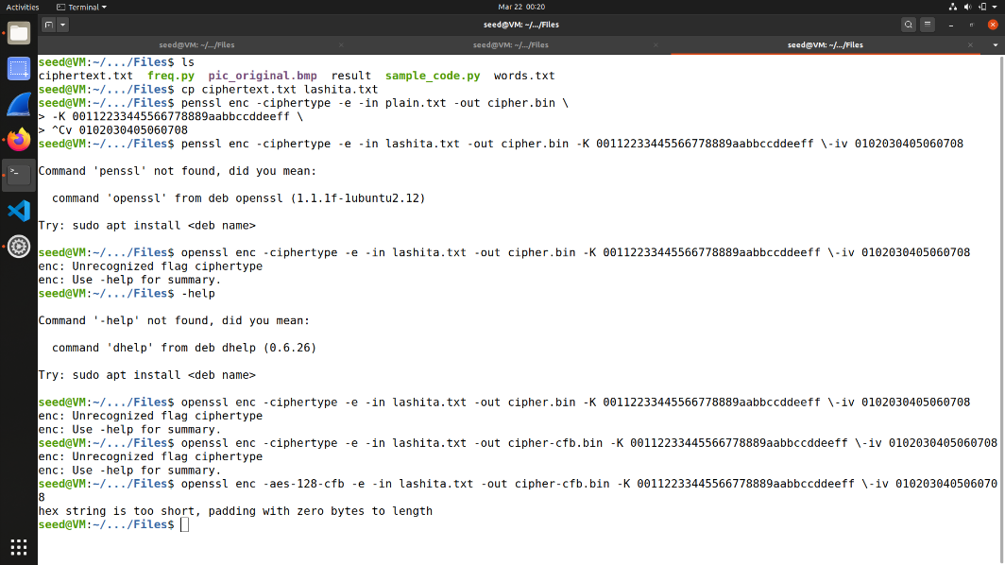

openssl enc command to encrypt/decrypt a file.

Task 3: Encryption Mode – ECB vs. CBC

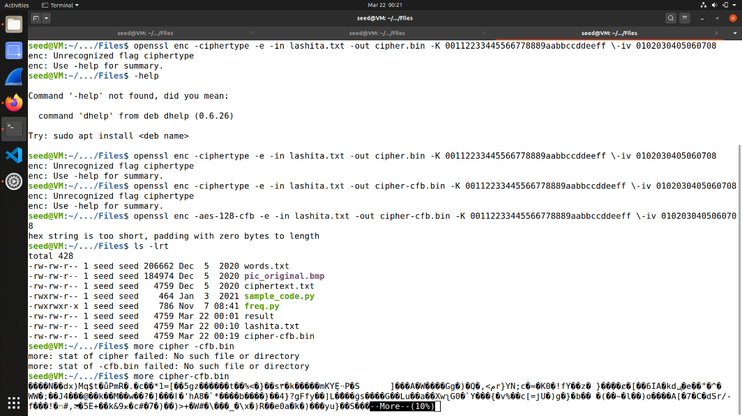Encryption with CBF

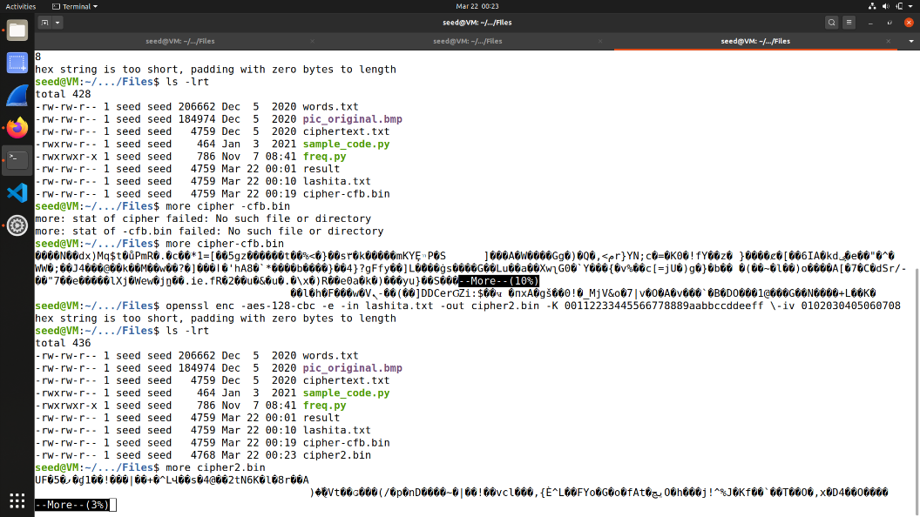

Encryption with CBC

Task 4: Padding  
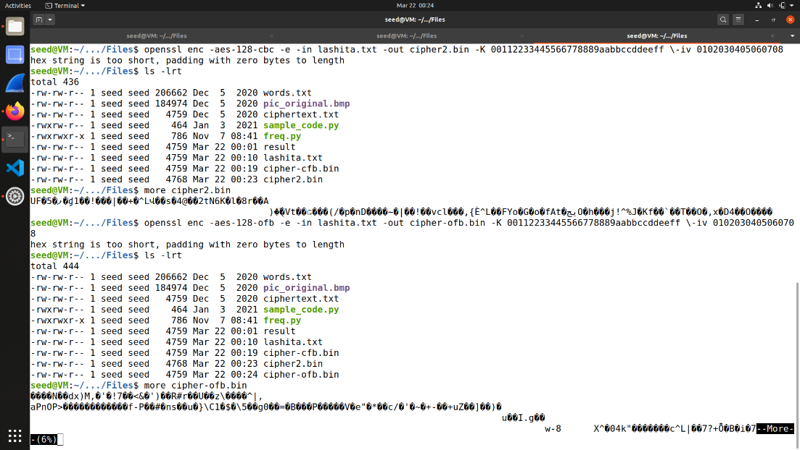Encryption with OFB

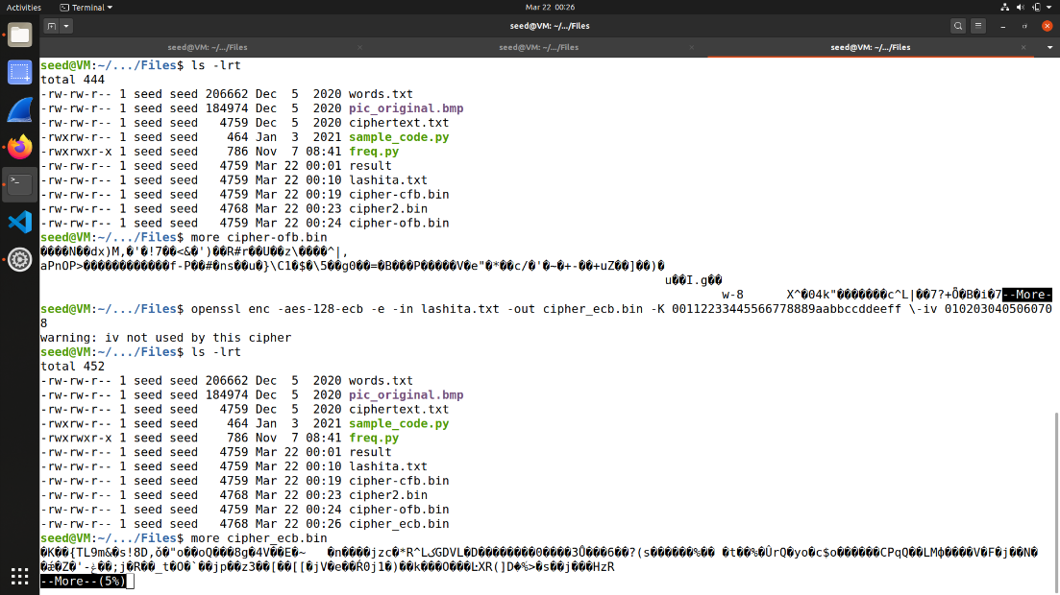

Encryption with ECB

Task 5: Error Propagation – Corrupted Cipher Text

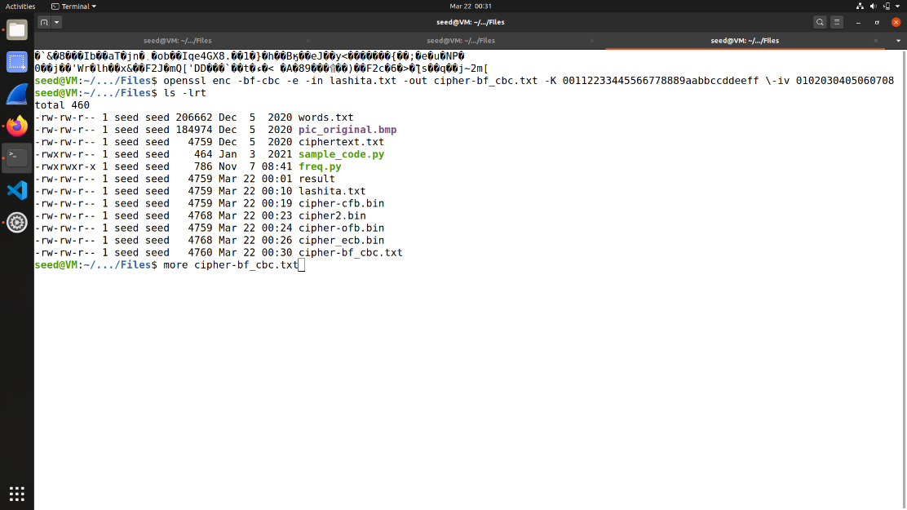Encryption with Blowfish

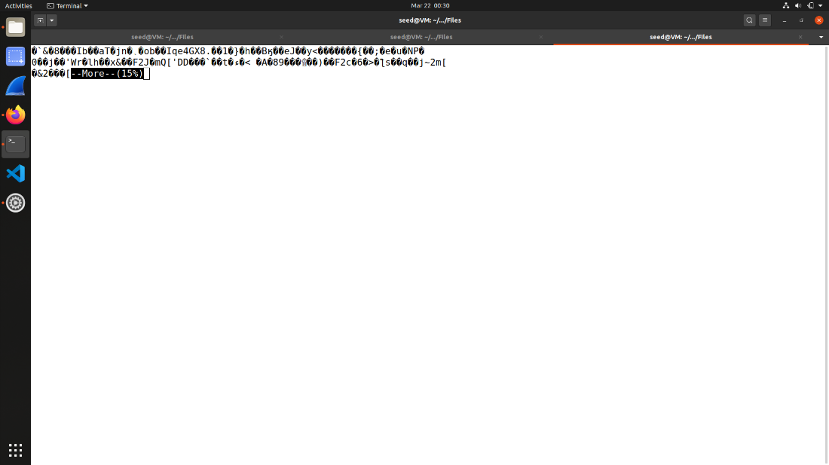

Task 6: Initial Vector (IV) and Common Mistakes

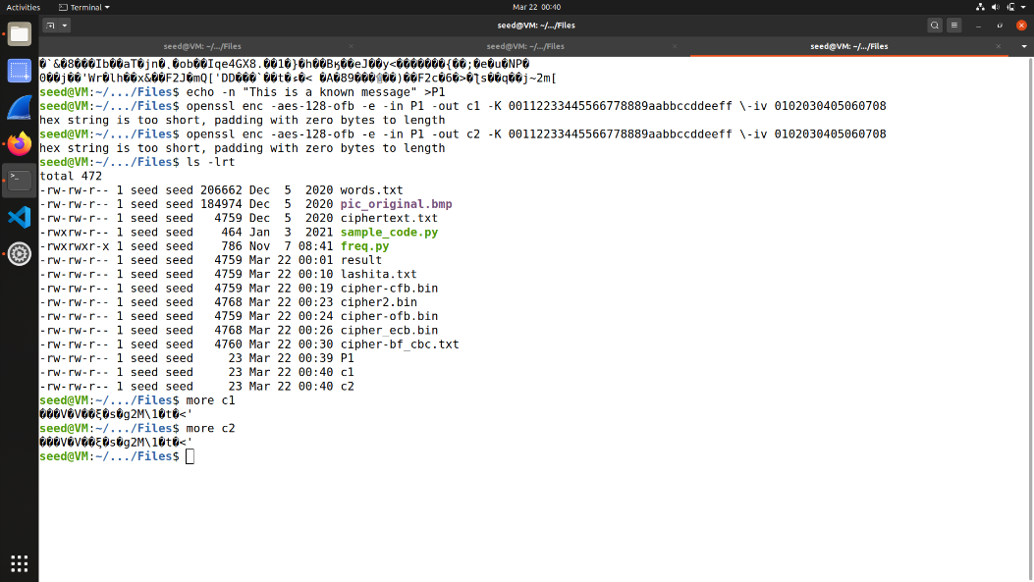6.1  
Two different IV’s

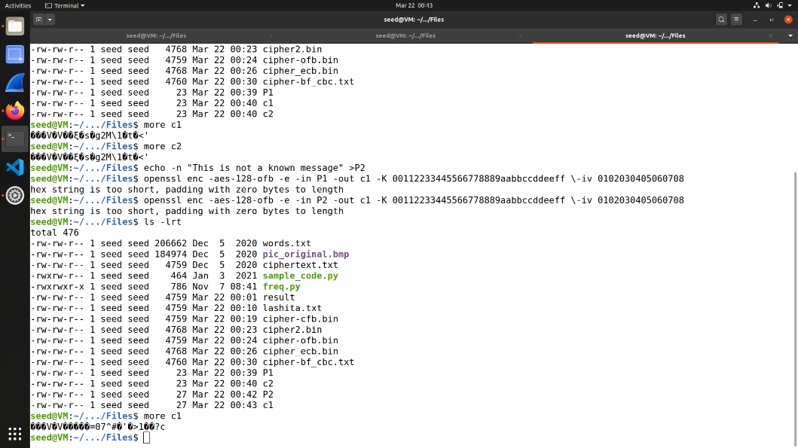

Using same IV on P1 & P2

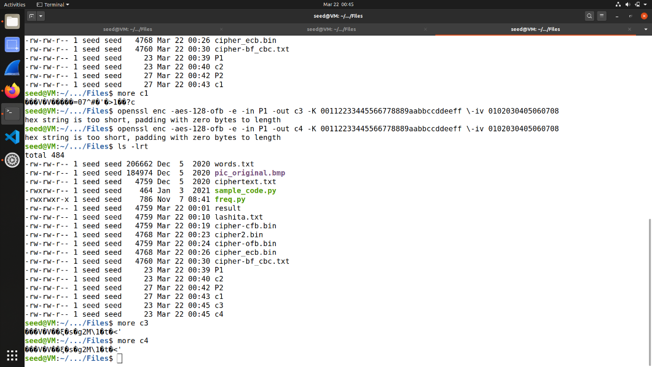

Using Different IV’s

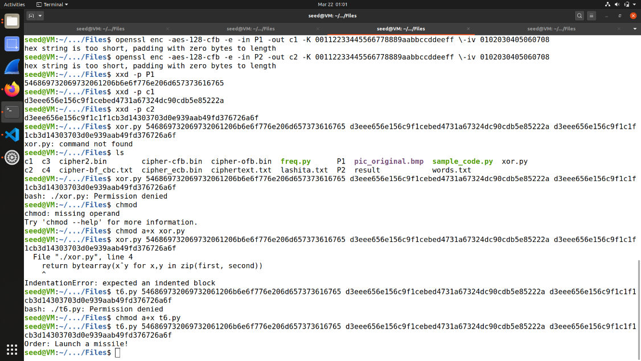

6.2  
using same IV

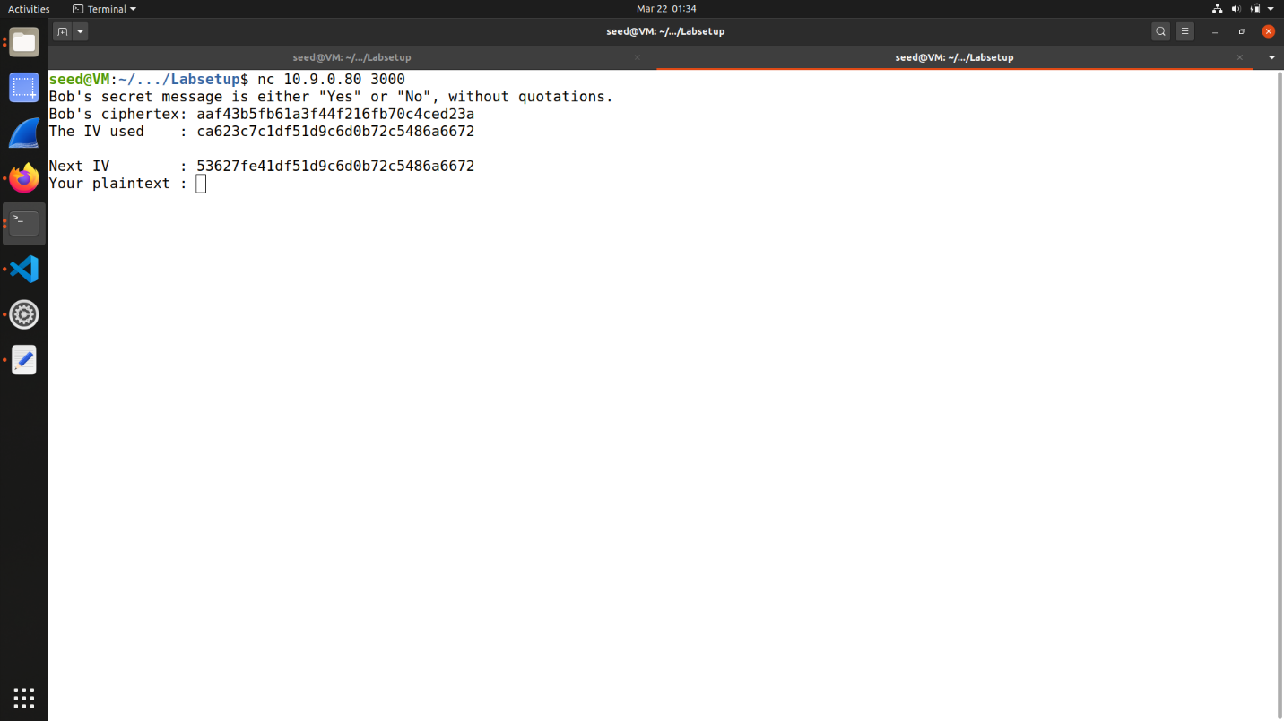6.3  
Using a Predictable IV

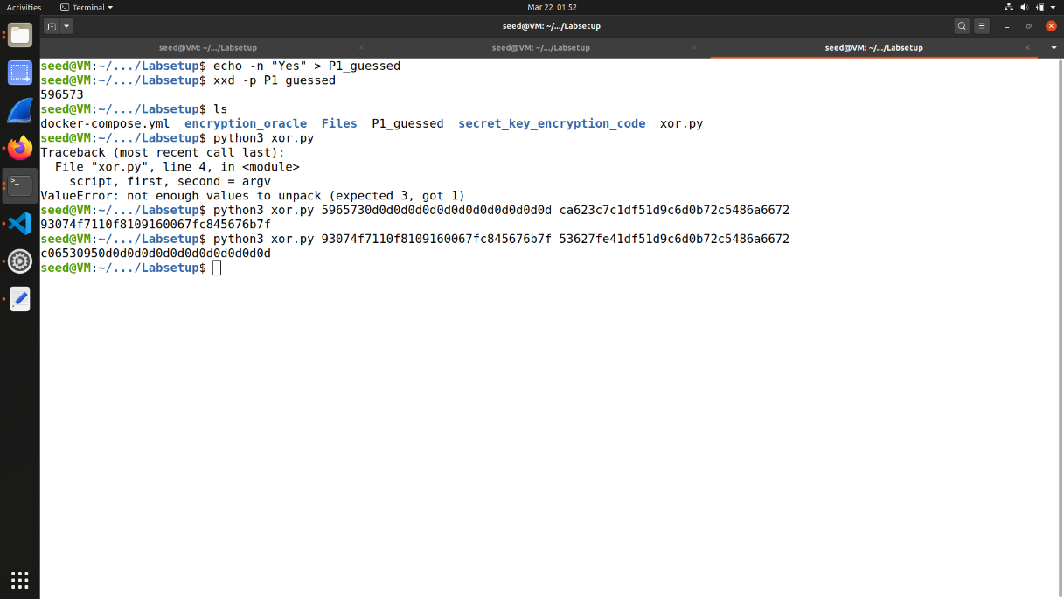

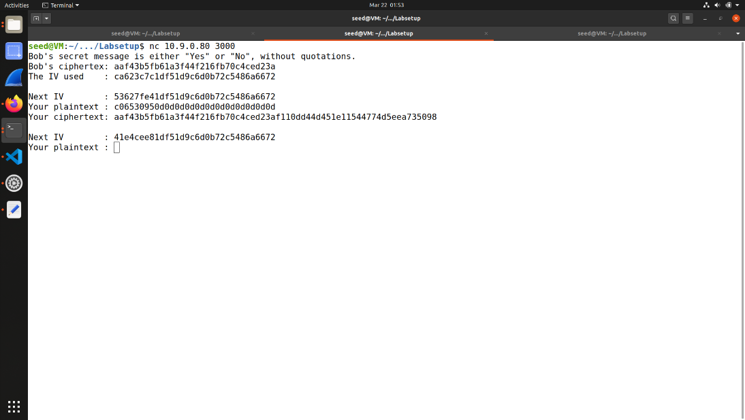

Task 7: Programming using the Crypto Library

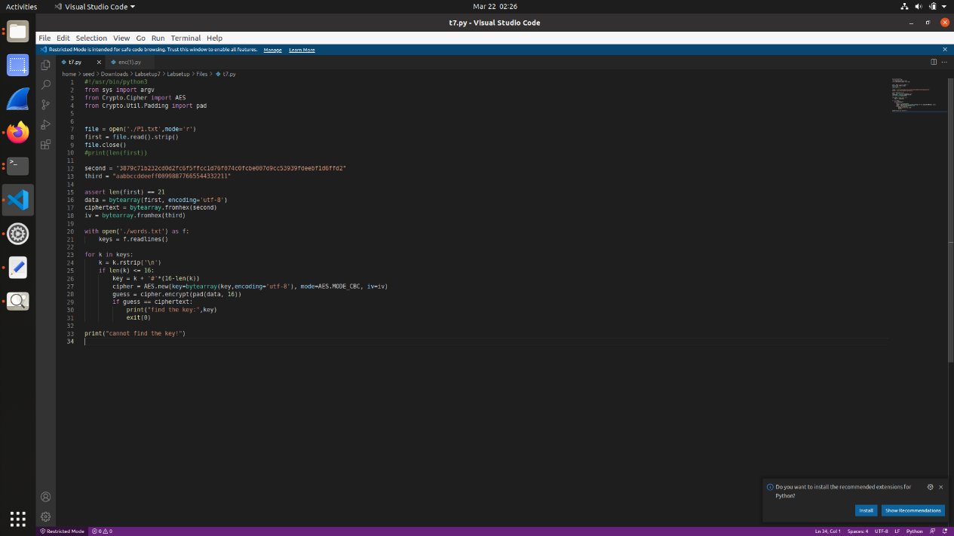

The aes-128-cbc cipher is used for the encryption

