ACS 54500 Cryptography and Network Security Lab 8: MD5 Collision Attack Lab

Task 1: Generating Two Different Files with the Same MD5 Hash

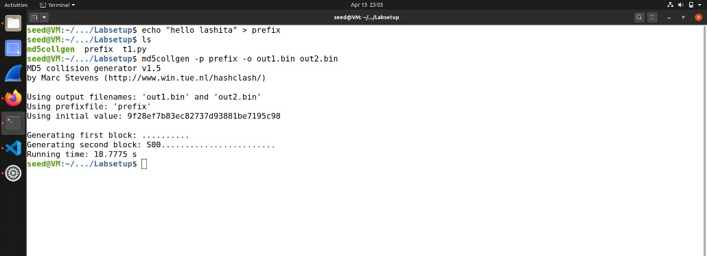Generating the binary files.

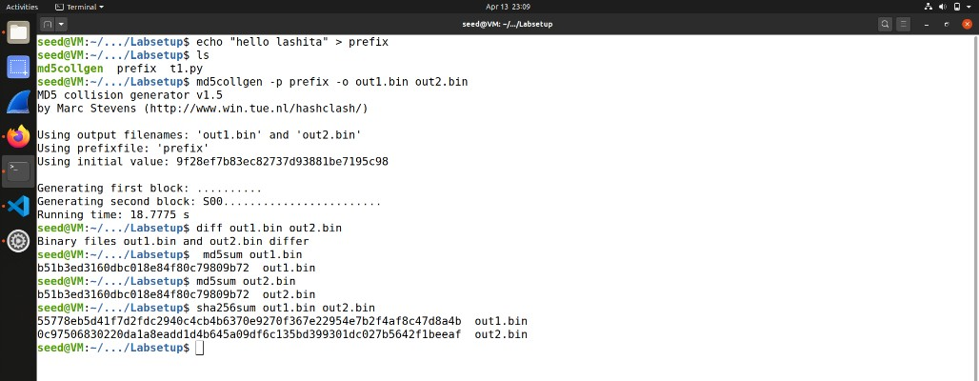Observing that binary files are different:

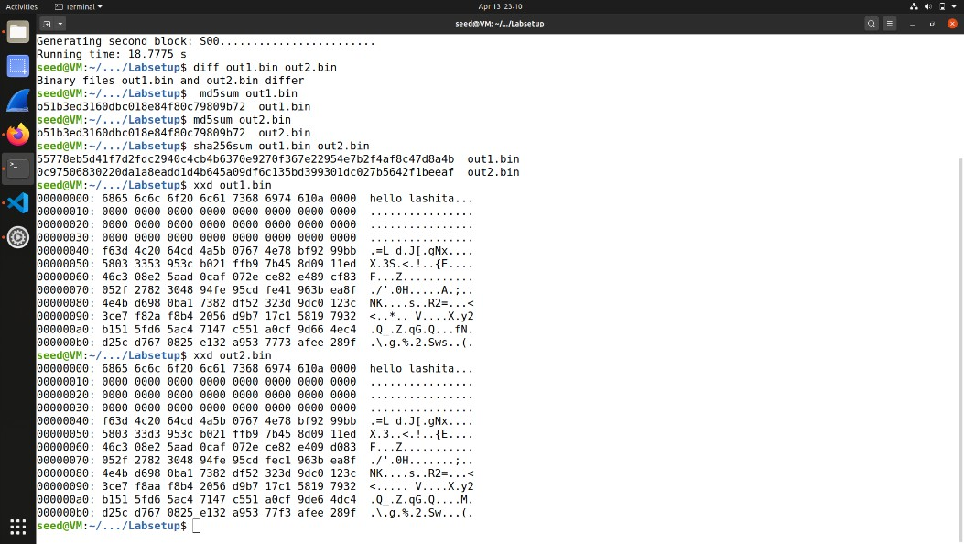Analyzing the binary file, the length of prefix will be padded only if it is a multiple of 64.

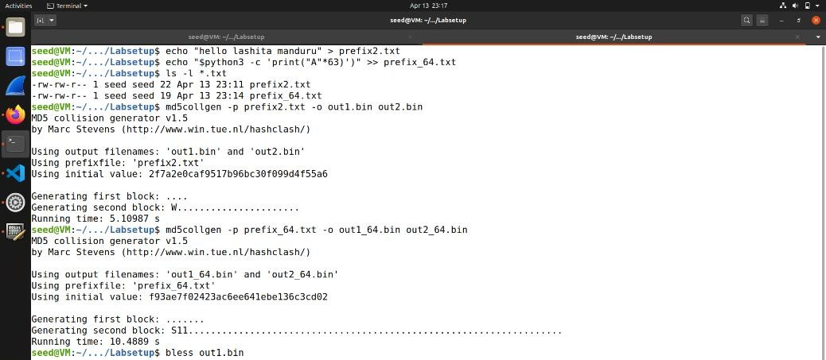Question 2:

Now prefix file is a multiple of 64:

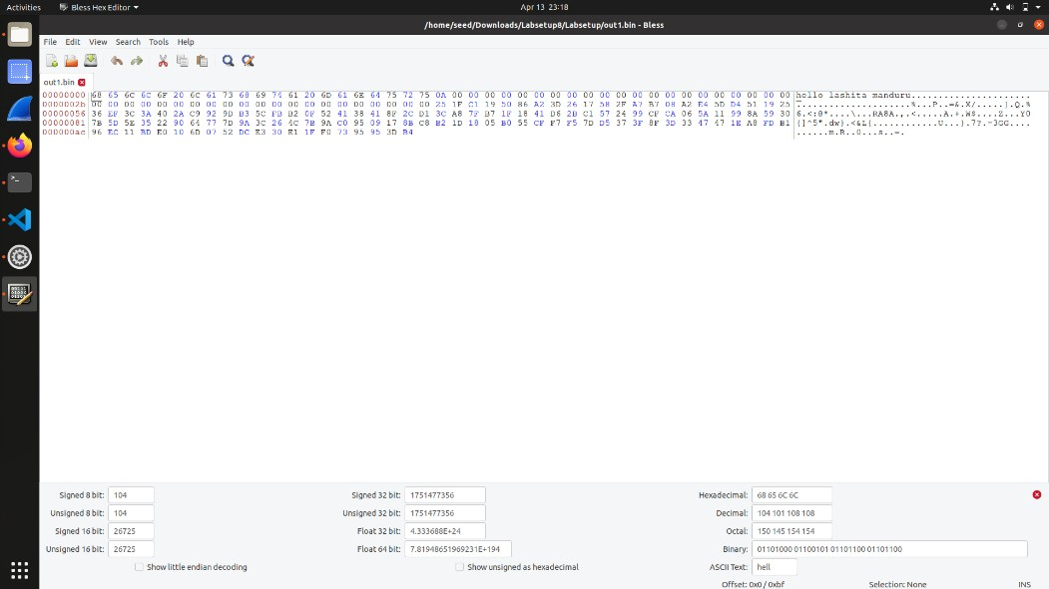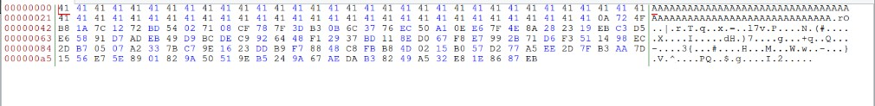

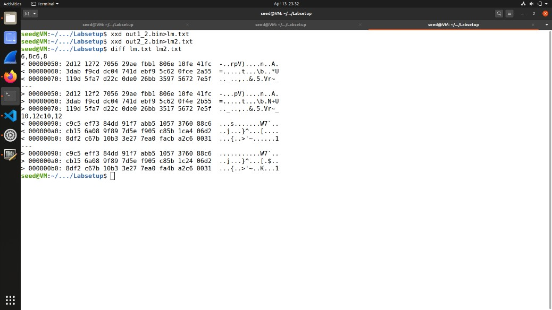Question 3:

Bytes are different.

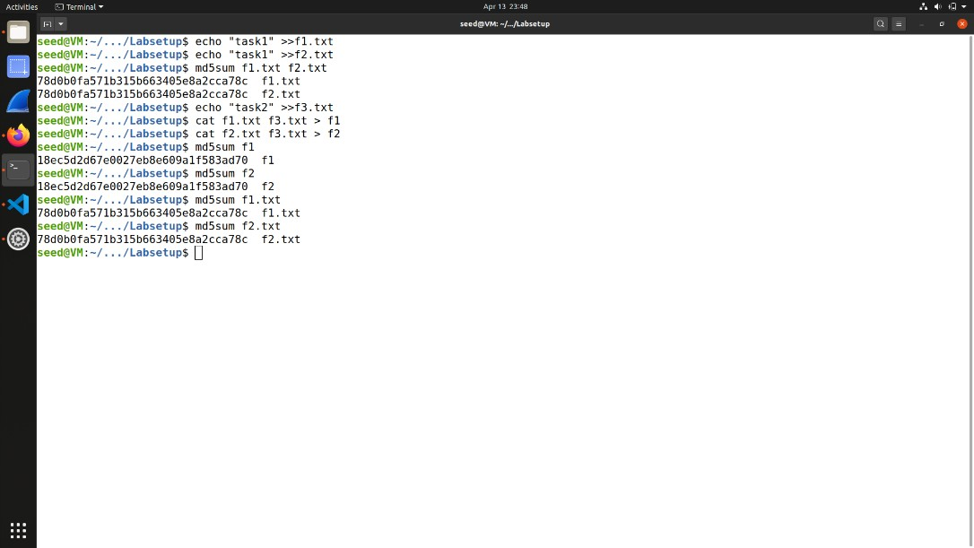 Task 2: Understanding MD5’s

Property

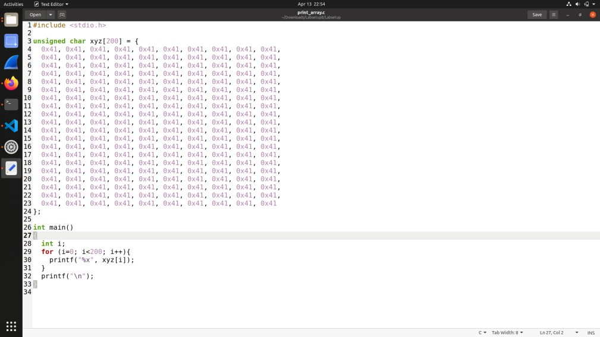Task 3: Generating Two Executable Files with the Same MD5 Hash

Using the print_array.c file:

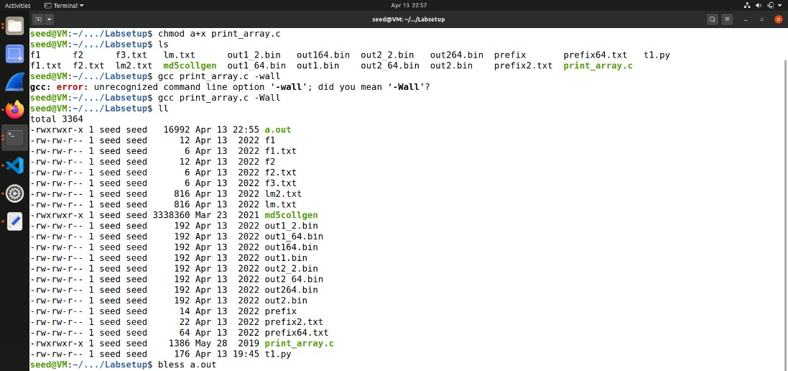

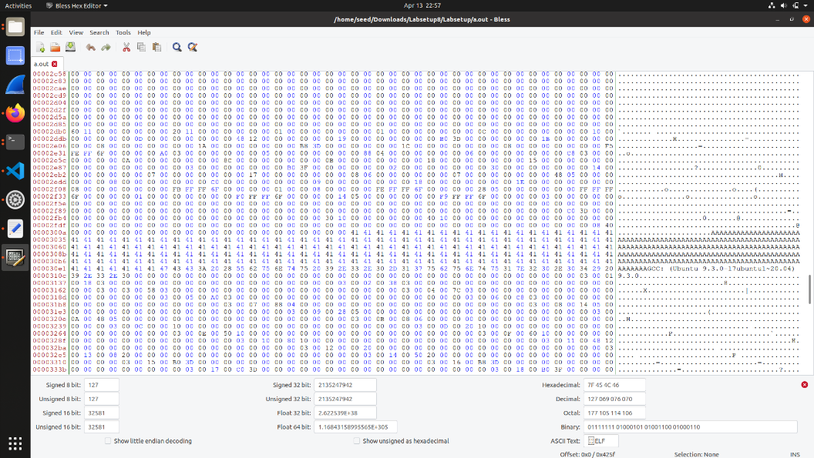Length of the prefix needs to be multiple of 64 bytes:

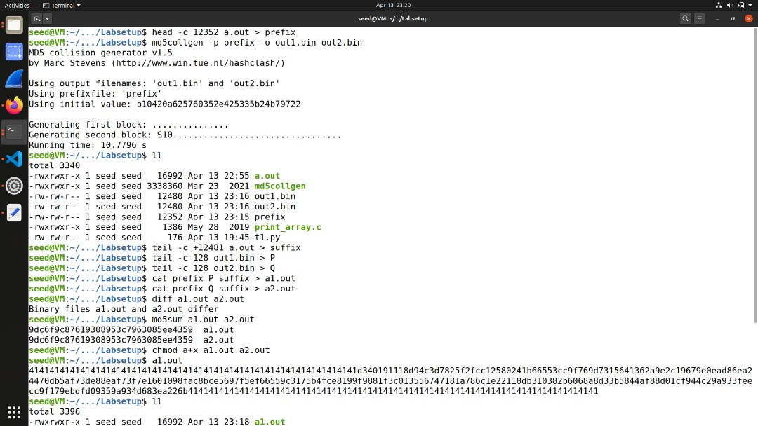

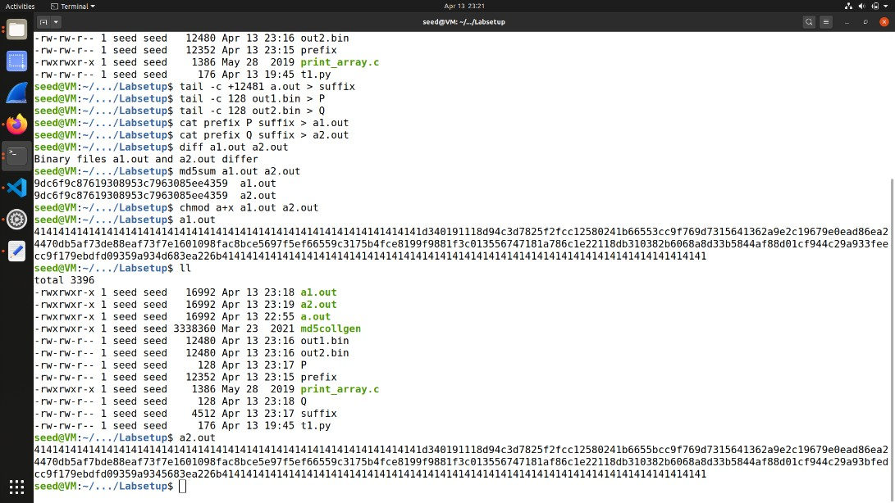both will have same hash value:

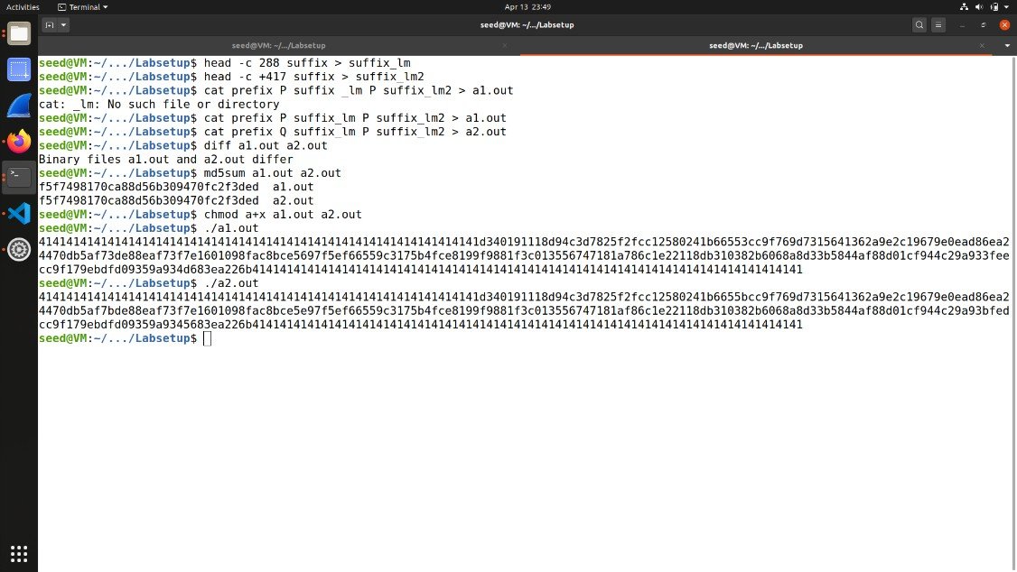Task 4: Making the Two Programs Behave Differently

