|  |  |
| --- | --- |
| **NAME:** | LASHYA P |
| **ROLL NO:** | 18BCS045 |
| **COURSE:** | INTERNET AND WEB PROGRAMMING |
| **CODE:** | **PROTO21 U18CSI6201** |
| **DATE:** | 26-10-2021 |

**EXPERIMENT 1**

**WEB PAGE FOR RESUME USING HTML AND CSS**

**AIM:**

To develop a HTML web page that contains the resume and apply style specification using CSS.

**PROCEDURE:**

The HTML tags for resume web page we have used ,

1. The <html> instructs the web page that the document is an HTML5 document .It is case sensitive .
2. The <head> element is a container for the tags that provide information about the document, for example <title> tag defines the title of the document.
3. The <body>element contains the documents actual content .inside the body element

* The paragraph tag <p> is used to define the paragraph
* The <li> tag is used to define the list
* The <ul> tag defines the unordered list
* The <title> tag defines the title of the page
* The <table> tag defines the table
* The <td> tag defines a cell in a table
* The <th> Defines a header cell in a table
* The <tr> tag defines the row in a table
* The <img> tag define the image

The CSS style tag we have used,

1. Border tag
2. Padding
3. Text align
4. Height
5. width

**SOURCE CODE:**

<!DOCTYPE html>

<html lang="en">

<head>

    <meta charset="UTF-8">

    <meta http-equiv="X-UA-Compatible" content="IE=edge">

    <meta name="viewport" content="width=device-width, initial-scale=1.0">

<title>Resume</title>

<STYLE>

    table {

    border: 1px solid black;

}

td {

    padding: 2px;

    border: 1px solid black;

}

</STYLE>

</head>

<body>

<div class="stuff" >

  <img align="left" src="https://media-exp1.licdn.com/dms/image/C4E03AQFlYJkUmtR8PA/profile-displayphoto-shrink_400_400/0/1623416615165?e=1640822400&v=beta&t=s4d-2FO3xqxBd63WDSOcPRLtqeCev8n3ZWZqZdeSUec" alt="profile image" width="140" height="140" >

<h1 align="right">Resume</h1>

<h2 align="right">LASHYA PONKUMAR</h2>

<h4 align="right">Graduate Innovation Engineer at Forge accelerator</h4>

<hr />

<br>

<b>

<p class="head">About Me</p>

</b>

 <p>A curious engineer in progress to learn new things and to innovate them.

      Naturally, I am excited to work as a team.

       I can quickly adapt to circumvent and I consider that's the greatest of all strength.

       I am a self motivating guy who is a good team player and punctual with time management. </p>

<b>

<p class="head">Skills</p>

</b>

<ul>

  <li>UI/UX</li>

  <li>Web Development</li>

  <li>Data Analyst</li>

  <li>Machine Learning</li>

</ul>

<b>

    <p class="head">Educational Qualifications</p>

    </b>

    <table>

        <tr id="heading">

            <td>Qualification</td>

            <td>School</td>

            <td>Percentage</td>

            <td>Year</td>

        </tr>

        <tr>

            <td>10</td>

            <td><a href="https://www.facebook.com/pages/category/School/Indian-matriculation-schoolHarur-198823593582064/">IMS</a></td>

            <td>94.4</td>

            <td>2016</td>

        </tr>

        <tr>

            <td>12</td>

            <td><a href="https://www.facebook.com/pages/category/School/Indian-matriculation-schoolHarur-198823593582064/">IMS</a></td>

            <td>92.6</td>

            <td>2018</td>

        </tr>

        <tr>

            <td>BE</td>

            <td><a href="https://www.kct.ac.in">KCT</a></td>

            <td>8.9</td>

            <td>2022</td>

        </tr>

    </table>

  <b>

    <p class="head">Certifications</p>

  </b>

  <ul>

    <li>Introduction to fullstack development</li>

    <li>Introduction to database management system</li>

    <li>Managing an Agile Team</li>

    <li>Mongodb basics</li>

    <li>Introduction to MYSQL</li>

  </ul>

  <b>

<p class="head">Experience</p>

</b>

<dl>

    <b><dt>Technophile Traine</dt></b>

      <dd>Acquire knowledge from various fields over the period, which helps me to improve thinking skills. One of the enthusiastic person in our team.Technophile training is the process where students are taught with engineering fundamental concepts, self development skills and to create innovative products.</dd>

    <b><dt>Innovation Engineer Traine</dt> </b>

      <dd>20-week program where we as a team collaborated with startups for solving real-world problems by developing a minimum usable prototype. We are guided by Forge's program leads and startup representatives to solve the problem </dd>

</dl>

<b>

    <p class="head">Projects</p>

    </b>

    <ul>

        <li>Exploratory Data Analysis</li>

        <li>Personal assistant application</li>

        <li>Automatic slide scanning device with multi slide acquisition module and collaborative website for pathologists</li>

        <li>Django - simple food blog app</li>

        <li>Movie Listing web application</li>

    </ul>

<b>

    <p class="head">Interests</p>

    </b>

    <ul>

      <li>Drawing</li>

      <li>Gardening</li>

      <li>Design</li>

      <li>Programming</li>

      <li>Computer Science</li>

    </ul>

<b>

<p class="head">Leadership Roles</p>

</b>

<ul>

    <li>Yoga Trainer for AGAM |2019-2020(A Platform for Yoga and Personal Development) </li>

    <li>Team Lead at Career Guidance Forum of Young Ones| August 2020 - August 2021</li>

    <li>One of the organizers serves as a mentor for this Hackathon - Servathon.</li>

    <li>Joint Treasurer for Rotaract Club of KCT. | June 2020 - June 2021</li>

    <li> Brigade Leader in Ignite'20. One of the Organizers of State Level Yoga Championship.</li>

</ul>

</body>

</html>

**OUTPUT:**

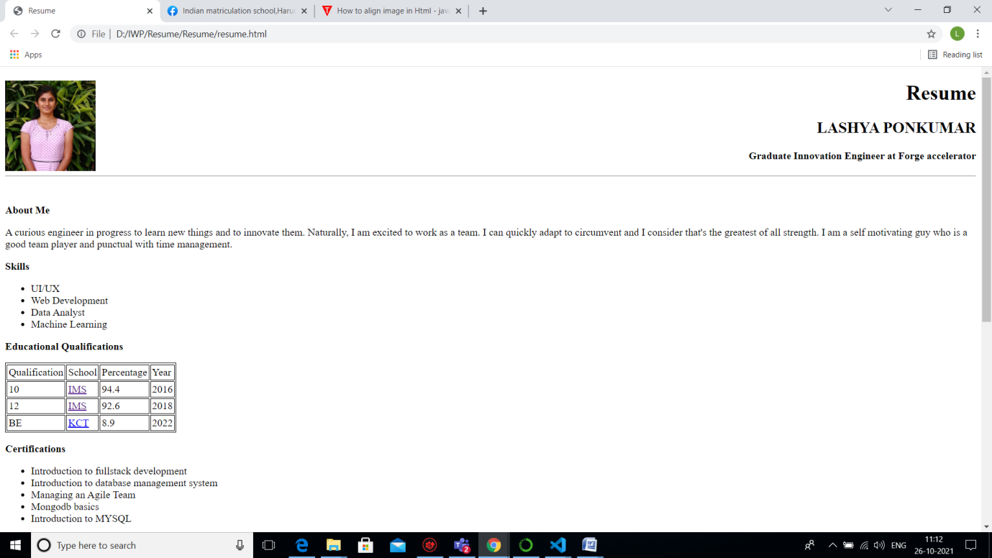

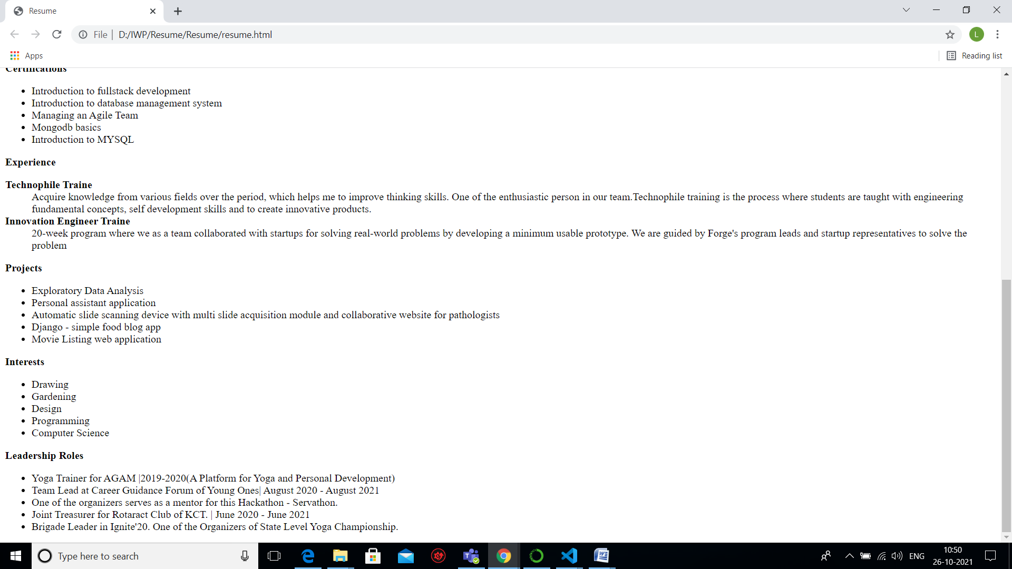

**RESULT:**

The HTML web page for the resume is successfully created and the some styles are applied to the web page.

[github link](https://github.com/Lashya13/Internet-and-web-programming/blob/main/resume.html)