|  |  |
| --- | --- |
| **NAME:** | LASHYA P |
| **ROLL NO:** | 18BCS045 |
| **COURSE:** | INTERNET AND WEB PROGRAMMING |
| **CODE:** | **PROTO21 U18CSI6201** |
| **DATE:** | 30-10-2021 |

**EXPERIMENT 1**

**APPLY STYLE SPECIFICATION IN HTML PAGE USING CSS (RESUME)**

**AIM:**

To develop a HTML web page that contains the resume and apply style specification using CSS.

**PROCEDURE:**

1. FIRST , WRITE THE CODE USING HTML IN VS CODE/ NOTEPAD any text editor.
2. SAVE IT AS .html FILE .
3. RUN THE CODE ON A BROWSER

**SOURCE CODE:**

<!DOCTYPE html>

<html>

<title>Resume</title>

<meta charset="UTF-8">

<meta name="viewport" content="width=device-width, initial-scale=1">

<link rel="stylesheet" href="https://www.w3schools.com/w3css/4/w3.css">

<link rel='stylesheet' href='https://fonts.googleapis.com/css?family=Roboto'>

<link rel="stylesheet" href="https://cdnjs.cloudflare.com/ajax/libs/font-awesome/4.7.0/css/font-awesome.min.css">

<style>

html,body,h1,h2,h3,h4,h5,h6 {font-family: "Roboto", sans-serif}

h2{

 color: rgb(223, 13, 59);

}

</style>

<body class="w3-light-grey">

<!-- Page Container -->

<div class="w3-content w3-margin-top" style="max-width:1400px;">

  <!-- The Grid -->

  <div class="w3-row-padding">

    <!-- Left Column -->

    <div class="w3-third">

      <div class="w3-white w3-text-grey w3-card-4">

        <div class="w3-display-container">

          <img src="Lakshe.jpeg" style="width:100%" alt="Avatar" >

          <div class="w3-display-bottomleft w3-container w3-text-black">

            <h2>Lashya Ponkumar</h2>

          </div>

        </div>

        <div class="w3-container">

          <p><i class="fa fa-briefcase fa-fw w3-margin-right w3-large w3-text-teal"></i>Graduate Innovation Engineer</p>

          <p><i class="fa fa-home fa-fw w3-margin-right w3-large w3-text-teal"></i>Dharmapuri, Tamil Nadu</p>

          <p><i class="fa fa-envelope fa-fw w3-margin-right w3-large w3-text-teal"></i>lashya.18cs@kct.ac.in</p>

          <p><i class="fa fa-phone fa-fw w3-margin-right w3-large w3-text-teal"></i>9597965854</p>

          <hr>

          <p class="w3-large"><b><i class="fa fa-asterisk fa-fw w3-margin-right w3-text-teal"></i>Skills</b></p>

          <p>MSQL</p>

          <div class="w3-light-grey w3-round-xlarge w3-small">

            <div class="w3-container w3-center w3-round-xlarge w3-teal" style="width:90%">90%</div>

          </div>

          <p>Python</p>

          <div class="w3-light-grey w3-round-xlarge w3-small">

            <div class="w3-container w3-center w3-round-xlarge w3-teal" style="width:80%">

              <div class="w3-center w3-text-white">80%</div>

            </div>

          </div>

          <p>Data Structure</p>

          <div class="w3-light-grey w3-round-xlarge w3-small">

            <div class="w3-container w3-center w3-round-xlarge w3-teal" style="width:75%">75%</div>

          </div>

          <p>Java</p>

          <div class="w3-light-grey w3-round-xlarge w3-small">

            <div class="w3-container w3-center w3-round-xlarge w3-teal" style="width:50%">50%</div>

          </div>

          <br>

          <p class="w3-large w3-text-theme"><b><i class="fa fa-globe fa-fw w3-margin-right w3-text-teal"></i>Languages</b></p>

          <p>English</p>

          <div class="w3-light-grey w3-round-xlarge">

            <div class="w3-round-xlarge w3-teal" style="height:24px;width:100%"></div>

          </div>

          <p>Tamil</p>

          <div class="w3-light-grey w3-round-xlarge">

            <div class="w3-round-xlarge w3-teal" style="height:24px;width:100%"></div>

          </div>

          <br>

        </div>

      </div><br>

    <!-- End Left Column -->

    </div>

    <!-- Right Column -->

    <div class="w3-twothird">

      <div class="w3-container w3-card w3-white w3-margin-bottom">

        <h2 class="w3-text-grey w3-padding-16"><i class="fa fa-suitcase fa-fw w3-margin-right w3-xxlarge w3-text-teal"></i>Work Experience</h2>

        <div class="w3-container">

          <h5 class="w3-opacity"><b>Technophile Trainee</b></h5>

          <h6 class="w3-text-teal"><i class="fa fa-calendar fa-fw w3-margin-right"></i>Aug 2019 - Feb 2020</h6>

          <p>Acquire knowledge from various fields over the period, which helps me to improve thinking skills. One of the enthusiastic person in our team.Technophile training is the process where students are taught with engineering fundamental concepts, self development skills and to create innovative products.</p>

          <hr>

        </div>

        <div class="w3-container">

          <h5 class="w3-opacity"><b>Innovation Engineer Trainee</b></h5>

          <h6 class="w3-text-teal"><i class="fa fa-calendar fa-fw w3-margin-right"></i>Mar 2012 - Dec 2014</h6>

          <p>20-week program where we as a team collaborated with startups for solving real-world problems by developing a minimum usable prototype. We are guided by Forge's program leads and startup representatives to solve the problem.</p>

          <hr>

        </div>

      </div>

      <div class="w3-container w3-card w3-white">

        <h2 class="w3-text-grey w3-padding-16"><i class="fa fa-certificate fa-fw w3-margin-right w3-xxlarge w3-text-teal"></i>Education</h2>

        <div class="w3-container">

          <h5 class="w3-opacity"><b>10th Grade</b></h5>

          <h6 class="w3-text-teal"><i class="fa fa-calendar fa-fw w3-margin-right"></i>March 2016</h6>

          <p>Indian Matric higher secondary school -  94.4%</p>

          <hr>

        </div>

        <div class="w3-container">

          <h5 class="w3-opacity"><b>12th Grade</b></h5>

          <h6 class="w3-text-teal"><i class="fa fa-calendar fa-fw w3-margin-right"></i>April -2018</h6>

          <p>Indian Matric Higher Secondary school - 92.6% </p>

          <hr>

        </div>

        <div class="w3-container">

          <h5 class="w3-opacity"><b>BE -CSE</b></h5>

          <h6 class="w3-text-teal"><i class="fa fa-calendar fa-fw w3-margin-right"></i>2018 -2022</h6>

          <p>Kumaraguru college of technology -  8.9 CGPA</p><br>

        </div>

      </div>

      <div class="w3-container w3-card w3-white">

        <h2 class="w3-text-grey w3-padding-16"><i class="fas fa-user-graduate fa-fw w3-margin-right w3-xxlarge w3-text-teal"></i>Leadership skills</h2>

        <div class="w3-container">

            <ul>

                <li>Yoga Trainer for AGAM |2019-2020(A Platform for Yoga and Personal Development) </li>

                <li>Team Lead at Career Guidance Forum of Young Ones| August 2020 - August 2021</li>

                <li>One of the organizers serves as a mentor for this Hackathon - Servathon.</li>

                <li>Joint Treasurer for Rotaract Club of KCT. | June 2020 - June 2021</li>

                <li> Brigade Leader in Ignite'20. One of the Organizers of State Level Yoga Championship.</li>

            </ul>

        </div>

    </div>

    <!-- End Right Column -->

    </div>

  <!-- End Grid -->

  </div>

  <!-- End Page Container -->

</div>

<footer class="w3-container w3-teal w3-center w3-margin-top">

  <p>Find me on social media.</p>

  <i class="fa fa-facebook-official w3-hover-opacity"></i>

  <i class="fa fa-instagram w3-hover-opacity"></i>

  <i class="fa fa-snapchat w3-hover-opacity"></i>

  <i class="fa fa-linkedin w3-hover-opacity"></i>

</footer>

</body>

</html>

**OUTPUT:**

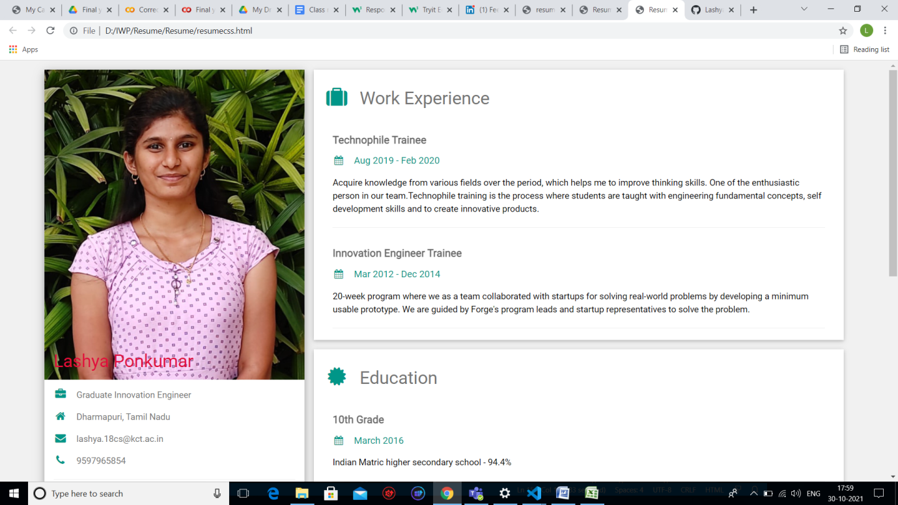

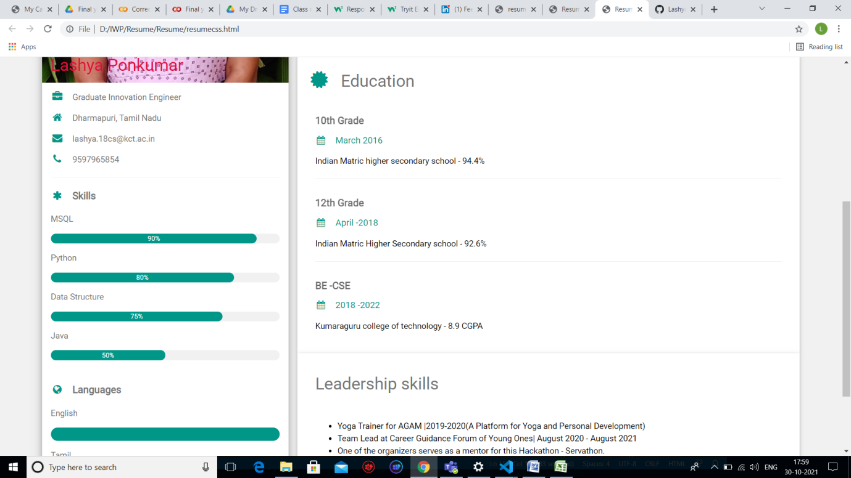

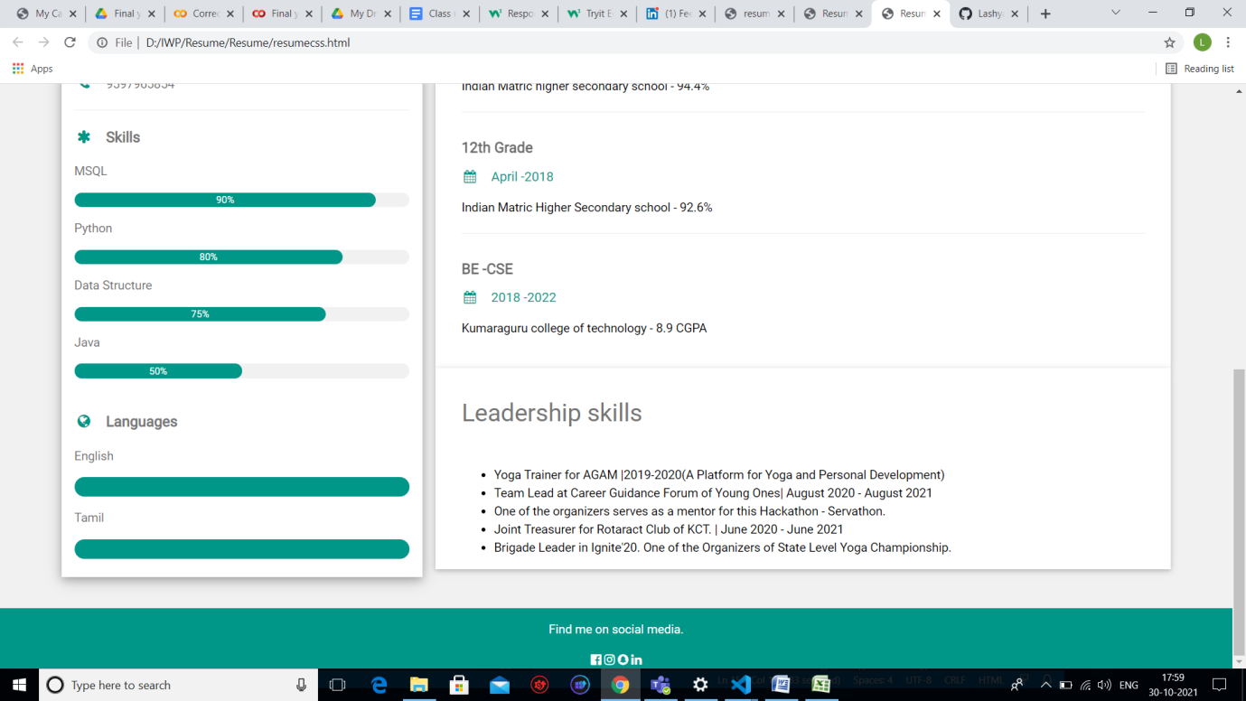

**RESULT:**

The HTML web page for the resume is successfully created and styles are applied to the web page.

[github link](https://github.com/Lashya13/Internet-and-web-programming/blob/main/resume.html)