**INTERNET AND WEBSITE DEVELOPMENT**

**EXPERIMENT- 7**

**NAME :BHRAMI.R.R**

**ROLLNO : 18BCS056**

**DATE :09-04-2021**

**AIM:**

To Apply JavaBean class to print information about a student class

**PROCEDURE:**

1.Open your tool and create a new file that will contain the Java bean source and save the file

2.Open your tool to create the class that will instantiate the Java bean and save it.

3.The program will instantiate the Java bean and then call the setter and getter methods of the newly created Java bean.

4.The details in the student class is displayed .

**CODE :**

**StudentsBean.java:**

public class StudentsBean {

private String firstName = null;

private String lastName = null;

private int age = 0;

public StudentsBean() {

}

public String getFirstName(){

return firstName;

}

public String getLastName(){

return lastName;

}

public int getAge(){

return age;

}

public void setFirstName(String firstName){

this.firstName = firstName;

}

public void setLastName(String lastName){

this.lastName = lastName;

}

public void setAge(int age){

this.age = age;

}

}

**NewFile.jsp:**

<html>

<head>

<title>get and set properties Example</title>

</head>

<body>

<jsp:useBean id = "students" class = "javabean.experiment.StudentsBean">

<jsp:setProperty name = "students" property = "firstName" value = "BHRAMI"/>

<jsp:setProperty name = "students" property = "lastName" value = "R R"/>

<jsp:setProperty name = "students" property = "age" value = "21"/>

</jsp:useBean>

<p>Student First Name:

<jsp:getProperty name = "students" property = "firstName"/>

</p>

<p>Student Last Name:

<jsp:getProperty name = "students" property = "lastName"/>

</p>

<p>Student Age:

<jsp:getProperty name = "students" property = "age"/>

</p>

</body>

</html>

**OUTPUT:**

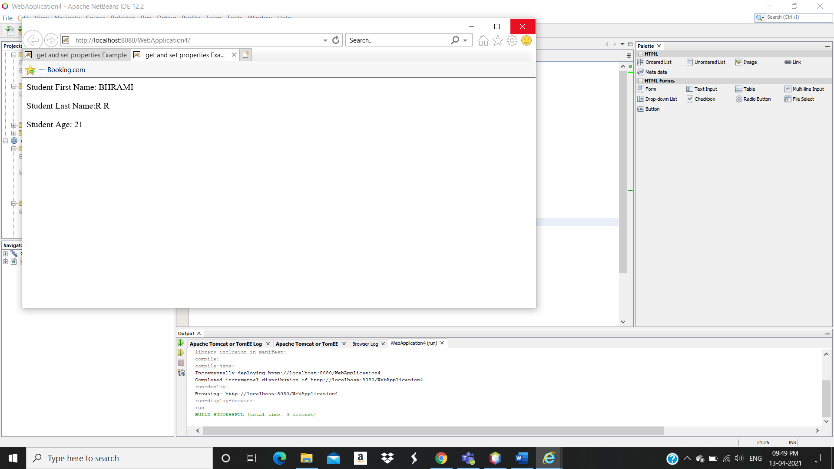

**RESULT :**

The JavaBean class to print information about a student class is successfully created.