GitHub link - [https://github.com/LasithaJananjaya/CS2023-Data-Structures-and-Algorithms---Workspace/tree/main/in-class-lab](https://github.com/LasithaJananjaya/CS2023-Data-Structures-and-Algorithms---Workspace/tree/main/in-class-lab9)10

**Section 1 - Implementing Graph ADT**

1. Write the adjacency list representation for the graph in Fig1.

1 -> 2 -> 3 -> 4 -> 5

2 -> 1 -> 3 -> 6

3 -> 1 -> 2

4 -> 1 -> 6 -> 7 -> 8

5 -> 1 -> 6 -> 7 -> 8

6 -> 2 -> 4 -> 5

7 -> 4 -> 5

8 -> 4 -> 5

1. By using comments provided in the code, complete the following *Node (struct), intializenodes, addedge*, *print* functions.
2. Create graph object and add the graph in Fig.1.
3. Print the adjacency list using the print function you implemented and take screenshot.

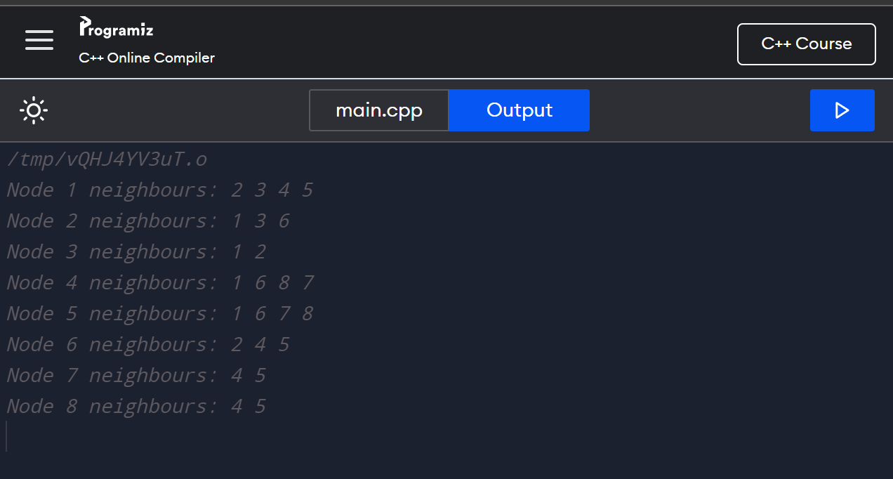

1. What is the change you will make in the addedge function so that Graph ADT could accept directed graphs. (Instead of accepting undirected graph, we need to accept directed graph). Write addedge altered function as your answer below.

void addedge(int u, int v, bool directed) {

nodes[u].neighbours.push_back(v);

if (!directed) {

nodes[v].neighbours.push_back(u)

}

**Section 2 - Working out link prediction, no coding required**

Let’s assume graph in Fig.2 is a social network graph of a social media platform, where nodes denote people and edges between them indicate that they are connected as friends. **Node 1** and **Node 4** just became friends, which of the **neighbours of Node 1** will you **suggest for Node 4** (in other word predict which neighbour of Node 1 can have an edge with Node 4). Utilize the similarity function provided to justify the answer.

$$Sim(a,b)=\frac{\# of shared neighbours between a,b}{Total neighbours in a,b}$$

Sim(4,2) = $\frac{2}{5}$ = 0.4

Sim(4,3) = $\frac{1}{5}$ = 0.2

Sim(4,5) = $\frac{4}{4}$ = 1

Therefore, **Node 4** is predicted to have an edge with **Node 5**.