Github link - [https://github.com/LasithaJananjaya/CS2023-Data-Structures-and-Algorithms---Workspace/tree/main/in-class-lab](https://github.com/LasithaJananjaya/CS2023-Data-Structures-and-Algorithms---Workspace/tree/main/in-class-lab8)9

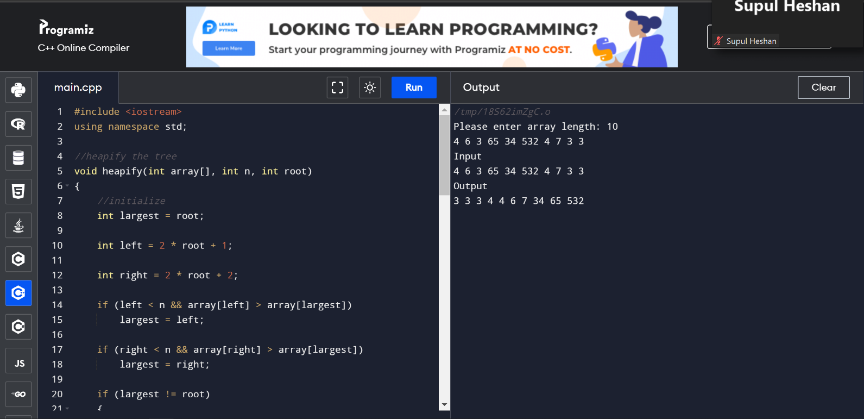

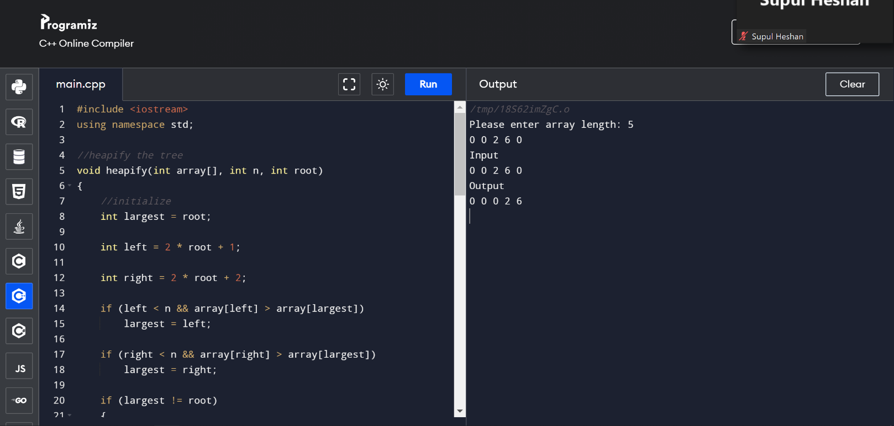

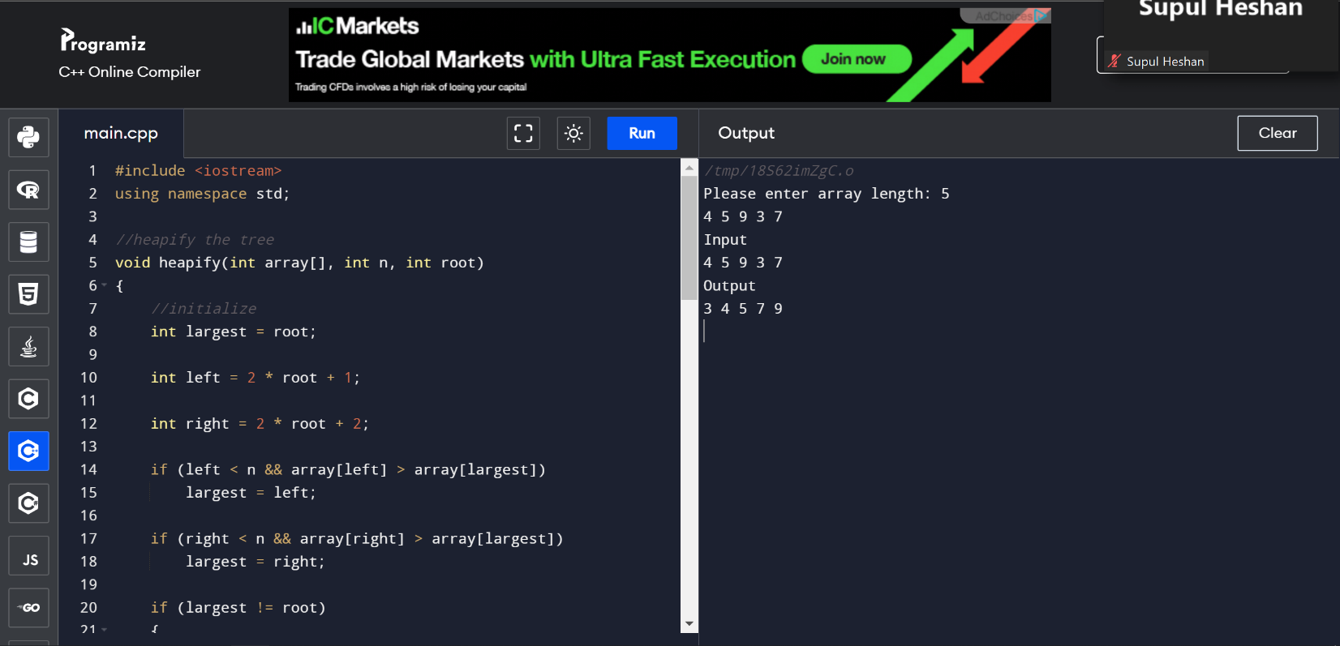

Heap sort is a sorting algorithm that utilizes a binary heap data structure to rearrange the input array. This technique involves iteratively exchanging the heap's root element with the last element in the heap and subsequently performing heapification on the remaining elements until the entire array is sorted. The algorithm boasts a time complexity of O(n log n), where n represents the number of elements in the input array. Additionally, it exhibits an optimal space complexity of O(1). However, it should be noted that Heap sort's efficiency is maximized when sorting large datasets, as its overhead can lead to slower sorting times when processing small datasets in comparison to other sorting algorithms.