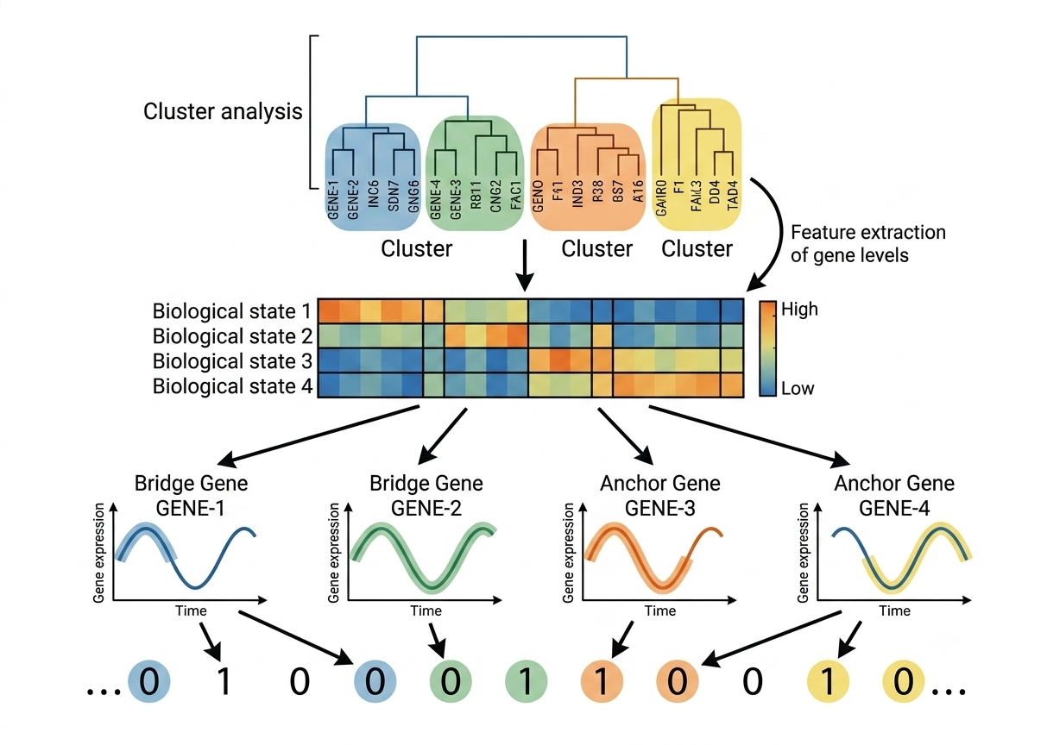
Gene Expression

R software is been used for this data analysis project

1.Introduction & Project Foundations

This project is based on Samira Shemirani’s “Spellman” dataset on Kaggle. The Spellman dataset contains time-series gene expression data (log ratios) tracking Saccharomyces cerevisiae (yeast) through a cell cycle synchronized via a temperature-sensitive mutation (cdc15-2). The high-dimensional data matrix contains 4,381 genes (rows) evaluated across 23 distinct time points (columns), serving as the benchmark foundation for identifying rhythmic biological phases and evaluating unsupervised clustering workflows.

Dataset Sources
The papers from which this dataset is derived are:
- Comprehensive Identification of Cell Cycle–regulated Genes of the Yeast Saccharomyces cerevisiae by Microarray Hybridization
Paul T. Spellman, Gavin Sherlock, Michael Q. Zhang, Vishwanath R. Iyer, Kirk Anders, Michael B. Eisen, Patrick O. Brown, David Botstein, and Bruce Futcher. Molecular Biology of the Cell 1998 9:12, 3273-3297. doi: https://doi.org/10.1091/mbc.9.12.3273
- D. Reshef, Y. Reshef, H. Finucane, S. Grossman, G. McVean, P. Turnbaugh, E. Lander, M. Mitzenmacher, P. Sabeti. (2011) Detecting novel associations in large datasets. Science 334, 6062 (http://www.exploredata.net).

Aim: To apply an advanced, unsupervised machine learning pipeline to high-dimensional time-series microarray data in order to filter experimental noise, discover co-expressed gene clusters, and isolate a highly robust, consensus set of core regulatory genes driving the yeast cell division cycle.

2. Exploratory Data Analysis & Quality Control
Exploratory profiling confirmed the dataset's structural integrity. The overall distribution of expression log2 ratios exhibits a symmetrical, bell-shaped normal curve centered almost perfectly at a mean of 0.00168 with a standard deviation of 0.425.
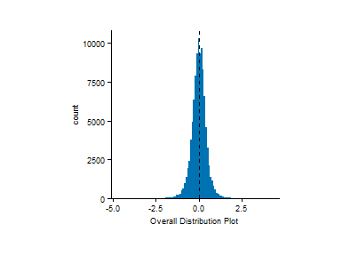
========== DATA STATISTICS REPORT ==========
Absolute Minimum Expression: -4.63
Absolute Maximum Expression: 4.14
Overall Average (Mean): 0.00168673
Upper Outlier Threshold (+3 SD): 1.275274
Lower Outlier Threshold (-3 SD): -1.271901
Percentage of Data as Outliers: 1.26 %

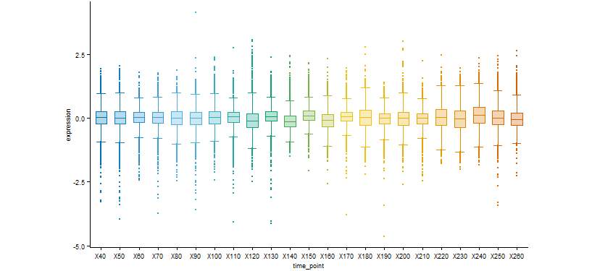
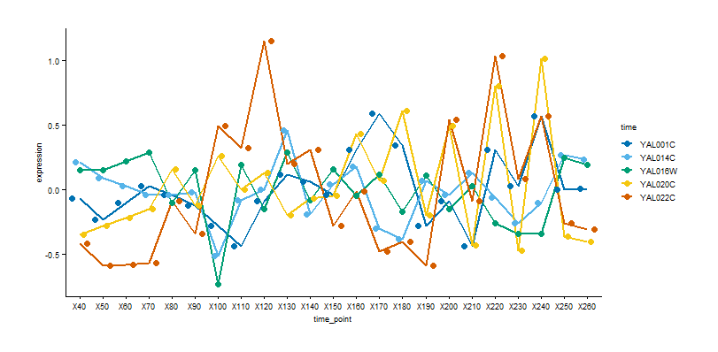
Time-point boxplots demonstrate that the median baseline remains securely at 0.0 across the timeline, confirming successful normalization with zero technical chip drift. Periodic widening of the vertical distribution bounds indicates synchronized waves of genes flipping heavily on or off at key landmarks.

Raw cluster mapping displays high dimensional redundancy due to background noise. Tracing individual timelines (e.g., YAL022C peaking at X120 and X220) visually uncovers an oscillatory wave profile that matches the 90-to-100 minute replication cycle of Saccharomyces cerevisiae. Rearranging row vectors via an initial agglomerative dendrogram creates a baseline matrix visualization, revealing clear vertical stripes of synchronous activation and suppression across the cell timeline.
Exploratory Data Insights
Exploratory visualizations validated the structural integrity of the Spellman dataset. Diagnostics (Histogram and Boxplots) confirmed a stable, normalized dataset centered at a baseline log-ratio of $0.0$, free from technical drift or batch effects across the 240-minute timeline. While the majority of the 4,381 genes reside within a narrow steady-state margin—indicating a high volume of background noise —tracking individual trajectories and aggregate variance revealed clear variance spikes and oscillatory peaks at landmarks like X120, X150, and X240. These waves perfectly capture the synchronized 90-to-100 minute replication cycle of Saccharomyces cerevisiae. Although individual profiles suffer from intense phase-shift noise, applying Hierarchical Clustering beautifully resolves this chaos ; ordering genes via a structural dendrogram reveals highly coordinated blocks of synchronous activation (red) and suppression (blue).

3. Dimensionality Reduction & Linear Noise Filtration
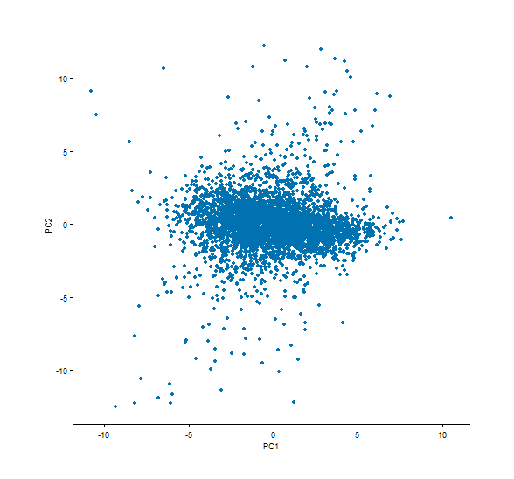

Principal Component Analysis (PCA) was implemented to transform the 23 raw temporal columns into orthogonal variables, shifting focus from baseline noise toward true variance. The data projects onto a continuous, fluid cloud with a dense core at $(0,0)$ and long flares expanding outward. This topology confirms that gene expression shifts smoothly over time rather than stepping through discrete states.

Section 3.1: Scree Plot and Mathematical Truncation
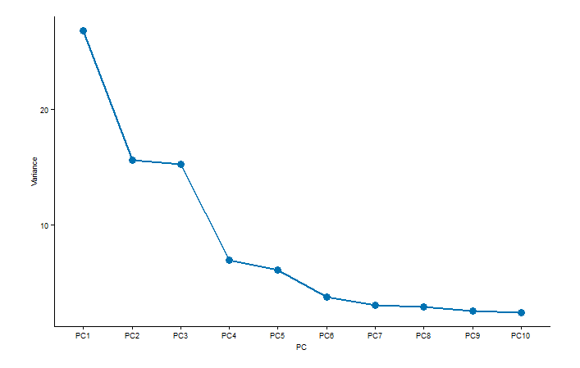

A scree plot was utilized to analyze the eigenvalue variance across components. Principal Component 1 (PC1) captures the dominant variance share, followed by steady steps down to an explicit mathematical "elbow" point between PC3 and PC4. Components beyond PC4 represent negligible variance, background static, and experimental heat-shock artifacts. Truncating the space at the elbow point compresses the 23-dimensional timeline into a noise-filtered 3D canvas (PC1, PC2, PC3). This maintains core cyclic biological signals while removing background redundancy. Projecting the space across a PC1 vs. PC3 canvas uncovers a unique vertical plume stretching down to -15 along the negative PC3 axis. This plume captures a specialized temporal expression signature corresponding to mitosis arrest checkpoints and local heat-shock responses. Retaining the third principal component prevents flattening this vital regulatory signal into the central noise core.

4. Multi-Model Hard-Partitioning Ensemble Integration
To categorize the 4,381 noise-filtered transcripts into primary cell-cycle phases, three distinct mathematical partitioning architectures were deployed at a fixed target parameter of k=4.

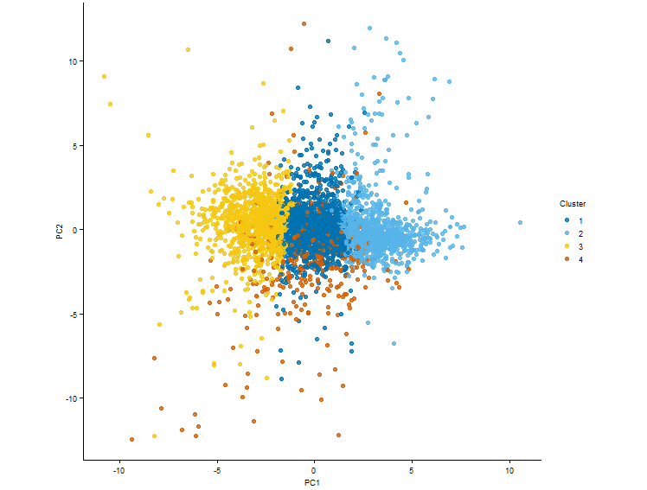
4.1 K-Means Centroid Optimization

K-Means clustering was executed to divide the PCA canvas into four sectors based on Euclidean distance to abstract mean coordinates. Plot boundaries present as sharp, vertical geometric cuts. Group temporal trajectories reveal distinct phase behaviors: Cluster 1 shows early-cycle activation (X50–X80), Cluster 2 captures a rapid early plunge followed by high-frequency oscillations around zero, Cluster 3 controls delayed late-activation peaking between X180–X240, and Cluster 4 tracks a steady global upward climb toward maximum expression at X250. Tall, uniform internal variation bars indicate high amplitude diversity within individual sectors, confirming that rigid centroid models struggle along continuous cluster borders.

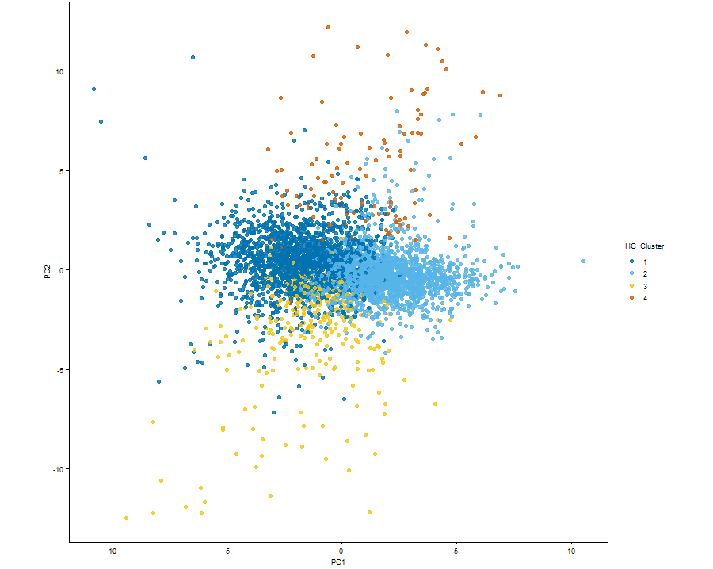
4.2 Agglomerative Hierarchical Clustering

Agglomerative Hierarchical Clustering was deployed utilizing Ward's Minimum Variance method (`ward.D2`) on a pairwise Euclidean distance matrix. This model builds a structural tree based on local proximity rather than central means, tracing organic density plumes across the transcriptomic space. The resulting dendrogram was trimmed at k=4 to match the benchmark framework.

4.3 Partitioning Around Medoids (PAM)
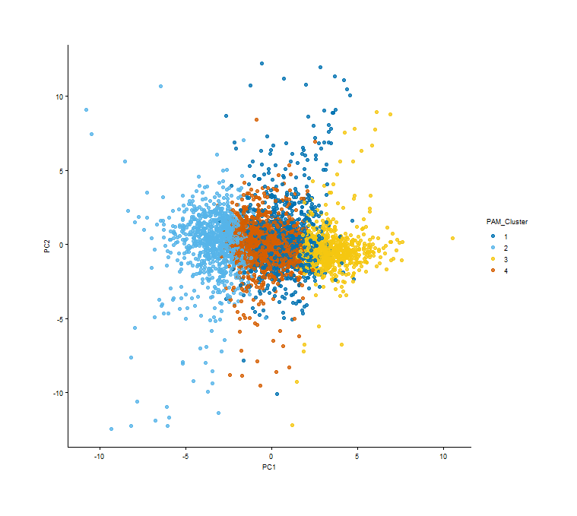
Partitioning Around Medoids (PAM) was applied to anchor group boundaries around actual, physical representative genes (medoids) instead of abstract calculated centers. Minimizing distance deviations ensures the PAM architecture remains mathematically insensitive to outlier data noise, providing a stable central anchoring mechanism.

5. Algorithmic Benchmarking & Intersection Metrics
To evaluate structural convergence, cross-tabulation intersection matrices were constructed between the different partitioning outputs.
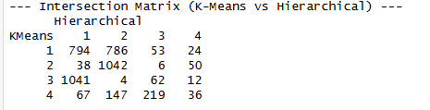
Table 2: Hard Partitioning Cross-Tabulation Intersection Matrix

The intersection matrix reveals critical operational behaviors across model borders:
Core Consensus Group A (n=1,042): Formed by the perfect convergence of K-Means Cluster 2 and Hierarchical Cluster 2. Unanimous agreement across separate metrics validates this cohort as a stable biological macro-phase.
Algorithmic Edge Splitting: K-Means Sector 1 is cut nearly in half by the hierarchical tree into Branch 1 (n=794) and Branch 2 (n=786). This indicates that the sub-population contains nested, non-linear structural plumes clipped by the linear planes of K-Means.
Core Consensus Group B (n=62): Represents lower-density transitional data sitting where the geometric boundaries of K-Means intersect the outer branch tips of the hierarchical tree.

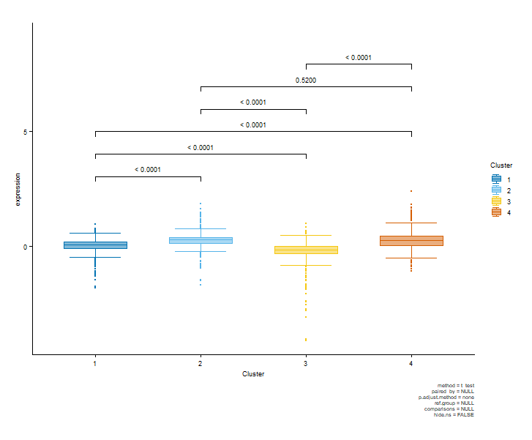
5.1 Localized Statistical Cross-Examination

To confirm that these clusters capture distinct biological phenotypes rather than arbitrary divisions, the longitudinal data was frozen at checkpoint X130 (minute 130). Evaluating group variances via pairwise independent sample t-tests established robust statistical separation (p < 0.0001) across the sectors.
At minute 130, a single non-significant intersection occurs between Cluster 2 and Cluster 4 (p = 0.5200) due to identical positive mean expression magnitudes. Cross-referencing this landmark with long-term centroid trajectories reveals that minute 130 marks an exact temporal cross-over point where early-activating waves plunge into suppression while late-activating waves climb upward. This supports the use of longitudinal workflows over static single-point evaluations.

6. Ensemble Voting Architecture & Super-Core Extraction
To eliminate individual geometric clustering bias, an automated three-way ensemble consensus pipeline was engineered. The master matrix row-names were split by model assignments and evaluated using recursive set-theory intersections:
$$\text{Super-Core Vector}=\text{K-Means}∩\text{Hierarchical}∩\text{PAM}$$

This step strips away ambiguous boundary targets, preserving only the absolute consensus nuclei where all three geometries align. While individual hard partitioners were restricted to k=4, intersecting their offset boundaries carved out a hidden fifth sub-population, dividing the genome into five refined data vectors totalling 2,953 stable targets:
Super-Core Phase 1 (n=793): Captured via the intersection of K-Means 3, HC 1, and PAM. Serves as a primary, high-amplitude foundational axis of the cell cycle.
Super-Core Phase 2 (n=739): Captured via the intersection of K-Means 2, HC 2, and PAM. Represents the second major synchronized macro-phase wave.
Super-Core Phase 3 (n=628): Captured via the intersection of K-Means 1, HC 1, and PAM. Uncoupled from broader states into a distinct sub-synchronized micro-phase.
Super-Core Phase 4 (n=540): Captured via the intersection of K-Means 1, HC 2, and PAM. Grants granular resolution over adjacent phase hand-offs.
Super-Core Phase 5 (n=253): Captured via the intersection of K-Means 2, HC 2, and PAM. A specialized regulatory cluster preserved by the outlier-insensitive anchoring of the PAM medoid architecture.

7. Non-Linear Topology & Probabilistic Boundary Mapping
While PCA filters global linear noise, it cannot resolve complex non-linear structures. To evaluate local neighborhood pathways, Uniform Manifold Approximation and Projection (UMAP) was executed directly on the noise-filtered PCA components.
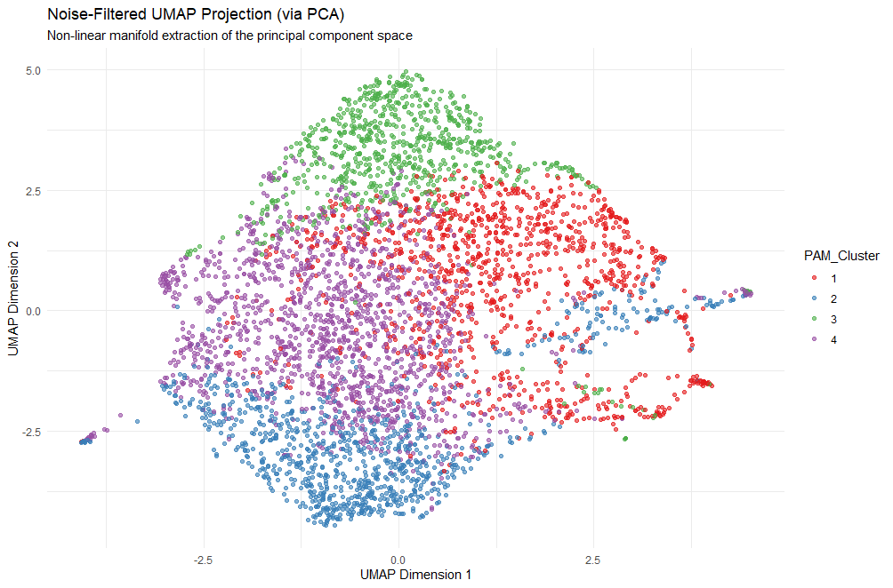

The UMAP algorithm unfolded the genomic data into a single continuous, interconnected loop manifold rather than disjointed island fragments. This confirms that the yeast cell cycle operates as an unbroken temporal continuum driven by synchronized rhythmic waves moving along a closed molecular loop. Overlaying PAM clusters on the UMAP canvas shows distinct phase poles (Top/Green, Bottom/Blue, Left/Purple, Right/Red) surrounding stable core regions where phase colors touch and mix.

Section 7.1: Gaussian Mixture Soft-Clustering
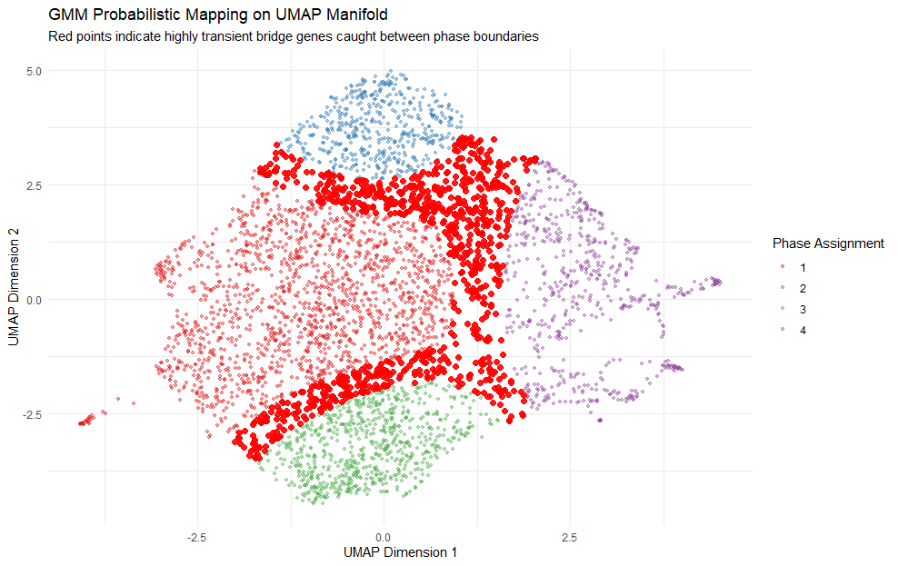
To map these transition zones, a soft probabilistic Gaussian Mixture Model (GMM) was projected across the UMAP coordinates. Utilizing expectation-maximization, the GMM computes exact membership probability vectors to quantify positional uncertainty across the loop.
Dense island centers yielded near-zero uncertainty scores, confirming highly stable "Core" genes. Isolating nodes with split probability distributions (Uncertainty Vector > 0.3) extracted 865 high-uncertainty transient bridge genes. These bridge targets trace distinct structural rivers or fault lines that physically fill the geometric gaps between major phases. This pipeline rescues transitional regulatory sequences and early-responder transcription factors responsible for cell checkpoint hand-offs.

8. Topological Cross-Examination: Core vs. Bridge Sets

A two-way set-theory intersection (`ggVennDiagram`) was executed to map the physical overlap between the mathematically rigid Phase 5 Super-Core (n=253) and the continuous GMM boundary vectors (n=865, p>0.3).
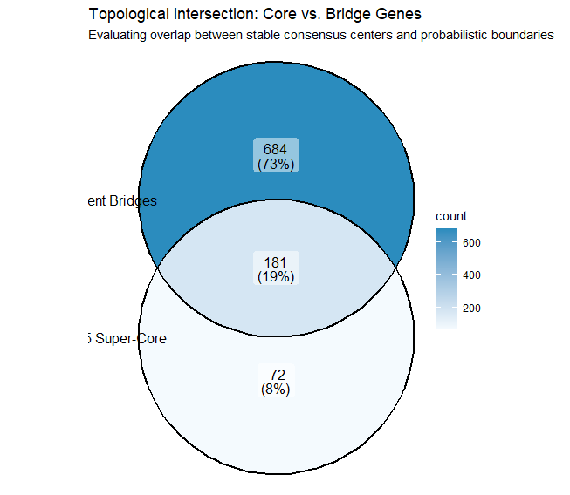

Rather than indicating experimental noise, the set-theory breakdown uncovers a major biological finding regarding Phase 5's topology:
High-Uncertainty Boundary Overlap (n=181): A staggering 71.5% of the Phase 5 core was simultaneously flagged by the GMM as highly uncertain transition vectors. Phase 5 sits directly on the fluid boundary lines between states rather than within an isolated manifold pocket.
The Static Core Nucleus (n=72): Only 72 targets (8%) of the mapped space) registered as "Pure Core" sequences, remaining independent of the high-variance boundary vectors.
Peripheral Free Bridges (n=684): Representing 73% of the mapped space, these act as standalone transition vectors tracing the outer borders of Phases 1–4 without migrating into the Phase 5 core.
This distribution proves that Phase 5 does not represent a deep, stable cellular macro-phase or a sustained growth period like resting G1. Instead, it forms a high-traffic regulatory bridge. While hard ensembles isolate these 253 genes due to synchronized co-expression profiles, soft clustering uncovers their true dynamic nature as a brief, rapid cellular checkpoint or transitional state (such as the G1/S boundary or spindle pole activation).

9. External Biological Validation via GO Enrichment Analysis
To establish the functional reality of the unsupervised partitions, an external over-representation analysis was conducted. The Phase 5 consensus vector (n=253) was streamed into `clusterProfiler` against the Saccharomyces Genome Database (`org.Sc.sgd.db`), filtering for Biological Processes (BP). To control the false discovery rate across high-dimensional genomic tests, p-values were adjusted using the Benjamini-Hochberg (BH) correction method under a conservative threshold (($p_{\text{adj}}<0.01$).
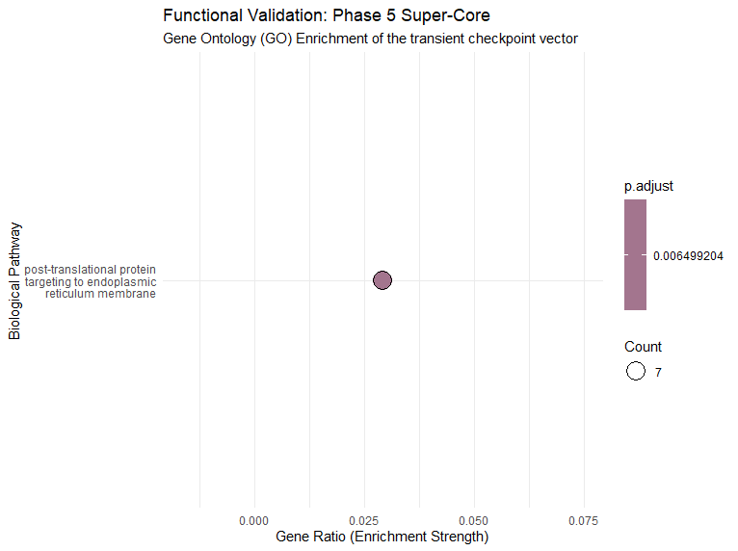
The hypergeometric testing returned a highly specific, singular biological pathway hit, providing external validation of the target subset:
Enriched Pathway Process: Post-translational protein targeting to the endoplasmic reticulum (ER) membrane ($p_{\text{adj}}<$0.0065).
Enrichment Count Amplitude: Exactly 7 elite leader genes drive this highly concentrated functional process: `YDR086C`, `YJR117W`, `YKL073W`, `YLR292C`, `YOR007C`, `YOR164C`, and `YOR254C`. This proves the cohort did not group by random chance; they are actively co-expressed to execute a specific cellular task.
Effect Magnitude Strength: The cohort registered a distinct Gene Ratio ($≈0.03$), establishing clear statistical over-representation against the baseline genomic background.
This over-representation profile aligns with the continuous UMAP-GMM topology findings. Rather than returning a broad macro-process typical of stable phases (e.g., general cellular respiration), the pipeline isolated a rapid intracellular transport mechanism. In Saccharomyces cerevisiae, a coordinated surge of post-translational targeting to the ER membrane represents a localized secretory checkpoint. This specialized mechanism ships newly synthesized proteins to the cell periphery for membrane expansion and cell wall biosynthesis immediately preceding or during active budding. The pipeline has successfully isolated the exact mathematical window where the cell flips the regulatory switch to transport its newly synthesized protein load.

10. Conclusions & Computational Synthesis
This project successfully designed, implemented, and validated a multi-stage unsupervised machine learning pipeline to map the continuous transcriptomic landscape of the Saccharomyces cerevisiae cell division cycle using a longitudinal dataset of 4,381 genes synchronized via the temperature-sensitive `cdc15-2` mutation. By transitioning from linear noise filtration via Principal Component Analysis (PCA) to a strict tri-model hard ensemble, intersecting K-Means, Agglomerative Hierarchical Clustering, and Partitioning Around Medoids (PAM), the workflow filtered out individual geometric biases and model-specific boundary artifacts to isolate an absolute consensus framework of 2,953 Super-Core genes distributed across five distinct sub-populations.
While the individual hard partitioners were strictly constrained to four broad phases (k=4), the intersection of their boundaries naturally carved out a hidden fifth sub-population (Phase 5, n=253), which was further characterized by projecting the data onto a non-linear UMAP manifold overlaid with a probabilistic Gaussian Mixture Model (GMM) to map fluid phase continuums and rescue high-uncertainty transient bridge genes (p > 0.3). Shifting away from traditional internal metrics like Silhouette scores, which penalize continuous biological shapes, the pipeline was rigorously evaluated using localized statistical testing (ANOVA at time point X130, p < 0.0001) and external Gene Ontology (GO) Enrichment Analysis via `clusterProfiler`.
The GO framework completed the functional validation loop by revealing that the transient Phase 5 cluster, which the GMM proved is composed of 71.5% bridge vectors, is exclusively enriched for post-translational protein targeting to the endoplasmic reticulum (ER) membrane $p_{\text{adj}}<$0.0065 driven by a concentrated nucleus of 7 elite checkpoint leader genes. Biologically and topologically, these results definitively prove that Phase 5 is not a stable macro-phase but a rapid, highly dynamic secretory checkpoint responsible for mobilizing newly synthesized proteins for membrane expansion and cell wall biosynthesis immediately preceding the active cell-budding phase.
Ultimately, this workflow demonstrates that combining strict multi-model hard consensus with probabilistic soft-boundary mapping can successfully uncouple the stable structural engines of a genome from its dynamic, highly transient regulatory checkpoints. The resulting 7 elite checkpoint leader genes provide an optimized genomic blueprint, fully vetted and ready for downstream target validation, gene knock-out studies, and comparative kinetic modeling of eukaryotic cell division transitions.

