Molecular Activity Prediction using MACCS Fingerprints

📌 Objective
The goal of this project is to predict the biological activity of molecules against a specific target enzyme using Machine Learning. Molecules are represented via MACCS structural fingerprints (167-bit binary arrays), and the task is a multi-class classification problem: Not Active (0), Weakly Active (1), and Strongly Active (2).

🧬 Domain Context & Explainable AI (ILP)
In Chemoinformatics, high-dimensional binary representations (like MACCS keys) map physical sub-structures to digital formats. This project was designed with **Explainable AI** and **Inductive Logic Programming (ILP)** principles in mind. Rather than relying solely on black-box predictions, the feature selection pipeline (using Rule Mining) extracts human-readable rules (e.g., "If substructure X is present, activity is strong") to directly support future drug design and chemical synthesis.

📊 Exploratory Data Analysis (EDA)
The initial dataset of 2,594 molecules exhibited a severe class imbalance, which is common in early-stage drug discovery:
* **Not Active (0):** 58%
* **Weakly Active (1):** 26%
* **Strongly Active (2):** 16%

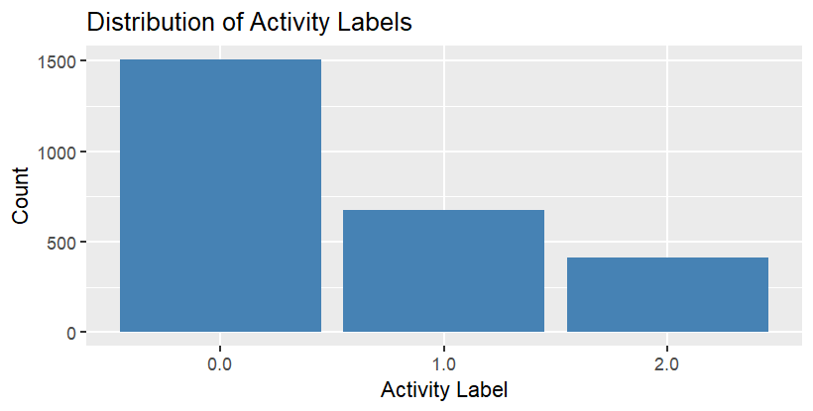
A heatmap of the MACCS features revealed strong correlations among specific structural fingerprints, indicating the need for aggressive dimensionality reduction.

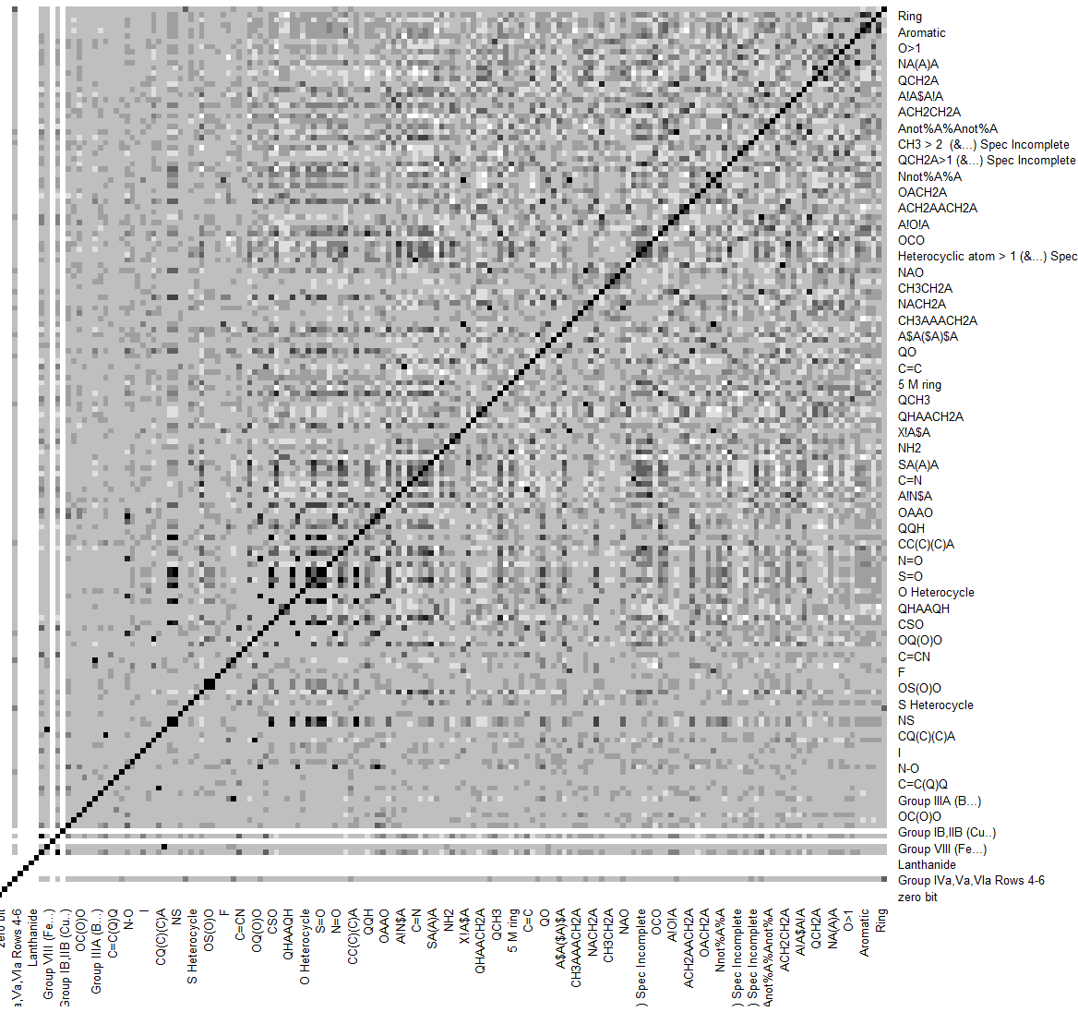

🚧 Challenges & Technical Limitations
A significant challenge in this project was the nature of the data: **167-dimensional, purely binary arrays.** * **Failure of Traditional Distance Metrics:** Algorithms relying on Euclidean distance (like K-Means, PCA, and MCA) failed to capture meaningful variance.
* **Clustering Roadblocks:** Hierarchical Clustering, K-Medoids (PAM), Spectral Clustering, and DBSCAN were tested. However, silhouette scores and elbow methods (WSS) demonstrated that continuous-distance algorithms struggle to separate sparse binary data effectively.

*Note: PCA scatterplots and PAM clustering outputs are available in the `assets/` folder, documenting these structural data limitations.*

🛠️ Data Engineering & Feature Selection Strategy
Because standard clustering failed, a multi-method **Consensus Feature Selection** approach was engineered to extract the most critical substructures:
1. **Statistical Testing**
2. **Association Rule Mining** (Apriori)
3. **Random Forest Feature Importance**
4. **Mutual Information** (Information Gain)

Features were ranked by how frequently they appeared across all four methods.

⚙️ Iterative Modeling & Evaluation
To address the class imbalance, a custom stratified sampling approach was applied (combining oversampling of the minority class and undersampling of the majority class).

**The "10 vs. 20 Features" Experiment:**
Initial models trained strictly on the top 10 consensus features underperformed. The pipeline was iteratively adjusted to expand the feature space to the top 20 features, which significantly improved the models' ability to detect the "Strongly Active" minority class. Models were evaluated using balanced F1-Score and ROC-AUC.

| Model | Accuracy | Precision | Recall | F1-Score | ROC-AUC |
| :--- | :---: | :---: | :---: | :---: | :---: |
| **Linear Baseline** | 16.02% | 12.37% | 33.40% | 15.28% | 51.96% |
| **Random Forest** | 56.56% | 51.34% | 52.95% | 51.83% | 69.96% |
| **XGBoost** | 53.86% | 50.93% | 55.36% | 51.35% | 71.65% |
| **SVM (Top Performer)**| **56.95%** | **51.91%** | **53.72%** | **52.53%** | **70.71%** |

*A Stacking Ensemble (combining RF, XGBoost, SVM, Decision Trees, and Neural Networks) was also engineered, though it introduced computational complexity with marginal gains over the tuned SVM.*

🚀 Future Enhancements
Based on the current pipeline's performance, the following roadmap is proposed for future iterations:
1. **Polynomial Feature Interactions:** Engineering new features that capture how existing MACCS bits interact or combine logically.
2. **Hyperparameter Optimization:** Implementing systematic Bayesian Optimization or Grid Search within a cross-validation framework for the SVM and XGBoost models.
3. **Probabilistic Stacking:** Transitioning the Stacking Ensemble from hard-voting (class labels) to soft-voting (probability scores) to improve predictive flexibility.

📁 Repository Structure
* `/assets` - Visualizations, PCA scree plots, clustering evaluations, and heatmaps.
* `/data` - Raw and processed molecular datasets.
* `/scripts`
* `01_data_cleaning_and_eda.R` - Data ingestion, missing value checks, and EDA.
* `02_feature_selection.R` - Multi-method consensus feature extraction.
* `03_model_training.R` - Data balancing and pipeline for SVM, XGBoost, RF, and Ensembles.
* `04_model_evaluation.R` - Model inference and metric generation.
* `Project_Presentation.pdf` - High-level slide deck summarizing methodology and conclusions.

