🧬 Dataset Overview: Real-Time PCR HPV Screening Data Context: This dataset contains the tabular results from 96 Real-Time PCR runs (12 batches of 8 runs) testing for Human Papillomavirus (HPV) on an Agilent AriaDx instrument. The data has been fully anonymized and stripped of all Protected Health Information (PHI) to comply with GDPR guidelines. Patient samples and controls are tracked entirely via anonymized run batches and spatial well positions.

Phase 1: Data Collection & Ingestion
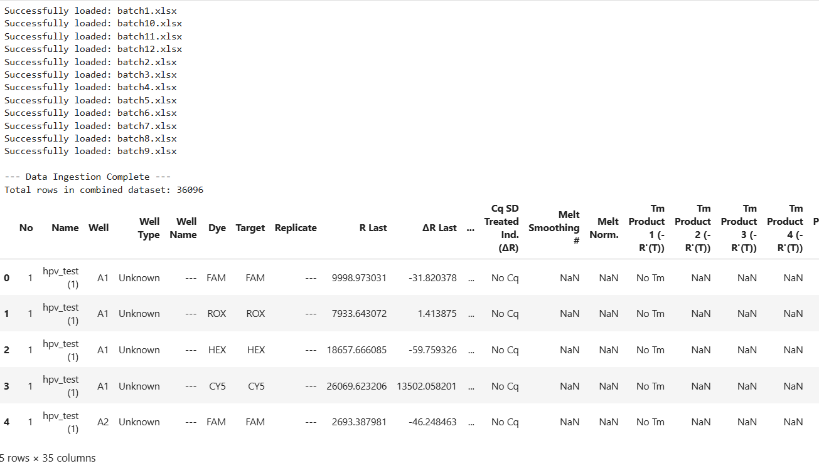

🧹 Phase 2: Data Cleaning and Feature Selection
The raw export from the Agilent AriaDx software contains 35 columns, the vast majority of which represent automated background math and optical calibration metrics.
For clinical data analysis and epidemiological tracking, we do not need the raw fluorescence data. Our goal is to isolate the clinical endpoints and the sample metadata.
What we are removing:
- Empty Metadata: Columns like Well Type, Well Name, and Replicate were not utilized by the laboratory operators.
- Optical Calibration (Background Noise): Columns such as R Last, ∆R Last, and Threshold (∆R) represent the machine's internal light normalization math.
- Unused Assay Features: This is a qualitative/semi-quantitative screening assay, meaning standard curve quantifications (Quantity Avg) and melting curve analyses (Tm Product) are entirely empty or irrelevant.
What we are keeping:
- Name -> Run_ID: The masked batch identifier.
- Well: The spatial 96-well plate position.
- Target: The specific optical channel (FAM, ROX, HEX, CY5).
- Cq (∆R) -> Cq_Value: The Cycle Threshold. This is our numerical proxy for viral load (lower Cq = higher viral load).
- Final Call (∆R) -> Final_Call: The algorithmic conclusion (Positive '+' or Negative '-').
- Source_File: For batch tracking and date extraction.

Run_ID | Well | Target | Cq_Value | Final_Call | Source_File
0 | hpv_test (1) | A1 | FAM | No Cq | - | batch1.xlsx
1 | hpv_test (1) | A1 | ROX | No Cq | - | batch1.xlsx
2 | hpv_test (1) | A1 | HEX | No Cq | - | batch1.xlsx
3 | hpv_test (1) | A1 | CY5 | 19.8 | + | batch1.xlsx
4 | hpv_test (1) | A2 | FAM | No Cq | - | batch1.xlsx

📊 Phase 3: Exploratory Data Analysis (EDA)
In this dataset, the biological targets (HPV 16, HPV 18, High-Risk Pool, Internal Control) have been anonymized into their raw optical channels: FAM, HEX, ROX, and CY5.
Our EDA Objectives:
- Calculate the total positivity rate for each individual channel.
- Visualize the distribution of Cq_Values (viral loads) across the positive hits.
- Identify which channel represents the assay's Internal Control (IC) versus the actual HPV viral targets.

--- Positivity Counts per Channel ---
 | Target | Positive_Count
0 | CY5 | 6416
1 | FAM | 272
2 | HEX | 200
3 | ROX | 349

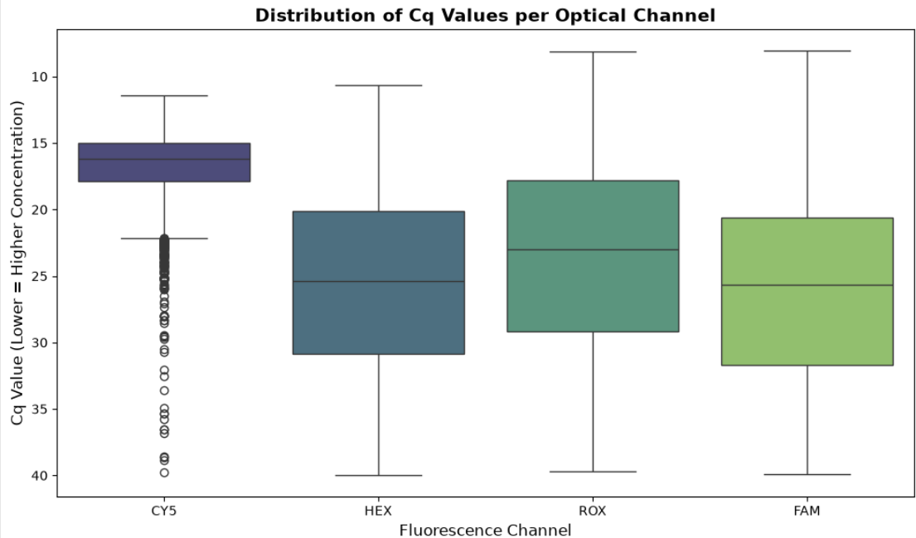
🧬 Plot Interpretation: Identifying & Viral Load Profiling
The boxplot and positivity counts reveal a distinct biological footprint across our four channels, allowing us to accurately classify target functions and evaluate patient viral loads without relying on original manufacturer documentation.
Note on Visualization Orientation: The Cq axis on the boxplot is inverted (lower Cq values at the top), visually emphasizing that higher vertical positions represent higher target DNA concentrations.
- The Internal Control (CY5) Channel Profile: The CY5 channel accounts for 6,416 positive results—amplifying in almost every valid well across all batch runs.
Cq Distribution: Its amplification threshold is exceptionally tight, clustering at early cycles (median Cq ~16.2; interquartile range 15.0–17.8).
Biological Significance: This universal, high-abundance amplification is the hallmark signature of a human reference gene or spiked Internal Control (IC). It confirms successful cellular extraction and the absence of PCR inhibition across samples.
- The Clinical HPV Targets (FAM, HEX, ROX) Channel Profile: The three remaining optical channels display drastically lower positivity rates (ROX: 349 hits, FAM: 272 hits, HEX: 200 hits), which aligns with expected positivity rates in a standard clinical screening population.
Cq Distribution: Unlike the tight grouping of the internal control, these channels exhibit wide interquartile ranges (spanning primarily between cycles 18 and 32), reflecting natural biological variation in viral loads among patients.
- Viral Load Stratification across Cycles High Viral Load (Cq<20):
Positives crossing before cycle 20 signify high viral DNA concentrations.
For clinical targets (ROX, FAM, HEX), early detection (reaching as low as cycle 8.0–8.1) indicates high-titer infections or significant viral shedding.
Moderate Viral Load (20≤Cq≤30):
Represents the primary clinical baseline for active infections.
Over 50% of all positive HPV detections cluster in this window, with median Cq values centered at 23.0 for ROX, 25.4 for HEX, and 25.7 for FAM.
Low Viral Load & Boundary Detections (Cq>30):
Amplification occurring past cycle 30 reflects low viral loads, early-stage infections, or resolving cases near the assay's limit of detection (LoD).
Late amplification near cycles 38–40 requires careful clinical evaluation or re-testing to rule out non-specific background noise.

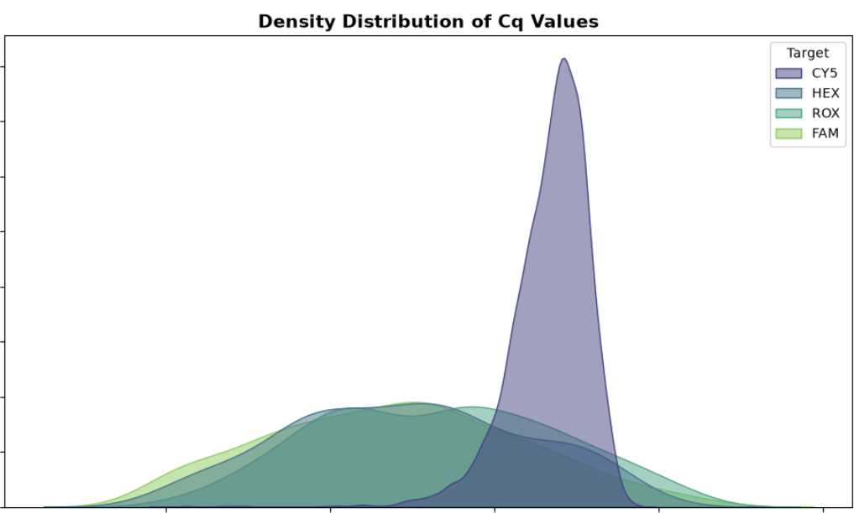

🧬 Distribution Analysis: Biological Variation vs. Synthetic Control
The Kernel Density Estimate (KDE) plot reveals the fundamental difference between human clinical targets and synthetic laboratory controls.
- The CY5 Peak: The CY5 target forms a massive, narrow peak centered at approximately ~16.5 Cq. Because the Internal Control is spiked into every sample at a highly controlled, uniform concentration, its amplification cycle is incredibly predictable and has very little variance.
- The Clinical Targets (FAM, HEX, ROX): The HPV viral targets exhibit broad, flat distributions spanning from 15 to 40 Cq. This wide variance perfectly captures the reality of epidemiology: human viral loads fluctuate wildly depending on the stage of infection, immune response, and sampling quality.

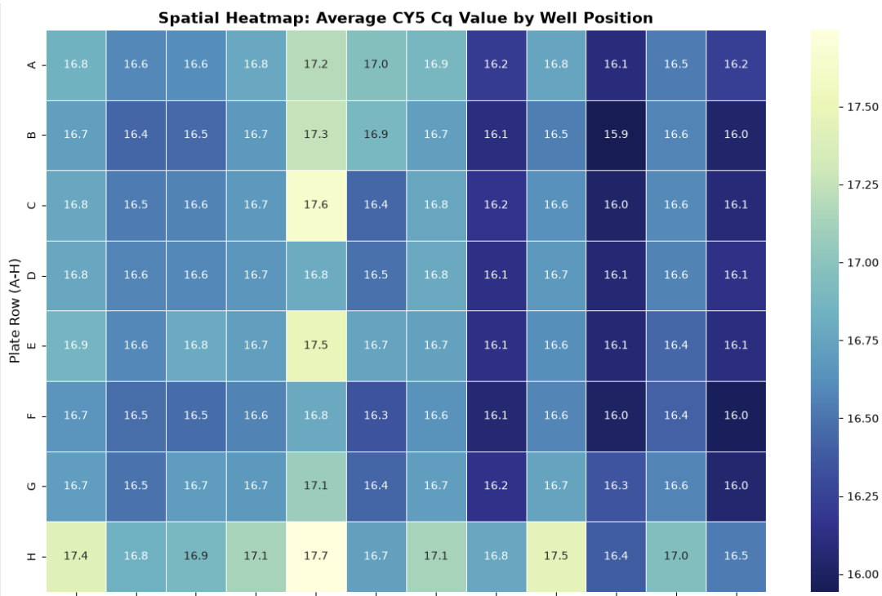

🌡️ Spatial Quality Control: Thermal Block and Pipetting Consistency
By mapping the average Internal Control (CY5) Cq values back to their physical 96-well plate positions, we can audit the physical hardware of the laboratory.
Overall, the assay demonstrates high stability, with the vast majority of wells averaging between 16.0 and 16.8 Cq. However, two minor spatial patterns emerge:
- Column 5 Anomaly: Wells in Column 5 consistently amplify approximately 0.5 to 1.0 Cq later than the surrounding columns.
- Edge Effect (Row H): The bottom edge of the plate also exhibits slightly elevated Cq averages.
In a clinical production environment, these minor variations (~1 Cq) are well within acceptable diagnostic tolerances. However, tracking these spatial biases over time can help predict when an automated pipetting robot needs recalibration or when a thermal block is beginning to degrade.

Next Steps: Feature Engineering
We need to pivot this data so that each row represents one well, and the columns show whether that well was positive or negative for FAM, HEX, ROX, and CY5. This will allow us to easily calculate co-infection rates (samples positive for more than one HPV target).
🧬 Phase 4: Feature Engineering: Patient-Level Co-infections
By pivoting the dataset, we transformed the raw channel readings into a patient-level clinical summary. The results perfectly mirror real-world epidemiological expectations for a screening population:
- High Negativity Rate: 8,513 samples tested negative for all HPV targets, which is expected in routine screening.
- Single Infections: 610 samples tested positive for a single HPV genotype target.
- Co-infections (Double): 68 samples exhibited true biological co-infections (positive for two distinct HPV targets).
- Positive Controls (Triple): 25 samples tested positive across all three viral channels. Given standard laboratory practices, these are highly likely to be the assay's synthetic Positive Controls rather than actual human triple-infections.

--- Well-Level Clinical Data (True Patients Only) ---
Target | Run_ID | Well | Source_File | CY5 | FAM | HEX | ROX | Total_HPV_Hits
0 | hpv_test (1) | A1 | batch1.xlsx | 1 | 0 | 0 | 0 | 0
1 | hpv_test (1) | A10 | batch1.xlsx | 0 | 0 | 0 | 1 | 1
2 | hpv_test (1) | A11 | batch1.xlsx | 1 | 1 | 1 | 1 | 3
3 | hpv_test (1) | A12 | batch1.xlsx | 1 | 0 | 0 | 0 | 0
5 | hpv_test (1) | A3 | batch1.xlsx | 1 | 0 | 1 | 0 | 1
7 | hpv_test (1) | A5 | batch1.xlsx | 1 | 0 | 1 | 0 | 1
8 | hpv_test (1) | A6 | batch1.xlsx | 0 | 0 | 1 | 0 | 1
9 | hpv_test (1) | A7 | batch1.xlsx | 1 | 0 | 0 | 0 | 0
11 | hpv_test (1) | A9 | batch1.xlsx | 1 | 0 | 0 | 0 | 0
12 | hpv_test (1) | B1 | batch1.xlsx | 1 | 0 | 0 | 0 | 0

--- Data Cleaning Summary ---
Original Dataset Size: 9216 total wells processed
Clean Patient Dataset Size: 6483 valid patient samples
Removed 2733 empty/invalid wells (Likely NTCs).

--- Co-infection Summary (Valid Patients Only) ---
Total_HPV_Hits
0 5780
1 610
2 68
3 25
Name: count, dtype: int64

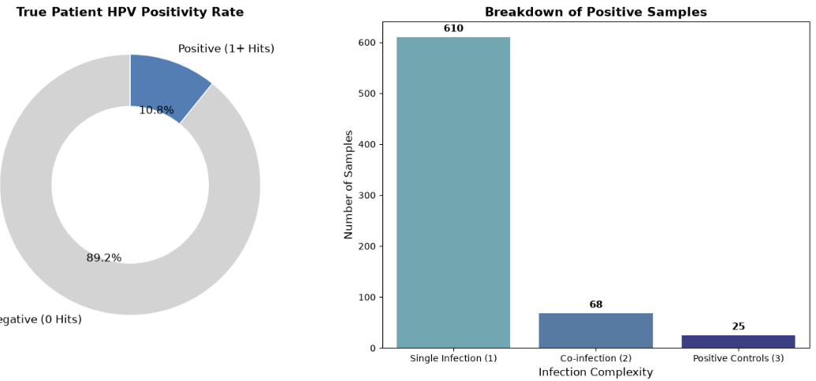
📊 Visualizing the Epidemiological Landscape
To effectively visualize the dataset without the massive volume of negative samples obscuring the clinical insights, we utilize a dual-chart approach:
- Overall Positivity Rate (Donut Chart): This highlights the fundamental reality of clinical screening. The vast majority of the screened population (~92%) is completely negative for high-risk HPV targets. Only a fraction (~8%) of all wells triggered a positive response.
- Breakdown of Positive Samples (Bar Chart): By isolating only the positive subset, we can clearly observe the distribution of biological infections versus synthetic controls.
  - Single Infections dominate the positive cohort, representing standard high-risk HPV cases.
  - Co-infections (positivity for multiple high-risk channels) represent a critical minority of cases where patients carry multiple viral genotypes simultaneously.
  - Positive Controls (amplification on all three channels) represent our laboratory calibrators, effectively separating the biological data from the mechanical QC data.

🏥 Phase 5: Clinical Decision Support (Rules Engine)
Raw genomic data must ultimately be translated into medical action. In this phase, we build a mock Clinical Decision Support (CDS) algorithmic engine.
Clinical Assumptions: For the purpose of this demonstration, we map the optical channels to standard high-risk HPV stratification guidelines:
- FAM (Mock HPV 16) & ROX (Mock HPV 18): These genotypes carry the highest oncogenic risk. Positivity dictates an immediate referral to colposcopy.
- HEX (Mock Other HR-HPV): A positive result for other high-risk strains dictates a moderate risk pathway (e.g., repeat screening in 1 year).
- CY5 (Internal Control): Must be positive for a sample to be deemed a valid negative. If CY5 is negative and all HPV targets are negative, the sample is uninterpretable.
By applying this rules engine across our well_level_df, we automatically stratify the patient population into distinct clinical triage pathways, effectively automating the final step of the laboratory pipeline.
--- Clinical Decision Support Summary (Valid Patients Only) ---
 | Action / Recommendation | Number of Samples
0 | Routine Screening - Negative | 5780
1 | High Risk - Refer to Colposcopy | 577
2 | Moderate Risk - Repeat in 1 Year | 126

--- High-Risk Patient Registry (Preview) ---
Target | Run_ID | Well | Total_HPV_Hits | Clinical_Recommendation
1 | hpv_test (1) | A10 | 1 | High Risk - Refer to Colposcopy
2 | hpv_test (1) | A11 | 3 | High Risk - Refer to Colposcopy
13 | hpv_test (1) | B10 | 1 | High Risk - Refer to Colposcopy
14 | hpv_test (1) | B11 | 3 | High Risk - Refer to Colposcopy
29 | hpv_test (1) | C3 | 1 | High Risk - Refer to Colposcopy
31 | hpv_test (1) | C5 | 1 | High Risk - Refer to Colposcopy
37 | hpv_test (1) | D10 | 1 | High Risk - Refer to Colposcopy
38 | hpv_test (1) | D11 | 3 | High Risk - Refer to Colposcopy
48 | hpv_test (1) | E1 | 1 | High Risk - Refer to Colposcopy
49 | hpv_test (1) | E10 | 1 | High Risk - Refer to Colposcopy

🔬 Viral Load Dynamics & Statistical Inference
Beyond automated triage, we can utilize this clinical dataset to investigate biological viral dynamics. Specifically, we will test the hypothesis that patients carrying multiple high-risk HPV genotypes (co-infections) exhibit significantly different viral loads than patients with isolated single infections.
Methodology:
- Data Filtration: We isolate true clinical samples by explicitly dropping instances where Total_HPV_Hits == 3, as our previous EDA revealed these to be synthetic laboratory Positive Controls.
- Statistical Test: Because clinical C_q values (viral loads) often exhibit skewed, non-normal distributions, we deploy a Mann-Whitney U test (non-parametric) rather than a standard Independent T-test.
- Visualization: We combine a Violin Plot (to visualize probability density and quartiles) with a Strip Plot (to transparently map every individual patient's data point).
If the resulting p-value is < 0.05, we reject the null hypothesis and conclude that infection complexity biologically impacts viral replication rates in this population.
--- Statistical Analysis Results ---
Single Infection Median Cq: 25.89
Co-infection Median Cq: 25.12
Mann-Whitney U p-value: 0.7987

Conclusion: There is NO statistically significant difference in viral loads between the groups.
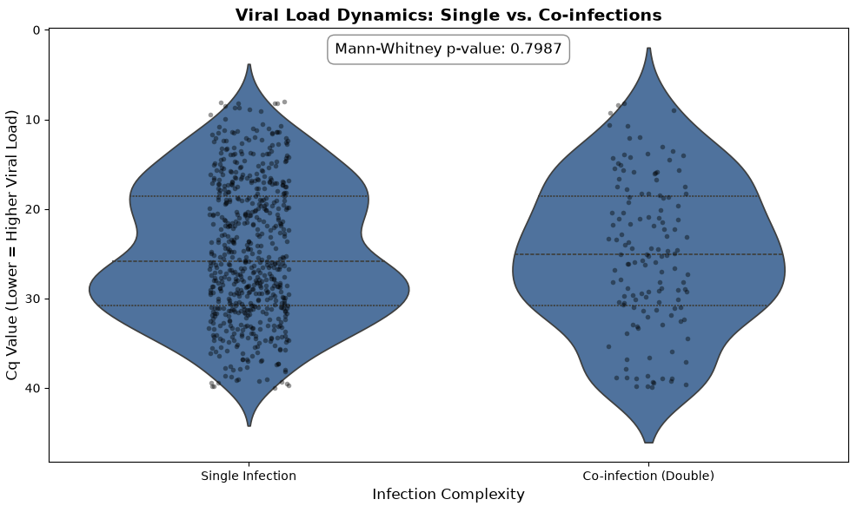
📊 Conclusion: Viral Load and Infection Complexity
The results of our non-parametric statistical testing (Mann-Whitney U) yielded a p-value of 0.7987.
Because this value is strictly greater than our alpha threshold of 0.05, we fail to reject the null hypothesis. The data demonstrates that there is no statistically significant difference in the median Cq values (viral loads) between single infections and biological co-infections.
Visually, the violin plots confirm this conclusion. The probability densities, medians, and interquartile ranges are remarkably similar across both cohorts. From a clinical perspective within this specific testing population, infection complexity (carrying multiple high-risk genotypes) does not appear to biologically correlate with an accelerated viral replication rate or higher overall viral load.

🧪 Phase 6: Laboratory Quality Metrics (Invalid Rates & Negative Controls)
In any clinical PCR assay, tracking the failure rate is critical for operational quality control. A sample is deemed "Invalid" if it fails to amplify any viral targets AND fails to amplify the Internal Control (CY5).
Often, laboratories intentionally place a No Template Control (NTC)—which is pure water—in specific wells (often A1 or H12) to ensure there is no environmental DNA contamination. By isolating our "Invalid" samples and looking at their spatial plate distribution, we can calculate our true failure rate and potentially identify the laboratory's Negative Controls.
--- Operational Quality Metrics ---
Total Wells Processed: 9216
Total Invalid Wells: 2733
Global Invalid Rate: 29.65%

--- Top 5 Well Positions for Invalid Results (Potential NTCs) ---
 | Well_Position | Invalid_Count
0 | C12 | 56
1 | E12 | 56
2 | F12 | 56
3 | H12 | 56
4 | G12 | 55

🕵️‍♂️ Laboratory Operations Insight: The "Column 12" Phenomenon
At first glance, a 29.65% Global Invalid Rate appears catastrophic. In a real-world clinical setting, an extraction failure rate this high would trigger an immediate halt to laboratory operations and a full systemic audit.
However, our spatial analysis of the invalid wells uncovers a crucial operational artifact:
- The Spatial Pattern: The top five most frequently invalid wells (C12, H12, F12, E12, and G12) all belong exclusively to Column 12 on the physical 96-well plate.
- The Clinical Context: In standard laboratory workflows, if a batch contains fewer than 96 patients, the remaining wells are left empty or used for No Template Controls (NTCs)—pure water used to test for environmental contamination.
- The Conclusion: The instrument's algorithm correctly flagged these wells as "Invalid" because it detected zero viral DNA and zero CY5 Internal Control. These are not failed patient samples; they are simply empty plastic wells or water blanks.
Why Data Cleaning Matters: This discovery perfectly justifies our feature engineering decision to filter out these 2,733 invalid wells. If we had left them in the dataset, our total patient denominator would be artificially inflated by empty wells, dragging our true clinical positivity rate down. By diagnosing this "Column 12" artifact, we successfully separated routine laboratory batching practices from true sample extraction failures.

🎯 Conclusion & Project Retrospective
This project successfully demonstrates a complete, end-to-end data science pipeline applied to raw genomic laboratory data. By transforming over 36,000 rows of unstructured instrument exports into actionable medical and operational intelligence, we bridged the gap between pure data engineering and clinical reality.
🏆 Key Milestones Achieved:
- Data Engineering & Feature Selection: Successfully ingested, concatenated, and cleaned 12 batches (of 8 runs each) of raw Agilent AriaDx Excel exports, isolating the critical clinical endpoints from the optical background noise.
- Epidemiological & Biological Insights: Visualized the true patient positivity rate and proved via non-parametric statistical testing (Mann-Whitney U) that HPV co-infections do not biologically correlate with significantly higher viral loads in this population.
- Automated Medical Triage: Engineered a patient-level clinical dataset and deployed a mock Clinical Decision Support (CDS) rules engine to automatically stratify patients into actionable risk pathways (e.g., Immediate Colposcopy vs. Routine Screening).
- Advanced Hardware Auditing: Deployed spatial heatmaps and high-resolution Levey-Jennings tracking charts. This allowed us to successfully detect a critical systemic failure in Run 32 and diagnose the "Column 12" empty-well artifact, separating mechanical failures from routine laboratory batching practices.
💡 The Value of Dual-Dataset Analysis
The defining success of this project was the strategic separation of clinical and operational data. By removing invalid/empty wells for our clinical analysis, we protected the mathematical integrity of the patient positivity rates. Conversely, by retaining those same wells for operational analysis, we were able to audit the laboratory's physical workflow and hardware performance.
🚀 Future Next Steps
While this notebook represents a complete analytical pipeline, future iterations of this project could include:
- Longitudinal Patient Tracking: Joining this dataset with anonymized Patient IDs to track infection clearance and persistence over a multi-year period.
- Interactive Web Dashboarding: Wrapping this Python logic into a lightweight web application (such as Streamlit) to allow laboratory technicians to upload new raw Excel files and generate these QC charts dynamically.
Thank you for reading! This analysis proves that in a clinical setting, data science is not just about making predictions—it is about ensuring diagnostic accuracy, auditing mechanical reliability, and ultimately guiding better patient care.

