Data Appendix

Jakub Lassak
Exercise 1 – TIER protocol and tidy data

During the exercises, I transformed the original billboard.csv data into tidy data using TIER protocol. The results obtained are large tables, so I will present only a sample of each of the results obtained.
A sample of the data received in the songData.csv file:
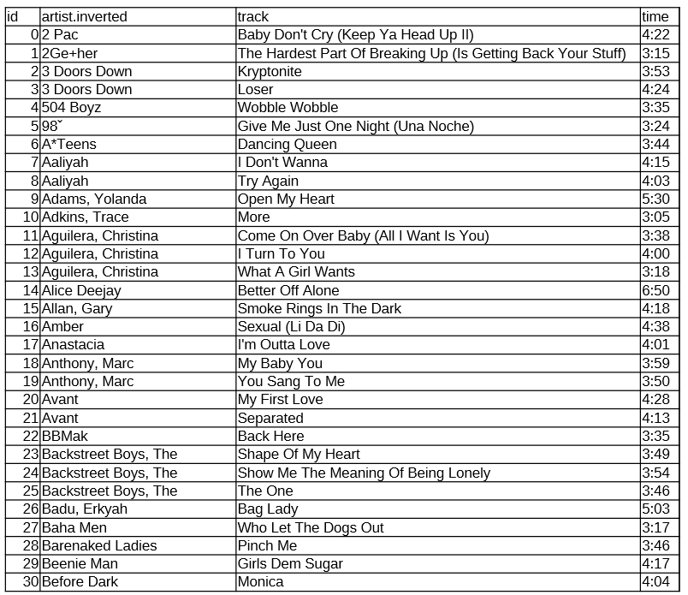

A sample of the data received in the rankingData.csv file:
