**Scenario**

You need to build a web application to add and list property details. The application interface should look like this:

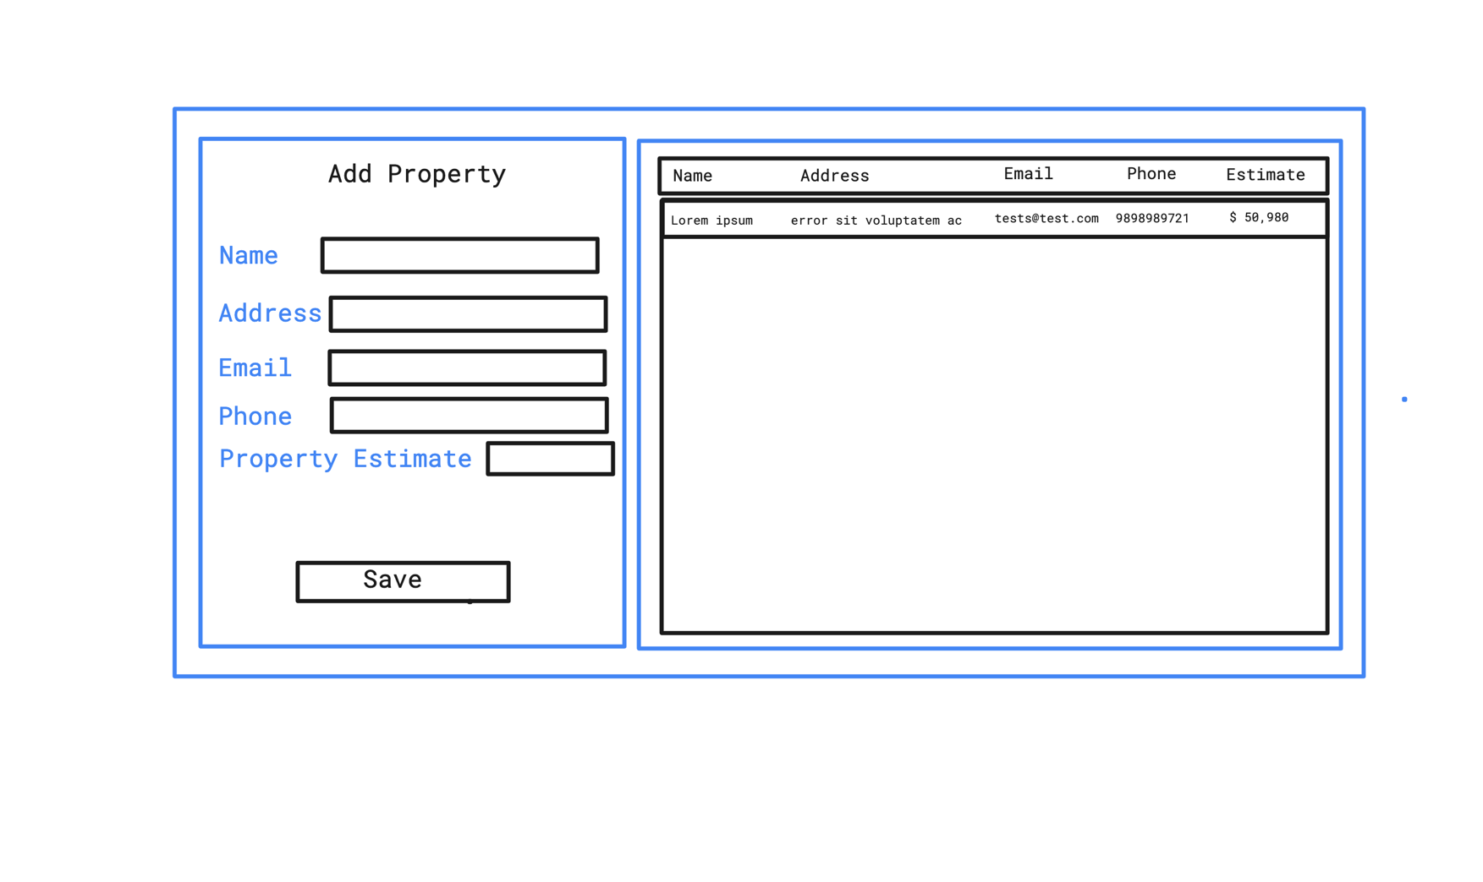

* The left panel is to add property details.
  + All the fields are mandatory
  + You should validate user inputs
* Right panel should list all the properties already loaded and the ones added from the left panel
* No need of a login page
* When the page is loaded, properties already in the DB should be listed
* Upon adding a new property (save button), it should immediately populate on the right panel
* No need to have a fancy UI
* Users should have a unique email and phone number,
* You need to implement an “update property” API endpoint, but no need to implement the UI for it. We’ll test that with postman. With the update API, all these 5 fields should be able to modify (you can decide what should be the primary key)
* Similarly search API endpoint – only search by name. Users should be able to search by a portion of the name, and case insensitive (i.e. Robert, rob, BERT, ObeR etc). Again just the endpoint, we’ll test using postman
* No need to delete a property

**Implementation**

Use any RDMS you like (i.e. MySql, PostgreSql)

Design a REST API and implement with .NET core latest

Frontend should be in Angular 13

*Bonus – Try dockerize :-D*

**Evaluation**

* We are not going to evaluate styling of the UI, but whether you’ve grasped the core concepts of Angular including widely used data loading methods
* How you have designed the REST API
  + REST API best practices
  + Backend architecture
  + Usage of a relevant ORM
* DB design, any performance improvements