**20CYS404**

Android Application Development

Lab Exam

V. Jayaraj

21026

**Qn - 1**

**Aim:**

To develop a Company Details App with connection to SQLite and Firebase

**Code:**

**Activity.xml**

<?xml version="1.0" encoding="utf-8"?>

<LinearLayout xmlns:android="http://schemas.android.com/apk/res/android"

xmlns:app="http://schemas.android.com/apk/res-auto"

xmlns:tools="http://schemas.android.com/tools"

android:layout_width="match_parent"

android:layout_height="match_parent"

android:orientation="vertical"

android:padding="16dp"

tools:context=".MainActivity">

<ImageView

android:id="@+id/amrita"

android:layout_width="match_parent"

android:layout_height="50dp"

android:layout_gravity="center"

android:contentDescription="Company Image"

android:src="@drawable/amrita" />

<TextView

android:layout_width="wrap_content"

android:layout_marginTop="10dp"

android:layout_height="wrap_content"

android:text="Jayaraj - 21026"/>

<ImageView

android:id="@+id/companyImage"

android:layout_width="match_parent"

android:layout_height="300dp"

android:layout_gravity="center"

android:contentDescription="Company Image"

android:src="@drawable/img" />

<EditText

android:id="@+id/companyName"

android:layout_width="match_parent"

android:layout_height="wrap_content"

android:hint="Company Name"

android:background="@drawable/edit_text_background"

android:padding="10dp" />

<EditText

android:id="@+id/description"

android:layout_marginTop="10dp"

android:layout_width="match_parent"

android:layout_height="wrap_content"

android:hint="Description"

android:background="@drawable/edit_text_background"

android:padding="10dp" />

<EditText

android:id="@+id/foundedDate"

android:layout_marginTop="10dp"

android:layout_width="match_parent"

android:layout_height="wrap_content"

android:hint="Founded Date"

android:background="@drawable/edit_text_background"

android:padding="10dp" />

<Button

android:id="@+id/saveButton"

android:layout_width="match_parent"

android:layout_height="wrap_content"

android:layout_marginTop="10dp"

android:text="Save"

android:background="@color/colorPrimary"

android:textColor="@android:color/white" />

<Button

android:id="@+id/searchButton"

android:layout_marginTop="20dp"

android:layout_width="match_parent"

android:layout_height="wrap_content"

android:text="Search Companies"

android:background="@color/colorAccent"

android:textColor="@android:color/white" />

<androidx.recyclerview.widget.RecyclerView

android:id="@+id/recyclerView"

android:layout_width="match_parent"

android:layout_height="wrap_content"

android:paddingTop="8dp"

android:nestedScrollingEnabled="false" />

</LinearLayout>

**AndroidManifest.xml**

<?xml version="1.0" encoding="utf-8"?>

<manifest xmlns:android="http://schemas.android.com/apk/res/android"

xmlns:tools="http://schemas.android.com/tools">

<uses-permission android:name="android.permission.INTERNET" />

<uses-permission android:name="android.permission.ACCESS_NETWORK_STATE" />

<application

android:allowBackup="true"

android:dataExtractionRules="@xml/data_extraction_rules"

android:fullBackupContent="@xml/backup_rules"

android:icon="@mipmap/ic_launcher"

android:label="@string/app_name"

android:roundIcon="@mipmap/ic_launcher_round"

android:supportsRtl="true"

android:theme="@style/Theme.CompanyDetails"

tools:targetApi="31">

<activity

android:name=".MainActivity"

android:exported="true">

<intent-filter>

<action android:name="android.intent.action.MAIN" />

<category android:name="android.intent.category.LAUNCHER" />

</intent-filter>

</activity>

<activity

android:name=".CompanyListActivity"

android:exported="true">

</activity>

</application>

</manifest>

**MainActivity.java**  
package com.example.companydetails;

import android.content.Intent;

import android.os.Bundle;

import android.widget.Button;

import android.widget.EditText;

import android.widget.Toast;

import androidx.appcompat.app.AppCompatActivity;

import com.google.firebase.FirebaseApp;

public class MainActivity extends AppCompatActivity {

EditText companyName, description, foundedDate;

Button saveButton, searchButton;

DatabaseHelper myDb;

FirebaseHelper firebaseHelper;

@Override

protected void onCreate(Bundle savedInstanceState) {

super.onCreate(savedInstanceState);

FirebaseApp.initializeApp(this);

setContentView(R.layout.activity_main);

companyName = findViewById(R.id.companyName);

description = findViewById(R.id.description);

foundedDate = findViewById(R.id.foundedDate);

saveButton = findViewById(R.id.saveButton);

searchButton = findViewById(R.id.searchButton);

myDb = new DatabaseHelper(this);

firebaseHelper = new FirebaseHelper();

saveButton.setOnClickListener(v -> {

String name = companyName.getText().toString();

String desc = description.getText().toString();

String date = foundedDate.getText().toString();

if (!name.isEmpty() && !desc.isEmpty() && !date.isEmpty()) {

myDb.insertData(name, desc, date);

firebaseHelper.saveCompanyToFirebase(new Company(name, desc, date));

Toast.makeText(MainActivity.this, "Company Saved", Toast.LENGTH_SHORT).show();

// Navigate to CompanyListActivity

Intent intent = new Intent(MainActivity.this, CompanyListActivity.class);

startActivity(intent);

} else {

Toast.makeText(MainActivity.this, "Please fill all fields", Toast.LENGTH_SHORT).show();

}

});

searchButton.setOnClickListener(v -> {

Intent intent = new Intent(MainActivity.this, CompanyListActivity.class);

startActivity(intent);

});

}

}

**CompanyList.java**

package com.example.companydetails;

import android.content.Intent;

import android.database.Cursor;

import android.os.Bundle;

import android.util.Log;

import android.view.Menu;

import android.view.MenuItem;

import android.widget.SearchView;

import android.widget.Toast;

import androidx.appcompat.app.AppCompatActivity;

import androidx.recyclerview.widget.LinearLayoutManager;

import androidx.recyclerview.widget.RecyclerView;

import java.util.ArrayList;

public class CompanyListActivity extends AppCompatActivity {

DatabaseHelper myDb;

RecyclerView companyRecyclerView;

SearchView searchView;

CompanyAdapter adapter;

ArrayList<Company> companyList;

@Override

protected void onCreate(Bundle savedInstanceState) {

super.onCreate(savedInstanceState);

setContentView(R.layout.activity_company_list);

// Initialize views and variables

companyRecyclerView = findViewById(R.id.companyRecyclerView);

searchView = findViewById(R.id.searchView);

myDb = new DatabaseHelper(this);

companyList = new ArrayList<>();

// Fetch data from database

loadCompanies();

// Set up RecyclerView

adapter = new CompanyAdapter(companyList);

companyRecyclerView.setLayoutManager(new LinearLayoutManager(this));

companyRecyclerView.setAdapter(adapter);

// Set up search view filtering

searchView.setOnQueryTextListener(new SearchView.OnQueryTextListener() {

@Override

public boolean onQueryTextSubmit(String query) {

return false;

}

@Override

public boolean onQueryTextChange(String newText) {

filterCompanies(newText);

return false;

}

});

}

private void loadCompanies() {

Cursor res = myDb.getAllData();

if (res == null || res.getCount() == 0) {

Toast.makeText(this, "No Data Found", Toast.LENGTH_SHORT).show();

return;

}

// Populate the company list

while (res.moveToNext()) {

companyList.add(new Company(res.getString(1), res.getString(2), res.getString(3)));

}

}

private void filterCompanies(String query) {

ArrayList<Company> filteredList = new ArrayList<>();

for (Company company : companyList) {

if (company.getCompanyName().toLowerCase().contains(query.toLowerCase())) {

filteredList.add(company);

}

}

adapter = new CompanyAdapter(filteredList);

companyRecyclerView.setAdapter(adapter);

}

@Override

public boolean onCreateOptionsMenu(Menu menu) {

getMenuInflater().inflate(R.menu.company_list_menu, menu);

return true;

}

@Override

public boolean onOptionsItemSelected(MenuItem item) {

if (item.getItemId() == R.id.add_company) {

Intent intent = new Intent(CompanyListActivity.this, MainActivity.class);

startActivity(intent);

return true;

}

return super.onOptionsItemSelected(item);

}

}

**Screenshots:**

|  |  |  |
| --- | --- | --- |
|  |  |  |

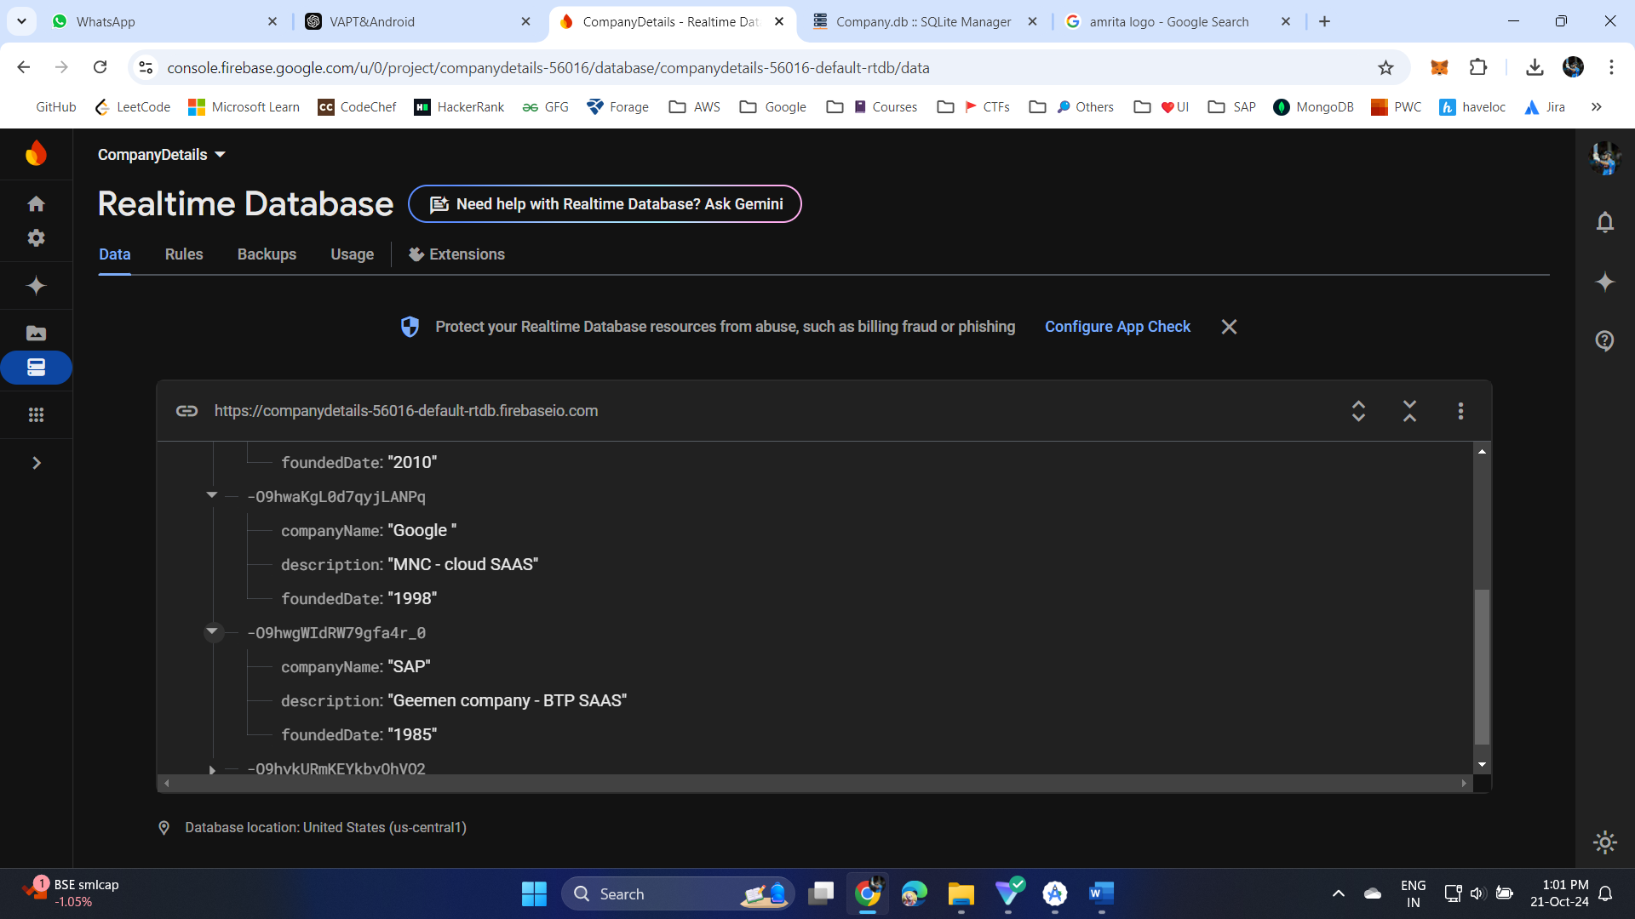

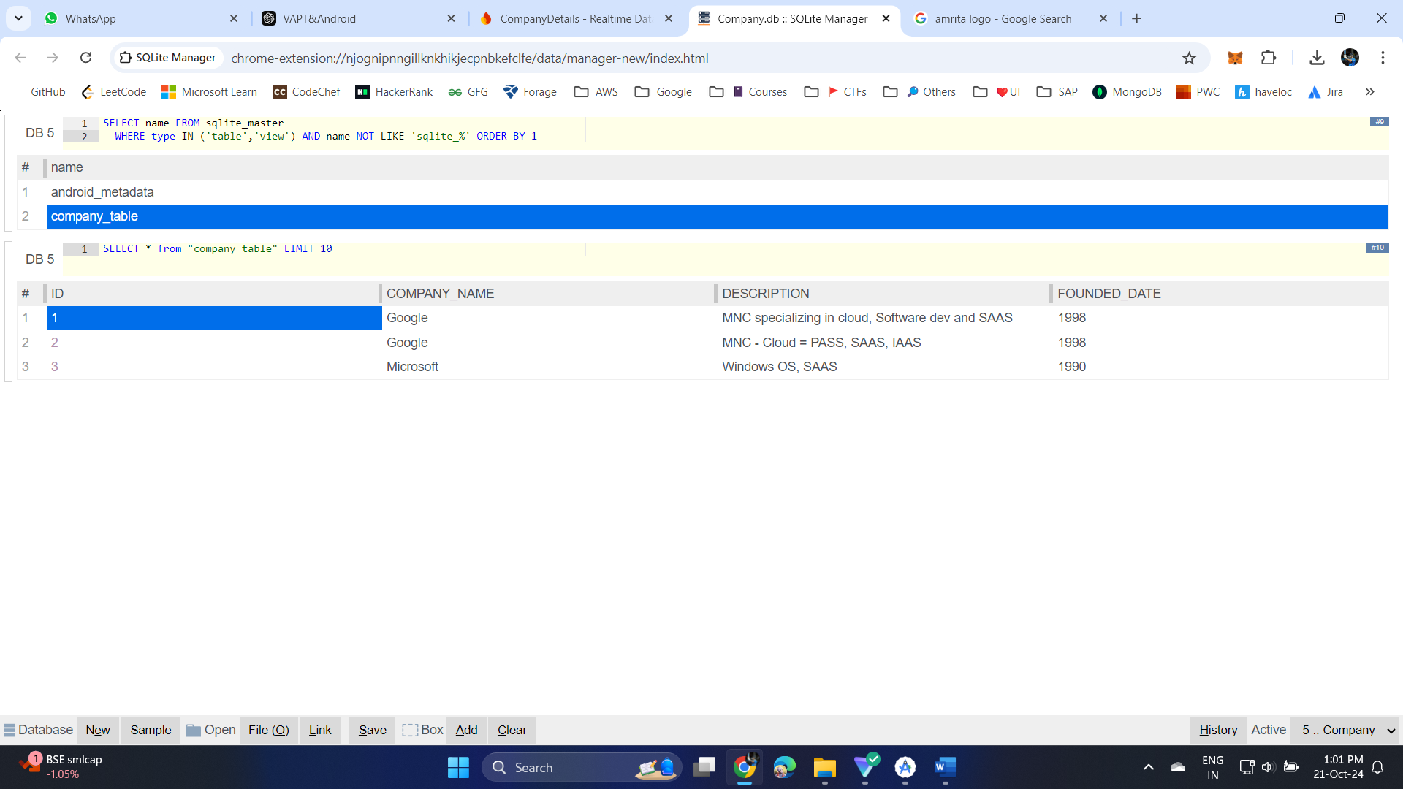

**Result:**

This is the required Application.