BAĞIMLILIK TEDAVİSİNDE NÖRO-KAVRAYICI ETKİLERİN KULLANILMASI

USING NEUROCOGNITIVE SKILLS IN ADDICTION TREATMENT

Barkan Var

Endüstri Mühendisliği

Sabancı Üniversitesi

İstanbul, Türkiye

[barkanvar@sabanciuniv.edu](mailto:barkanvar@sabanciuniv.edu)

Egemen Yiğit Kömürcü

Elektronik Mühendisliği

Sabancı Üniversitesi

İstanbul, Türkiye

ekomurcu@sabanciuniv.edu

Selim Balcısoy

Bilgisayar Mühendisliği

Sabancı Üniversitesi

İstanbul, Türkiye

[balcisoy@sabanciuniv.edu](mailto:balcisoy@sabanciuniv.edu)

Prof.Dr.Kültegin Ögel

Moodist Hastanesi

İstanbul, Türkiye

Hocamızın mail adresi

Buğra Kaya

Bilgisayar Mühendisliği

Sabancı Üniversitesi

İstanbul, Türkiye

bugrakaya@sabanciuniv.edu

Berke Özten

Bilgisayar Mühendisliği

Sabancı Üniversitesi

İstanbul, Türkiye

[berkeozten@sabanciuniv.edu](mailto:berkeozten@sabanciuniv.edu)

Kemal Kılıç

Endüstri Mühendisliği

Sabancı Üniversitesi

İstanbul, Türkiye

kkilic@sabanciuniv.edu

Uzman Psikolog Kinyas Tekin

Moodist Hastanesi

İstanbul, Türkiye

kinyastekin@gmail.com

***Abstract — Addiction has been a problem which rapidly grows in Turkey and presumably, the effectiveness of treatment services for addiction has been gaining importance in recent years. Addiction is described as a brain disease. When the addict starts using the substance, many changes occur in his/her brain. Therefore, discovering the neuropsychological changes in the addict’s brain provides an important roadmap for the treatment process. On the other hand, studies show that when the addict becomes aware of the changes in his/her own brain, it helps the addict to be more motivated and willing to change his/her habit i.e. stop using drugs [1]. In this paper, clustering algorithms are used to classify the performances of the players of a gamificatiın application developed for Moodist Hospital The advantages and disadvantages of Principal Component Analysis method is discussed. Additionaly, Electroencephalogram (EEG) will be demonstrated to monitor the changes on the brains of the players.***

Keywords — addiction treatment, app development, statistical analysis, EEG

Özetçe — Bağımlılık ülkemizde her geçen gün artan bir problem haline gelmektedir. Buna paralel olarak bağımlılık tedavisi de gün geçtikçe önem kazanmaktadır. Bağımlılık beyinsel bir hastalık olarak tanımlanmaktadır. Hasta maddeyi kullanmaya başladığında beyninde çeşitli değişimler meydana gelir. Bu yüzden bağımlılık tedavisinde hastanın nörobilişsel değişimlerini incelemek önem arz etmektedir. Öte yandan, hastanın beynindeki değişimlerin farkına vardıkça tedavi olmaya yönelik motivasyonun arttığına dair bulgular çeşitli çalışmalar sonucu saptanmıştır [1]. Bu çalışmada önceden geliştirilen bir test uygulamasının sonucunda oyuncuların performansları güdümsüz makine öğrenmesi metodlarından gruplama kullanılarak sınıflandırılmıştır. Çok boyutlu veri setleri Temel Bileşen Analizi metodu kullanılarak indirgenmiş ve görselleştirilmiştir. Ek olarak, oyuncuların beyinlerindeki değişimler EEG kullanılarak ele alınmıştır.

Anahtar kelimeler — bağımlılık tedavisi, uygulama geliştirme, istatistiksel analiz, EEG

# Introductıon

Moodist is one of the most significant hospitals in its own area. The hospital hosts patients who has addiction problems related to excess usage of alcohol, drugs and other chemicals. The hospital is responsible for treating those patients not only physiologically but also psychologically. For the latter part, the hospital regularly conducts some tests in order to measure various mental characteristics of the patients; such as their capability of taking risks, memory, carefulness abilities and their impulse to different stimulus. However, those tests are conducted with the help of ‘paper and pen”. In order to help the hospital to adapt those tests into a digital platform, a web-based application has been developed. Moreover, a clustering approach which can be helpful for the hospital to evaluate the performances of the patients has been designed.

# OBJECTIVES/TASKS

This project consists of two main parts.

1) Developing a web-based application for the paper-pen tests

2) Coming up with statistical analysis after performing the tests

The objective is to classify the players of 4 different tests separately, to interpret if the player performs better than average

or not. Each test has different features that are gathered in distinct dataframes. For the classification problem, ‘K-means clustering algorithm’ has been used. The conventional approach of K-means algorithm helps clustering input data by randomly selecting ‘k’ points and minimizing the difference between input data and those ‘k’ points [2]. Here, the problem is to determine how many points (i.e. number of ‘k’) are needed to be selected. Moreover, those clusters are visualized in scatter plots for a better understanding. However, 3 out of 4 tests have more than 3 features and this makes it impossible to be shown as a visualization. There, Principal Component Analysis (PCA) has been used. The main principle of PCA is to reduce the dimensionality (i.e. removing the variables that are mostly correlated with each other [3]. Lastly, the bar charts to demonstrate each player’s performance for all 4 tests has been drawn, based on averaging a variable of each row. The details are going to be mentioned below.

The realistic constraints play an important role in the course of the project. Since this project is basically a health project, the application should not give any harm to the players. The development process has been paid attention by taking this into consideration in particular.

# proposed solutıons and methods

There are 4 tests that have been developed, each of them having 2-min durations:

#### Attention Test: The players of this test press ‘space’ button as soon as they see ‘A’ after ‘X’. Many side affects have been added to the game to distract the players’ attention such as different sounds, shapes etc. The data collected from this game are the following:

#### Error ratio: If the player sees A after X 10 times and presses ‘space’ button 6 times, the error ratio is 4/10

* *Reaction time: How many seconds does it take for the patient to press ‘space’ button?*

#### Impulse Test: When the player sees a red triangle, it presses on the button ‘C’ and when the player sees a green circle, it presses on ‘N’. The data to be gathered is as follows:

#### Number of correct presses, number of incorrect presses, reaction time

#### Memory Test: A series of numbers are served to the player. As soon as the demonstration of numbers end, the player is asked for entering the numbers it memorizes. The length of the data series is to be collected at the end of this game.

#### Risk Test: The players of this test inflates baloons with different colours. They press space button to inflate the baloons. The probability of bursting for orange, blue and green baloons are 1/64, 1/128, 1/256 for each of the baloons respectively. The player can stop inflating the balloon and put the points that have been collected into the pocket. The goal of this test is to measure the risk-taking capacity of the players. The points of each player is going to be collected at the end of this test.

The second step of the project is to cluster the performances of the players [4]. The clustering operation is conducted on Jupyter Notebook platform.

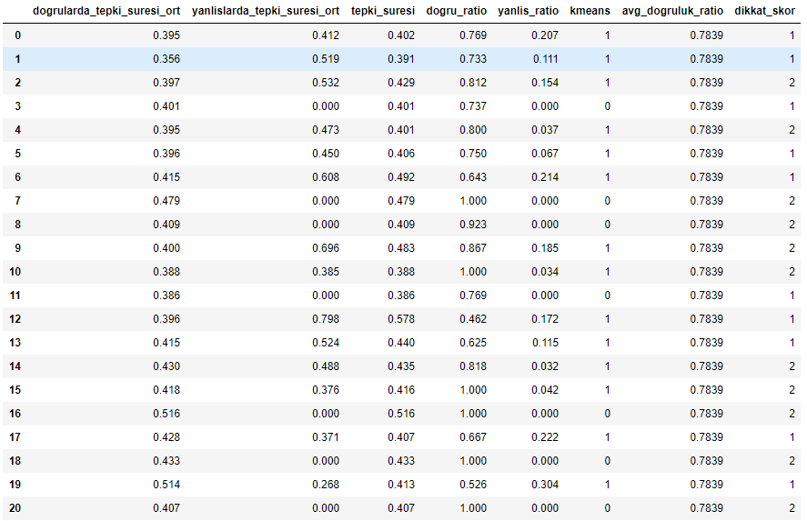

Figure 1. Attention Test Table

Figure 1 shows the results for attention test. The columns are average reaction time for correct/incorrect answers, average reaction time, ratio of correct/incorrect answers, results of k-means clustering results, average of “dogru_ratio” rows and a scoring metric (dikkat_skor).

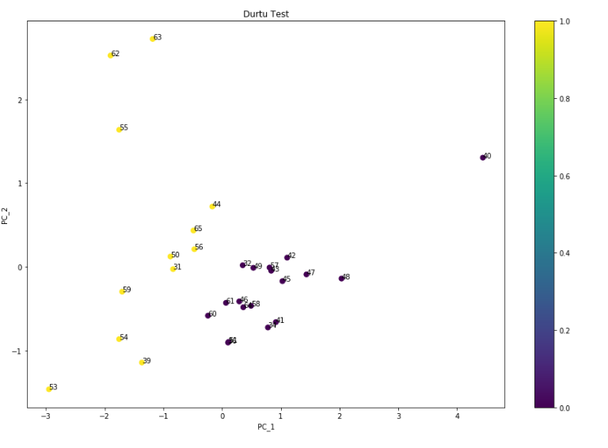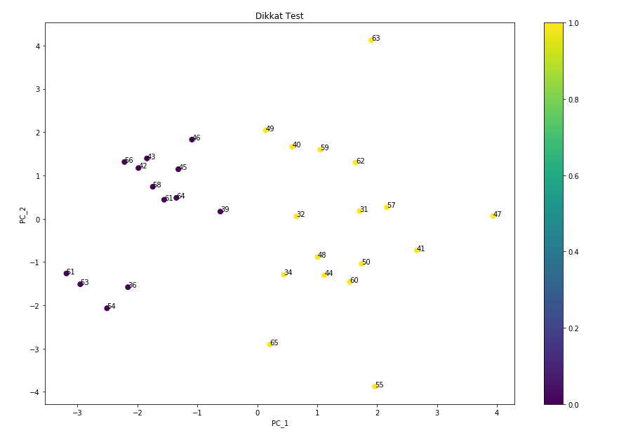

Figure 2. Scatter plot using PCA for attention test

The clustering results for attention test is demonstrated at figure 2. In order to evaluate which color (purple/yellow) performs better compared to the other one, PC1 axis has been investigated, since it indicates the most important features. ID 47, 63 and 55 are the rightmost ones when “dogru_ratio” column has been sorted in descending order, it has been realized that these 3 ID’s constitute the 3 bottom rows. This indicates that “dogru_ratio” is a very significant feature to cluster those ID’s. Then for the ones whose “dogruluk_ratio” are lower than average, “yellow” is appointed as an attention score. For the ones whose “dogruluk_ratio” are above the average, purple is assigned. Our hypothesis is “if k-means score of a single ID is 1, then its attention score should be yellow and if k-means score is 0, the attention score should be purple.” When this is to be evaluated, 20/30 = 66% accuracy has been ensured.

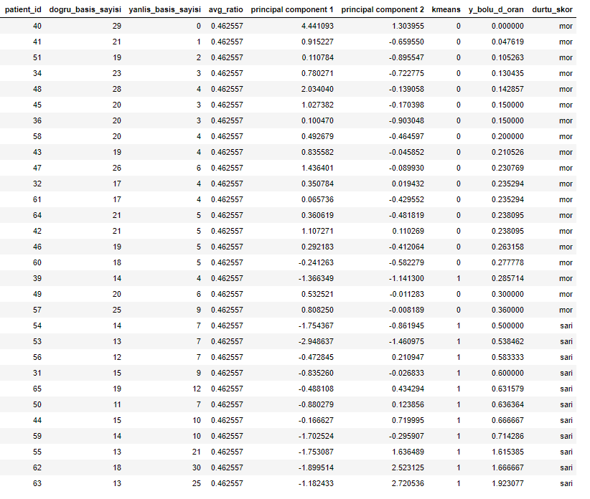

Figure 3. Impulse Test Table

Figure 4. Scatter plot using PCA for impulse test

Figure 3 and 4 demonstrates the results for impulse test. Number of correct/incorrect presses and their ratio is used as variables. In order to interpret which groups performs better, the ratio of incorrect presses over correct ones has been taken as a benchmark. If a player’s “y_bolu_d_oran” is lower than the average, its impulse score is assigned as purple and yellow for vice versa. The hypothesis is “if k-means label of a player is 0, then its impulse score should be purple and if the k-means label is 1, the impulse score should be yellow”. The accuracy score for this hypothesis is 29/30 = 97%.

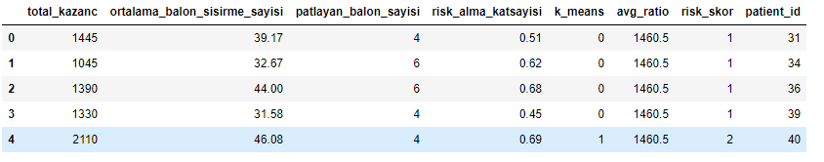

Figure 5. Table using first 5 rows for risk test

Figure 5 demonstrates the data and results for risk test. If the total gain of a player from risk test is less than the average, a risk score is assigned as 1 and vice versa.

ekran görüntüsü içeren bir resim

Açıklama otomatik olarak oluşturuldu

Figure 6. Bar chart for memory test

Figure 6 is a bar chart which demonstrates the number of players with the levels that they could reach during their play. If the level of a player is less then the average, then its score is assigned as 1 and if the opposite happens, its score is 2.

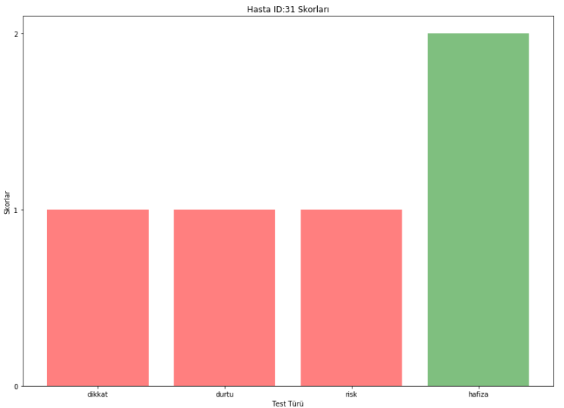

Figure 7. Performance histogram of a player

Figure 7 is the performance histogram of a player in order to analyze each player’s scores obtained by 4 test and conclude whether a single player’s performance is less or above then the average. The histogram implies that player 31 is below than average in risk, impulse and attention tests but above average in memory test compared to the peers.

All those analysis indicate that PCA reduces the dimension of the multivariate data, therefore the visualisations for grouping multivariate data can be created using PCA. However, PCA itself does not explain which group performs better. In order to evaluate this, further analysis is required such as defining manual scoring metrics by making use of one pivot variable. Also, the importance of the variables for each test varies. One feature can be more important than the other while grouping the data and it is essential to identify the most important ones and treat the patient by taking this into consideration.

After designing and implementing the software, we also analyzed the brain signals of us, what the changes have been made in our brain before and after the Moodist software tests such as memory, risk and impulse tests. We tried to measure the brain waves via Electroencephalography (EEG) which is done by connecting approximately 20 electrodes to the head. We could achieve the amplitude of brain waves including Theta, Alpha, Beta1, Beta2 and Gamma waves through the reports of autotrain-brain software [5].

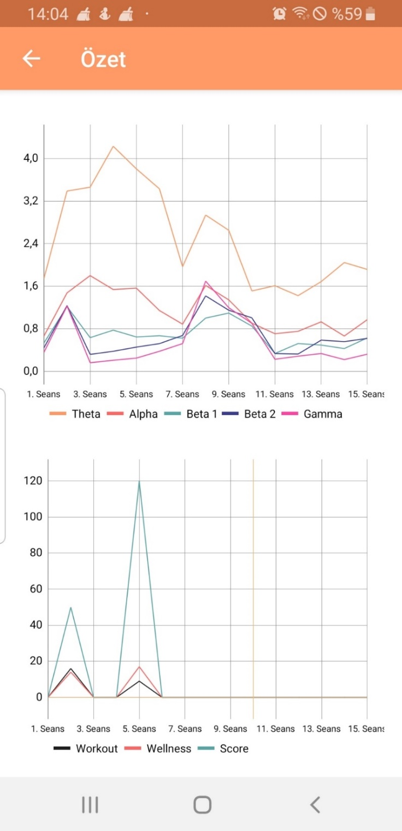

Figure 8. Demonstration of amplitude of brain signals with respect to sessions.

The results are stated in Figure 8 so that the information belonging to 14. session demonstrates the measurement of brain signals before applying the Moodist test to person, as 15. session shows us the measurement after the tests. As a result of the tests, the amplitude of the Theta signal is significantly decreased whilst the alpha signal is significantly increased. However, the others are not affected much by the test, but they are slightly increased.

For interpretation, theta waves increase when sleeping and dreaming on the other hand, situations of thinking, learning and being alert positions makes the amplitude increased. As a result, tests make one focus and think about it, so the amplitude of alpha waves is expectedly increased. Also, theta wave values significantly decreased.

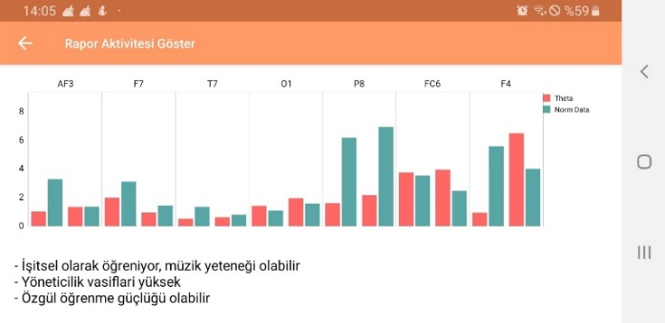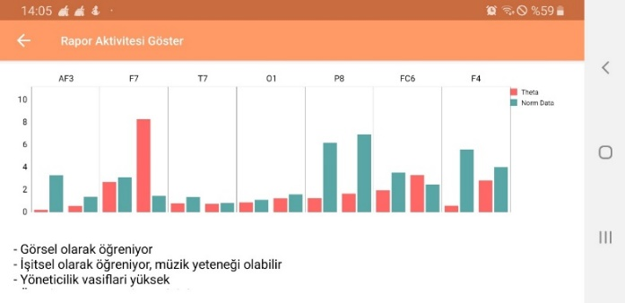

Figure 9. Brain signals in different brain regions before and after the tests.

Above graph shows us that how much the different brain regions function and the attributes of the brain is stated briefly as 3 sentences. First graph demonstrates the research before applying the test whilst right one does after. Since first one shows the measurement before test, the person has specific learning disability. Furthermore, since the tests include visual and audial items, the results after tests, second graph, indicate that the person actively learning visually and audially. Besides, F7 which indicates anxiety is considerably increased due to the stress on the tests [6]. In conclusion, these actual test results endorse the hypothesis that tests increase person’s concentration and anxiety.

# References

1. *Drugs, Brains, and Behavior The Science of Addiction. (2014). Retrieved from* [*https://www.drugabuse.gov/sites/default/files/soa_2014.pdf*](https://www.drugabuse.gov/sites/default/files/soa_2014.pdf)
2. *Yi, F., & Moon, I. (2013). Extended K-Means Algorithm (Publication). Hangzou, China. Retrieved from*

[*https://icproxy.sabanciuniv.edu:2158/document/6642738*](https://icproxy.sabanciuniv.edu:2158/document/6642738)

1. *Smith, L. (2002). A tutorial on Principal Components Analysis (Publication).Retrieved from*

*<http://www.cs.otago.ac.nz/cosc453/student_tutorials/principal_components.pdf>*

1. *Eroglu, G., Ekici, B., Arman, F., Gürkan, M., Çetin, M., & Balcisoy, S. (2018, November). Can we predict who will respond more to neurofeedback with resting state EEG?. In 2018 Medical Technologies National Congress (TIPTEKNO) (pp. 1-4). IEEE.*
2. *Eroğlu, G., Aydın, S., Çetin, M., & Balcisoy, S. (2018, May). Improving cognitive functions of dyslexies using multi-sensory learning and EEG neurofeedback. In 2018 26th Signal Processing and Communications Applications Conference (SIU)(pp. 1-4). IEEE*
3. *Eroğlu, G., Çetin, M., & Balcisoy, S. (2018, May). Electroencephalographic identifiers of reading abilities in turkish language. In 2018 26th Signal Processing and Communications Applications Conference (SIU) (pp. 1-4). IEEE.*