setwd("G:/2glkx/data")
d= read.table("ew1.csv",header=F, sep=",")
d1<-data.frame(F1=d$V2,F2=d$V3)
t1=paste("x",1:5,sep = "")
t2=paste("s",1:30,sep = "")
d3=c(t1,t2)
win.graph(90,50) #设置窗口大小
plot(d1,pch=20,main="二维散点图")
playwith(plot(1:5, log="x"))
playwith(plot(1:30, log="s"))
text(d1[c(-31,-33),],d3[c(-31,-33)],col="red",adj=c(0.1,1),cex=0.9)
text(d1[31,1],d1[31,2],"s26",col="red",adj=1,cex=0.9)
text(d1[33,1],d1[33,2],"s28",col="red",adj=0,cex=0.9)
locator(1,type = "p") #在图中找出原点坐标
arrows(-0.3507046,-0.4767645,d1[1,1],d1[1,2])
arrows(-0.3507046,-0.4767645,d1[2,1],d1[2,2])
arrows(-0.3507046,-0.4767645,d1[3,1],d1[3,2])
arrows(-0.3507046,-0.4767645,d1[4,1],d1[4,2])
arrows(-0.3507046,-0.4767645,d1[5,1],d1[5,2])
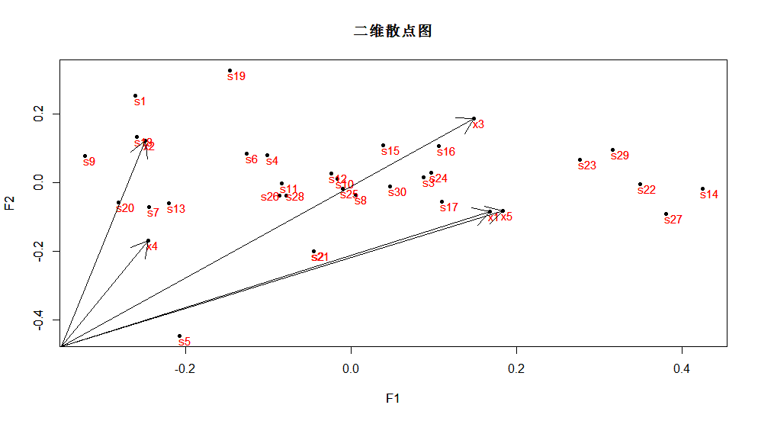
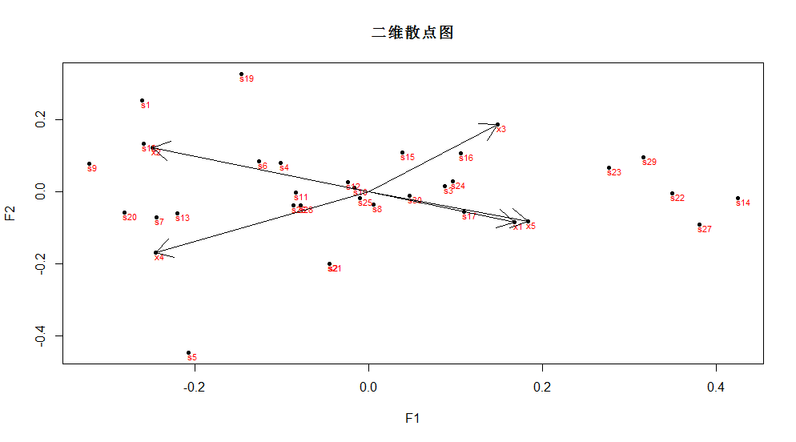
二维图
library("scatterplot3d")
setwd("G:/2glkx/data")
d= read.table("sw.csv",header=F, sep=",")
d2<-data.frame(F1=d$V2,F2=d$V3,F3=d$V4)
scatterplot3d(d2,highlight.3d=TRUE,col.axis="blue",col.grid="lightblue",main="三维散点图", pch=20)
playwith(plot(1:5, log="x"))
playwith(plot(1:30, log="s"))

t1=paste("x",1:5,sep = "")
t2=paste("s",1:30,sep = "")
d3=c(t1,t2)
text(d2,d3,col="red",adj=c(0.1,1,1),cex=0.7) #cex 设置文字大小
r=locator(1,type="p")
r
x1=c(0,0,0)
y1=c(0.953,0.258,0.157)
lines(x1,y1)
arrows(x1,y1)

arrows(0,0,0;0.953,0.258,0.157)
arrows(0,0,0,0.230,0.002,0.973)
#arrows(0,0,0,0.975,-0.139,0.174)
arrows(0,0,0,0.122,0.993,0.001)
arrows(0,0,0,0.942,0.248,0.227)
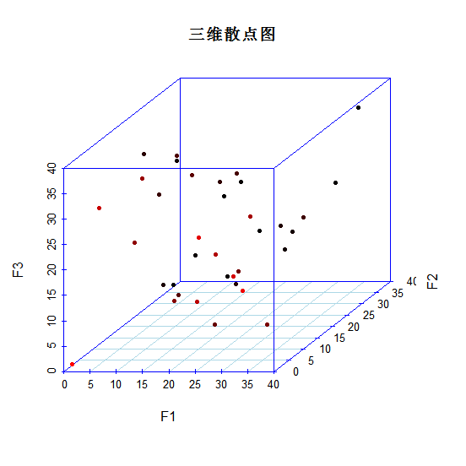
三维图

