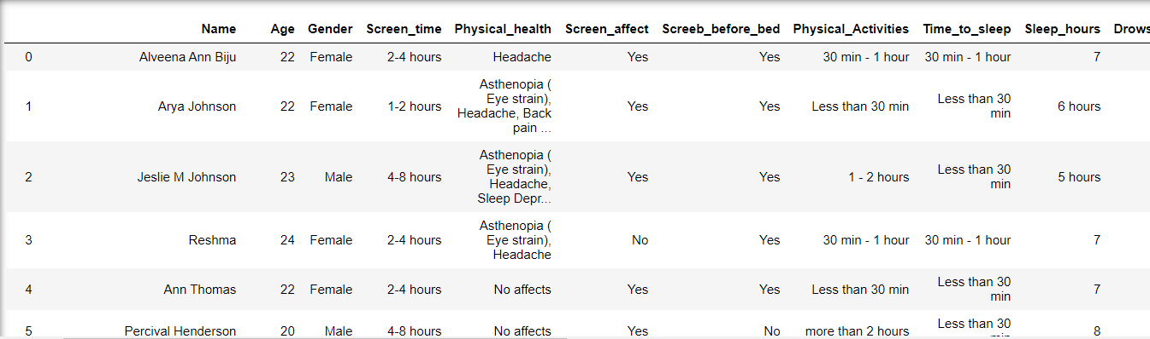

Fig 1: Initial Data

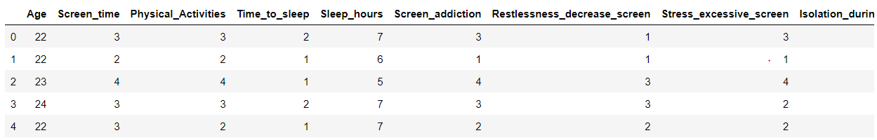

Fig 2: Data After Preprocessing

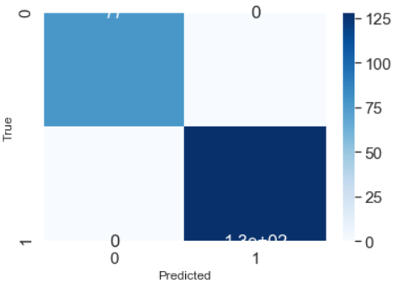

Fig 3: Confusion matrix of random forest

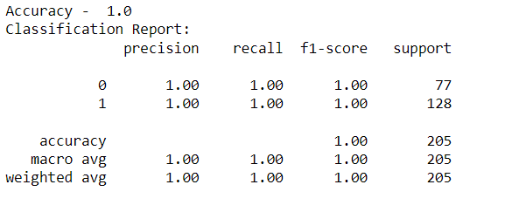

Fig 4 : Classification report of random forest