Explainability of the predictions of Machine and Deep learning models for the Heart health
Dr. B Bharghavi ¹ and M.V. Sri Lasya ²
¹ Gitam Deemed University, Hyderabad
² Gitam Deemed University, Hyderabad
Abstarct:
Machine learning and deep learning models have become increasingly prevalent in the field of healthcare, particularly in the prediction of heart health outcomes. However, the inherent complexity of these models can make them difficult to interpret and explain to end-users, such as clinicians. This research paper explores the importance of model explainability in the context of heart health prediction, examines the current state of explainable artificial intelligence (XAI) techniques, and discusses the challenges and potential solutions for improving the transparency and interpret-ability of these models.
Keywords: Machine learning, Deep Learning,Explainability.
- Introduction :

The use of machine learning and deep learning algorithms in the healthcare industry has grown exponentially in recent years, driven by the availability of large datasets and the potential to improve diagnostic accuracy, clinical decision-making, and patient outcomes. One area where these models have shown particular promise is in the prediction of heart health, where they can be used to identify individuals at risk of developing cardiovascular diseases, such as coronary artery disease, heart failure, and arrhythmias[2,4].
But it is quite important and imperitive to understand and interpret the resultrs of the machine learning and deep learing models for better understanding and interpreting the models and thereby draw necessary insights so that the diagnosis improves[3,9].
The explainability of the models was done using model agnostic methods like SHapley Additive exPlanations (SHAP) and Diverse Counteractual Explanations (DiCE)[9,7,10]. For this study, we used two datasets available from kaggle. They can be found in [1] of the reference section.

- Literature Survey :

In the recent years, the application of machine learning and deep learning in health care has seen significant advancements. These modes have been utilized to predict various health outcomes, including cardiovascular diseases,due to their ability to handle and analyze large and complex datasets. However, the black-box nature of these models can pose a challenge for the interpretability and trust, especially in the critical fields like healthcare.

Explainable AI (XAI) Techniques:
Explainable AI aims to make the decisions of ML and DL models understandable to humans. Various XAI techniques have been proposed, which can be broadly categorized into model-specific and model-agnostic methods:

1. Model-Specific Methods: These methods are tailored for specific types of models. For example:
Decision Trees: Inherently interpretable as they provide a clear decision path.
Rule-Based Models: Provide human-readable rules derived from data.
Attention Mechanisms in Neural Networks: Highlight important features or inputs that influence the model's decisions.
LayerWise Relevance Propagation (LRP)[8] : It is a very neural network specific method for explaining how the weights are updated with respective to each layer.

2. Model-Agnostic Methods: These methods can be applied to any model, such as:
LIME (Local Interpretable Model-agnostic Explanations): Generates local approximations of the model to explain individual predictions. SHAP (SHapley Additive exPlanations): Uses game theory to attribute the contribution of each feature to the model's prediction. Feature Importance Analysis: Measures the impact of each feature on the model's output.DiCE (Diverse Counterfactual Explanations): Gives the ‘what-if’ predictions of the model’s by tweaking the feature values to a certain extent to get the expected outcome. Several machine learning techniques have been explored for predicting heart health, each with varying degrees of success and interpretability:

1. Traditional Machine Learning Models:.
Logistic Regression: Commonly used for binary classification problems, offering a balance between performance and interpretability
Decision Trees: Provide a visual representation of decision rules, making them easy to interpret.
Support Vector Machines (SVMs): Effective for high-dimensional data but less interpretable.
2. Ensemble methods:

Random Forests: Combine multiple decision trees to improve accuracy and robustness but can be harder to interpret.
AdaBoost: Enhances the performance of weak learners but increases complexity.
Gradient Boosting Machines (GBMs): Powerful predictors but often considered black-box models.
Histogram Gradient Boosting Machines : It is more faster edition of the Gradient Boosting machines but can be considered as a black box model.

3. Deep Learning Models:
Multilayer Perceptrons (MLPs): Used for their ability to capture complex patterns in data, though they are less interpretable.

Challenges and Potential Solutions.
The main challenges in implementing XAI techniques for heart health prediction includeTrade-off Between Accuracy and Interpretability: More complex models often provide better performance but at the cost of interpretability. Data Quality and Representation: Ensuring the data used is representative and of high quality is crucial for both model accuracy and interpretability. Integration with Clinical Workflow: XAI tools must be seamlessly integrated into clinical workflows to be useful to practitioners Potential solutions to these challenges involve developing hybrid models that balance performance and interpretability, improving data preprocessing techniques,and creating user-friendly interfaces for XAI tools.

2. Methodology:
The data is collected from kaggle, one of the best sources of datasets for machine learning and deep learning tasks were collected. For the link to the dataset, kindly refer ¹ in the References.

  - Data Acquisition and Preprocessing
The dataset of dimensions 70,000 rows and 12 columns. The features were all numeric in nature and the data is encoded. The target feature ‘cardio’ is in the binary format where ‘1’ indicates that there is a heart related condition and ‘0’ otherwise. Some features like systolic pressure and diastolic pressure, smoke and alcohol were also considered. Another dataset used is

Data preprocessing: The initial phase of Exploratory Data Analysis has shown that the data is having some missing values and outliers were present in two records. The missing values were dropped and the outliers were imputed using the quartiles of the individual records.
The size of the dataset came down to 64,502 records.The data has been scaled using the MinMaxScaler as we do not want our models to give us skewed results towards the values having high numerica value. So all the features are brought to the same scale.
We tried to improve the model’s performance by employing one of the most important feature transformation techniques : Principal Component Analysis. The untransformed and the transformed data were kept in separate variables to understand and pick up the better performing model.

Model Construction : The task was the supervised machine learning one which is classification. The classifiers considered are Decision Tree, Logistic Regression and Support Vector Machine.

The ensembling models like Random Forest, AdaBoost and Histogram- Gradient Boosting trees were also considered. A mulitlayer perceptron is also constructed for this dataset as it is more complicated compared to the machine learning models and explainability will make more sense for such black box models.

The simpler models tend to overfit to the training data and their results can sometimes be unreliable as they do not have greater level of accuracy. The complex models , often have greater level of generalization and produce greater level of accuracy but they are quite difficult to understand and interpret.
Table 1. The results of the training of models on 713 records dataset
MODEL | TRAINING ACCURACY | TESTING ACCURACY | F2 SCORE
DECISION TREE | 100 | 98.59 | 0.97
RANDOM FOREST | 100 | 100 | 1.0
LOGISTIC REGRESSION | 81.96 | 82.24 | 0.84
SUPPORT VECTOR MACHINE | 88.97 | 87.85 | 0.89
ADABOOST | 100 | 94.39 | 0.92
HISTOGRAM BASED GRADIENT BOOSTING MACHINE | 100 | 100 | 1.0

Table 2. The results of training of models on the 70,000 records dataset
MODEL | TRAINING ACCURACY | TESTING ACCURACY | F2 SCORE
DECISION TREE | 99.98 | 62.20 | 0.62
LOGISTIC REGRESSION | 72.52 | 71.47 | 0.67
SUPPORT VECTOR MACHINE | 72.33 | 71.23 | 0.64
RANDOM FOREST | 99.98 | 69.90 | 0.68
ADAPTIVE BOOSTING | 99.98 | 71.92 | 0.67
HISTOGRAM BASED GRADIENT BOOSTING MACHINE | 74.15 | 72.13 | 0.69
MUTLILAYER PERCEPTRON | 72.92 | 72.49 | 0.68

Fig. 1. The Feature importance calculated using the AdaBoost on 70,000 records dataset.
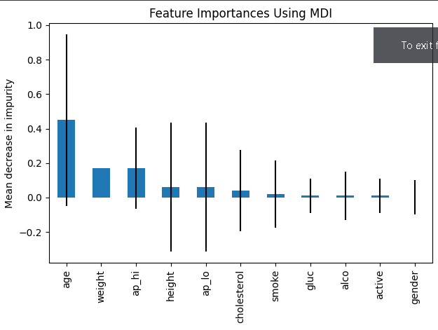

Fig. 2. Feature importance of the random forest on the 713 records dataset
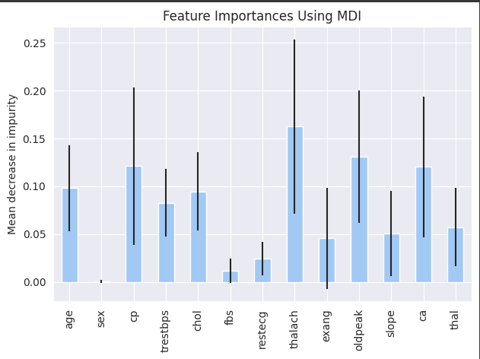

Fig.3. The evaluation accuracy vs iterations on the neural network on 70,000 records dataset
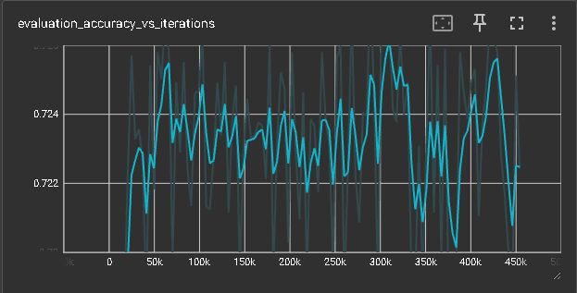

Fig. 4. The epoch loss of the neural network 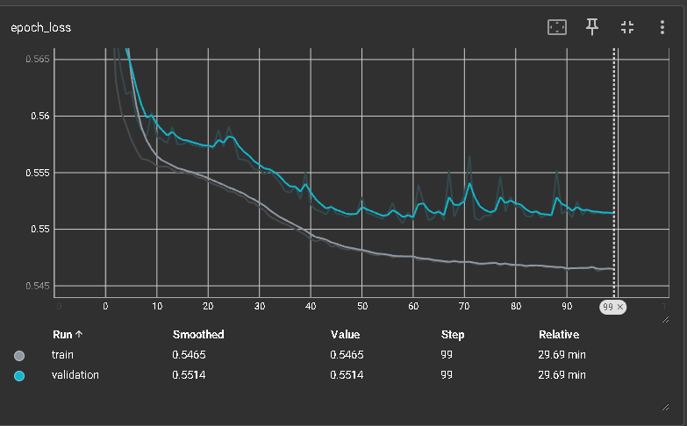

Explainable AI Techniques used :

SHAP(SHapley Additive Predictions) : SHAP is a model agnostic explanation technique used to understand the model’s interpretability. The model used with SHAP to interpret is the multilayer perceptron. The outputs looked as follows

Fig.5. Shap results of feature importance for the 70,000 records dataset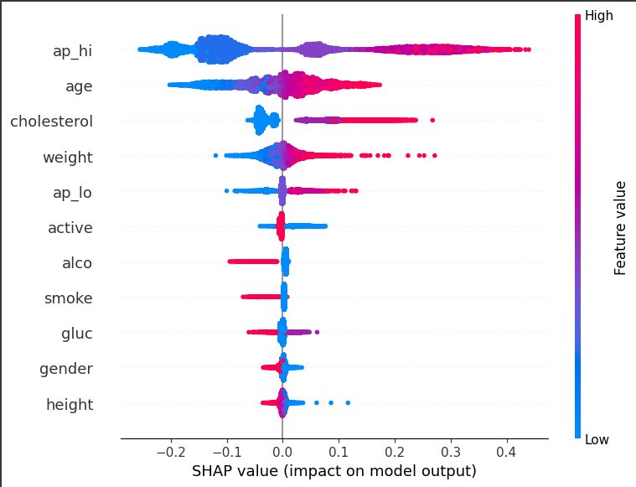

  - DiCE( Diverse Counterfactual Explanations) : Diverse counterfactual explanations is a powerful model agnostic library which gives us the posible counterfactuals in a record to get the desired outcome. For example: one of the records in the dataset looked as follows :

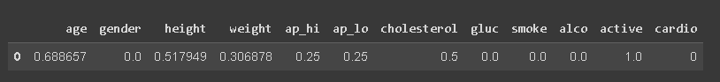

The outcome of DICE outcome looked as follows 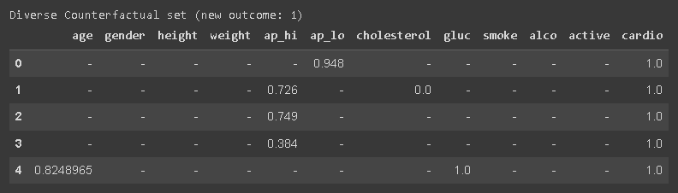

DiCE can be used to calculate the feature importance like the local and global feature importance. For a sample of 100 records, global feature importance was calculated and a bar plot is plotted. The results are turned out to be as follows :
Fig.6. Global feature importance using DiCE on 70,000 records dataset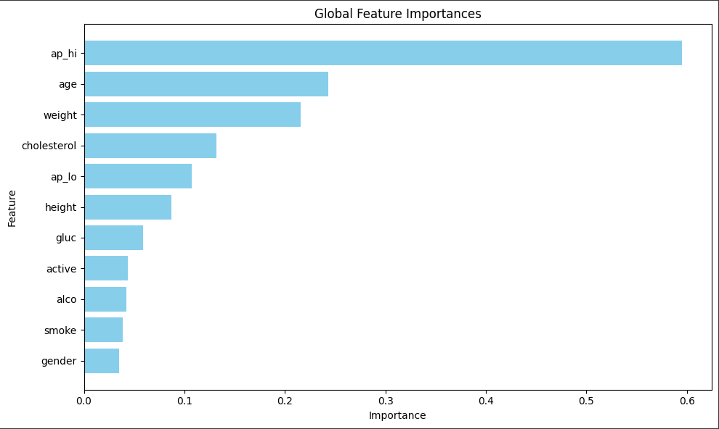

Fig.7. Global feature importance using DiCE on the 713 records dataset
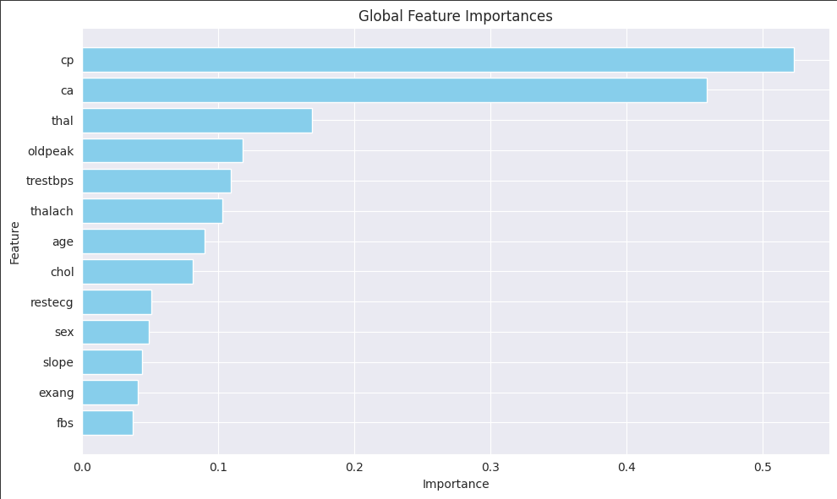

- Experimentation results :
The analysis of the larger dataset ended up explaining the fact that there is a huge importance to the feature ‘ap_hi’ and ‘age’ in the predictions. The detailed explanation can be :
‘ap_hi’ is the feature which stands for the systolic blood pressure. This is a feature of high importance and it could be one of the main reasons for having a heart related issue.
‘age’ can be an influential factor in having heart related issues and the risk of having a cardiac issue is high when you are older.
‘Cholesterol’ and ‘weight’ are two features with almost equal importance and if not taken care properly can be detrimental for the heart.

The analysis of the smaller dataset ended up explaining the fact that there is a huge impact of the features like : ‘cp’, ‘ca’, ‘thalach’
‘cp’ stands for the chest pain type which is of the greater importance and is one of the most important features in the existence of the heart disease.
‘ca’ is another important feature which stands for the number of major vessels coloured by fluoroscopy.
‘thalach’ stands for the maximum heart rate which can be an indicator of an underlying heart conditions like ‘heart arrhythmia’ .

Conclusion :
The results and the model’s predictions clearly indicate that maintaining a healthy lifestyle significantly reduces the likelihood of developing cardiac issues. This finding underscores the critical role of preventive measures in cardiovascular health. However, the explainability of black-box models remains a crucial challenge. As these models become increasingly complex and powerful, understanding their decision-making processes becomes more difficult.
Explainability is essential not only for gaining the trust of healthcare professionals and patients but also for ensuring that the models’ predictions are reliable and actionable. Therefore, it is imperative to advance the concept of explainability by developing better tools and techniques. These advancements should aim to minimize the tradeoff between performance and interpretability, allowing us to harness the full potential of machine learning models while maintaining transparency and accountability.
Future research should focus on creating explainable AI frameworks that can provide clear, understandable insights into model behavior. This will involve integrating explainability methods, such as LIME, SHAP, and counterfactual explanations, into the model development process. By doing so, we can ensure that the models not only perform well but also offer valuable explanations that can guide clinical decision-making and improve patient outcomes.

References :

1. Link to the datasets :
https://www.kaggle.com/datasets/sulianova/cardiovascular-disease-dataset
https://www.kaggle.com/datasets/yasserh/heart-disease-dataset

2. C. M. Bhatt, P. Patel, T. Ghetia, and P. L. Mazzeo, “Effective Heart health prediction using Machine Learning techniques,” Artificial Intelligence Algorithms for healthcare ,2020.

3. F. Gabbay, S. Bar-Lev, O. Montano, and N. Hadad, “A LIME-Based Explainable Machine Learning Model for predicting the severity level of COVID-19,” Applied Sciences,2021.

4. M. Llugiqi, F. J. Ekaputra, and M. Sabou, “Leveraging Knowledge Graphs for Enhancing Machine Learning based Heart Health Prediction,” w3id.org,, 2024.

5. C. Zhang, S. Bengio, M. Hardt, B. Recht, and O. Vinyals, “Understanding Deep Learning (Still) Requires Rethinking Generalization,” dl.acm.org, 2021.

6. N. Burkart and M. F. Huber, “A Survey on the Explainability of the supervised machine learning,”, jair.org, 2021.

7. I. Meyuhas, A. B. Arie, Y. Horesh, and D. Deutch, “CFDB: Machine Learning model analysis via Databases of Counterfactuals,” dl.acm.org, 2022.

8. S. Bach, G. Montavon, K. R. Muller, and W. Samek, “Layer-wise relevance propagation for deep neural network architectures,” researchgate.net, 2016.

9. P. Linardatos, V. Papastefanopoulos, and S. Kotsaintis, “Explainable AI: A review of Machine Learning Interpretability Methods,” mdpi.com ,2020.

10. R. K. Mothilal, A. Sharma, and C. Tan, “Explaining machine learning classifiers through diverse counterfactual explanations,”dl.acm.org , 2020.

