Explainability of the Predictions of Machine Learning and Deep Learning Models for the Heart Health
Bhargavi B¹ and M. V. Sri Lasya ²
bballa@gitam.edu¹, vmuppira@gitam.in²
^{1,2}Gitam Deemed University, Hyderabad

Abstract:
Machine learning and deep learning models have become increasingly prevalent in the field of healthcare, particularly in the prediction of heart health outcomes. However, the inherent complexity of these models can make them difficult to interpret and explain to end-users, such as clinicians. This research paper explores the importance of model explainability in the context of heart health prediction, examines the current state of explainable artificial intelligence (XAI) techniques and discusses the challenges and potential solutions for improving the transparency and interpretability of these models.
Keywords: Machine learning, Deep Learning, Explainability.

1 Introduction

The use of machine learning and deep learning algorithms in the healthcare industry has grown exponentially in recent years, driven by the availability of large datasets and the potential to improve diagnostic accuracy, clinical decision-making and patient outcomes. One area where these models have shown particular promise is in the prediction of heart health, where they can be used to identify individuals at risk of developing cardiovascular diseases, such as coronary artery disease, heart failure, and arrhythmias [2, 4].
But, it is quite important and imperative to interpret the results of the machine learning and deep learning models. By interpreting the models, we can draw necessary insights so that there is improvement in diagnosis[3, 9]. We used model agnostic methods like SHapley Additive exPlanations (SHAP) and Diverse Counteractual Explanations (DiCE) [9, 7, 10] to interpret the models on heart health datasets.

2 Literature Survey
The field of machine learning (ML) has seen significant advancements, particularly in applications like heart disease prediction and the development of explainable models. This literature survey summarizes recent research contributions in these areas.

Machine Learning for Heart Disease Prediction
Rsearchers have explored effective heart disease prediction using various machine learning techniques. Their study compared multiple algorithms to identify the most effective methods for predicting heart disease, emphasizing the need for high accuracy and reliability in medical diagnoses [2]. Similarly it was discussed in [3] leveraging knowledge graphs to enhance machine learning-based heart disease prediction. Their approach integrates structured medical knowledge with patient data, aiming to improve predictive accuracy and provide more interpretable results .

The reference [4] provided a review of various machine learning interpretability methods, discussing the strengths and weaknesses of each approach. Their work offers a comprehensive overview of current techniques and their applicability in different contexts . Additionally, [9] focused on explaining machine learning classifiers through diverse counterfactual explanations. This method helps in understanding how slight changes to input features can alter the model's output, thereby providing insights into the model's decision-making process .

2.1 Explainable AI (XAI) Techniques
Explainable AI aims to make the decisions of ML and DL models understandable to us. Various XAI techniques have been proposed, which can be broadly categorized into model-specific and model-agnostic methods.

Model-Specific Methods. These methods are tailored for specific types of models. For example, decision trees are inherently interpretable as they provide a clear decision path. The rule-based models provide human-readable rules derived from data. The attention mechanisms in neural networks highlight the important features or inputs that influence the model's decisions. Layer-wise Relevance Propagation (LRP) [8] is a neural network specific method for explaining how the weights are updated with respective to each layer.
Model-Agnostic Methods. These methods can be applied to any model. For instance, LIME (Local Interpretable Model-agnostic Explanations) generates local approximations of the model to explain individual predictions. SHAP (SHapley Additive exPlanations) uses game theory to attribute the contribution of each feature to the model's prediction. Feature Importance Analysis masures the impact of each feature on the model's output. DiCE (Diverse Counterfactual Explanations) gives the ‘what-if’ predictions of the model by tweaking the feature values to a certain extent to get the expected outcome. Several machine learning techniques have been explored for predicting heart health, each with varying degrees of success and interpretability.

Traditional Machine Learning Models. Logistic Regression is commonly used for binary classification problems, offering a balance between performance and interpretability. Decision Trees provide a visual representation of decision rules, making them easy to interpret. Support Vector Machines (SVMs) are effective for high-dimensional data but less interpretable.
Ensemble methods. Random Forests combine multiple decision trees to improve accuracy and robustness but can be harder to interpret. AdaBoost enhances the performance of weak learners but increases complexity. Gradient Boosting Machines (GBMs) are powerful predictors but often considered black-box models. Histogram Gradient Boosting Machine is more faster version of the Gradient Boosting machines but can be considered as a black box model.

Deep Learning Models. Multilayer Perceptrons (MLPs) with many hidden layers can be used for their ability to capture complex patterns in data, though they are less interpretable.

2.2 Challenges and Potential Solutions. The significant challenges in implementing XAI techniques for heart health prediction include trade-off between accuracy and interpretability. More complex models often provide better performance but at the cost of interpretability. Another challenge is data quality and representation. Ensuring the data used is representative and of high quality is crucial for both model accuracy and interpretability. It is also challenging to integrate with clinical workflow. XAI tools must be seamlessly integrated into clinical workflows to be useful to practitioners. Potential solutions to these challenges involve developing hybrid models that balance performance and interpretability, improving data preprocessing techniques and creating user-friendly interfaces for XAI tools.

3 Methodology

3.1 Data Acquisition and Preprocessing. The heart health dataset [1] has 70,000 instances with 12 features. The features were all numeric in nature and the data is encoded. The target feature ‘cardio’ is in the binary format where ‘1’ indicates that there is a heart related condition and ‘0’ otherwise. Some features like systolic pressure and diastolic pressure, smoke and alcohol were also considered. Another smaller dataset [2] used is also related to heart health with similar features [1].

Data preprocessing. The initial phase of Exploratory Data Analysis has shown that the data is having some missing values and outliers were present in two records. The missing values are dropped and the outliers imputed using the quartiles of the individual records.
The size of the dataset [1] came down to 64,502 records. The data has been scaled using the MinMaxScaler as we do not want our models to give us skewed results towards the values having high numerical values. So, all the features are brought to the same scale. We tried to improve the model’s performance by employing Principal Component Analysis. The untransformed and the transformed data were kept in separate variables to understand and pick up the better performing model.

3.2 Model Construction. The task involved classification based supervised machine learning. The classifiers considered are Decision Tree, Logistic Regression and Support Vector Machine. The ensemble models like Random Forest, AdaBoost and Histogram- Gradient Boosting trees were also considered. A mulitlayer perceptron is also constructed for this dataset[1] as it is more complicated compared to the machine learning models and explainability will make more sense for such black box models.

The simpler models tend to overfit to the training data and their results can sometimes be unreliable as they do not have greater level of accuracy. The complex models , often have greater level of generalization and produce greater level of accuracy but they are quite difficult to understand and interpret.

4 Experiments and Results
Table 1. The results of the training of models on 713 records dataset
Model | Training Accuracy | Test Accuracy | F2 score
Decision Tree | 100 | 98.59 | 0.97
Random Forest | 100 | 100 | 1.0
Logistic Regression | 81.96 | 82.24 | 0.84
SVM | 88.97 | 87.85 | 0.89
Adaboost | 100 | 94.39 | 0.92
Histogram Gradient Boosting Machine | 100 | 100 | 1.0

Table 2. The results of training of models on the 70,000 records dataset
Model | Training Accuracy | Test Accuracy | F2 score
Decision Tree | 99.98 | 62.20 | 0.62
Random Forest | 72.52 | 71.47 | 0.67
Logistic Regression | 72.33 | 71.23 | 0.64
SVM | 99.98 | 69.90 | 0.68
Adaboost | 99.98 | 71.92 | 0.67
Histogram Gradient Boosting Machine | 74.15 | 72.13 | 0.69
Multilayer Perceptron | 72.92 | 72.49 | 0.68

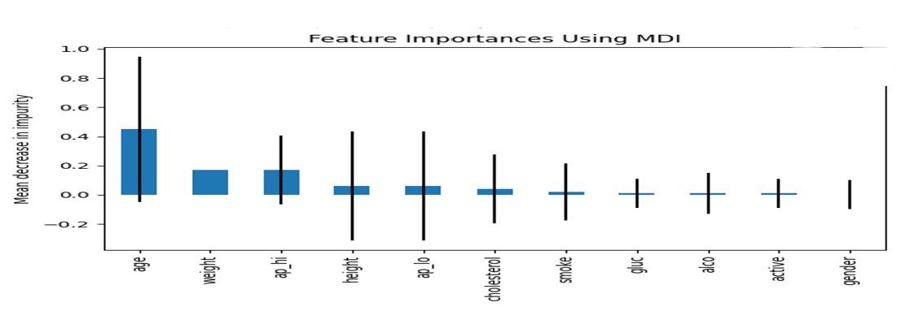

Fig. 1. The Feature importance calculated using the AdaBoost on dataset[1].

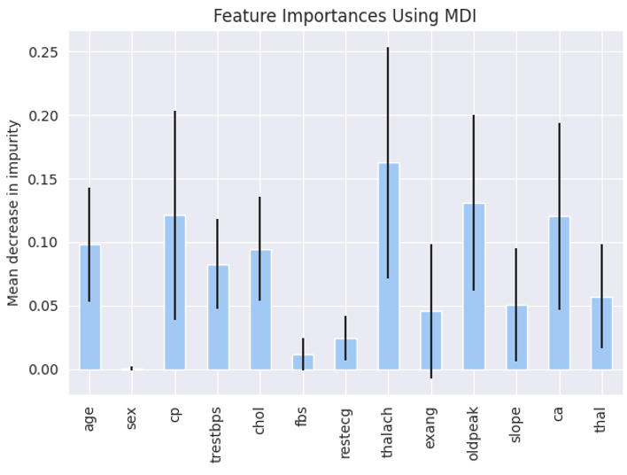Fig. 2. Feature importance of the random forest on the dataset[11].

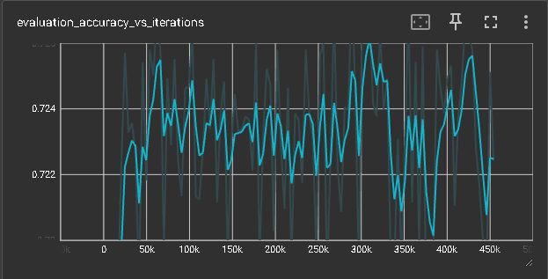
Fig. 3. The evaluation accuracy vs iterations on the neural network on dataset[1]

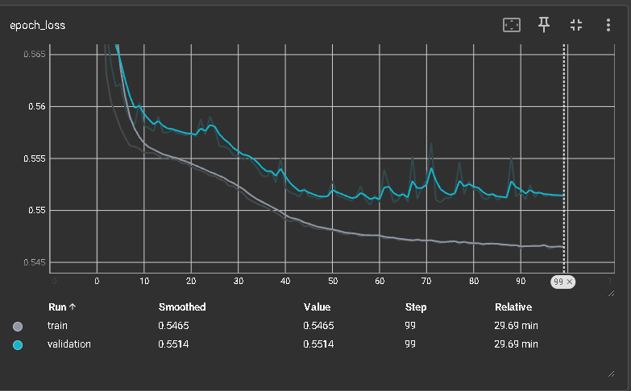Fig. 4. The epoch loss of the neural network

4.1 Explainable AI Techniques :

SHAP(SHapley Additive Predictions). SHAP is a model agnostic explanation technique used to understand the model’s interpretability. The model used with SHAP to interpret is the multilayer perceptron. The outputs are shown in Fig. 5.

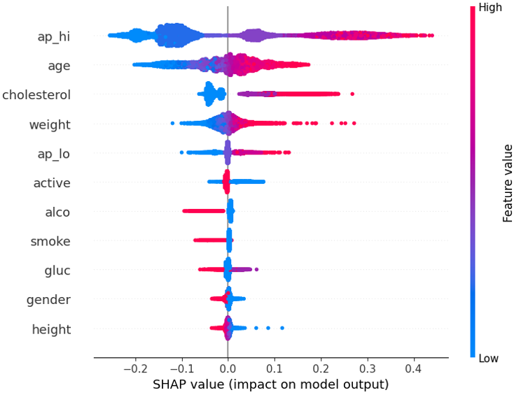

Fig. 5. SHAP results of feature importance for the 70,000 records dataset

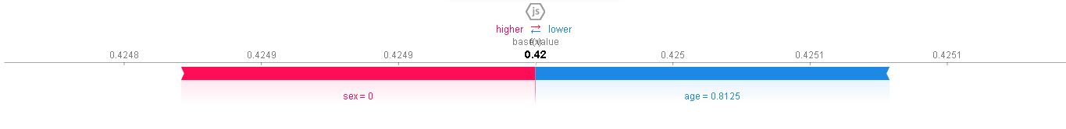

Fig. 6. SHAP force plot for dataset[11] for having the outcome as 1



Fig. 7. SHAP force plot for dataset[11] for having the outcome as 0

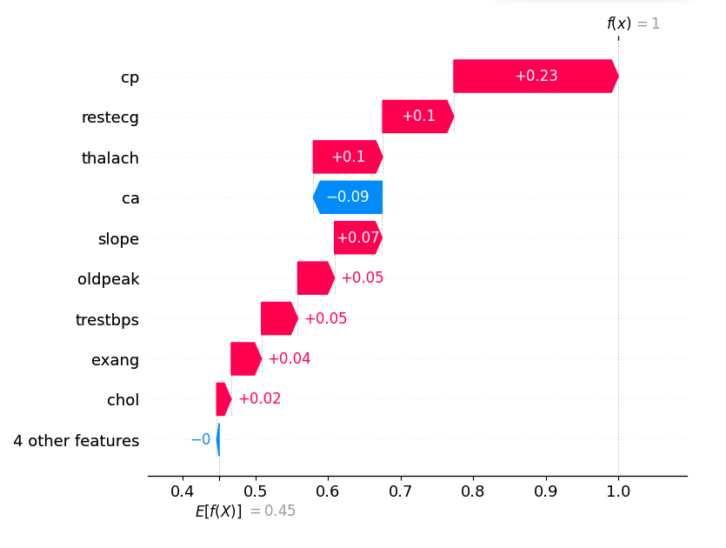

Fig. 8. SHAP waterfall plot for record [0]

DiCE( Diverse Counterfactual Explanations). Diverse counterfactual explanations is a powerful model agnostic library which gives us the possible counterfactuals in a record to get the desired outcome. For example, one of the records in the dataset is shown in Fig. 6.

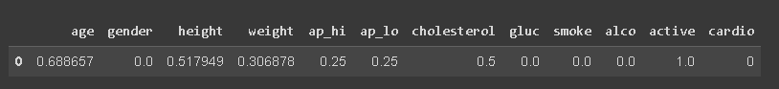
Fig. 9. An example of DiCE outcome to change the value of the target.

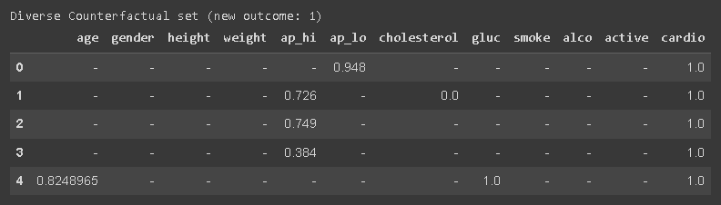
Fig. 10. Multiple Outcomes of DiCE to change the outcome value.

The outcome of DICE outcome is shown in Fig. 7. DiCE can alsobe used to calculate the global feature importance. For a sample of 100 records, global feature importance was calculated as shown in Fig. 8 and Fig. 9.

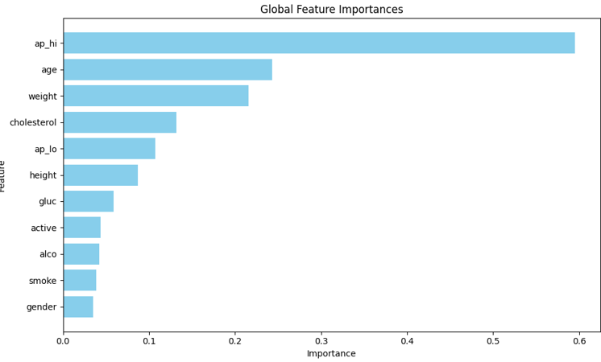
Fig. 11. Global feature importance using DICE on the dataset [1].

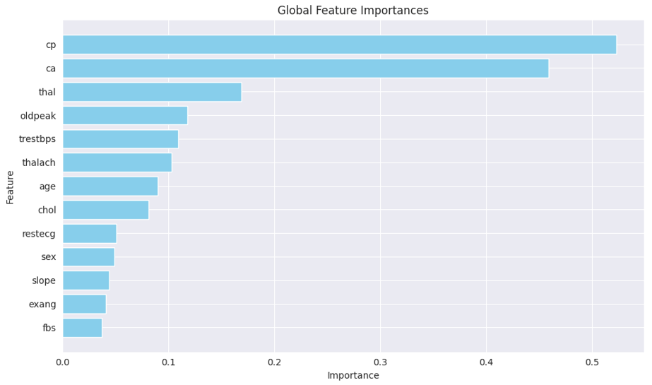Fig. 12. Global feature importance using DICE on the dataset[11]

Experimentation And Results:
The results from SHAP and DiCE are quite interesting and the analysis of the data gave the results as follows:
The analysis of the dataset [1] revealed that the features ‘ap_hi’ (systolic blood pressure) and ‘age’ are highly significant in predicting heart-related issues. Systolic blood pressure is a critical factor and could be a primary reason for heart problems. Age is also influential, as the risk of cardiac issues increases with age. Additionally, ‘cholesterol’ and ‘weight’ are important features; if not managed properly, they can be detrimental to heart health.
In contrast, the analysis of the dataset [11] highlighted the significant impact of features such as ‘cp’, ‘ca’, and ‘thalach’. ‘cp’ (chest pain type) is one of the most important indicators of heart disease. ‘ca’ (number of major vessels colored by fluoroscopy) is another crucial feature. ‘thalach’ (maximum heart rate) can indicate underlying heart conditions like heart arrhythmia.

5 Conclusion
The results and the model’s predictions clearly indicate that maintaining a healthy lifestyle significantly reduces the likelihood of developing cardiac issues. This finding underscores the critical role of preventive measures in cardiovascular health. However, the explainability of black-box models remains a crucial challenge. As these models become increasingly complex and powerful, understanding their decision-making processes becomes more difficult.
Explainability is essential not only for gaining the trust of healthcare professionals and patients but also for ensuring that the models’ predictions are reliable and actionable. Therefore, it is imperative to advance the concept of explainability by developing better tools and techniques. These advancements should aim to minimize the trade-off between performance and interpretability, allowing us to harness the full potential of machine learning models while maintaining transparency and accountability.
Future research should focus on creating explainable AI frameworks that can provide clear, understandable insights into model behaviour. This will involve integrating explainability methods such as LIME, SHAP and counterfactual explanations, into the model development process. By doing so, we can ensure that the models not only perform well but also offer valuable explanations that can guide clinical decision-making and improve patient outcomes.

References

1. Cardiovascular Disease Dataset, https://www.kaggle.com/datasets/sulianova/cardiovascular-disease-dataset, last accessed 2024/07/30.

2. Bhatt CM, Patel P, Ghetia T, Mazzeo PL. Effective heart disease prediction using machine learning techniques. Algorithms. 2023 Feb 6;16(2):88.

3. Gabbay F, Bar-Lev S, Montano O, Hadad N. A lime-based explainable machine learning model for predicting the severity level of covid-19 diagnosed patients. Applied Sciences. 2021 Nov 5;11(21):10417.

4. Llugiqi M, Ekaputra FJ, Sabou M. Leveraging Knowledge Graphs for Enhancing Machine Learning-based Heart Disease Prediction,2021.

5. Zhang C, Bengio S, Hardt M, Recht B, Vinyals O. Understanding deep learning (still) requires rethinking generalization. Communications of the ACM. 2021 Feb 22;64(3):107-15.

6. Burkart N, Huber MF. A survey on the explainability of supervised machine learning. Journal of Artificial Intelligence Research. 2021 Jan 19;70:245-317.

7. Meyuhas I, Ben Arie A, Horesh Y, Deutch D. CFDB: Machine Learning Model Analysis via Databases of CounterFactuals. InProceedings of the 2022 International Conference on Management of Data 2022 Jun 10 (pp. 2401-2404).

8. Binder A, Bach S, Montavon G, Müller KR, Samek W. Layer-wise relevance propagation for deep neural network architectures. InInformation science and applications (ICISA) 2016 2016 (pp. 913-922). Springer Singapore.

9. Linardatos P, Papastefanopoulos V, Kotsiantis S. Explainable ai: A review of machine learning interpretability methods. Entropy. 2020 Dec 25;23(1):18.

10. Mothilal RK, Sharma A, Tan C. Explaining machine learning classifiers through diverse counterfactual explanations. InProceedings of the 2020 conference on fairness, accountability, and transparency 2020 Jan 27 (pp. 607-617).

11. Janosi,Andras, Steinbrunn,William, Pfisterer,Matthias, and Detrano,Robert. (1988). Heart Disease. UCI Machine Learning Repository. https://doi.org/10.24432/C52P4X.

