**TASK 10: PERFORM DATA VISUALIZATION USING DIFFERENT LIBRARIES**

**AIM:**Performing Data Visualization using different libraries

**Dataset Description:**

* The tips dataset is used for performing data visualizations/
* It is a dataset of dimensions 244 rows x 7 columns and has no missing values.

**Source Code:**

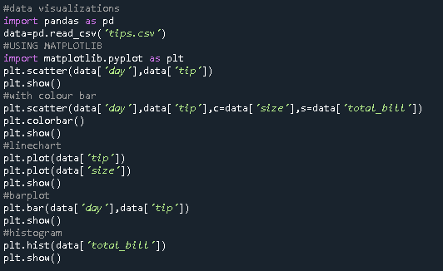

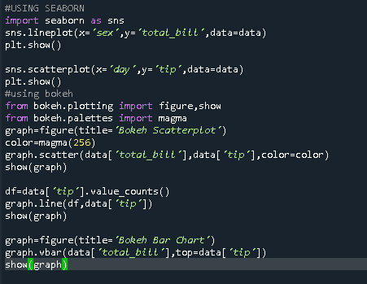

**Outputs:**

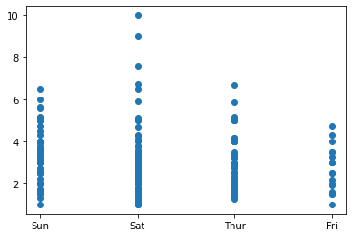

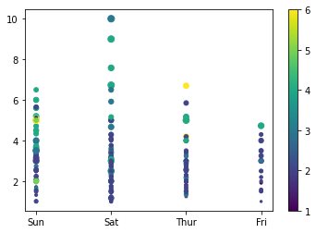

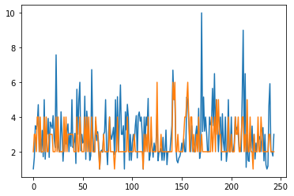

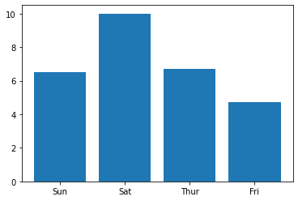

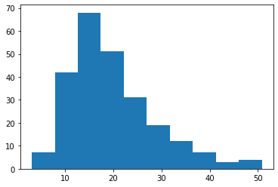

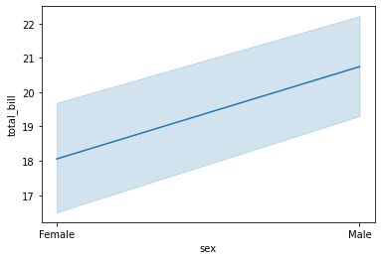

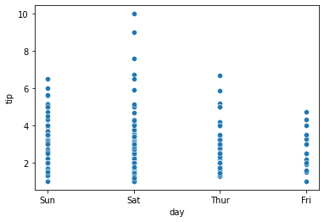

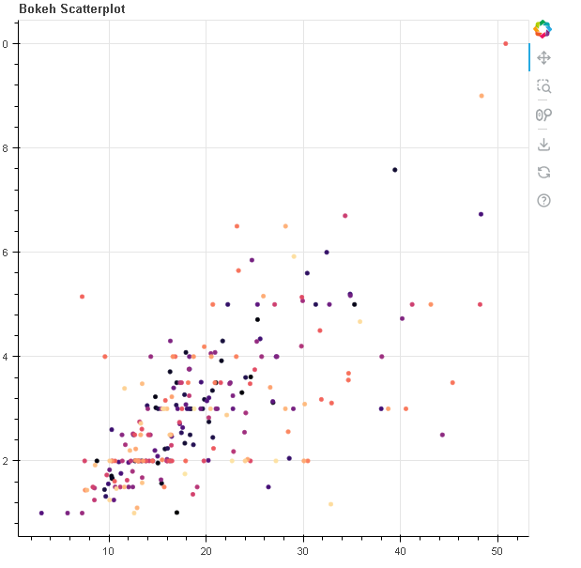

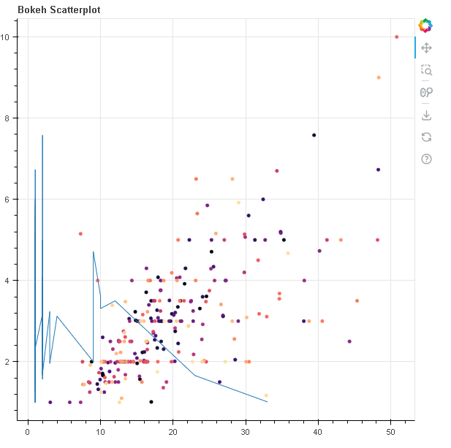

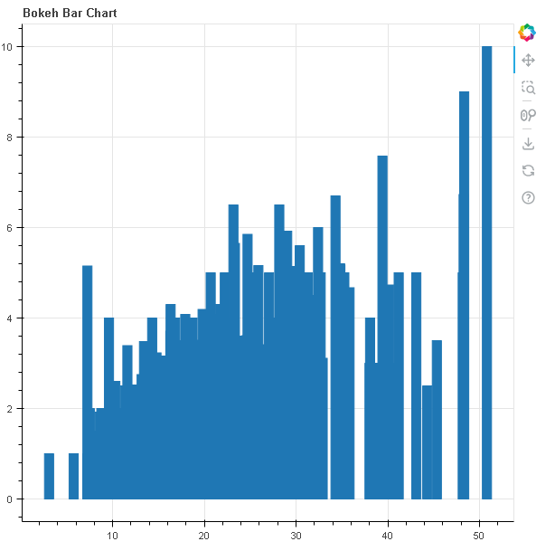

**Observations:**

* Matplotlib is a powerful library where we can construct many plots.However, matplotlib is having many parameters to pass.
* Seaborn is another powerful library for visualization which can construct many plots and is easier to use
* Bokeh is a great data visualization library which can create some advanced visualizations and can generate the visualizations in web format.

**Conclusion:**

The type of library is to be chosen as per the requirement and as per the plot.