AI TRAINING – ASSIGNMENT 01
AI Fundamentals: Explore, Understand & Explain
Self-Exploration Assignment | Beginner Level
Topic Area | AI overview, AI vs ML vs DL vs GenAI, use cases, and career map
Mode | Self-exploration + research + practical thinking
Suggested Time | 2–3 hours
Submission | One document / PDF containing your answers, examples, and reflections

1. What is this assignment about?
This is not a memorization assignment. Your goal is to explore AI yourself, understand the basic concepts, and explain them in simple words. You are expected to search, watch short videos if needed, use AI tools for clarification, and compare information from multiple sources.
Important: Do not simply copy an AI-generated answer. Use AI as a learning assistant, then rewrite the ideas in your own words and add your own examples.
2. Learning Goals
- Understand what Artificial Intelligence means at a high level.
- Clearly distinguish AI, Machine Learning, Deep Learning, and Generative AI.
- Identify real-world AI use cases across different industries.
- Understand the major career paths available in AI and related technology roles.
- Explain the concepts in your own words instead of relying on textbook definitions.
- Apply the concepts to a practical real-world example.
- Identify common misunderstandings or errors and improve your explanation.
3. Your Mission
Imagine that a friend who knows nothing about AI asks you: “What exactly is AI, what is the difference between AI, ML, DL and GenAI, where is AI used, and what can I become if I learn AI?”
Your job is to create a beginner-friendly answer that your friend can understand in 10 minutes.
4. Step 1 – Explore: What is AI?
Do your own research and answer the following questions:
1. What is Artificial Intelligence in your own words?
A.Artificial intelligence is a technology that enables machines /computers to perform tasks that normally require human intelligence
2. What makes a system 'intelligent'?
A intelligent system is a system that can learn from data , understand information, solve promblems and make decisions
3. Give at least 5 examples of AI that you may interact with in daily life.
A.face recognition,voice recognition, recommendation system, google maps, error detection,
4. Choose one AI example and explain what the system is doing.
A. Youtube recommendation-When we watch a video on YouTube, search for videos, like them, or skip them, YouTube analyzes our activity to understand our interests. Based on this, it recommends videos that match our interests.
5. Is every software application an AI application? Explain why or why not.
No. Not every software application is an AI application. Some software only follows fixed instructions and does not learn or make decisions. AI applications can learn from data and perform tasks that need human-like intelligence.
6. What are 2 things AI can do well and 2 things AI may struggle with?
A. 1.Analyze large amounts of data quickly.
2. understand speech
AI MAY STRUGGLE WITH :
1.Humans emotions does't understand
2.Giving correct answers all the time, especially when the data is incomplete or wrong.

Research rule: Use at least 3 learning sources. These can be articles, videos, official documentation, or educational websites.
Tip: Try searching for simple explanations first. If two sources disagree, investigate why.
5. Step 2 – The Big Picture: AI vs ML vs DL vs GenAI
This is the most important part of the assignment. Do not memorize definitions. Build a mental model.
First, complete this comparison table in your own words:
Concept | What is it? | How does it learn/work? | Simple example | Relationship | Your analogy
AI | The broad science of making machines that act/think like humans | Use rules/logic or patterns to help solve problems or make decisions | Face recognition is an example of ai becouse it can analyze facial feature and identify or verify a person | The overarching concept that ML + DL + GenAI all fall under | big umbrela
Machine Learning (ML) | The method of ai training where computer learnregularities from data sets instead of using hard-coded instructions | ML works by learning patterns from data and using those patterns to make predictions or make decisions | self- drivings cars | The engines that underlies most of modern AI, is part of the broader concept of AI | A students learing from ,many examples and then solving a new problem
Deep Learning (DL) | An ML disciplain that use multi layered networks to extrapolate associations from large sets of data | DL learns complex patterns from data useing multiple neural natwork layers and use them to produce an output | Face recognition on phones or selfdriving cars | A specific area of ML, which enables computers to discern subtle patterns. The advanced quality-control cameras that can individually spot microscopic p | The advanced quality-control cameras that can individually spot microscopic product defects
Generative AI (GenAI) | A type of DL, which allows computers to generate new data as opposed to simply identifying patterns | Process natural language or images to create new text/images with similar content | ChatGPT writing essays or Midjourney image creation | GenAI is a part of AI that uses ML/DL to create new content. | sometimes,if you ask for something impossible, the chef will confidently serve you a dish that looks perfect but tastes like cardboard

Now answer these questions:
1. Is ML a part of AI? Explain with a simple example.
A.Yes. ML is “a method of AI training” and is the “engine” which underlies most of modern AI. Think of AI as the overarching concept, with ML nested inside of it. A simple example would be the spam filter in your email. Instead of a human writing a permanent rule of what looks like spam, ML learns regularities from data sets to find junk mail automatically.
2. Is Deep Learning a type of Machine Learning? Explain.
a. Yes. Deep Learning is a type of Machine Learning that uses neural networks with multiple layers to learn complex patterns from data.
3. Is Generative AI the same thing as AI? Why?
No. AI is the broad, “overarching concept” of making machines act or think like humans. Generative AI is essentially the exact opposite of broad, and it is in fact the most “deepest layer of AI.” While a standard AI might use basic logic to solve a problem, GenAI is programmed to parse through natural language or images to generate original content (such as ChatGPT)
4. Can an AI system exist without Machine Learning? Research and explain one example
.A.Yes. An AI system can exist without Machine Learning. Some AI systems use predefined rules and logic instead of learning from data. Example: chess game
5. Draw a simple diagram showing the relationship between AI, ML, DL and GenAI.
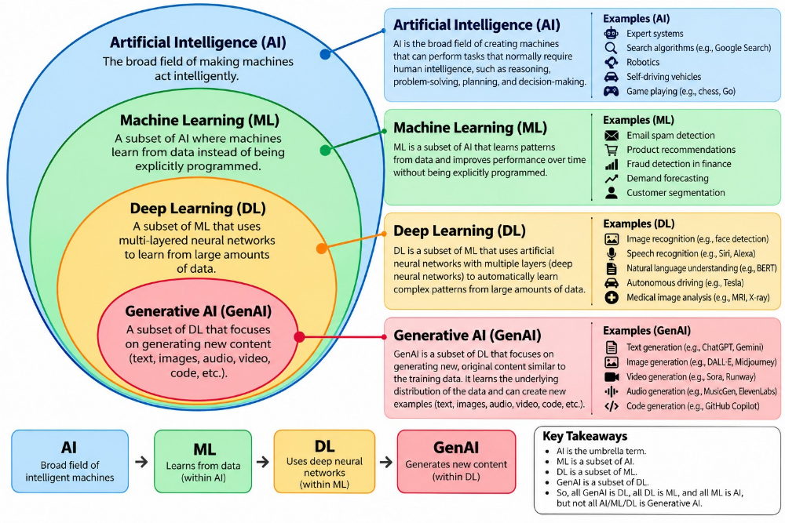

6. Create one real-world analogy to explain all four concepts together.
A.AI: A fully automated factory that builds products without human hands.
ML: The robotic assembly line inside the factory that learns how to put together the products faster over time.
DL: The advanced quality-control cameras that can individually spot microscopic product defects on that assembly line.
GenAI: The automated R&D department that can devies broad new product designs from scratch
6. Step 3 – Use Case Hunt
Find AI applications in different industries. Do not use only ChatGPT examples.
Industry | AI use case | AI / ML / DL / GenAI? | Who benefits? | What could go wrong?
Banking / Finance | Fraud Detection: analyzing a stream of transactions to spot suspicious transactions | ML | Customers with stolen cards don’t lose money; banks lose fewer fraud payments. | Legitimate-looking card payments get declined when traveling abroad, or fraud is accidentally authorized.
Healthcare | Automated Medical Imaging – scanning Xrays or MRI scans to spot signs of tumors | DL(CNN) | Doctors spend less time on routine scans; patients get better care. | AI may give a wrong diagnosis, which could lead to incorrect treatment.
Education | Personalized Learning – generating customized study questions for a student’s skill level | GEN AI (LLM) | Students get 24/7 learning support; teachers spend less time crafting quizzes | AI may confidently make up fake history or math concepts
Retail / E-commerce | Product Recommendations : recommending products based on what customers search, view, or buy | ML | Customers find relevant products faster; stores can improve the shopping experience. | AI may recommend irrelevant or unsuitable products to customers
Manufacturing | Predictive Maintenance is AI predicts when a machine may fail | ML | Factory workers and companies | AI may make a wrong prediction.
Agriculture | Crop Disease Detection – scanning photos of crops to spot health issues | DL | Farmers treat only affected plants/crops, reducing pesticide use | AI may detect a disease incorrectly.
Transportation | Traffic Management – AI analyzes traffic and helps manage traffic flow. | DL | Drivers and passengers | AI may make a wrong traffic decision.
Entertainment / Media | Content Recommendation – AI recommends movies, videos, or music based on user activity. | GENAI | Users and media companies | AI may recommend irrelevant or repetitive content.

Challenge: Find one AI use case that you think is surprisingly useful and explain why.
AI-Based Electricity Saving System
The AI-Based Electricity Saving System helps people save electricity in homes, colleges, offices, and businesses. It collects information about the electricity used by lights, fans, ACs, and computers.AI checks this information and learns the normal usage. If too much electricity is being used or some appliances are not needed, the system alerts the user and gives suggestions to save electricity.For example, it may suggest turning off unused appliances or using the AC less during some hours. It can also predict future electricity usage and help reduce electricity bills.
This system helps save electricity, save money, and reduce energy waste

7. Step 4 – Mini Practical Exercise: Design an AI Solution
Choose ONE problem from your college, personal life, local community, or a business you know. Design a simple AI-based solution. You do not need to build the software.
1. What problem are you trying to solve?
A.I am trying to solve the problem of unnecessary electricity usage and energy waste
2. Who faces this problem?
A.Students, families, offices, colleges, and businesses face this problem
3. What information/data would your system need?
A.The system would need data about electricity usage from lights, fans, ACs, computers, and other appliances.
4. Would you use AI, ML, DL, GenAI, or a combination? Why?
A.I would use Machine Learning (ML) because it can learn the normal electricity usage and find unusual usage.
5. What would the system take as input?
A.It would take electricity usage data and the time of usage.
6. What would the system produce as output?
A.It would give alerts, saving suggestions, and future electricity usage predictions
7. Give one example of how a user would interact with it.
A.For example, a user checks the app and sees an alert saying that the AC is using too much electricity
8. What could go wrong with your solution?
A. The system may give a wrong alert or make an incorrect prediction about electricity usage.
9. How would you reduce or handle that risk?
A.I would use accurate data, test the system regularly, and allow users to check the information before taking action.
Example idea (do not copy): A college assistant that answers student questions about assignments, attendance rules, and course material.
8. Step 5 – Career Map: Where Can AI Take You?
Explore AI-related career paths. The goal is not to decide your career today; it is to understand what different roles actually do and what skills they require.
Role | What do they do? | Key skills | Typical tools/technologies | Would I explore it? Why?
AI / ML Engineer | Build and deploy AI and Machine Learning systems. | Python, ML, problem-solving, statistics | Python, Scikit-learn, TensorFlow, PyTorch | Yes. I like building AI systems and solving problems.
Data Scientist | Analyze data and build models to find patterns and make predictions. | Python, statistics, data analysis, ML | Python, Pandas, NumPy, Jupyter | Yes. I am interested in finding useful information from data.
Data Analyst | Study data and create reports to help businesses make decisions. | Excel, SQL, data visualization, communication | Excel, SQL, Power BI, Tableau | Yes. I like working with data and finding useful insights.
Generative AI / LLM Engineer | Build applications that use AI models to generate text, images, code, or other content. | Python, LLMs, prompt design, APIs | Python, PyTorch, Hugging Face, LLM APIs | Yes. I am interested in Generative AI and how AI creates content.
AI Product Manager | Plan AI products and work with technical teams to build useful products. | Communication, planning, business knowledge, AI basics | analytics tools, AI platform | I LIke planning products and working with people and technology.
AI Researcher | Develop new AI methods, algorithms, and models through research and experiments. | Mathematics, research, ML, problem-solving | Python, PyTorch, TensorFlow, research papers | I enjoy learning how new AI methods are developed
Computer Vision Engineer | Build systems that understand images and videos. | python,deep learning | openCN,CNNs | interested in how computers can understand images and videos.
NLP Engineer | Teach computers to understand human language | Understanding of syntax structure, text pattern recognition | Python, Hugging Face, GPT | Yes: NLP is all about extracting valuable insights and patterns from text data, which is similar to my dashboard project where I used Python to analyze and explain data
MLOps / AI Platform Engineer | Automate pipelines- create automated workflows for data ingestion, model training testing and deployment | Cloud infrastructure and automation | Docker, Kubernetes, AWS, GitHub Actions | Maybe: As I have achieved the 'DevOps Decode' certification, and I am very interested in learning how to deploy applications to the cloud
AI Application Developer | Create the website or mobile application that users interact with, often involving some back-end development to connect different parts of the system | Front-end web development, API integration | Python, Streamlit, HTML/CSS, REST APIs | Absolutely: This type of work is exactly what I am aiming to do! Using Python and Streamlit to build web applications with embedded GenAI features is my preferred approach
9. Step 6 – Career Self-Check
Based on your exploration, answer:
Which AI-related role interests you most right now?
A.I am most interested in becoming an AI Application Developer
Why does it interest you?
A. I love the idea of building complete end-to-end web applications that people will actually use. This role allows me to combine traditional software engineering with cutting-edge AI capabilities (like chatbots or data readers) without having to do heavy mathematical modeling.
What skills do you already have that may help?
A.The technical skills I already have include proficiency in Python and SQL. Through my previous project, I also acquired knowledge of using the Streamlit framework, and I have successfully built a connection between the Gemini API and a working prototype of an application.
What are 3 skills you need to learn next?
A. 1 Back-end development: I need to learn web frameworks such as FastAPI or Node.js
2. Front-end development: To build better interfaces than the default Streamlit one, I need to improve my HTML, CSS, and JavaScript skills
3. Cloud deployment: I should also learn the fundamentals of cloud infrastructure and how my application can be hosted there using Docker and AWS (in the context of my DevOps Decode)
What would your 2-month learning roadmap look like?
A.In the first month, I would focus on learning web development fundamentals. This would entail doing a short course on FastAPI (to develop the back end of my apps) and studying JavaScript (to build better interfaces). In the second month, I would spend more time learning how my web apps can be deployed using cloud infrastructures. To practice, I could take my Smart Data Analytics Dashboard, containerize it with Docker, and then deploy it on a cloud platform so that it becomes accessible to anyone with an Internet connection
What would you like to build after learning the basics?
A.I would like to develop a Full-Stack Smart Study Assistant. It would be a web app where students can upload their class notes (in PDF format or as text), and the system would use an AI API to generate a study guide, a practice quiz, and simplified explanations of difficult concepts
10. Step 7 – Common Errors: Find and Fix Them
For each statement below, decide whether it is correct, partially correct, or incorrect. Then explain why.
1. “AI and Machine Learning are exactly the same thing.”
Your verdict + correction: NO ,Artificial intelligence is technology that enables computers to perform tasks that normally require human intelligence and Ml is a subset of ai ,that enables computers to learn from data improve their performance without being explicity programmed for every task
2. “Deep Learning is unrelated to Machine Learning.”
Your verdict + correction: NO,ML and DL both learn from data. DL is a type of ML that uses multiple layers of neural networks to learn complex patterns, especially from large amounts of data.
3."ChatGPT is just a search engine"
Your verdict + correction:No. ChatGPT is not just a search engine. It is a Generative AI system that can understand questions and generate answers, explanations, summaries, and other content.
4. “Generative AI always gives correct answers.”
Your verdict + correction: NO,because Generative AI does not always give correct answers. It can sometimes provide incorrect or misleading information.
5. “If a company uses AI, it does not need humans anymore.”
Your verdict + correction: NO,. AI can help humans perform tasks faster and more efficiently, but humans are still needed for decision-making, creativity, communication, problem-solving, and managing AI systems.
6. “More data automatically means a better AI system.”
Your verdict + correction: No. More data does not always make an AI system better. The data should be accurate, relavent and high-quality
11. Step 8 – Teach It Back
Pretend you are the trainer. Explain the following in a way that a Class 10 student can understand:
1. What is AI?:
A.Artificial intelligence(AI) is a technology that enables machines to perform tasks that normally require human intelligence
2. AI vs ML:
A.Artificial intelligence(AI) is a technology that enables manchines to perform tasks that normally require human intelligence
ML Machine learning :ML is a subset of AI that allows computers to learn from data and improve their performance without being explicitly programmed for every tasks
3. ML vs DL:
A.ML is a subset of AI that allows computers to learn from data and improve their performance without being explicitly programmed for every task.
A.Deep learing is a subset of ML that uses multi layared artificial neural networks to learn complex pattern from large amount of data
4. What is Generative AI?:
A.generative ai is an ai technology that can create new content such as text ,images,audio,video,and code
5 One real-world AI use case:
A. Youtube recommendation-When we watch a video on YouTube, search for videos, like them, or skip them, YouTube analyzes our activity to understand our interests. Based on this, it recommends videos that match our interests.
6. One AI career path:
A.web developer ,deep learning,data ,machine learing, data analytics.
12. Final Challenge – 5-Minute AI Explanation
Record a 3–5 minute video or prepare a 1-page explanation as if you are teaching a friend. You must cover: AI → ML → DL → GenAI → real-world use case → career path.
Optional: Use a diagram, analogy, or story. Avoid reading a copied definition.
13. What to Submit
- AI explanation in your own words
- AI vs ML vs DL vs GenAI comparison table
- Relationship diagram
- 8-industry use-case table
- One AI solution design
- AI career map
- Career self-check
- Common errors and corrected explanations
- Teach-it-back answers
- Final 3–5 minute explanation OR 1-page summary
14. Self-Evaluation Checklist
I can... | Yes | Need More Practice | Notes
Explain AI without using a memorized definition. | Yes | ☐ | I can explain AI in my own words.
Explain the relationship between AI, ML, DL and GenAI. | Yes | ☐ | I understand how AI, ML, DL, and GenAI are related.
Give real-world examples of AI. | Yes | ☐ | Examples like YouTube recommendations and face recognition.
Identify whether a use case involves ML, DL or GenAI. | Yes | ☐ | I can identify common AI use cases.
Explain at least 5 AI career roles. | Yes | ☐ | Data scientist,AI Enginner,prompt Engineer,NLP Engineer,Machine Learing Engineer
Design a basic AI solution for a real problem. | Yes |  | I designed an AI-based electricity-saving system.
Identify common AI misconceptions. | Yes | ☐ | I can identify common wrong ideas about AI
Teach the basics of AI to another person. | Yes | ☐ | I can explain AI, ML, DL, and GenAI in simple words
15. Rules for Using AI During This Assignment
- You MAY use ChatGPT, Gemini, Claude, Perplexity, YouTube, Google, and other learning resources.
- Use AI to explain, compare, question, and give examples—not to blindly copy your submission.
- If you use an AI-generated explanation, verify it using another source.
- Your final answers should be written in your own words.
- If you discover that an AI tool gave you an incorrect answer, mention the mistake and explain the correction. This is part of the learning.
- Add sources/links for important information you researched.
16. Trainer's Evaluation Guide
Area | What to look for | Suggested Weight
Concept understanding | Correct distinction between AI, ML, DL and GenAI | 25%
Own explanation | Simple language, examples, analogies, not copied definitions | 20%
Use cases | Relevant and correctly classified examples | 15%
Practical thinking | Problem → data → AI approach → output → risks | 20%
Career exploration | Understanding of roles and skills | 10%
Reflection & error correction | Can identify and fix misconceptions | 10%

Remember: The goal is not to know everything about AI today. The goal is to learn how to explore, question, understand, and explain AI.

