AI ASSISTED CODING

ASSIGNMENT-8.4

BATCHN0:04

ROLLNO:2403A52082

TASK-1:

PROMPT:input:3 and output:9.write a python code that gives square of a number and satisfies the given test case

Code:

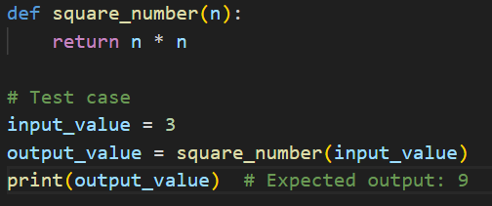

Output:

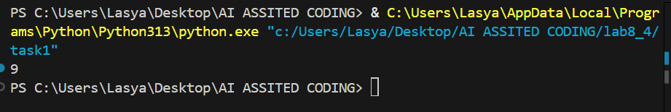

Observation:

this code defines a function to return the square of a number and prints the square of 3, which is 9.

TASK-2:

PROMPT: INPUT:user@example.com and write a python code to satisfy the given input

Code:

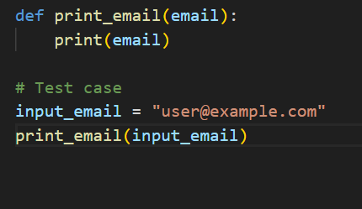

Output:

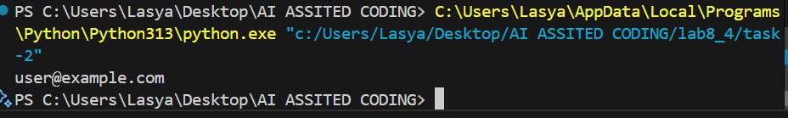

Observation: This code defines a function [print_email(email)](vscode-file://vscode-app/c:/Users/Lasya/AppData/Local/Programs/Microsoft%20VS%20Code/resources/app/out/vs/code/electron-browser/workbench/workbench.html) that prints the given email address.It sets [input_email](vscode-file://vscode-app/c:/Users/Lasya/AppData/Local/Programs/Microsoft%20VS%20Code/resources/app/out/vs/code/electron-browser/workbench/workbench.html) to "user@example.com" and calls [print_email(input_email)](vscode-file://vscode-app/c:/Users/Lasya/AppData/Local/Programs/Microsoft%20VS%20Code/resources/app/out/vs/code/electron-browser/workbench/workbench.html" \o "), which outputs the email to the console.

TASK-3:

PROMPT: input:a=3,b=10,c=5 and max=b and write a python code to get max of three numbers and satisfies the input.

Code:

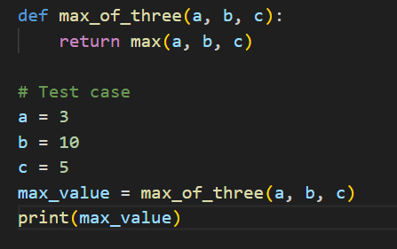

Output:

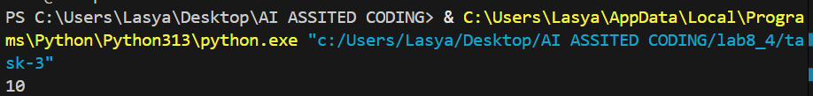

Observation: This code defines a function [max_of_three(a, b, c)](vscode-file://vscode-app/c:/Users/Lasya/AppData/Local/Programs/Microsoft%20VS%20Code/resources/app/out/vs/code/electron-browser/workbench/workbench.html" \o ") that returns the largest of three numbers using Python’s built-in [max()](vscode-file://vscode-app/c:/Users/Lasya/AppData/Local/Programs/Microsoft%20VS%20Code/resources/app/out/vs/code/electron-browser/workbench/workbench.html) function.  
It sets [a = 3](vscode-file://vscode-app/c:/Users/Lasya/AppData/Local/Programs/Microsoft%20VS%20Code/resources/app/out/vs/code/electron-browser/workbench/workbench.html), [b = 10](vscode-file://vscode-app/c:/Users/Lasya/AppData/Local/Programs/Microsoft%20VS%20Code/resources/app/out/vs/code/electron-browser/workbench/workbench.html), and [c = 5](vscode-file://vscode-app/c:/Users/Lasya/AppData/Local/Programs/Microsoft%20VS%20Code/resources/app/out/vs/code/electron-browser/workbench/workbench.html), then finds and prints the maximum value, which is 10.

TASK-4:

PROMPT: INPUT:add_item-apples,remove_item grapes,total_price and write a python code to satisfy the given inputs.

Code:

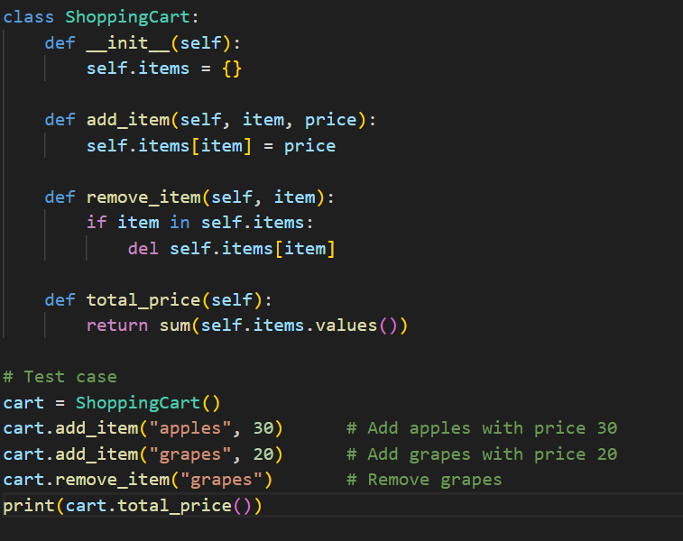

Output:

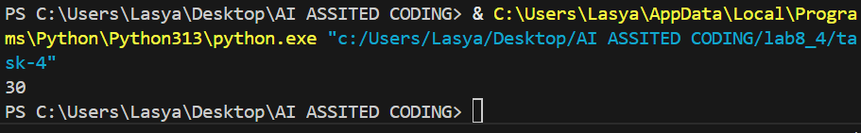

Observation: This code creates a shopping cart, adds apples and grapes, removes grapes, and prints the total price (30).

TASK-5:

PROMPT: INPUT:121,OUTPUT:PALINDROME AND WRITE A PYTHON CODE THAT SATISFIES THE TESTCASE

CODE:

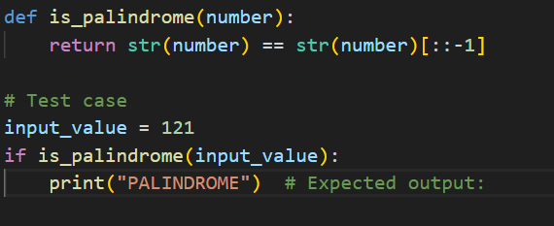

OUTPUT:

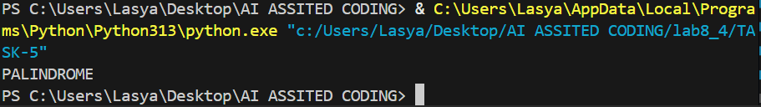

EXPLANATION: This code defines a function [is_palindrome(number)](vscode-file://vscode-app/c:/Users/Lasya/AppData/Local/Programs/Microsoft%20VS%20Code/resources/app/out/vs/code/electron-browser/workbench/workbench.html" \o ") that checks if a number reads the same forwards and backwards by converting it to a string and comparing it to its reverse.  
It tests the function with 121, and prints "PALINDROME" if the number is a palindrome.