AI ASSISTED CODING

BATCHNO:04

ASSIGNMENT-6.4

ROLLNO:2403A52082

TASK-1:

• Start a Python class named Student with attributes name, roll_number, and marks. Prompt  
GitHub Copilot to complete methods for displaying details and checking if marks are above  
average.

PROMPT:

1.Create a Python class named Student with attributes: name, roll_number, and marks.

2.add a method display_details() to print all students information

3.add a method is_passed() that checks if marks are above average (eg:40) and print pass or fail.

4. modify the code for the user to take input from the users.

Code:

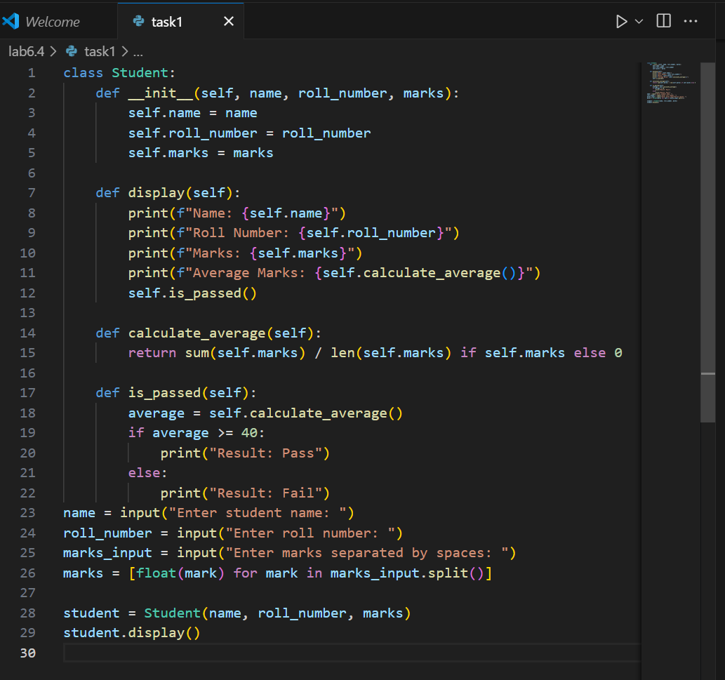

Output:

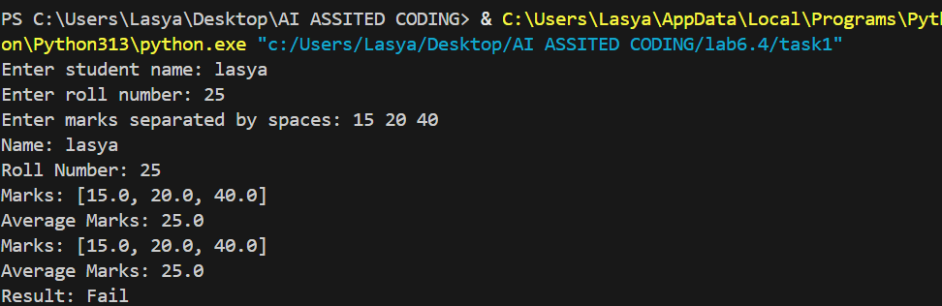

Observation:

The code defines a [Student](vscode-file://vscode-app/c:/Users/Lasya/AppData/Local/Programs/Microsoft%20VS%20Code/resources/app/out/vs/code/electron-browser/workbench/workbench.html) class with attributes for name, roll number, and marks. It calculates the average marks and checks if the student has passed (average ≥ 40). The program takes user input for all attributes and displays the student's details and result.

TASK-2:

Write the first two lines of a for loop to iterate through a list of numbers. Use a comment prompt to let Copilot suggest how to calculate and print the square of even numbers only

PROMPT:

write a code to print the square of the even numbers only

CODE:

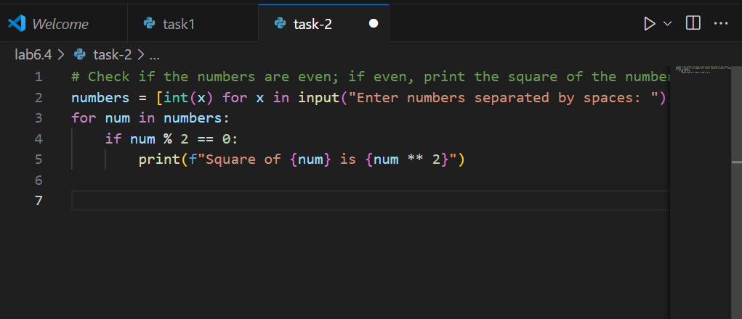

OUTPUT:

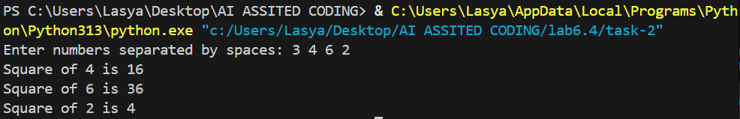

OBSERVATION:

The code takes a list of numbers as input, checks each number to see if it is even, and prints the square of each even number. Odd numbers are ignored.

TASK3:

Create a class called BankAccount with attributes account_holder and balance. Use Copilot to

complete methods for deposit(), withdraw(), and check for insufficient balance.

PROMPT: Create a Python class called BankAccount with attributes account_holder and balance. Implement methods deposit(amount), withdraw(amount), and get_balance(). The withdraw method should check for insufficient funds and prevent overdrawing. Include print statements to show transaction results and current balance.

CODE:

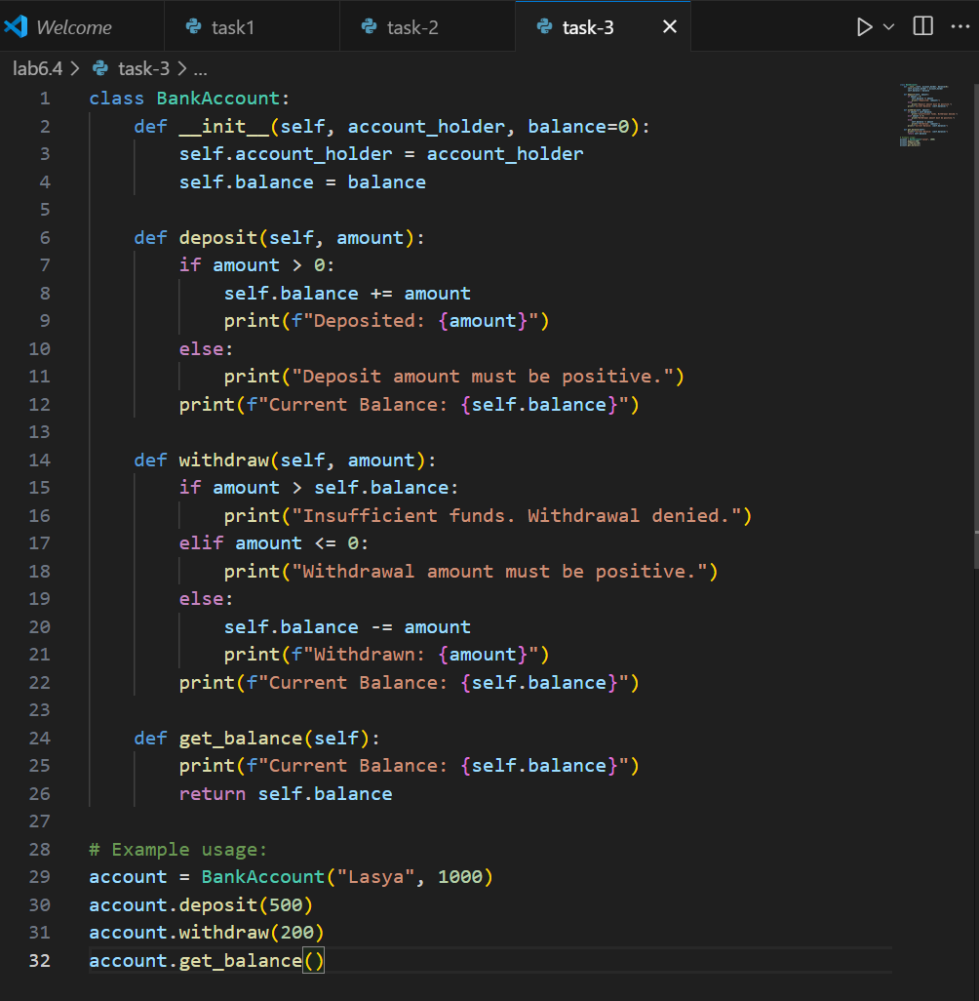

OUTPUT:

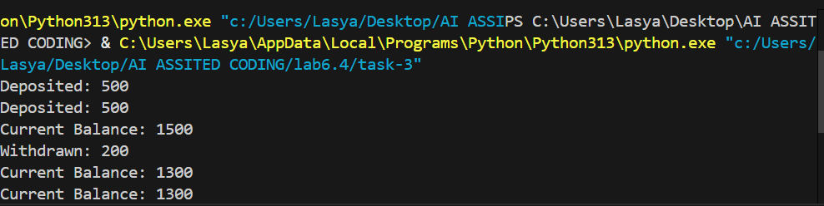

EXPLANATION:

The code defines a BankAccount class with methods to deposit and withdraw money, check for insufficient funds, and display the current balance. It shows transaction results using print statements. An example demonstrates creating an account and performing transactions.

TASK4:

Define a list of student dictionaries with keys name and score. Ask Copilot to write a while

loop to print the names of students who scored more than 75.

PROMPT:

Define a list of student dictionaries with keys 'name' and 'score'. Write a complete while loop to print the names of students who scored more than 75, with proper condition checks and formatted output

CODE:

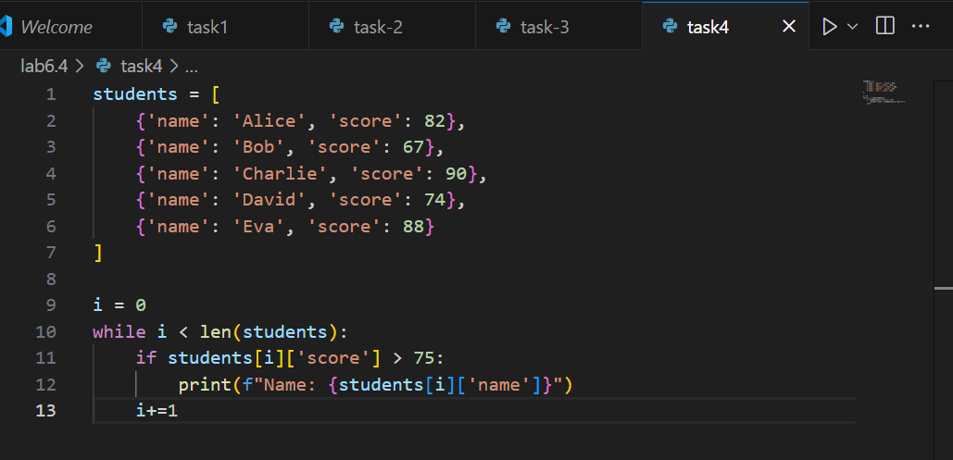

OUTPUT:

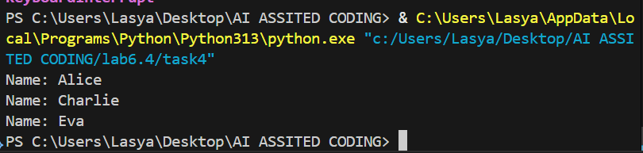

OBSERVATION:

The code defines a list of student dictionaries with names and scores. It uses a while loop to check each student's score, and prints the name of students who scored more than 75. The loop continues until all students are checked.

TASK5:

Begin writing a class ShoppingCart with an empty items list. Prompt Copilot to generate methods to add_item, remove_item, and use a loop to calculate the total bill using conditional discounts.

PROMPT:

write a python code to generate methods to add_item, remove_item, and use a loop to calculate the total bill using conditional discounts.

CODE:

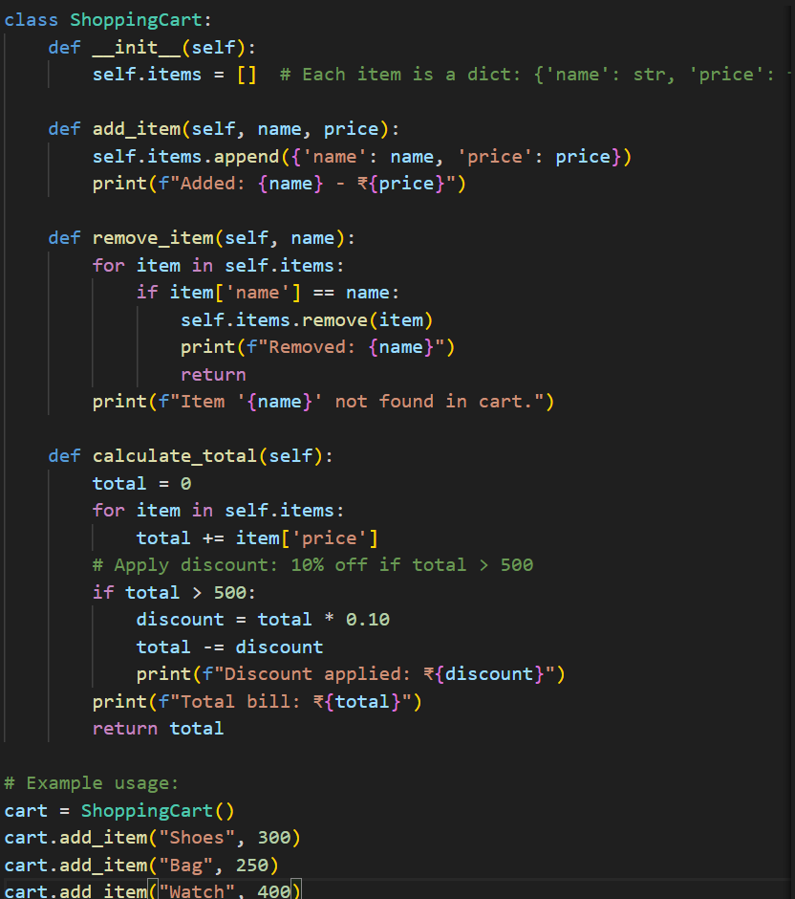

OUTPUT:

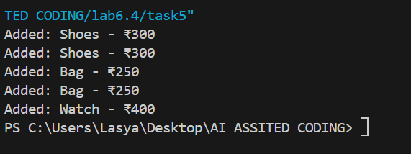

OBSERVATION:

The code defines a [ShoppingCart](vscode-file://vscode-app/c:/Users/Lasya/AppData/Local/Programs/Microsoft%20VS%20Code/resources/app/out/vs/code/electron-browser/workbench/workbench.html" \o ") class with methods to add and remove items, and calculate the total bill. If the total exceeds 500, a 10% discount is applied. Example usage demonstrates adding and removing items, then calculating the final bill.