Cognizant Digital Nurture 4.0
Name: Gandu Lasya Sri
Email: gandulasyasri@gmail.com
Superset ID:6428164
Mandatory Hands-On Exercises
React
Task: 1. ReactJS-HOL

Objectives

Define SPA and its benefits
SPA (Single Page Application) is a type of web application that loads a single HTML page and updates content dynamically using JavaScript, without refreshing the whole page.
Benefits of SPA:
- Fast loading after first visit
- Smooth user experience (no full-page reloads)
- Reduces server load
- Ideal for dynamic apps (like Gmail, Facebook, etc.)

Define React and identify its working
React is a JavaScript library used to build fast and interactive user interfaces (UIs). It was developed by Facebook.
How React Works:
- React uses components (reusable building blocks of UI)
- Uses JSX (JavaScript + HTML syntax)
- React keeps a copy of the actual DOM (called Virtual DOM)
- When data changes, only the required part of the UI updates — not the whole page

Identify the differences between SPA and MPA
SPA (Single Page App) vs. MPA (Multi Page App):
SPA:
- Loads once, then updates dynamically
- Fast after first load
- Smooth, app-like user experience
- More complex development
- Examples: Gmail, Facebook
MPA:
- Loads a new page for each request
- Slower due to full-page reloads
- Traditional website feel
- Simpler development
- Examples: Amazon, Wikipedia

Explain Pros & Cons of Single-Page Application
Pros:
- Fast performance after first load
- Better user experience (no reloads)
- Efficient use of APIs
- Easier to convert into mobile apps
Cons:
- Large initial load
- Poor SEO
- Requires good JavaScript knowledge
- Navigation/history management can be tricky

Explain about React
React is a powerful JavaScript library used to build modern and scalable UIs. It allows developers to build apps using components, making code modular and reusable.
Key Uses:
- Building Single Page Applications (SPA)
- Creating dynamic and responsive UIs
- Building mobile apps (React Native)

Define virtual DOM
Virtual DOM is a lightweight copy of the real DOM maintained by React in memory.
How it works:
- React updates the Virtual DOM when data changes
- Compares it with the old Virtual DOM (diffing)
- Updates only the changed parts in the actual DOM (reconciliation)
This improves speed and efficiency.

Features of React
- Component-Based: UI is split into reusable components
- JSX: JavaScript with HTML-like syntax
- Virtual DOM: Faster updates with efficient diffing
- Unidirectional Data Flow: Data flows from parent to child
- Hooks: Write logic using functions (e.g., useState, useEffect)
- Reusable & Maintainable: Code is clean and easy to manage
React Hands-on Submission: MyFirstReact Application

Step-by-Step Process to Create a React App
1. Create the React App using CRA
In the terminal, run:
npx create-react-app myfirstreact

- This installs all necessary React setup files.
- A new folder named myfirstreact is created.
2. Navigate to Project Folder
cd myfirstreact
3. Open in VS Code
code .
This opens the project folder in Visual Studio Code.
4. Modify App.js to Display Welcome Message
- Go to src/App.js
- Delete all default code
- Replace it with:
import React from 'react';

function App() {
return (
<div>
<h1>Welcome to the first session of React</h1>
</div>
);
}

export default App;
5. Start the Application
Run the app using:
npm start
- This opens the browser at http://localhost:3000
- You will see the message:
Welcome to the first session of React

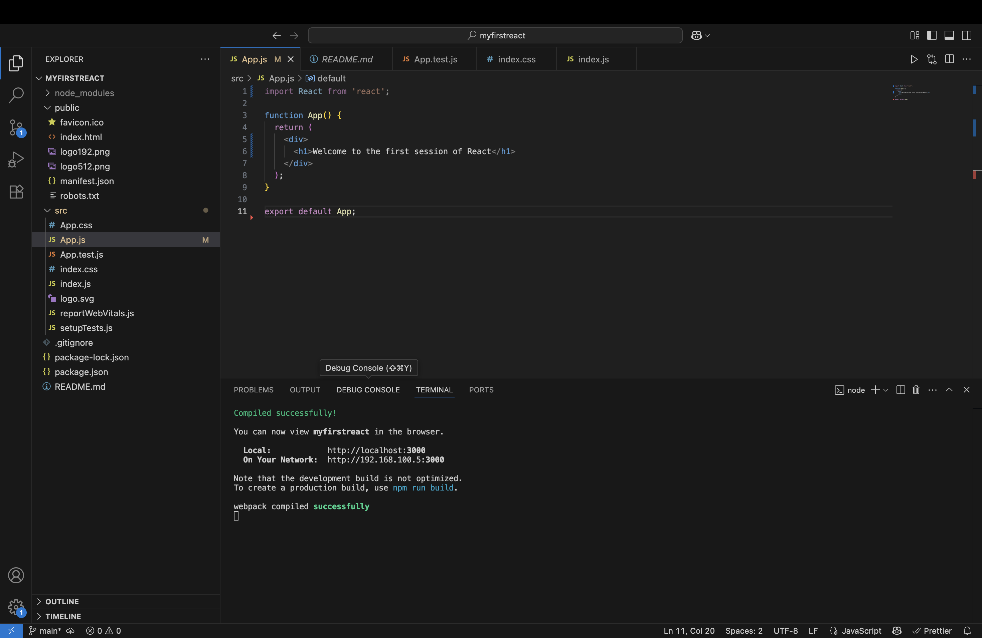
Output
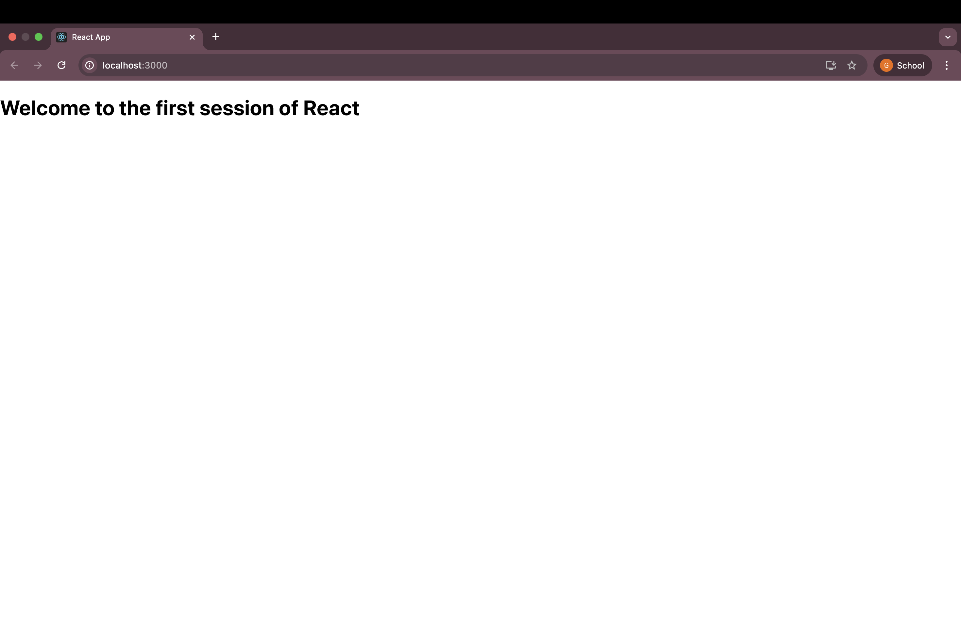

Task: 2. ReactJS-HOL

Objectives

Explain React Components
React components are the core building blocks of any React application. They are reusable, self-contained pieces of UI that return JSX (HTML-like code). A component can be thought of as a JavaScript function or class that describes how a section of the UI should appear.

Differences between Components and JavaScript Functions
React Components | JavaScript Functions
Return JSX (UI structure) | Return values or logic outputs
Used to build UI | Used for calculations or actions
Can manage state | No built-in state
Supports lifecycle methods | No lifecycle awareness
Part of React environment | General JavaScript

Types of Components in React
- Class Components – Traditional way using ES6 classes.
- Function Components – Modern, simpler way using functions. Hooks can be used for state and side effects.

Class Component
A class component is a JavaScript class that extends React.Component. It has access to state, props, and lifecycle methods.
import React, { Component } from 'react';

class Welcome extends Component {
render() {
return <h1>Hello from Class Component!</h1>;
}
}

Function Component
A function component is a simple JavaScript function that returns JSX. With React Hooks, function components can also manage state and side effects.
import React from 'react';

function Welcome() {
return <h1>Hello from Function Component!</h1>;
}

Define Component Constructor
In class components, the constructor() is used to initialize local state and bind methods.
constructor(props) {
super(props);
this.state = { name: 'Lasya' };
}
- It is the first method called when a component is created.

Define render() Function
The render() method is used in class components to return JSX. It is called every time the component is updated.
render() {
return <h1>Welcome to React</h1>;
}
- It’s mandatory in every class component.
1. Create the React App
In the terminal, run:
npx create-react-app studentapp
- This installs all required dependencies.
- A folder named studentapp is created.

2. Navigate into the Project Folder
cd studentapp

3. Open Project in VS Code
code .
- This opens the entire project in Visual Studio Code.

4. Create a Components Folder
Inside the src folder:
- Right-click → New Folder → Name it components

5. Create Home Component
Inside components folder:
- Right-click → New File → Home.js
Paste the following code:
import React from 'react';

function Home() {
return (
<div style={{
display: 'flex',
justifyContent: 'center',
alignItems: 'center',
fontSize: '20px'
}}>
Welcome to the Home page of Student Management Portal
</div>
);
}

export default Home;

6. Create About Component
Inside components folder:
- Right-click → New File → About.js
import React from 'react';

function About() {
return (
<div style={{
display: 'flex',
justifyContent: 'center',
alignItems: 'center',
fontSize: '20px'
}}>
Welcome to the About page of the Student Management Portal
</div>
);
}

export default About;

7. Create Contact Component
Inside components folder:
- Right-click → New File → Contact.js
Paste:
import React from 'react';

function Contact() {
return (
<div style={{
display: 'flex',
justifyContent: 'center',
alignItems: 'center',
fontSize: '20px'
}}>
Welcome to the Contact page of the Student Management Portal
</div>
);
}

export default Contact;

8. App.js
Go to src/App.js, replace all content with:
import React from 'react';
import Home from './components/Home';
import About from './components/About';
import Contact from './components/Contact';

function App() {
return (
<div>
<Home />
<About />
<Contact />
</div>
);
}

export default App;

9. Start the React App
In the terminal:
npm start

Outputs:
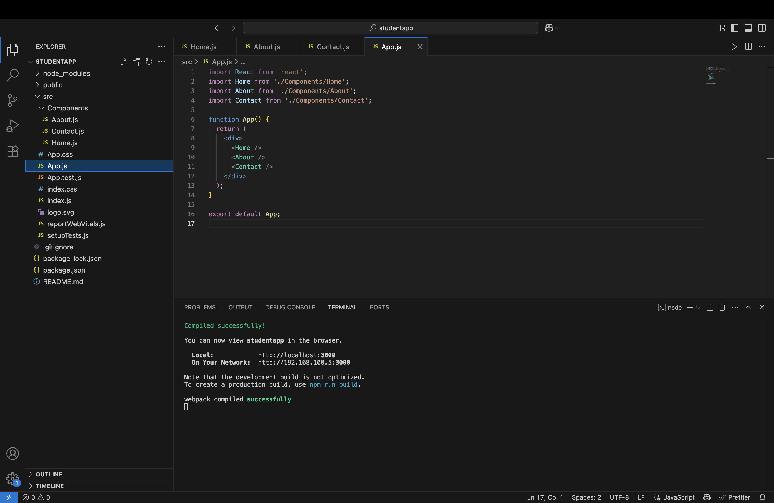
Task: 3. ReactJS-HOL
Step-by-Step Instructions to Implement scorecalculatorapp

1. Create the React App
npx create-react-app scorecalculatorapp
cd scorecalculatorapp

2. Create Folders & Files
Inside the src folder:
- Create folder: Components
  - Inside Components, create file: CalculateScore.js
- Create folder: Stylesheets
  - Inside Stylesheets, create file: mystyle.css

3. Add This Code to CalculateScore.js
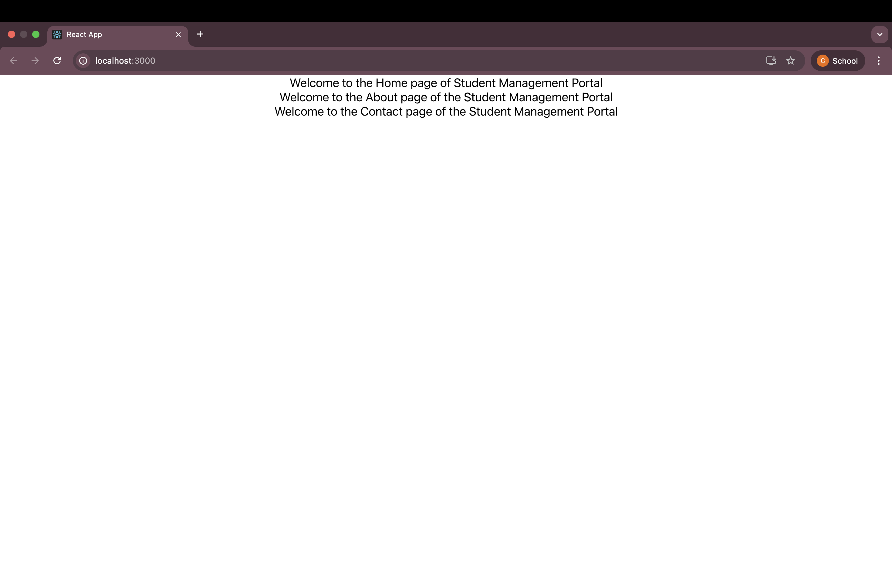
import '../Stylesheets/mystyle.css';

const percentToDecimal = (decimal) => {
return (decimal.toFixed(2) + "%");
};

const calcScore = (total, goal) => {
return percentToDecimal(total / goal);
};

export const CalculateScore = ({ Name, School, total, goal }) => {
return (
<div className="formatstyle">
<h1><font color="Brown">Student Details:</font></h1>

<div className="Name">
<b> Name: </b>
<span>{Name}</span>
</div>

<div className="School">
<b> School: </b>
<span>{School}</span>
</div>

<div className="Total">
<b> Total: </b>
<span>{total}</span> Marks
</div>

<div className="Score">
<b> Score: </b>
<span>{calcScore(total, goal)}</span>
</div>
</div>
);
};

4. Add This CSS to mystyle.css
.Name {
font-weight: 300;
color: blue;
}

.School {
color: crimson;
}

.Total {
color: darkmagenta;
}

.formatstyle {
text-align: center;
font-size: large;
}

.Score {
color: forestgreen;
}

5. Modify App.js
import React from 'react';
import { CalculateScore } from './Components/CalculateScore';

function App() {
return (
<div>
<CalculateScore
Name="Lasya"
School="MVSR Engineering College"
total={480}
goal={500}
/>
</div>
);
}

export default App;

6. Run the App
npm start
Open your browser and go to:
http://localhost:3000

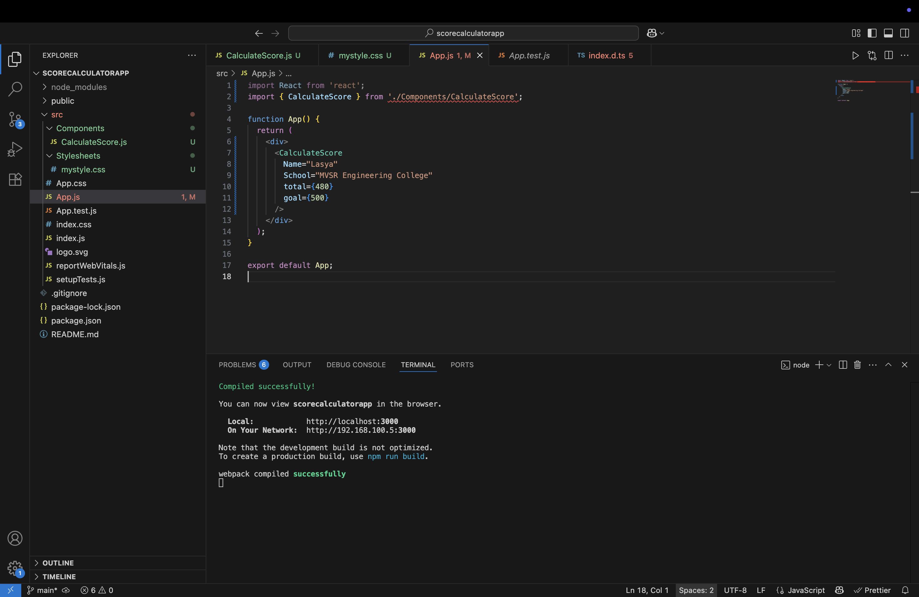
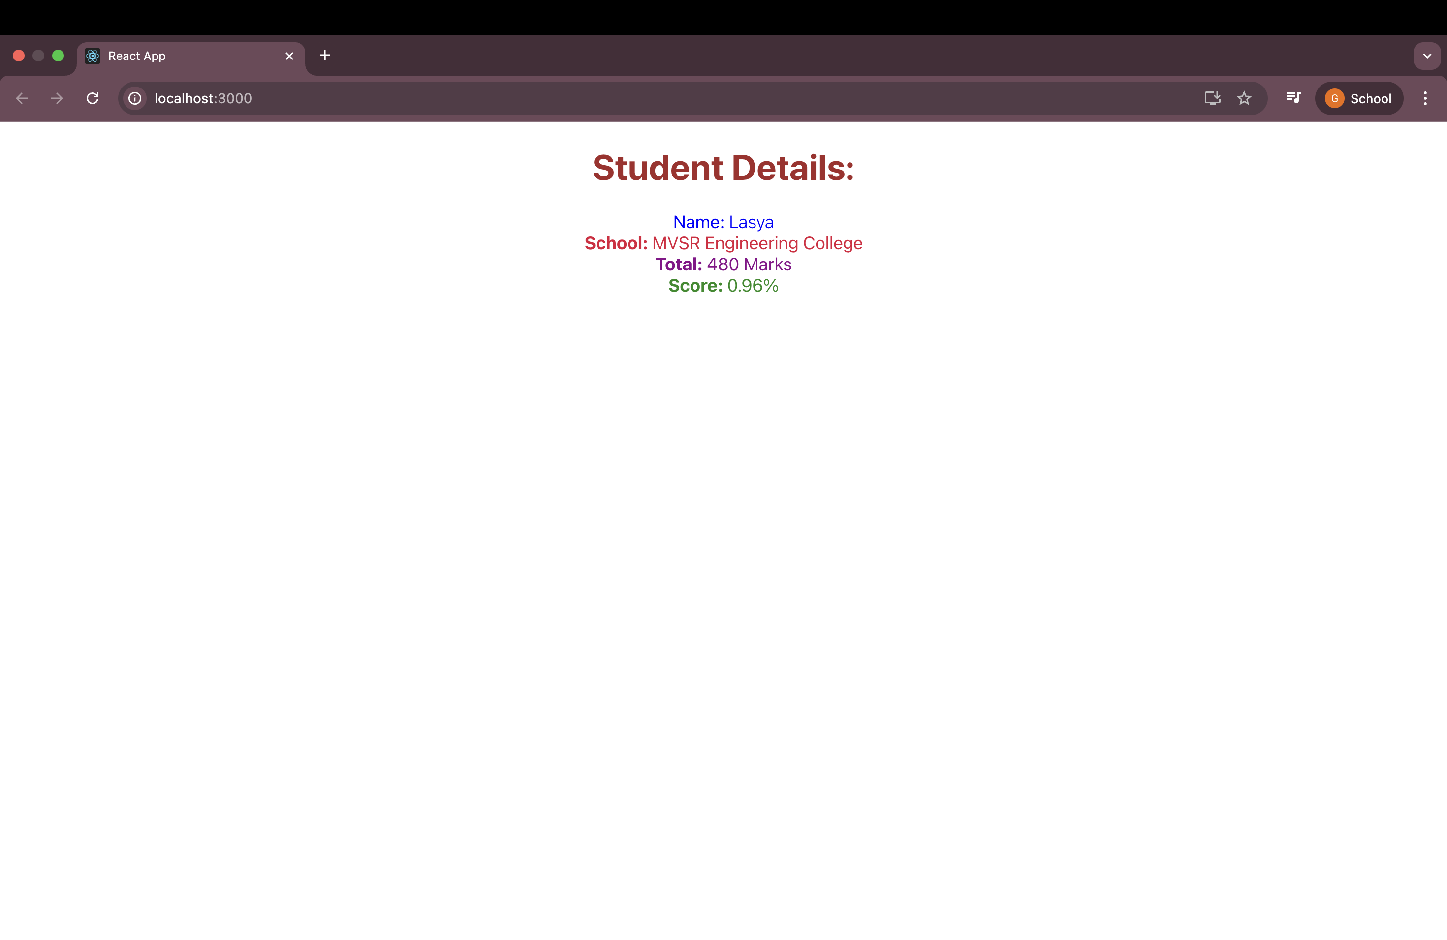
Output:

Task: 4. ReactJS-HOL
Component Life Cycle in React
1. Need and Benefits of Component Life Cycle
When building React applications, components are the building blocks. Every component goes through a series of steps from creation to removal. These steps are called the component life cycle.
Why is it needed?
- It helps us understand when a component is created, updated, or destroyed.
- Allows developers to write specific code during different stages (like fetching data after the component mounts).
- It improves the performance and predictability of the app.
Benefits:
- Better control over what happens at each stage.
- Can perform clean-up activities before the component is removed.
- Helps in debugging and performance tuning.
- Ideal place for API calls, subscriptions, and DOM updates.
2. Life Cycle Hook Methods in Class Components
React provides different built-in methods that are called at different points in the life cycle. These methods are called life cycle hooks.
Mounting (when component is created and added to the DOM):
- constructor()
- static getDerivedStateFromProps()
- render()
- componentDidMount()
Updating (when props or state changes):
- static getDerivedStateFromProps()
- shouldComponentUpdate()
- render()
- getSnapshotBeforeUpdate()
- componentDidUpdate()
Unmounting (when component is removed):
- componentWillUnmount()
Error Handling:
- componentDidCatch()
- static getDerivedStateFromError()
3. Sequence of Steps in Rendering a Component
Here is the order in which the methods are called when a component is rendered:
Mounting:
- constructor()
- getDerivedStateFromProps()
- render()
- componentDidMount()
Updating (when state or props change):
- getDerivedStateFromProps()
- shouldComponentUpdate()
- render()
- getSnapshotBeforeUpdate()
- componentDidUpdate()
Unmounting:
- componentWillUnmount()

Objective:
To understand the React class component life cycle by creating a blog application that fetches data from a public API using lifecycle methods like constructor(), componentDidMount(), render(), and componentDidCatch().

Step-by-Step Implementation
Step 1: Create a new React App
Open terminal and run the following commands:
npx create-react-app blogapp
cd blogapp
code .
This creates a new project and opens it in VS Code.

Step 2: Create Post class file
In the src folder, create a new file Post.js and add:
class Post {
constructor(id, title, body) {
this.id = id;
this.title = title;
this.body = body;
}
}

export default Post;
This class represents each blog post.

Step 3: Create Posts component
Create another file Posts.js in src and write:
import React from "react";
import Post from "./Post";

class Posts extends React.Component {
constructor(props) {
super(props);
this.state = {
posts: [],
};
}

loadPosts() {
fetch("https://jsonplaceholder.typicode.com/posts")
.then((res) => res.json())
.then((data) => {
const postList = data.slice(0, 5).map(
(p) => new Post(p.id, p.title, p.body)
);
this.setState({ posts: postList });
})
.catch((err) => console.error("Error fetching:", err));
}

componentDidMount() {
this.loadPosts();
}

componentDidCatch(error, info) {
alert("An error occurred in Posts component!");
console.log(error, info);
}

render() {
return (
<div style={{ padding: "20px", fontFamily: "Arial" }}>
<h2 style={{ color: "#2c3e50" }}>Blog Posts</h2>
{this.state.posts.map((post) => (
<div
key={post.id}
style={{
marginBottom: "20px",
borderBottom: "1px solid #ccc",
paddingBottom: "10px",
}}
>
<h4 style={{ color: "#34495e" }}>{post.title}</h4>
<p>{post.body}</p>
</div>
))}
</div>
);
}
}

export default Posts;
This component uses the Fetch API and React lifecycle methods.

Step 4: Add Posts component to App.js
import React from "react";
import Posts from "./Posts";

function App() {
return (
<div className="App">
<h1>My Blog App</h1>
<Posts />
</div>
);
}

export default App;
This renders the Posts component in the main app.

Step 5: Run the application
In terminal:
npm start
The browser will open at http://localhost:3000 showing the blog posts.

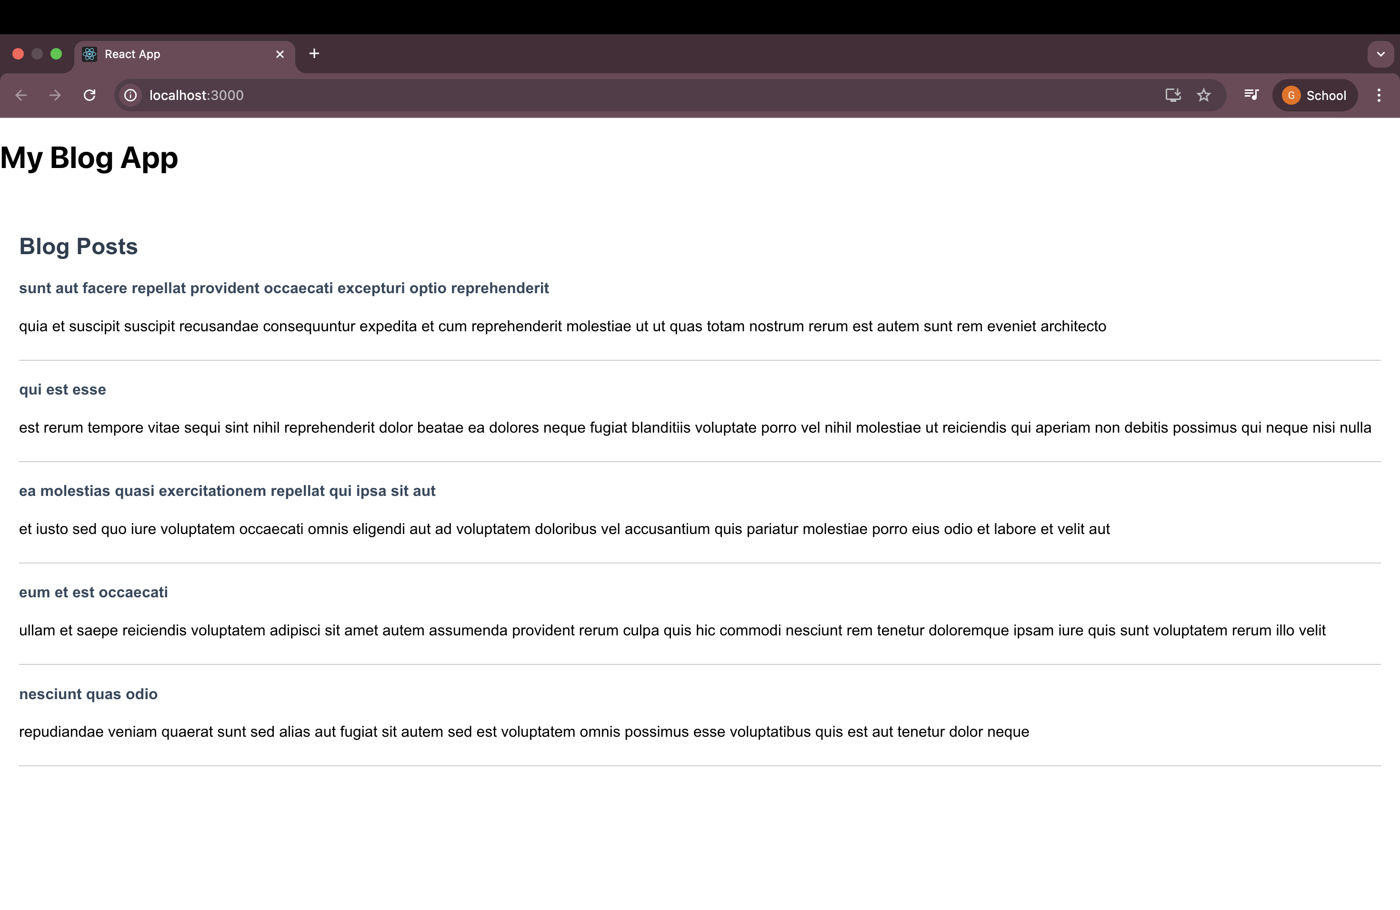
Output Screenshot:
React Lifecycle Methods Used
Lifecycle Method | Role
constructor() | Initializes state
componentDidMount() | Called once component mounts; used to fetch data
render() | Renders the JSX UI on screen
componentDidCatch() | Captures errors and displays alerts

Task: 5. ReactJS-HOL
Understanding the Need for Styling React Components
Styling helps React components become visually appealing and enhances user experience. It ensures consistency across the app and makes interfaces user-friendly.

Types of Styling in React
1. CSS Modules
- Scope styles to individual components.
- Prevents global class name conflicts.
- Example:
import styles from './Button.module.css';
<button className={styles.primary}>Click</button>
2. Inline Styles
- JavaScript-style objects.
- Useful for dynamic or conditional styles.
- Example:
const style = { color: 'blue', padding: '10px' };
<div style={style}>Hello</div>

Step-by-Step Instructions
Step 1: Create and Open a New React App
- Create a new React application:
npx create-react-app cohorttracker
cd cohorttracker
code .
Step 2: Install Project Dependencies
- Inside the project folder, run:
npm install
Step 3: Create a CSS Module
- Create file CohortDetails.module.css.
- Add styles:
.box {
width: 300px;
display: inline-block;
margin: 10px;
padding: 10px 20px;
border: 1px solid black;
border-radius: 10px;
}
dt {
font-weight: 500;
}
Step 4: Update Component CohortDetails.js
- Import CSS module:
import styles from './CohortDetails.module.css';
- Use styles and inline color:
<div className={styles.box}>
<h3 style={{ color: cohort.status === 'ongoing' ? 'green' : 'blue' }}>
{cohort.name}
</h3>
<dl>
<dt>Start Date:</dt>
<dd>{cohort.startDate}</dd>
<dt>Status:</dt>
<dd>{cohort.status}</dd>
</dl>
</div>
Step 5: Add Sample Data and Render Component in App.js
const cohorts = [
{ id: 1, name: 'React Basics', startDate: '2025-07-01', status: 'ongoing' },
{ id: 2, name: 'Advanced Node', startDate: '2025-05-15', status: 'completed' },
{ id: 3, name: 'Fullstack Development', startDate: '2025-08-10', status: 'ongoing' }
];

function App() {
return (
<div className="app-container">
<h1>Welcome to the first session of React</h1>
{cohorts.map(cohort => (
<CohortDetails key={cohort.id} cohort={cohort} />
))}
</div>
);
}
Step 6: Run the Application
- Start the app:
npm start
- Verify that the styles are applied correctly.

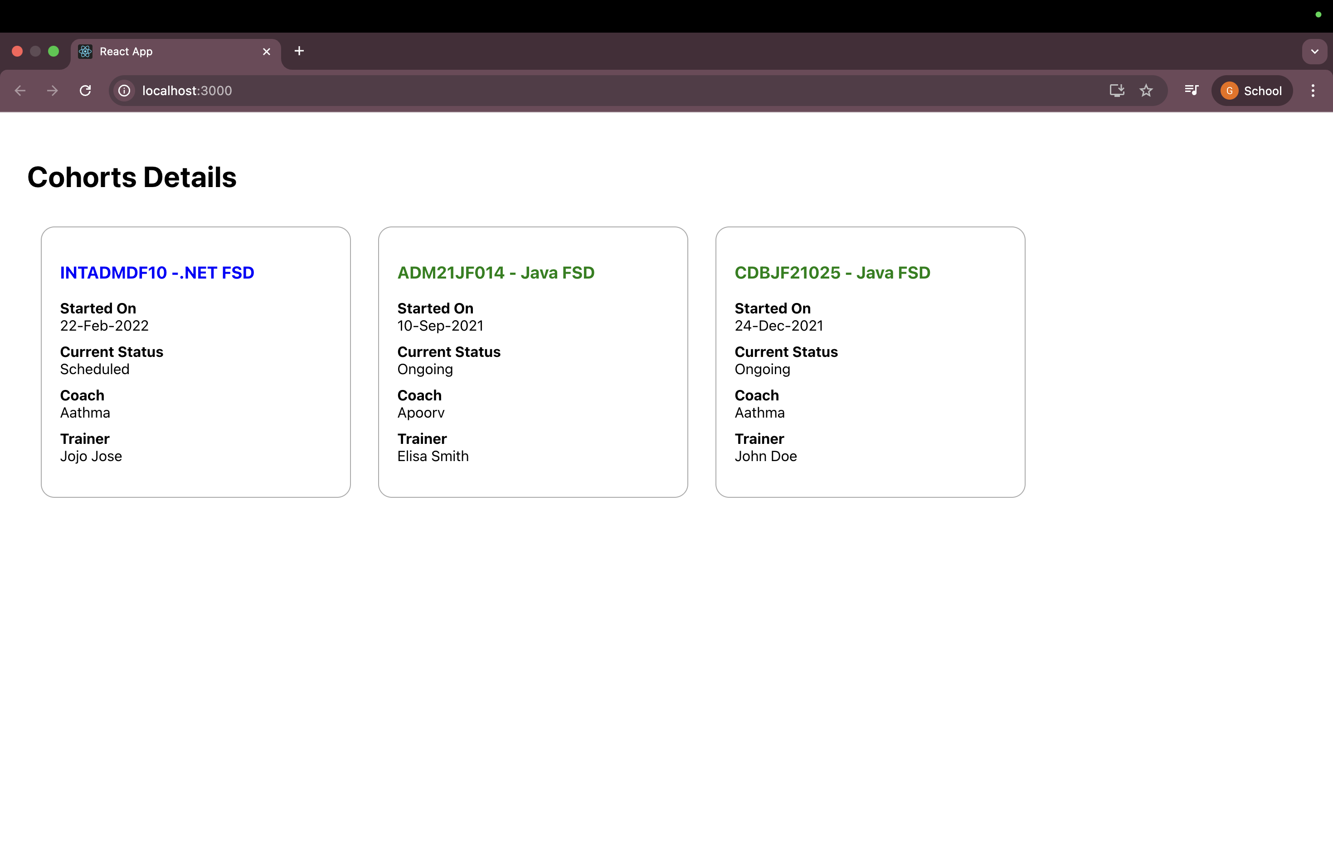
Output:

