Cognizant Digital Nurture 4.0
Name: Gandu Lasya Sri
Email: gandulasyasri@gmail.com
Superset ID:6428164
Mandatory Hands-On Exercises
Git
Task: 1. Git-HOL
Objective
In this lab, I practiced basic Git operations like git init, git status, git add, git commit, git push, and git config. I also used GitLab as my remote repository and VS Code as the default editor for Git.

Steps I Followed
Step 1: Git Configuration
- I opened the Terminal on my Mac and checked if Git was installed:
git --version

- Then I configured my Git username and email:
git config --global user.name "Lasya Sri Gandu"
- git config --global user.email "youremail@example.com"

- I confirmed the setup with:
git config --global --list

Step 2: Setting VS Code as Git Editor
- I checked if VS Code CLI was working:
code --version
- I initially had issues with the code command, so I removed the old symlink and recreated it:
sudo rm /usr/local/bin/code
- sudo ln -s "/Applications/Visual Studio Code.app/Contents/Resources/app/bin/code" /usr/local/bin/code

- After it worked, I set VS Code as my Git editor:
git config --global core.editor "code --wait"

- I confirmed it with:
git config --global --get core.editor

Step 3: Creating the Local Git Repository
- I created my project folder and initialized Git:
mkdir GitDemo
- cd GitDemo
- git init

- Then I created the welcome file:
echo "Hello from Lasya!" > welcome.txt

- I checked the Git status:
git status

- I added the file:
git add welcome.txt

- I committed using:
git commit
- → VS Code opened, and I added the message: Initial commit - added welcome.txt

Step 4: Pushing to GitLab
- I created a new project called GitDemo in GitLab
- I copied the remote repo URL:
https://gitlab.com/Lasyasri05-group/GitDemo.git
- I linked the remote with:
git remote add origin https://gitlab.com/Lasyasri05-group/GitDemo.git

- GitLab had a README file, so I fixed the conflict:
git pull --rebase origin main

- Then I pushed:
git push -u origin main

- When prompted, I used my GitLab username and personal access token

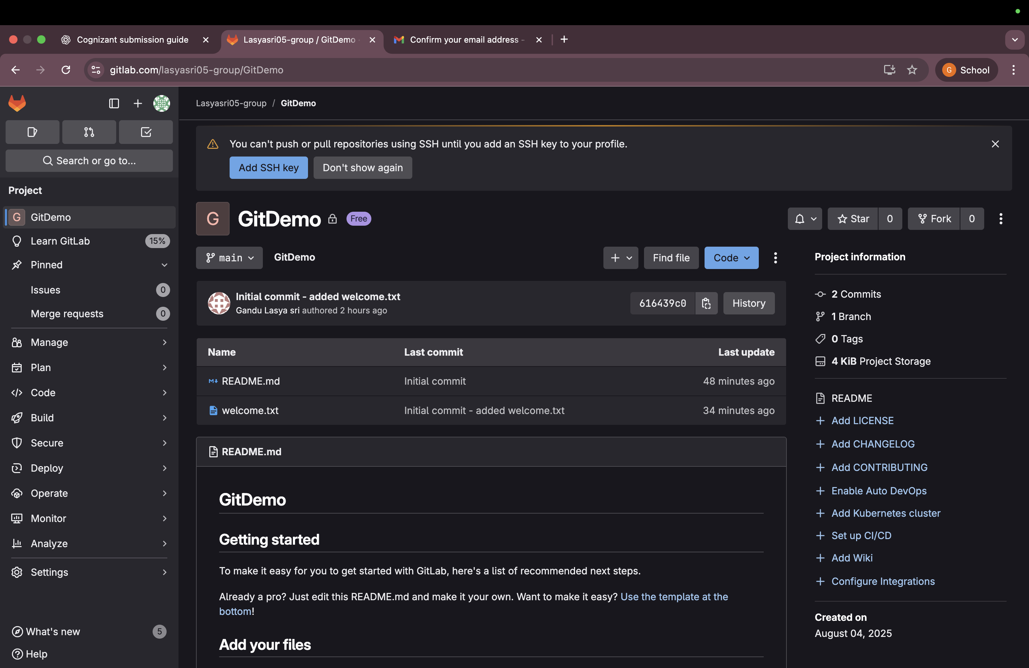
Final Result
At the end, I checked my GitLab repo. The welcome.txt file and my commit were successfully pushed and visible.

Task: 2. Git-HOL

Objective
In this hands-on task, I learned how to ignore unwanted files and folders in a Git repository using the .gitignore file. I tested this by creating .log files and a log folder and ensuring they were not tracked by Git.

Steps I Followed
Step 1: Opened Existing Git Project
- I navigated into my existing Git project:
cd ~/GitDemo
- code .

Step 2: Created Files to Ignore
- Inside VS Code, I created:
  - A file: debug.log
  - A folder: log/
    - Inside it, I created a file: server.log
Project structure:
GitDemo/
├── welcome.txt
├── debug.log
└── log/
└── server.log

Step 3: Created .gitignore File
- I created a new file named .gitignore
- I added the following lines:
*.log
log/

- This tells Git to ignore all .log files and the entire log folder

Step 4: Verified Git Ignore Behavior
- I checked the Git status:
git status
- Git ignored both debug.log and the log/ folder
- Only .gitignore appeared as untracked

Step 5: Committed .gitignore
- I staged and committed the .gitignore file:
git add .gitignore
- git commit -m "Added .gitignore to ignore .log files and log folder"
- git push

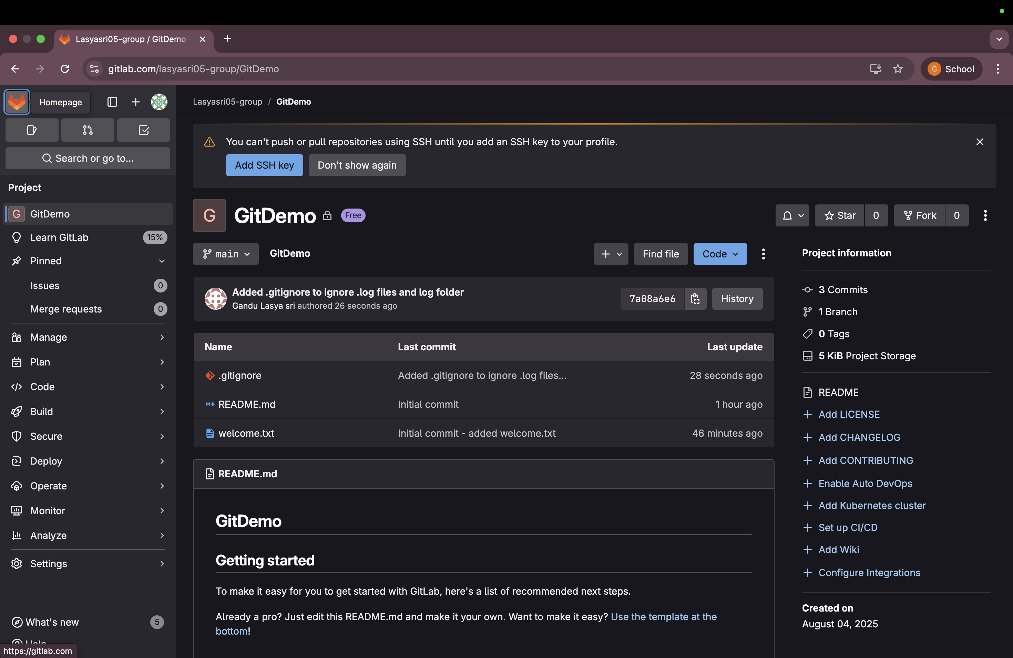
Final Result
- .log files and the log/ folder were successfully ignored
- .gitignore was pushed to GitLab

Task: 3. Git-HOL

Objective
In this lab, I practiced creating a Git branch, making changes, committing them, and then merging the branch back into the main branch. I also used GitLab to push my branch and create a merge request.

Steps I Followed with Screenshots
Step 1: Open Project in VS Code
cd ~/GitDemo
code .

Step 2: Create and Switch to New Branch
git checkout -b GitNewBranch
Output:
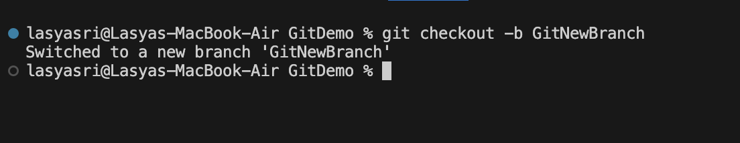
Switched to a new branch 'GitNewBranch'

Step 3: Create a File in the New Branch
echo "This is from the new branch" > newfeature.txt
Verify:
cat newfeature.txt
Output:
This is from the new branch

Step 4: Stage and Commit the File
git add newfeature.txt
git commit -m "Added newfeature.txt in GitNewBranch"
Output:
Step 5: Push the Branch to GitLab
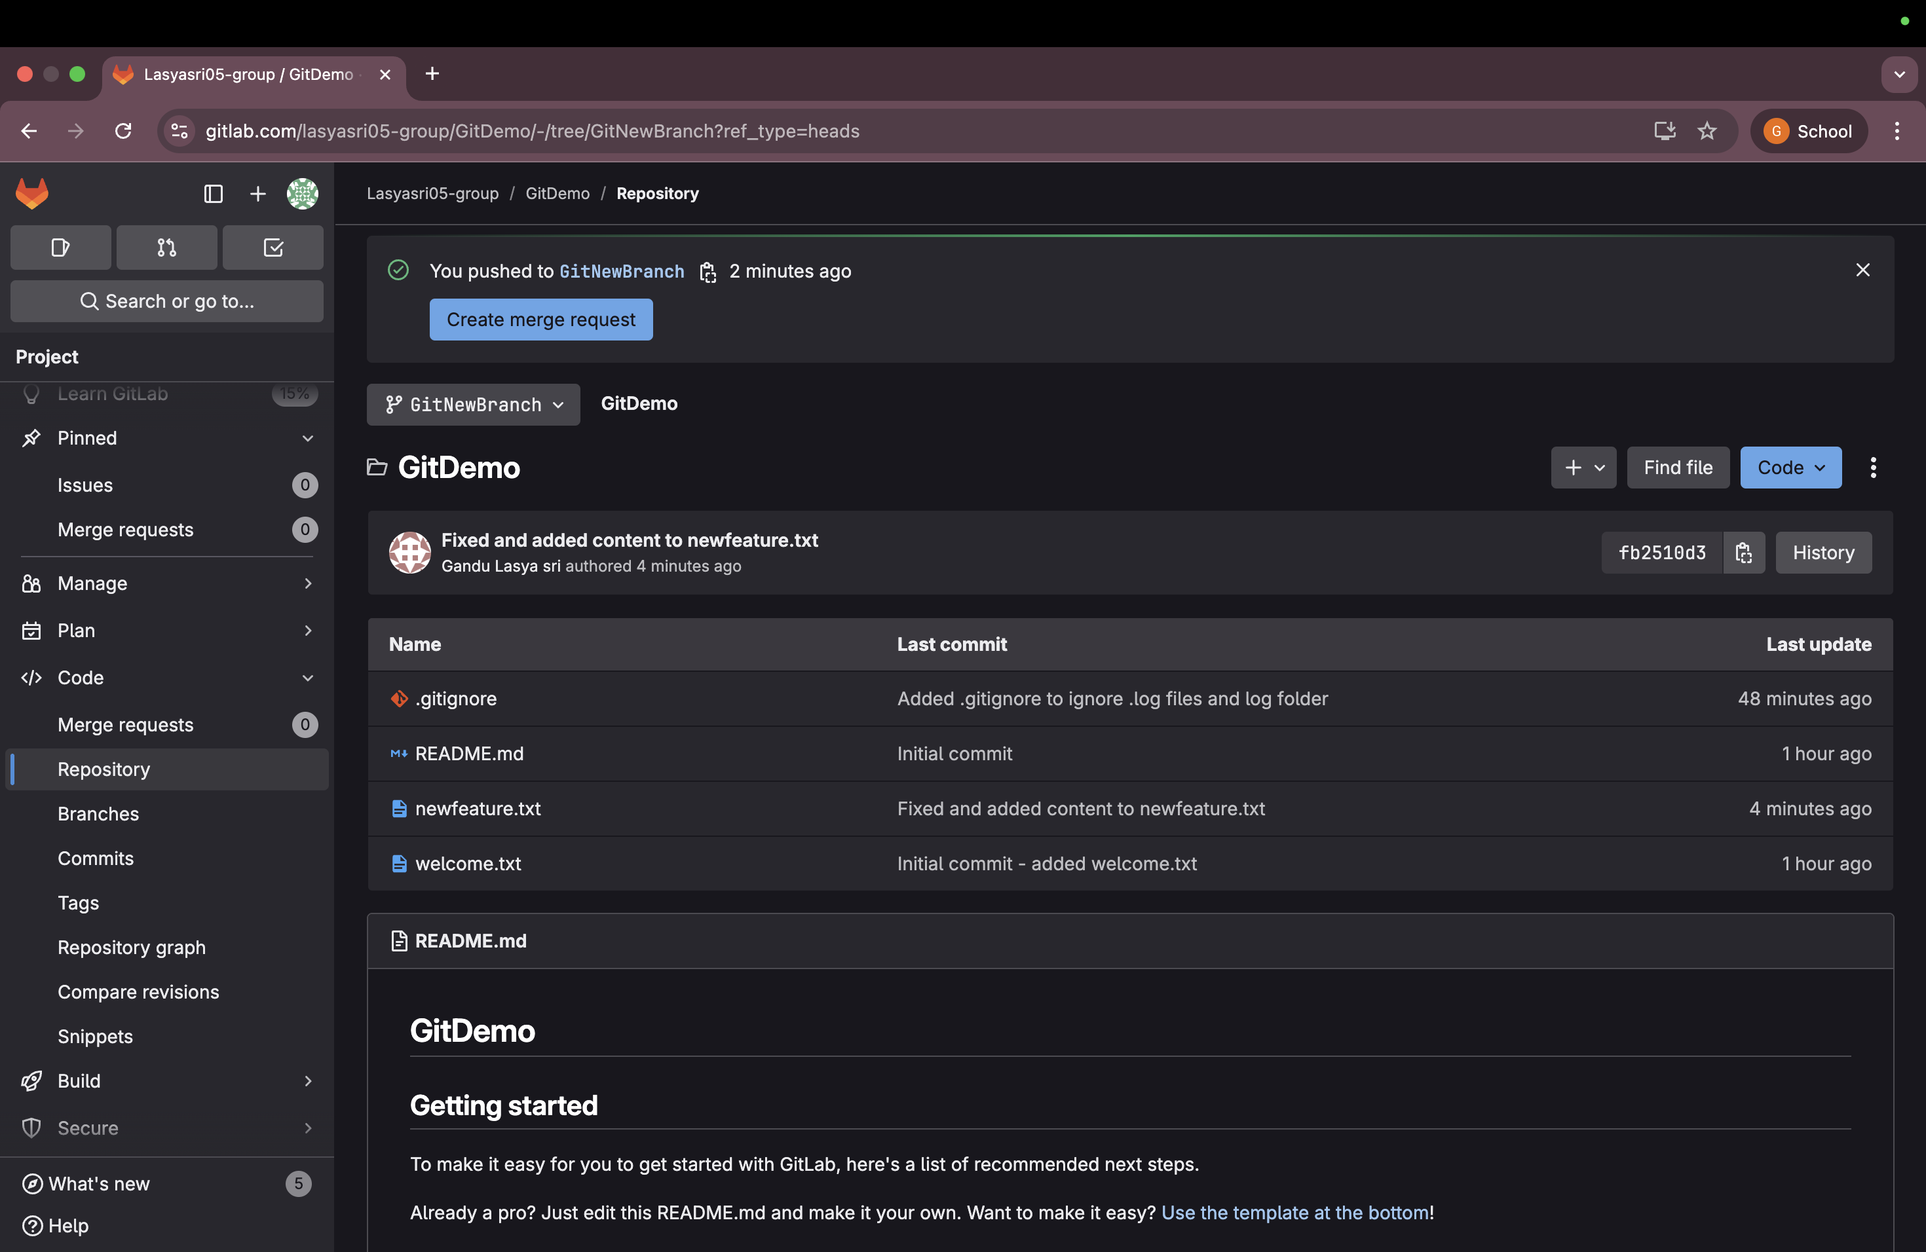
git push -u origin GitNewBranch

Step 6: Switch to Main Branch
git checkout main
Output:
Switched to branch 'main'
Your branch is up to date with 'origin/main'.
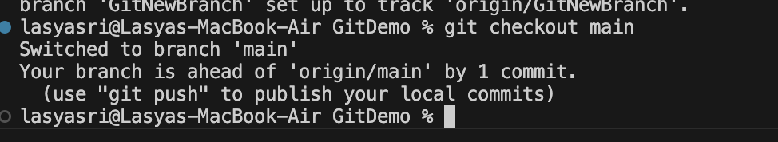
Step 7: Compare Differences Between Branches
git diff main..GitNewBranch
Output:
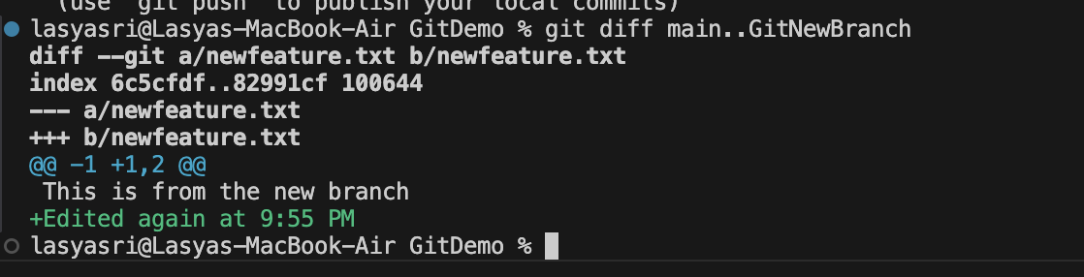
+This is from the new branch

Step 8: Merge Branch into Main
git merge GitNewBranch
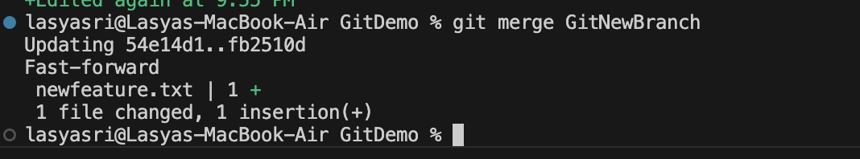
Output:

Step 9: View Commit History as Graph
git log --oneline --graph --decorate
Output:
* abc1234 (HEAD -> main, origin/main) Added newfeature.txt in GitNewBranch
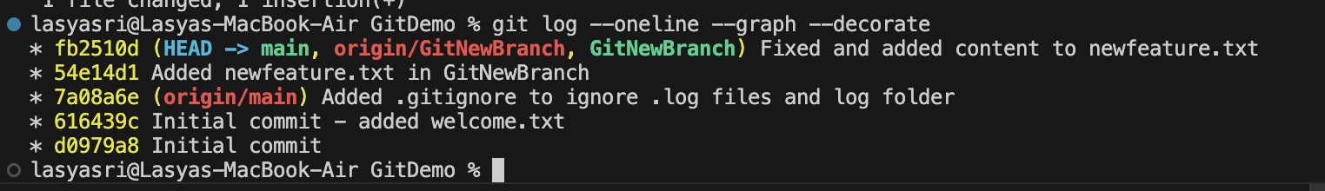
* 456abcd Initial commit - added welcome.txt

Step 10: Delete the Merged Branch and Check Status
git branch -d GitNewBranch
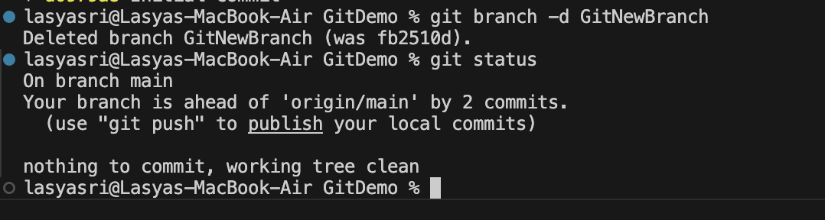
git status
Task: 4. Git-HOL

Objective
In this lab, I practiced basic Git operations like git init, git status, git add, git commit, and git merge. I also resolved a conflict between branches using VS Code.
Steps I Followed
Step 1: Initialized Git Repository
mkdir git-lab
cd git-lab
git init

Step 2: Created a New Branch
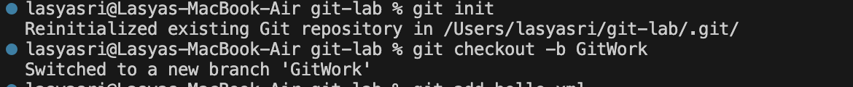
git checkout -b GitWork

Step 3: Added hello.xml in GitWork
- File content:
<!-- hello.xml -->
<message>Hello from GitWork branch</message>
git add hello.xml
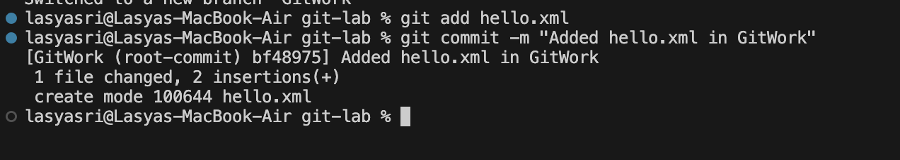
git commit -m "Added hello.xml in GitWork”

Step 4: Created master branch and conflicting version
git checkout -b master
- Changed file content to:
<!-- hello.xml -->
<message>Hello from master branch</message>
git add hello.xml
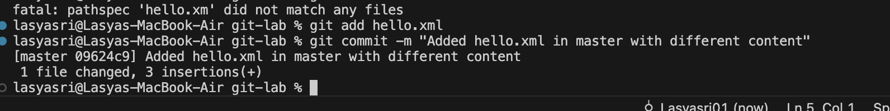
git commit -m "Added hello.xml in master with different content”

Step 5: Viewed Git Log
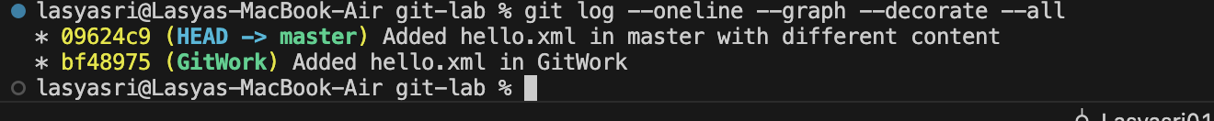
git log --oneline --graph --decorate --all

Step 6: Viewed Difference
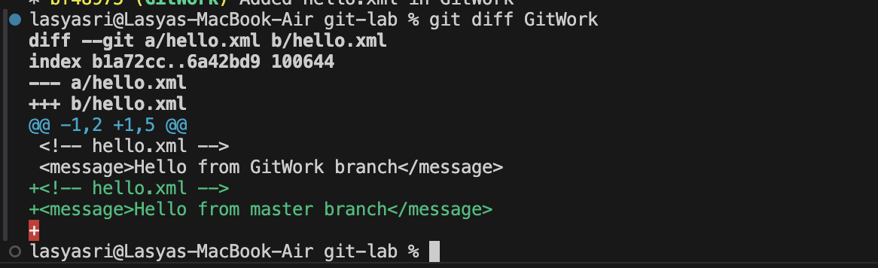
git diff GitWork

Step 7: Merged GitWork into master (Conflict)
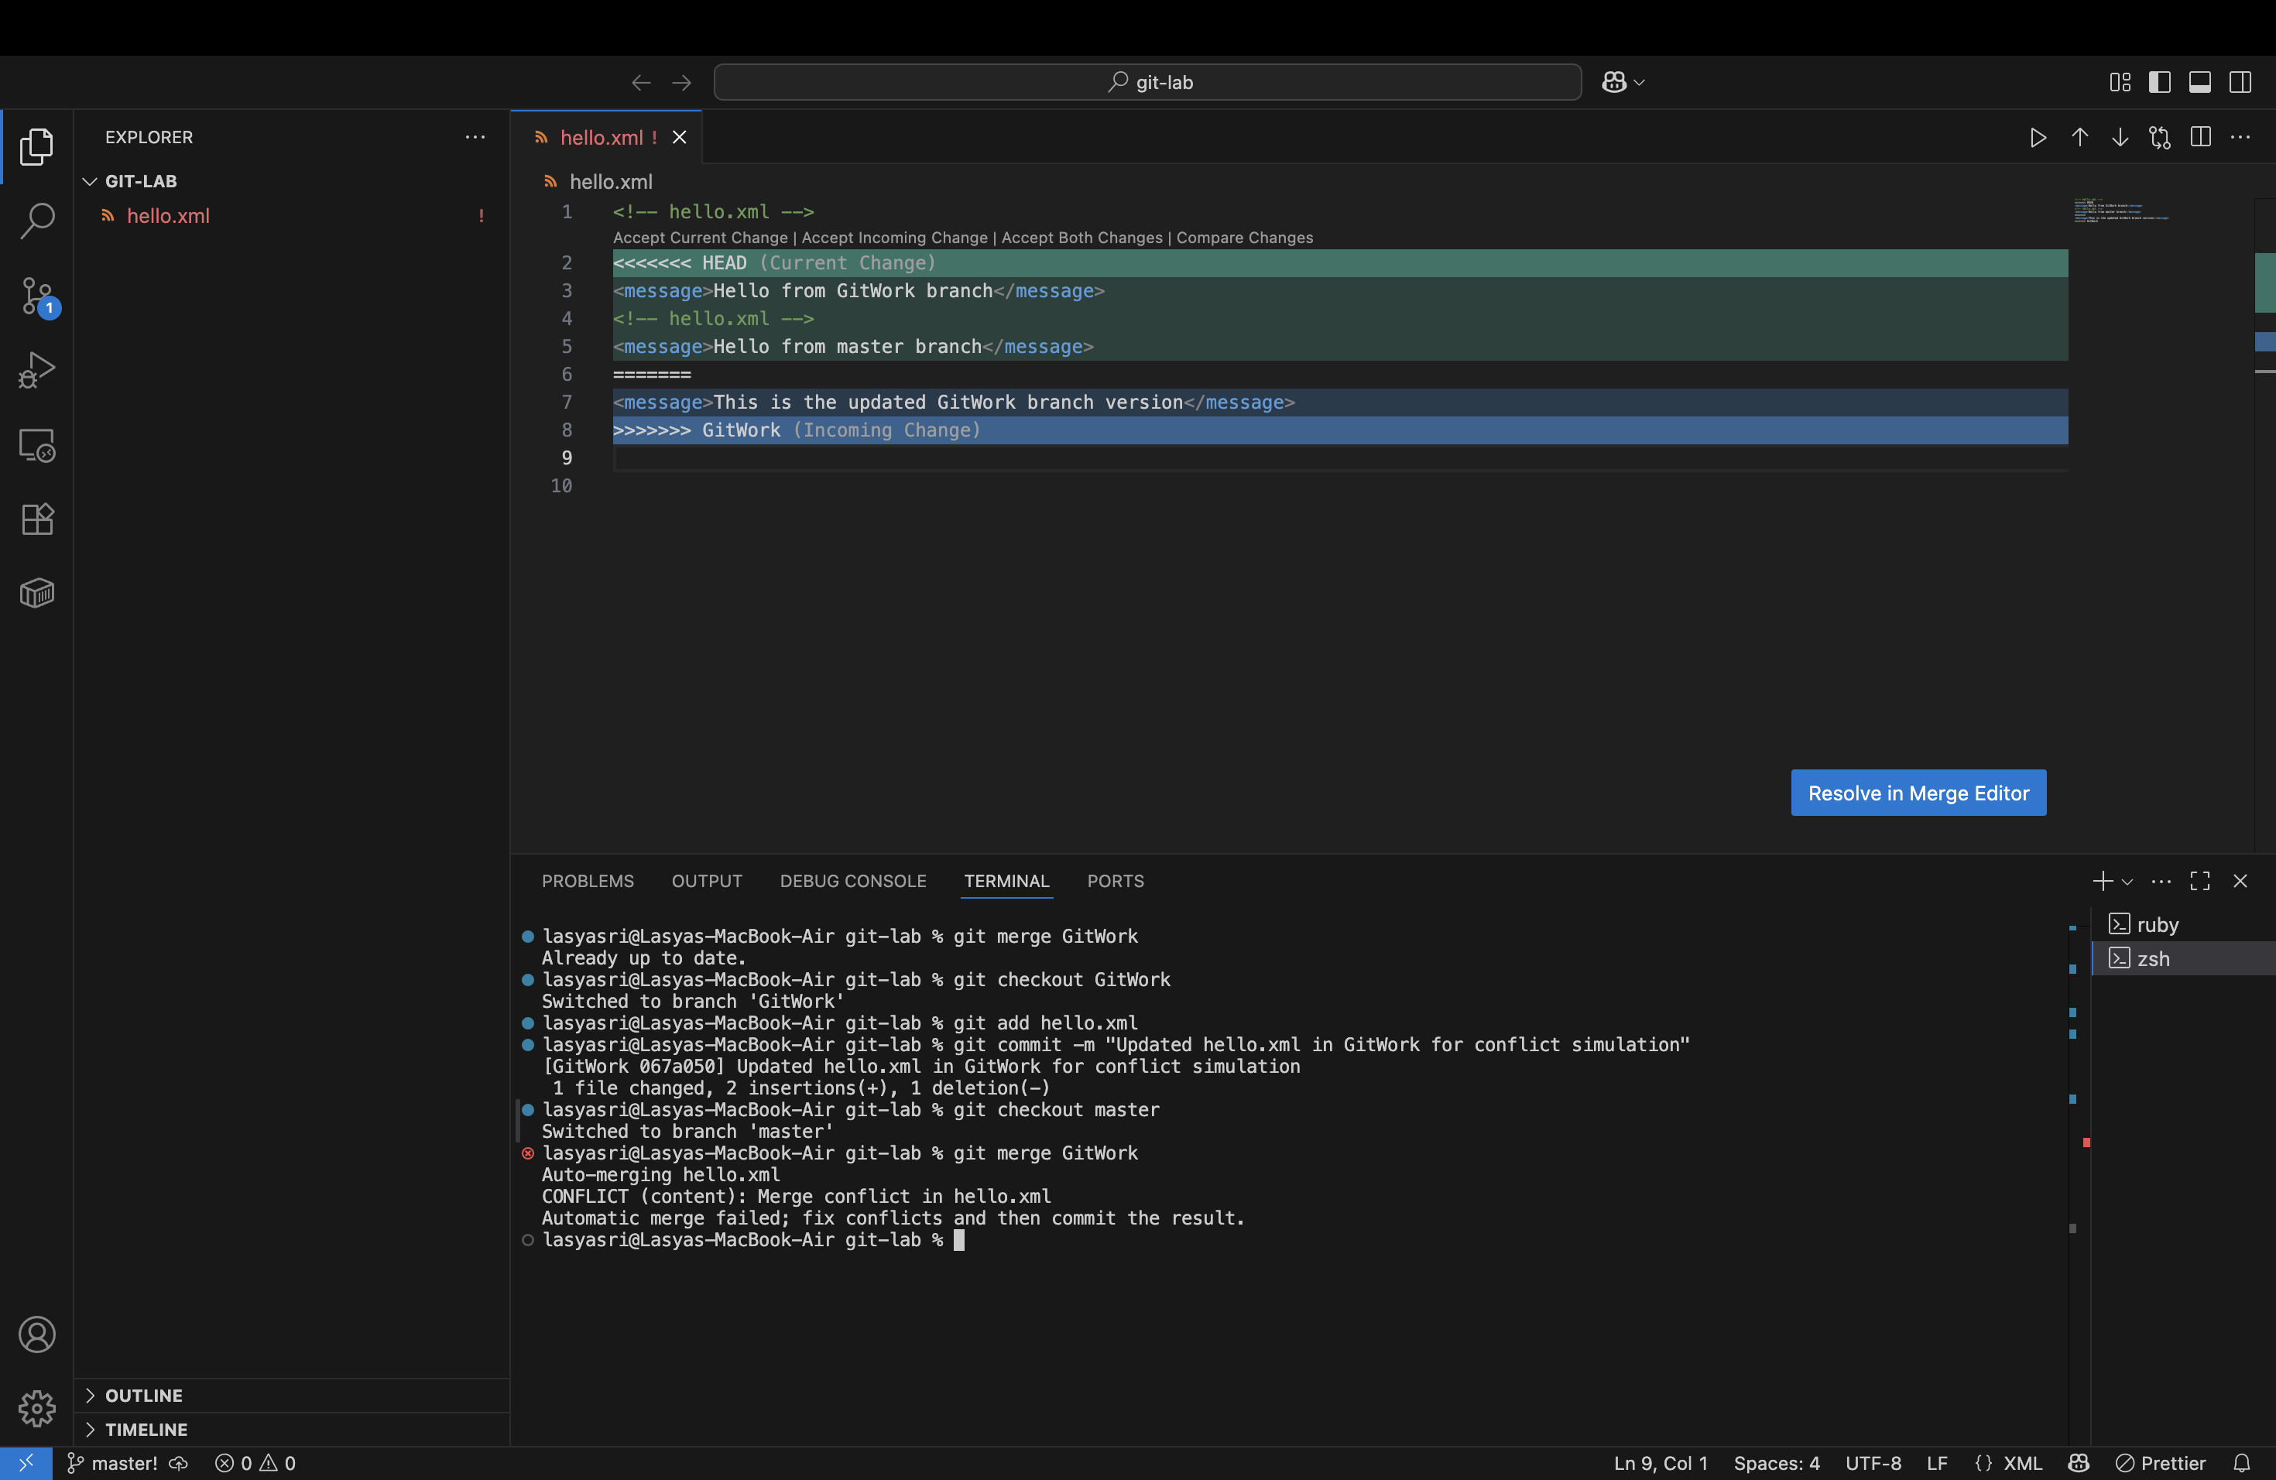
git merge GitWork

Step 8: Resolved Conflict
- Final version:
<!-- hello.xml -->
<message>Both branches greet you!</message>
git add hello.xml
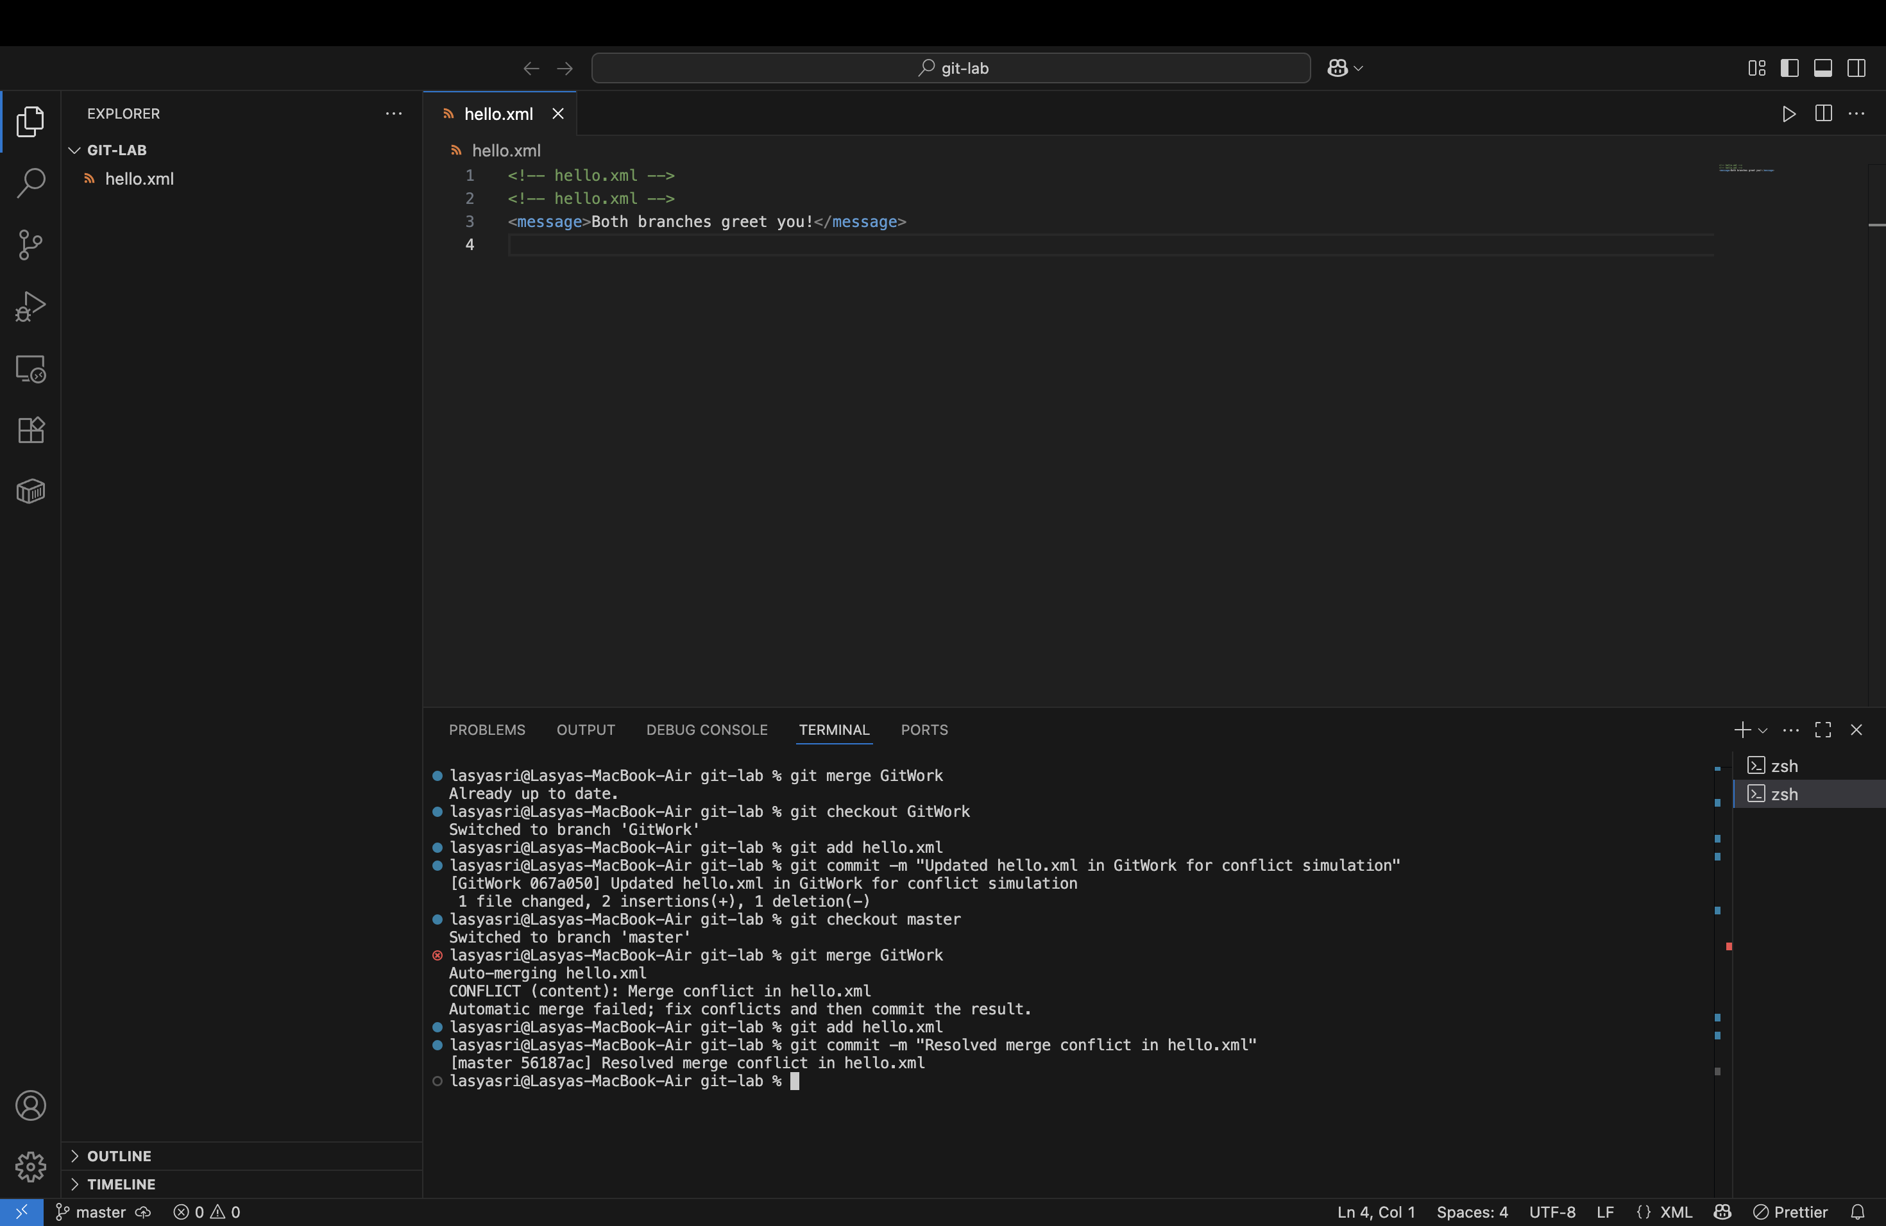
git commit -m "Resolved conflict"

Step 9: Created .gitignore
touch .gitignore
- Content:
*.orig
git add .gitignore
git commit -m "Added .gitignore"

Step 10: Deleted GitWork branch
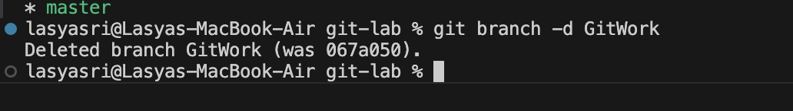
git branch -d GitWork

Step 11: Final Git Log
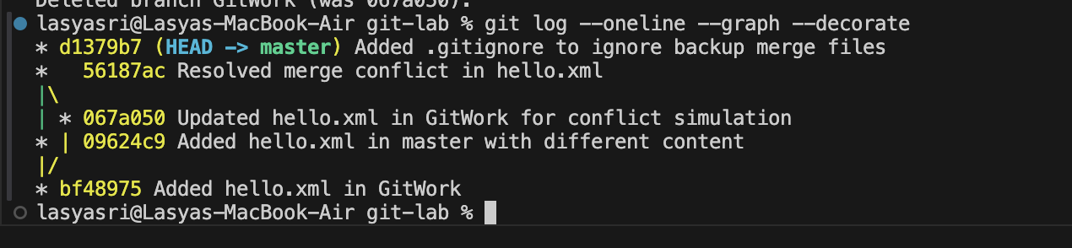
git log --oneline --graph --decorate

Final Result
Successfully completed the Git merge conflict resolution lab. All commands worked as expected and each step was tested locally using VS Code and terminal.
Task: 5. Git-HOL
Objective
In this hands-on task, I learned how to clean up my local Git repository and push the local changes to the remote GitHub repository. I verified the sync between local and remote using git status, git config, git remote, git push, and checked the final result on GitHub.

Step 1: Created New Git Project Locally
I opened VS Code terminal and ran the following:
mkdir git-lab-clean
cd git-lab-clean
git init
This created a fresh Git project named git-lab-clean and initialized Git tracking.

Step 2: Configured Git
git config --global user.name "LASYASRI015"
git config --global user.email "245122737081@mvsrec.edu.in"
git config --global core.editor "code --wait"
git config --list
This ensured Git is set up with my identity and that VS Code is the default editor.

Step 3: Created and Committed a File
I created hello.xml using either the terminal or VS Code editor. File content:
<!-- hello.xml -->
<message>Hello again from Git!</message>
Then I committed it:
git add hello.xml
git commit -m "Initial commit with hello.xml"

Step 4: Created Repository on GitHub
I logged into https://github.com, clicked New, and created a repo named git-lab-clean without a README or .gitignore file.

Step 5: Connected Local Repo to Remote GitHub Repo
git remote add origin https://github.com/LASYASRI015/git-lab-clean.git
git remote -v
This linked my local folder to the GitHub repository.

Step 6: Pushed Local Code to GitHub
git push -u origin main
Since my local default branch was main, I pushed it to the GitHub repo.

Step 7: Verified in GitHub Web
I visited:
https://github.com/LASYASRI015/git-lab-clean
and confirmed that hello.xml and my commit appeared correctly.

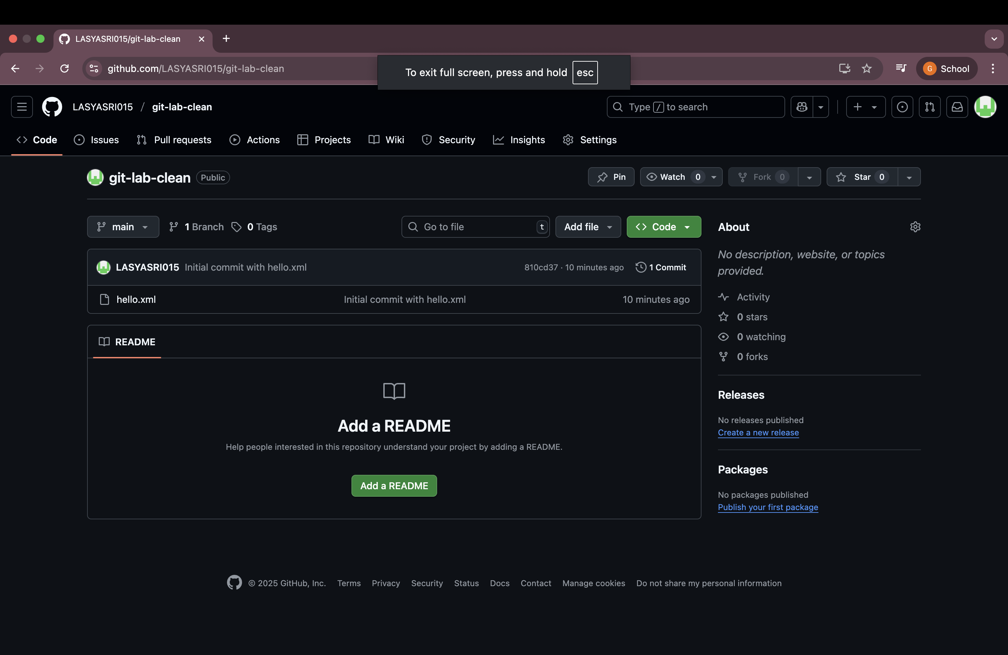
Final Result
Successfully pushed the clean Git project to GitHub. The local and remote repositories are fully in sync. All Git operations (init, config, add, commit, remote, push) were performed using VS Code and terminal, and verified via GitHub web interface.

