Cognizant Digital Nurture 4.0
Name: Gandu Lasya Sri
Email: gandulasyasri@gmail.com
Superset ID: 6428164
Mandatory Hands-On Exercises
Microservices with API gateway
Task : Creating Microservices for account and loan
Solution :
Account Microservice:
- Go to https://start.spring.io/
  - Group: com.cognizant
  - Artifact: account
  - Add: Spring Web, Spring Boot DevTools
  - Generate & download zip
- Import this project into Eclipse.
- Create AccountController:
package com.cognizant.account;
import org.springframework.web.bind.annotation.GetMapping;
import org.springframework.web.bind.annotation.PathVariable;
import org.springframework.web.bind.annotation.RequestMapping;
import org.springframework.web.bind.annotation.RestController;
@RestController
@RequestMapping("/accounts")
public class AccountController {
@GetMapping("/{number}")
public Account getAccount(@PathVariable String number) {
return new Account(number, "savings", 234343);
}

class Account {
public String number;
public String type;
public double balance;

public Account(String number, String type, double balance) {
this.number = number;
this.type = type;
this.balance = balance;
}
}
}

- Run app and then test in browser:
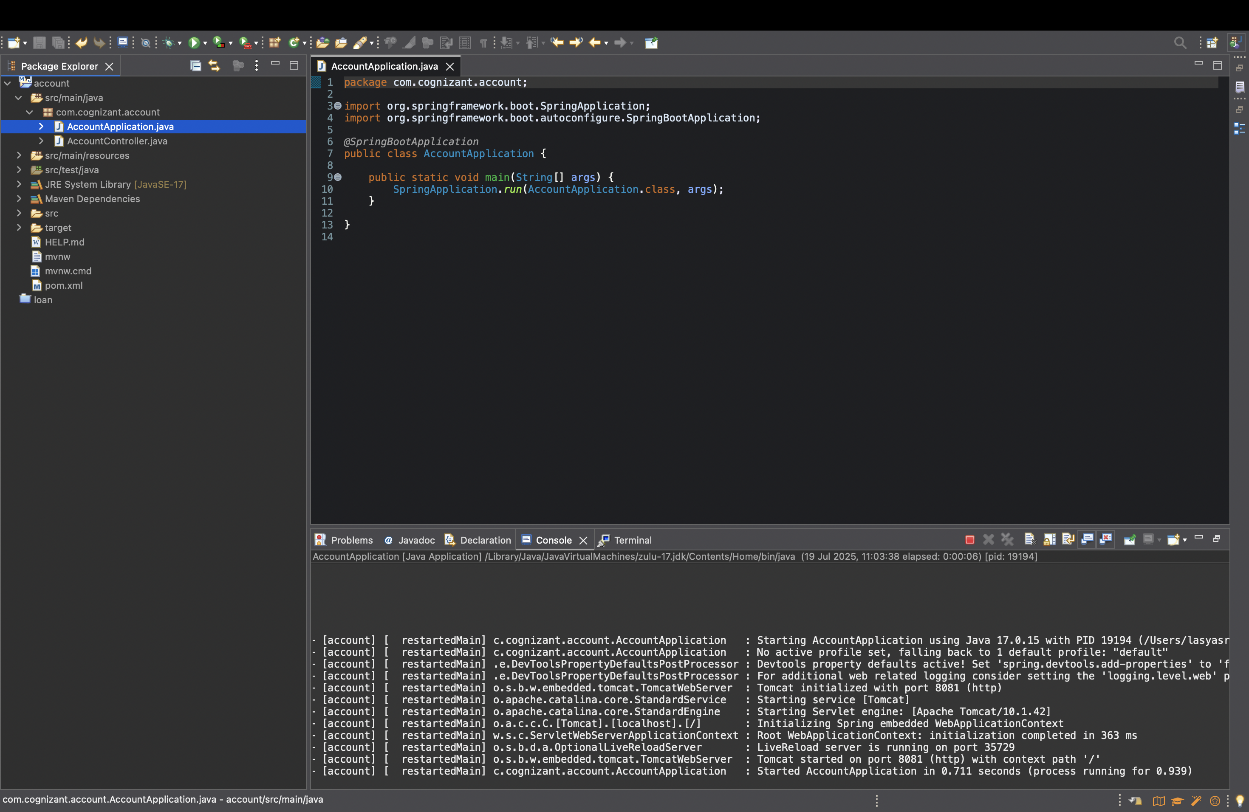
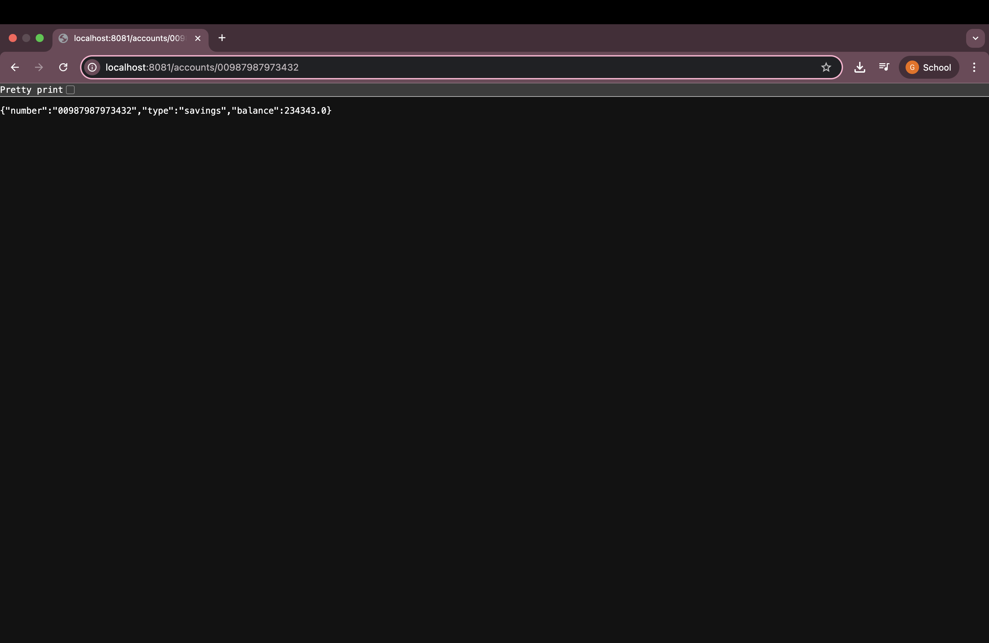

Loan Microservice:
- Go to https://start.spring.io/
  - Group: com.cognizant
  - Artifact: loan
  - Add: Spring Web, Spring Boot DevTools
  - Generate & download zip
- Import this project into Eclipse.
- Create LoanController:
package com.cognizant.loan;
import org.springframework.web.bind.annotation.GetMapping;
import org.springframework.web.bind.annotation.PathVariable;
import org.springframework.web.bind.annotation.RestController;
@RestController

public class LoanController {
@GetMapping("/loans/{number}")
public Loan getLoanDetails(@PathVariable String number) {
return new Loan(number, "car", 400000, 3258, 18);
}

class Loan {
public String number;
public String type;
public double loan;
public int emi;
public int tenure;

public Loan(String number, String type, double loan, int emi, int tenure) {
this.number = number;
this.type = type;
this.loan = loan;
this.emi = emi;
this.tenure = tenure;
}
}

}
- Run app and then test in browser:
