Cognizant Digital Nurture 4.0
Name: Gandu Lasya Sri
Email: gandulasyasri@gmail.com
Superset ID:6428164
Mandatory Hands-On Exercises
React
Task: 9.ReactJS-HOL

Objectives

List the features of ES6
In ES6 (also called ECMAScript 2015), JavaScript got a lot of improvements that made it easier and more modern to use. Some of the main features are:
- let and const to declare variables with proper scope.
- Arrow functions (=>) for shorter function writing.
- Template literals using backticks (`) and ${} to include variables inside strings.
- Default parameter values in functions.
- Rest (...args) and Spread (...array) operators.
- Destructuring to get values from arrays or objects easily.
- Enhanced object literals.
- Promises for better handling of asynchronous code.
- Classes and Inheritance for object-oriented programming.
- Modules for importing and exporting code.
- New data structures like Map and Set.
- for...of loop to iterate over arrays and strings.

Explain JavaScript let
The let keyword is used to declare variables in a block scope (inside {}). Unlike var, it doesn’t allow redeclaring the same variable in the same block. But you can change its value.
Example:
let num = 10;
num = 20; // works fine
let num = 30; // Error: already declared

Identify the differences between var and let
Feature | var | let
Scope | Function-scoped | Block-scoped
Hoisting | Yes (value is undefined) | Yes (but can't use before declaration)
Redeclaration | Allowed | Not allowed in the same block
Temporal Dead Zone | No | Yes (before it’s initialized)

Explain JavaScript const
The const keyword is used to declare constant variables. Once you assign a value to a const, you can’t change it. It is also block-scoped like let. However, for arrays and objects, you can still modify the inside content.
Example:
const PI = 3.14;
PI = 3.15; // Error: cannot reassign

const arr = [1, 2];
arr.push(3); // Works: array is still the same reference

Explain ES6 class fundamentals
ES6 introduced the class keyword which makes it easier to write object-oriented code in JavaScript. It lets you define a blueprint for creating objects.
Example:
class Student {
constructor(name) {
this.name = name;
}

introduce() {
console.log("Hi, I am " + this.name);
}
}

const s1 = new Student("Lasya");
s1.introduce();

Explain ES6 class inheritance
You can create a child class from a parent class using extends. The child class can use super() to call the parent constructor.
Example:
class Animal {
constructor(name) {
this.name = name;
}

sound() {
console.log(this.name + " makes a sound.");
}
}

class Dog extends Animal {
sound() {
console.log(this.name + " barks.");
}
}

const d = new Dog("Tommy");
d.sound();

Define ES6 arrow functions
Arrow functions are a shorter way to write functions in JavaScript. They don’t have their own this, which is helpful in some cases.
Examples:
Simple function:
const add = (a, b) => a + b;
Single parameter (no need for brackets):
const square = x => x * x;
Multiple lines (use {} and return):
const greet = name => {
return "Hello, " + name;
};

Identify set() and map(), explain neatly
Set in JavaScript:
A Set stores unique values. That means it will automatically remove duplicates. You can add, delete, and check if a value exists.
Example:
let mySet = new Set();
mySet.add(1);
mySet.add(2);
mySet.add(1); // Ignored, already exists
console.log(mySet); // Set(2) {1, 2}
Map in JavaScript:
A Map stores key-value pairs. Unlike regular objects, keys in a Map can be of any type.
Example:
let myMap = new Map();
myMap.set("name", "Lasya");
myMap.set(1, "One");
console.log(myMap.get("name")); // Lasya
Maps also allow methods like .set(), .get(), .has(), .delete(), and .clear().

ReactJS Hands-On Lab Submission: cricketapp

Step 1: Creating the React Application
Open Visual Studio Code and in the terminal run the following commands:
npx create-react-app cricketapp
cd cricketapp
npm start
This will create a React project and open it in the browser at http://localhost:3000
Step 2: Creating Components
Inside the src folder, create two new files: ListofPlayers.js and IndianPlayers.js
ListofPlayers.js
import React from 'react';

function ListofPlayers() {
const players = [
{ name: 'Player1', score: 90 },
{ name: 'Player2', score: 45 },
{ name: 'Player3', score: 70 },
{ name: 'Player4', score: 30 },
{ name: 'Player5', score: 80 },
{ name: 'Player6', score: 55 },
{ name: 'Player7', score: 95 },
{ name: 'Player8', score: 65 },
{ name: 'Player9', score: 40 },
{ name: 'Player10', score: 75 },
{ name: 'Player11', score: 60 }
];

const below70 = players.filter(player => player.score < 70);

return (
<div>
<h2>All Players and Scores</h2>
{players.map((player, index) => (
<p key={index}>{player.name}: {player.score}</p>
))}

<h2>Players with Score Below 70</h2>
{below70.map((player, index) => (
<p key={index}>{player.name}: {player.score}</p>
))}
</div>
);
}

export default ListofPlayers;
IndianPlayers.js
import React from 'react';

function IndianPlayers() {
const oddTeam = ['Player1', 'Player3', 'Player5'];
const evenTeam = ['Player2', 'Player4', 'Player6'];

const [odd1, odd2, odd3] = oddTeam;
const [even1, even2, even3] = evenTeam;

const T20 = ['PlayerA', 'PlayerB'];
const Ranji = ['PlayerC', 'PlayerD'];
const mergedPlayers = [...T20, ...Ranji];

return (
<div>
<h2>Odd Team Players</h2>
<p>{odd1}, {odd2}, {odd3}</p>

<h2>Even Team Players</h2>
<p>{even1}, {even2}, {even3}</p>

<h2>Merged T20 and Ranji Trophy Players</h2>
{mergedPlayers.map((player, index) => (
<p key={index}>{player}</p>
))}
</div>
);}
export default IndianPlayers;

Step 3: Updating App.js
Replace the code in App.js with the following:
import React from 'react';
import './App.css';
import ListofPlayers from './ListofPlayers';
import IndianPlayers from './IndianPlayers';

function App() {
const flag = true;

return (
<div className="App">
<h1>Cricket App</h1>
{flag ? <ListofPlayers /> : <IndianPlayers />}
</div>
);
}

export default App;
Step 4: App.css (default styling)
Use the original default App.css. You do not need to change colors or design. Keep it as created by Create React App unless you want to style it on your own.
Step 5: Running the Application
In the terminal, make sure you are inside the cricketapp folder. Then run:
npm start
The app will open in the browser at http://localhost:3000
Step 6: Output
If flag is set to true in App.js:
- You will see the ListofPlayers component displaying all 11 players
- It also shows players with scores below 70 using arrow function filter
If flag is set to false:
- You will see IndianPlayers component displaying Odd and Even team players using destructuring
- It also shows the merged T20 and Ranji players using spread operator
Summary of ES6 Features Used:
- map method for looping over arrays
- Arrow functions for filtering
- Destructuring to extract players from arrays
- Spread operator to merge two arrays
- Conditional rendering using a flag
Outputs:
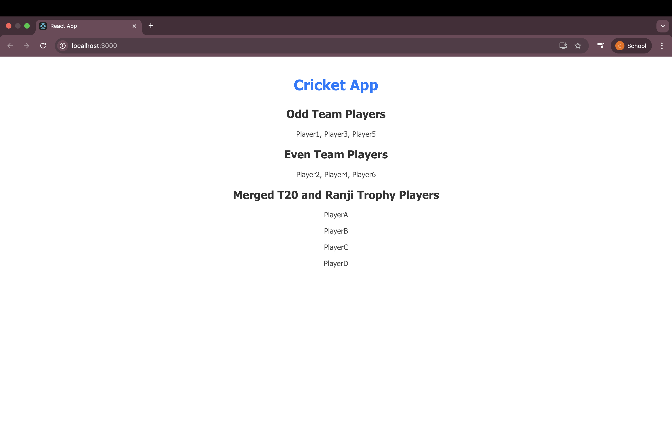
If Flag=false:
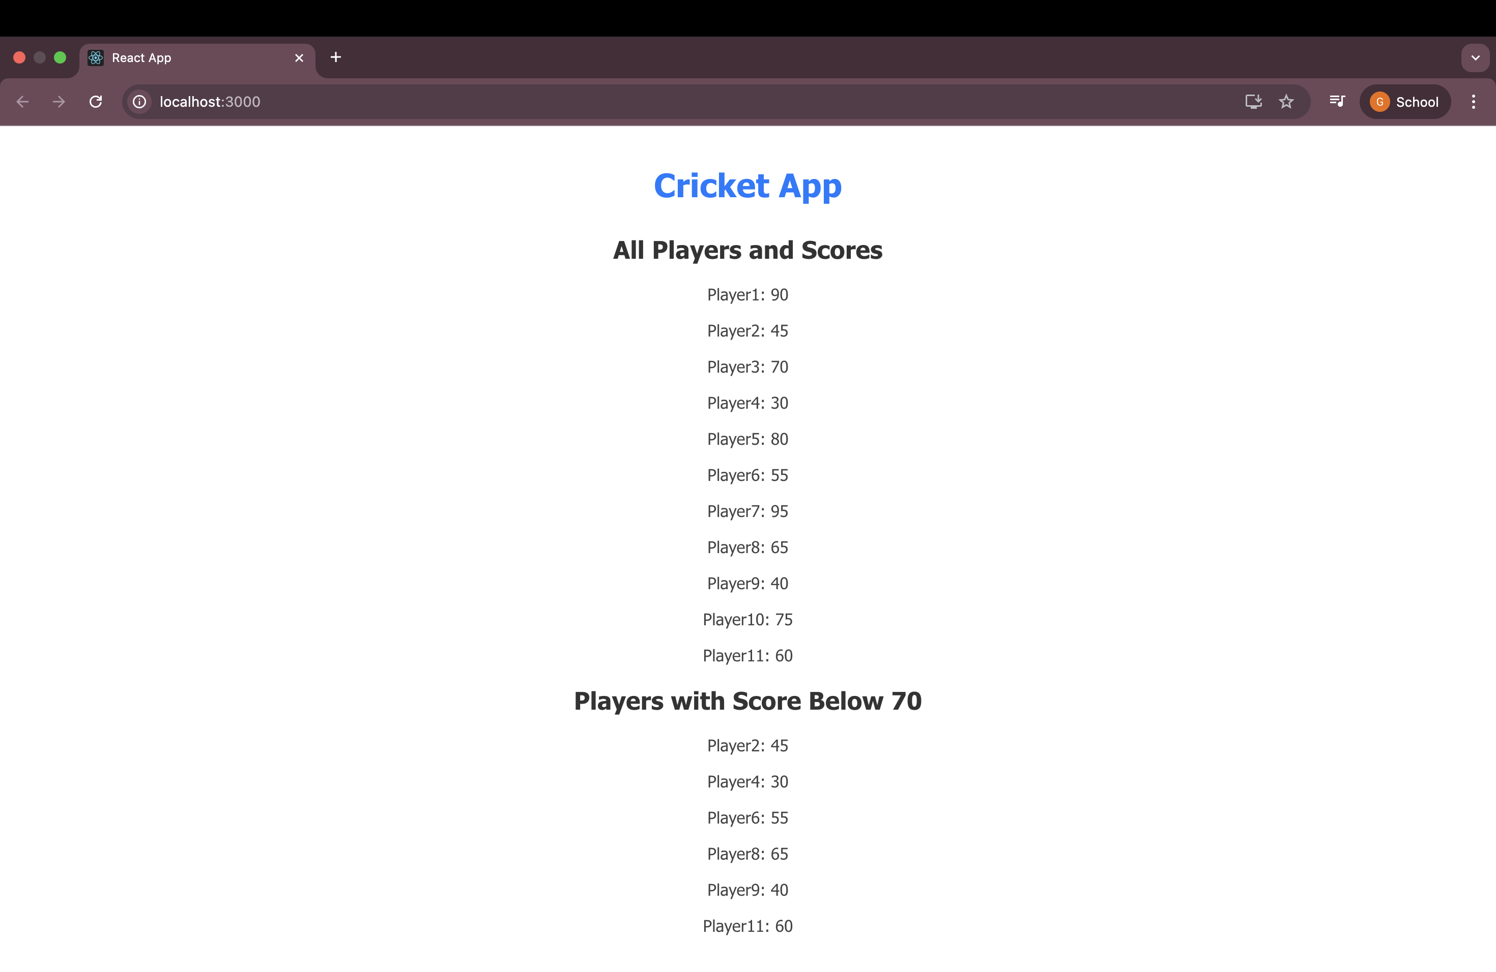
If Flag=True:

Task: 10. ReactJS-HOL

Objectives
JSX and React Fundamentals
Define JSX
JSX stands for JavaScript XML. It is a syntax extension for JavaScript that looks like HTML. React uses JSX to describe what the UI should look like. It makes it easier to write and understand React components because we can write HTML-like code inside JavaScript.
Example:
const element = <h1>Hello, world!</h1>;

Explain about ECMA Script
ECMA Script (or ES) is the official standard of JavaScript. It defines how JavaScript works. Versions like ES5, ES6 (also called ES2015), and newer ones bring new features to JavaScript.
Examples of ES6 features:
- let, const for variable declarations
- Arrow functions: () => {}
- Template literals: Hello ${name}
- Spread operator: [...arr]

Explain React.createElement()
React.createElement() is the method React uses to create virtual DOM elements. JSX code is actually converted into React.createElement() calls behind the scenes.
Example:
const element = React.createElement('h1', null, 'Hello, world!');
This does the same thing as:
const element = <h1>Hello, world!</h1>;

Explain how to create React nodes with JSX
In JSX, we can create nodes (elements) using HTML-like syntax.
Example:
const heading = <h2>Welcome to React</h2>;
const paragraph = <p>This is a paragraph.</p>;
These elements are stored in variables and can be returned from a React component.

Define how to render JSX to DOM
To show JSX content on the screen, we use the ReactDOM.render() method.
Example:
const element = <h1>Hello!</h1>;
ReactDOM.render(element, document.getElementById('root'));
This will show "Hello!" in the HTML element with id "root".

Explain how to use JavaScript expressions in JSX
You can use any JavaScript expression inside JSX by wrapping it in curly braces {}.
Examples:
const name = 'Lasya';
const greeting = <h1>Hello, {name}!</h1>;
You can also use math or function calls:
const total = <p>Total: {5 + 10}</p>;

Explain how to use inline CSS in JSX
In JSX, inline CSS is written using a JavaScript object inside style={{}}. The keys should be in camelCase instead of regular CSS syntax.
Example:
const heading = <h1 style={{ color: 'blue', fontSize: '24px' }}>Styled Text</h1>;
This will make the text blue and font size 24px.
ReactJS Hands-On Lab Submission: officespacerentalapp
Step 1: Create a React Application
Open VS Code terminal and run the following commands:
npx create-react-app officespacerentalapp
cd officespacerentalapp
npm start
This command creates a new React app and opens it in the browser at http://localhost:3000.

Step 2: Open App.js and Remove Default Code
Inside the src folder, open App.js and delete the default content.
Replace it with the following code:
import React from 'react';

function App() {
const heading = <h1 style={{ textAlign: 'center', color: 'blue' }}>Office Space Rental App</h1>;

const officeImage = "https://via.placeholder.com/400x200?text=Office+Image";

const singleOffice = {
name: "Prime Office Tower",
rent: 55000,
address: "123 MG Road, Hyderabad"
};

const officeList = [
{ name: "Workspace Hub", rent: 45000, address: "Ameerpet" },
{ name: "Elite Towers", rent: 70000, address: "Gachibowli" },
{ name: "Startup Square", rent: 60000, address: "Madhapur" }
];

return (
<div style={{ padding: '20px', fontFamily: 'Arial', textAlign: 'center' }}>
{heading}

<img
src={officeImage}
alt="Office Space"
style={{ width: '400px', height: 'auto', margin: '20px auto' }}
/>

<h2>Featured Office</h2>
<p><strong>Name:</strong> {singleOffice.name}</p>
<p>
<strong>Rent:</strong>{' '}
<span style={{ color: singleOffice.rent > 60000 ? 'green' : 'red' }}>
₹{singleOffice.rent}
</span>
</p>
<p><strong>Address:</strong> {singleOffice.address}</p>

<h2>All Office Listings</h2>
{officeList.map((office, index) => (
<div
key={index}
style={{
border: '1px solid gray',
padding: '10px',
margin: '10px auto',
width: '300px',
textAlign: 'left'
}}
>
<p><strong>Name:</strong> {office.name}</p>
<p>
<strong>Rent:</strong>{' '}
<span style={{ color: office.rent > 60000 ? 'green' : 'red' }}>
₹{office.rent}
</span>
</p>
<p><strong>Address:</strong> {office.address}</p>
</div>
))}
</div>
);
}

export default App;

Step 3: What This Code Does
- heading uses JSX to create a heading with inline styling.
- img uses an online image link and JSX attributes to display the image.
- singleOffice is an object containing office name, rent, and address.
- A list of multiple office objects (officeList) is displayed using .map().
- Conditional styling is applied:
  - If rent > 60000, rent is shown in green.
  - If rent < 60000, rent is shown in red.

Step 4: Run the Application
In the terminal, run:
npm start
You will see the output in your browser at http://localhost:3000.

Step 5: Output You Should See
- A centered heading: "Office Space Rental App"
- An image of an office space
- A block for the featured office
- A list of 3 more office listings using map()
- Rent value in red or green based on the amount
ES6 and JSX Concepts Used:
- JSX syntax and elements
- JavaScript expressions in JSX
- Object and Array usage
- map() for looping
- Conditional rendering with inline styles
- Inline CSS styling using the style={{}} syntax
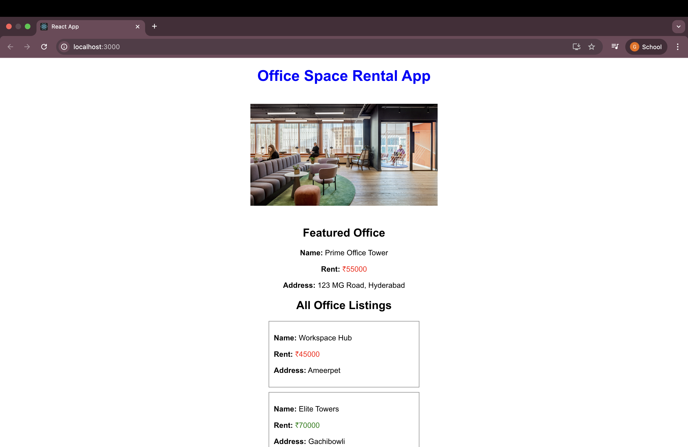
Output:
Task: 11 ReactJS-HOL
Objectives:
ReactJS Events
React Events Explanation:
React events are just like HTML DOM events (like onclick, onchange, etc.), but they follow a different naming convention and are used in JSX. React wraps the native browser events in a cross-browser wrapper called SyntheticEvent, which ensures consistent behavior across all browsers.

Event Handlers in React:
Event handlers are the functions that run when an event (like a button click) happens.
Example:
function handleClick() {
alert("Button clicked!");
}
<button onClick={handleClick}>Click Me</button>
In the above example, handleClick is an event handler connected to the onClick event.

What is a Synthetic Event?
A Synthetic Event in React is a wrapper around the browser’s native event. It combines the behavior of different browsers into one consistent interface.
Example:
function handleClick(e) {
console.log(e.type); // 'click'
}
This event object e is a synthetic event that React creates. It behaves like the browser event but works the same across all browsers.

React Event Naming Convention:
React uses camelCase for event names, unlike HTML which uses lowercase.
HTML | React
onclick | onClick
onchange | onChange
onsubmit | onSubmit

Also, in React you pass a function without calling it:
// Correct
<button onClick={doSomething}>Click</button>

// Incorrect
<button onClick={doSomething()}>Click</button>

Summary:
- React uses Synthetic Events for cross-browser support
- Event handlers are functions attached to events like clicks
- Use camelCase for event names in JSX
- Always pass the function reference, not the function call
These concepts are commonly used while building interactive UI in React apps.

ReactJS Hands-On Lab Submission: Event Handling & CurrencyConvertor App

Step-by-Step Implementation in VS Code
Step 1: Create the React App
Open terminal in VS Code and run:
npx create-react-app eventexamplesapp
cd eventexamplesapp
npm start
This will create and launch the app in your browser at http://localhost:3000.

Step 2: Update App.js
Go to the src folder. Open App.js and replace all the code with:
import React from 'react';
import CurrencyConvertor from './CurrencyConvertor';

class App extends React.Component {
constructor(props) {
super(props);
this.state = {
counter: 0
};
this.increment = this.increment.bind(this);
this.sayHello = this.sayHello.bind(this);
}

increment() {
this.setState({ counter: this.state.counter + 1 });
this.sayHello();
}

decrement = () => {
this.setState({ counter: this.state.counter - 1 });
};

sayHello() {
alert("Hello! This is a static message.");
}

sayWelcome = (message) => {
alert(message);
};

handleClick = () => {
alert("I was clicked");
};

render() {
return (
<div style={{ padding: '20px', fontFamily: 'Arial' }}>
<p>{this.state.counter}</p>

<button onClick={this.increment}>Increment</button><br /><br />
<button onClick={this.decrement}>Decrement</button><br /><br />
<button onClick={() => this.sayWelcome("Welcome to ReactJS")}>Say welcome</button><br /><br />
<button onClick={this.handleClick}>Click on me</button><br /><br />

<CurrencyConvertor />
</div>
);
}
}

export default App;

Step 3: Create CurrencyConvertor.js
Inside src/, create a new file named CurrencyConvertor.js and paste this:
import React, { useState } from 'react';

function CurrencyConvertor() {
const [rupees, setRupees] = useState('');

const handleSubmit = () => {
const rate = 80; // 1 INR = 80 Euro (for example)
const result = parseFloat(rupees) * rate;
alert(`Converting to Euro Amount is ${result}`);
};

return (
<div>
<h2 style={{ color: 'green', fontWeight: 'bold' }}>Currency Convertor!!!</h2>

<label>Amount: </label>
<input
type="number"
value={rupees}
onChange={(e) => setRupees(e.target.value)}
/><br /><br />

<label>Currency: </label>
<input type="text" value="Euro" readOnly /><br /><br />

<button onClick={handleSubmit}>Submit</button>
</div>
);
}

export default CurrencyConvertor;

Step 4: Run the App
If not already running, use:
npm start
The browser will open at http://localhost:3000.

Expected Output Matches the Document Screenshot:
- A number showing counter (e.g., 1)
- Buttons: Increment, Decrement, Say welcome, Click on me (stacked)
- Heading: Currency Convertor!!! in green and bold
- Input box for amount, read-only Euro box, and Submit button
- On clicking Submit → an alert shows: "Converting to Euro Amount is ..."

Key Concepts Demonstrated:
- State management using this.state and useState
- Event handling using onClick
- Calling multiple methods in one handler
- Passing arguments to functions
- Using alert() for synthetic event and result display
Output:
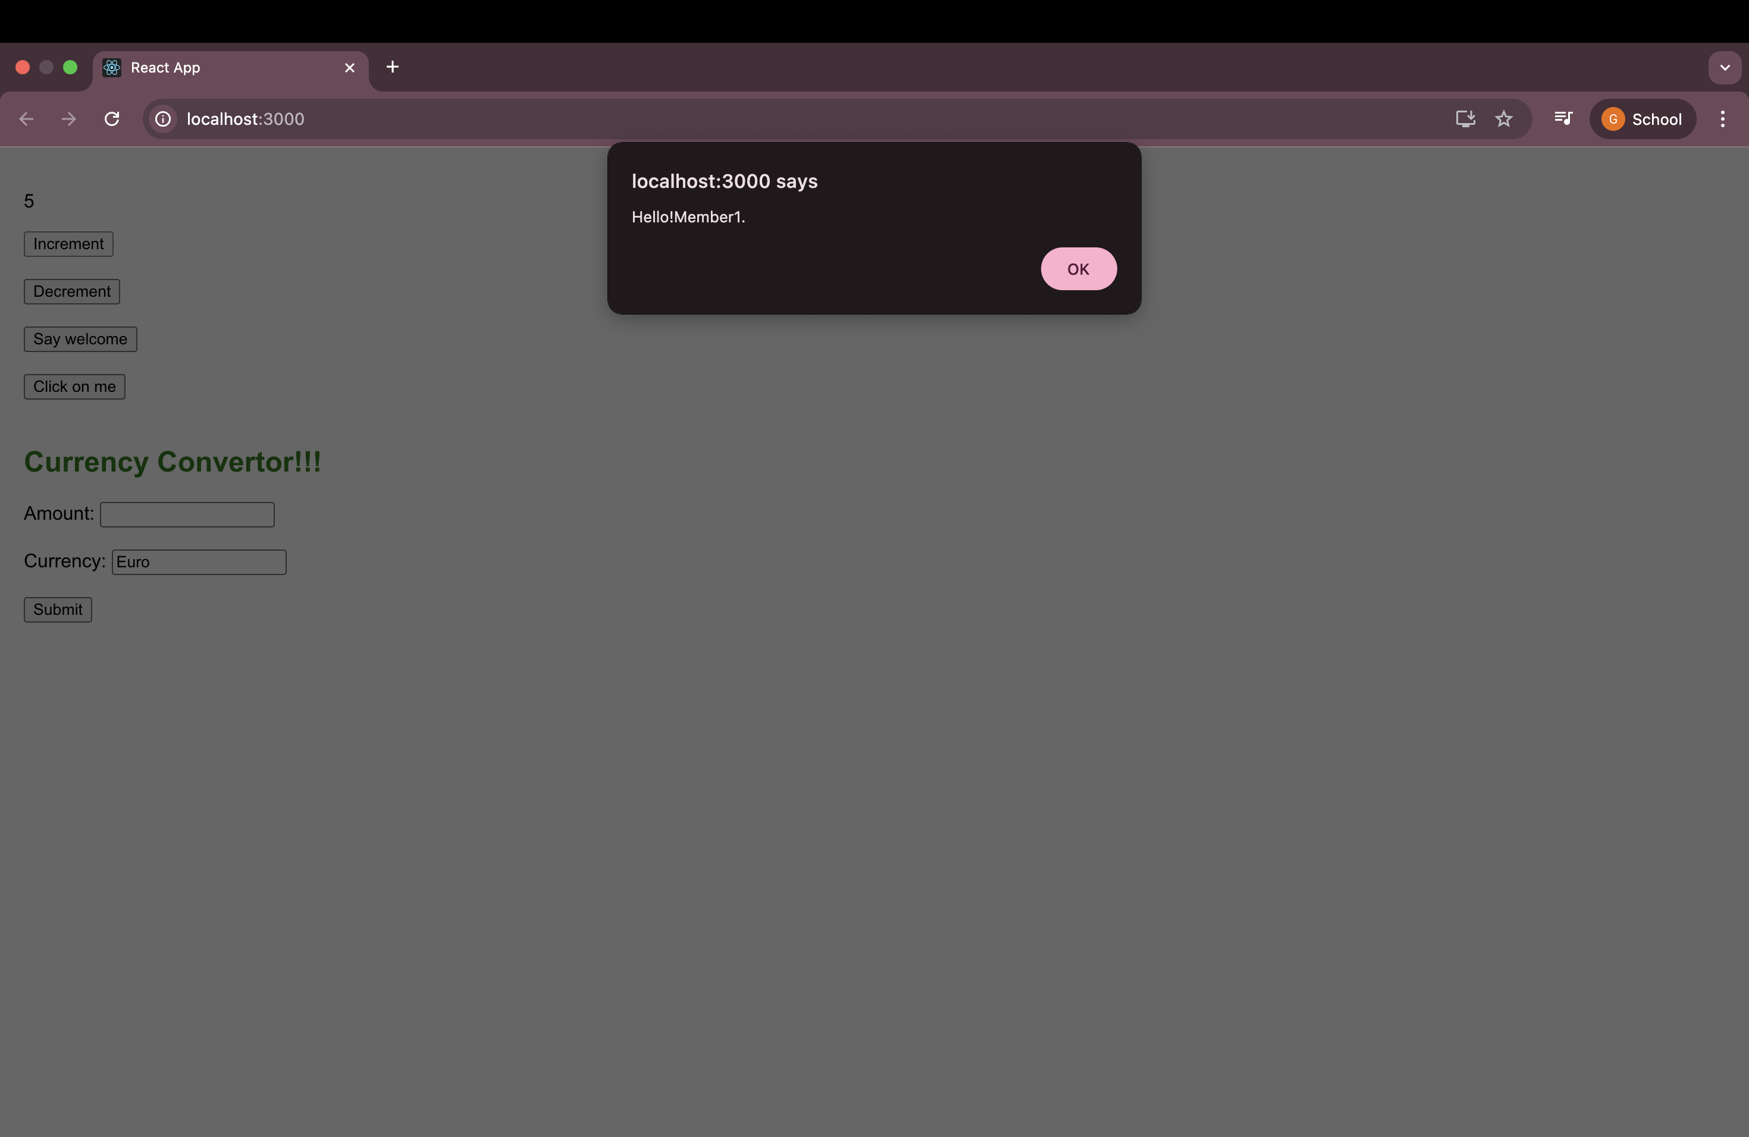
The output shows the initial counter value and an 'Increment' button. When the button is clicked, it increases the counter by 1 and displays an alert box saying 'Hello!Member1.'
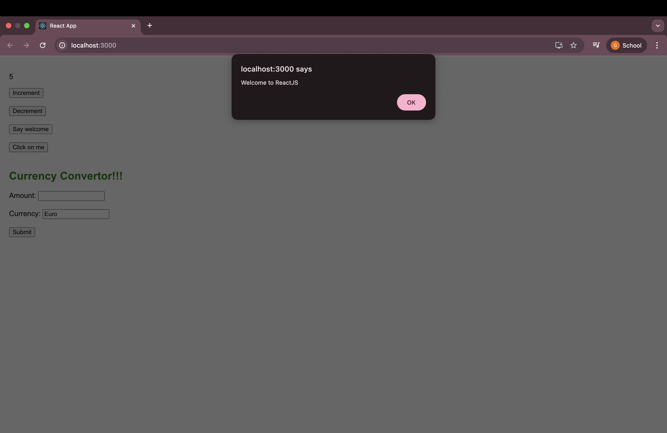
This output shows a 'Say Welcome' button. When clicked, it calls a function that takes the message 'Welcome' as an argument and displays it in an alert box.

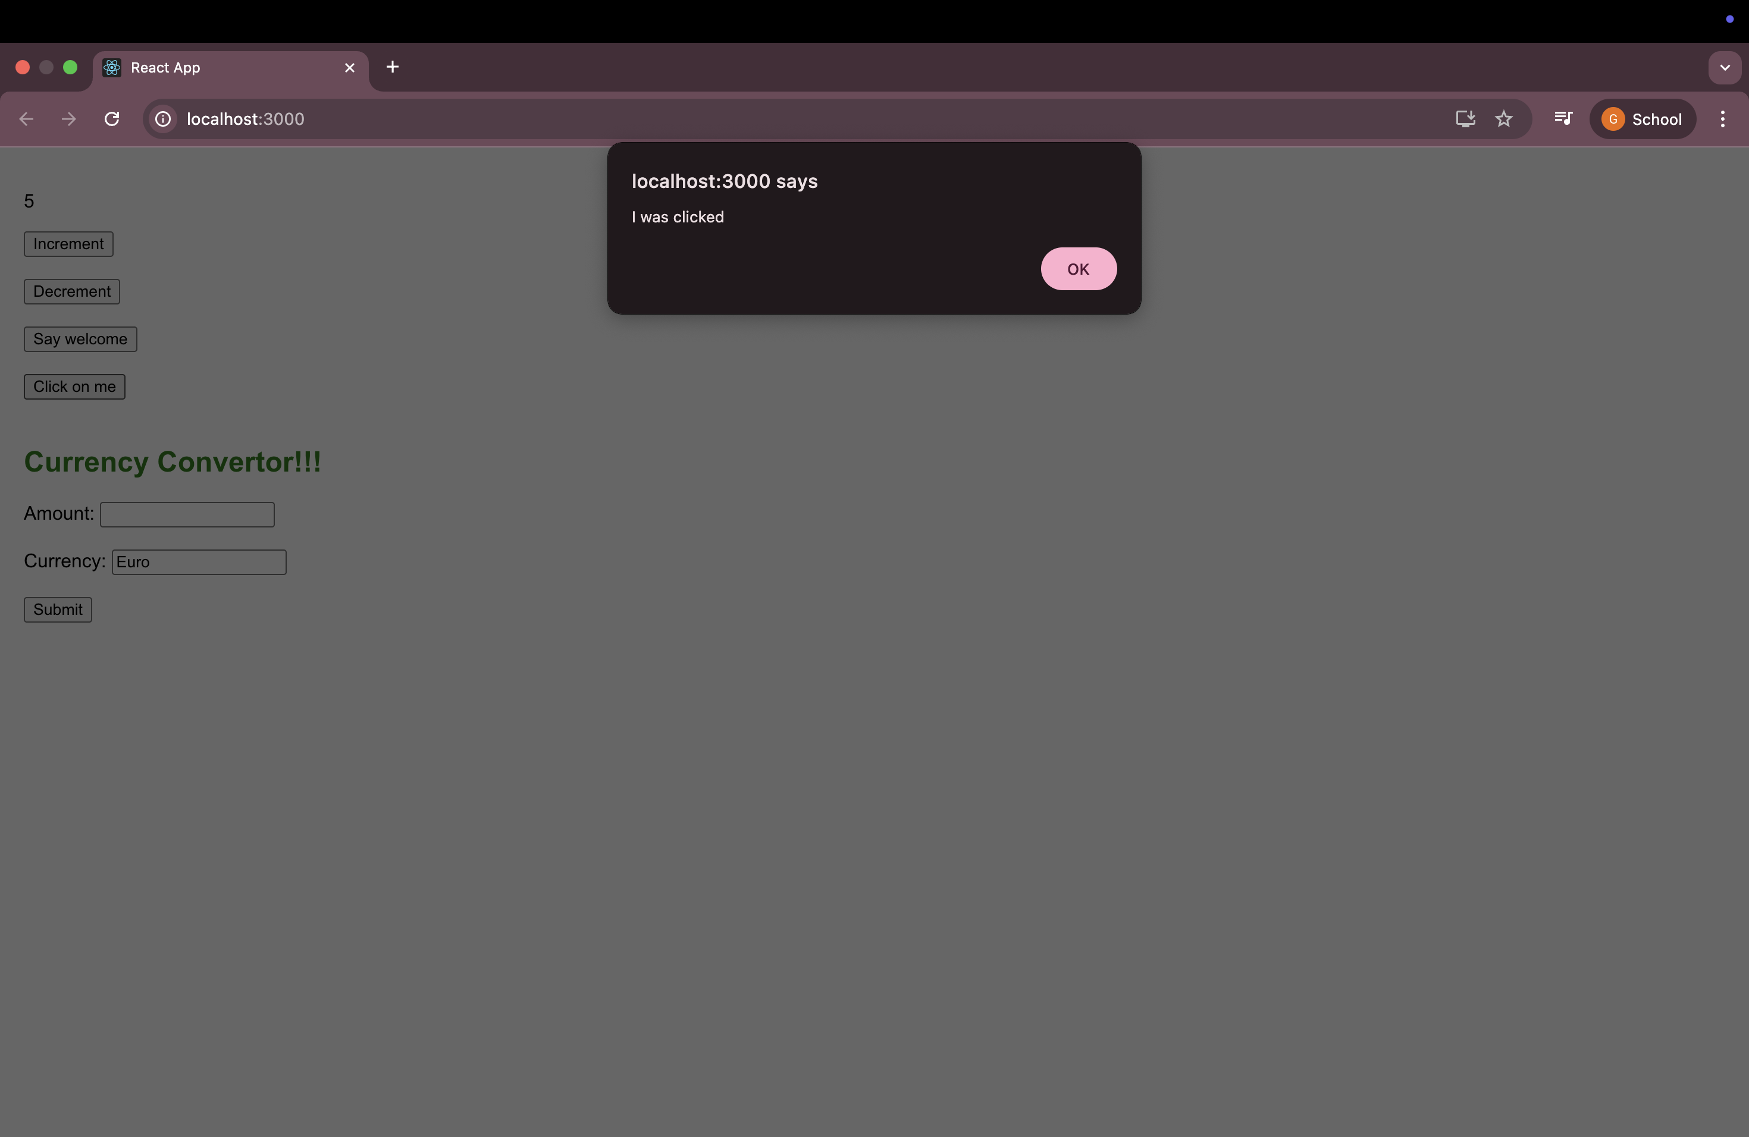
This output shows a button labeled 'Click on me'. When clicked, it triggers a synthetic event in React using the onClick handler, and displays an alert box saying 'I was clicked’.

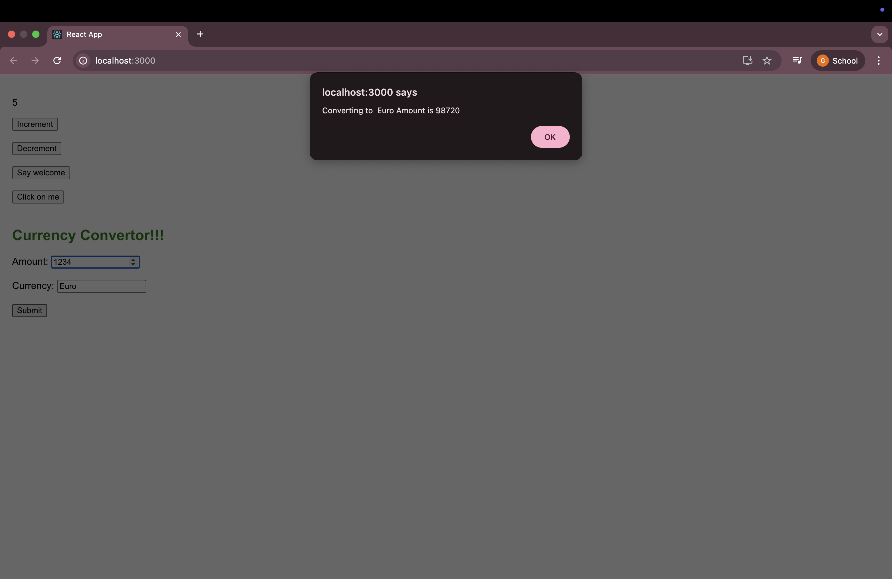
This output displays a CurrencyConvertor component with an input field to enter amount in Indian Rupees, and a read-only field labeled 'Euro'. When the 'Submit' button is clicked, it triggers the handleSubmit function which calculates the Euro equivalent using a fixed conversion rate and shows the result in an alert box.
Task: 12. ReactJS-HOL
Objectives:

What is Conditional Rendering in React?
Conditional rendering means showing or hiding parts of a React component depending on some condition. It is like how we use if-else in JavaScript.
Example:
{isLoggedIn ? <UserGreeting /> : <GuestGreeting />}
If the user is logged in, it shows UserGreeting. Otherwise, it shows GuestGreeting.

What are Element Variables in React?
Element variables are used to store JSX in a variable and then return that variable in the component’s render output. This helps with writing cleaner conditional code.
Example:
let greeting;
if (isLoggedIn) {
greeting = <UserGreeting />;
} else {
greeting = <GuestGreeting />;
}

return (
<div>
{greeting}
</div>
);
This avoids repeating the if-else inside JSX and keeps the JSX neat.

How to Prevent Components from Rendering in React?
To stop a component from rendering, we can:
- Use a condition and return null:
function WarningBanner(props) {
if (!props.showWarning) {
return null;
}
return <div>Warning!</div>;
}
Here, the component returns null if showWarning is false. So nothing will show.
- Use short-circuit &&:
{show && <ComponentName />}
This only renders the component if show is true.
ReactJS Hands-On Lab: ticketbookingapp
Objective:
Build a React app using functional components to show conditional rendering based on login status.
Step 1: Create the React App
npx create-react-app ticketbookingapp
cd ticketbookingapp
npm start
This creates the app and runs it on localhost:3000

Step 2: Create Component - UserGreeting.js
Inside src/, create a file called UserGreeting.js:
import React from 'react';

function UserGreeting() {
return <h1>Welcome back, User! You can now book your flight tickets.</h1>;
}

export default UserGreeting;

Step 3: Create Component - GuestGreeting.js
import React from 'react';

function GuestGreeting() {
return <h1>Welcome Guest! Please login to book your tickets.</h1>;
}

export default GuestGreeting;

Step 4: Create Component - LoginButton.js
import React from 'react';

function LoginButton(props) {
return (
<button onClick={props.onClick}>
Login
</button>
);
}

export default LoginButton;

Step 5: Create Component - LogoutButton.js
import React from 'react';

function LogoutButton(props) {
return (
<button onClick={props.onClick}>
Logout
</button>
);
}

export default LogoutButton;

Step 6: Create Component - Greeting.js
import React from 'react';
import UserGreeting from './UserGreeting';
import GuestGreeting from './GuestGreeting';

function Greeting(props) {
const isLoggedIn = props.isLoggedIn;
if (isLoggedIn) {
return <UserGreeting />;
}
return <GuestGreeting />;
}

export default Greeting;

Step 7: Update App.js with Conditional Logic
Replace all code in App.js with:
import React, { useState } from 'react';
import Greeting from './Greeting';
import LoginButton from './LoginButton';
import LogoutButton from './LogoutButton';

function App() {
const [isLoggedIn, setIsLoggedIn] = useState(false);

const handleLoginClick = () => {
setIsLoggedIn(true);
};

const handleLogoutClick = () => {
setIsLoggedIn(false);
};

return (
<div style={{ textAlign: 'center', marginTop: '50px' }}>
<Greeting isLoggedIn={isLoggedIn} />
{isLoggedIn ? (
<LogoutButton onClick={handleLogoutClick} />
) : (
<LoginButton onClick={handleLoginClick} />
)}
</div>
);
}

export default App;

Expected Output Behavior:
- Default: Guest message + Login button
- After Login: Shows user message + Logout button
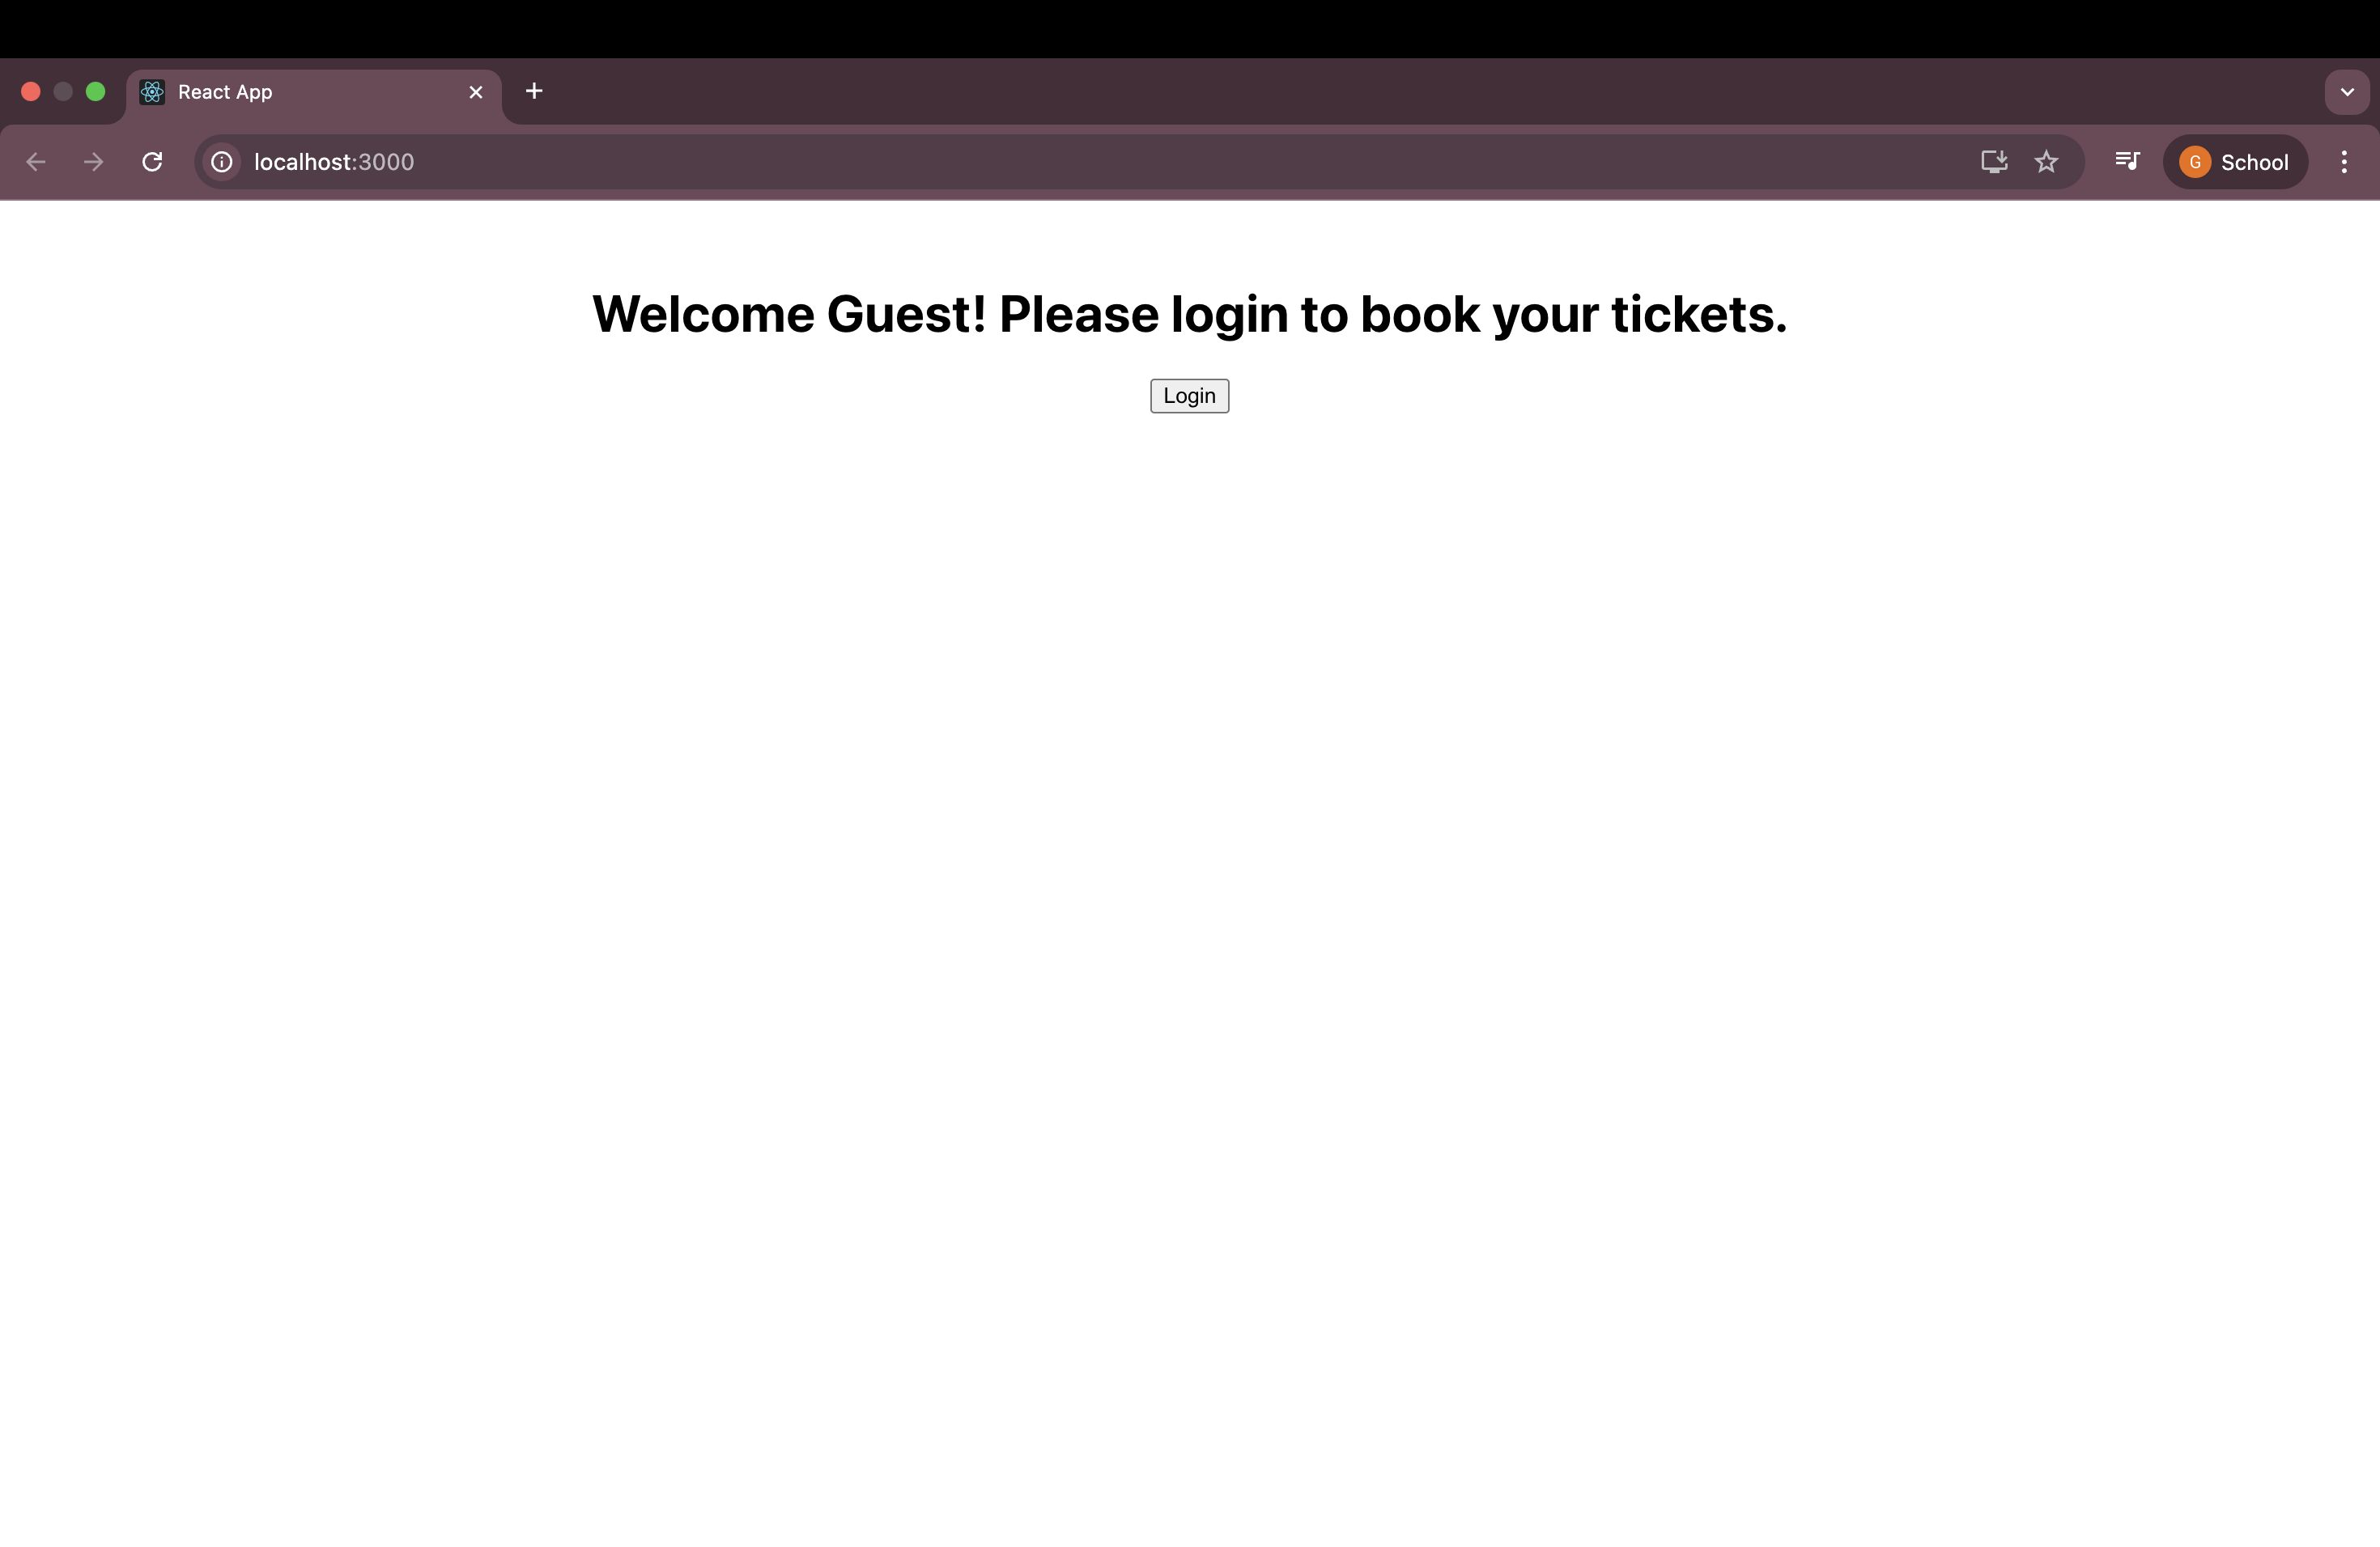
- After Logout: Back to Guest message

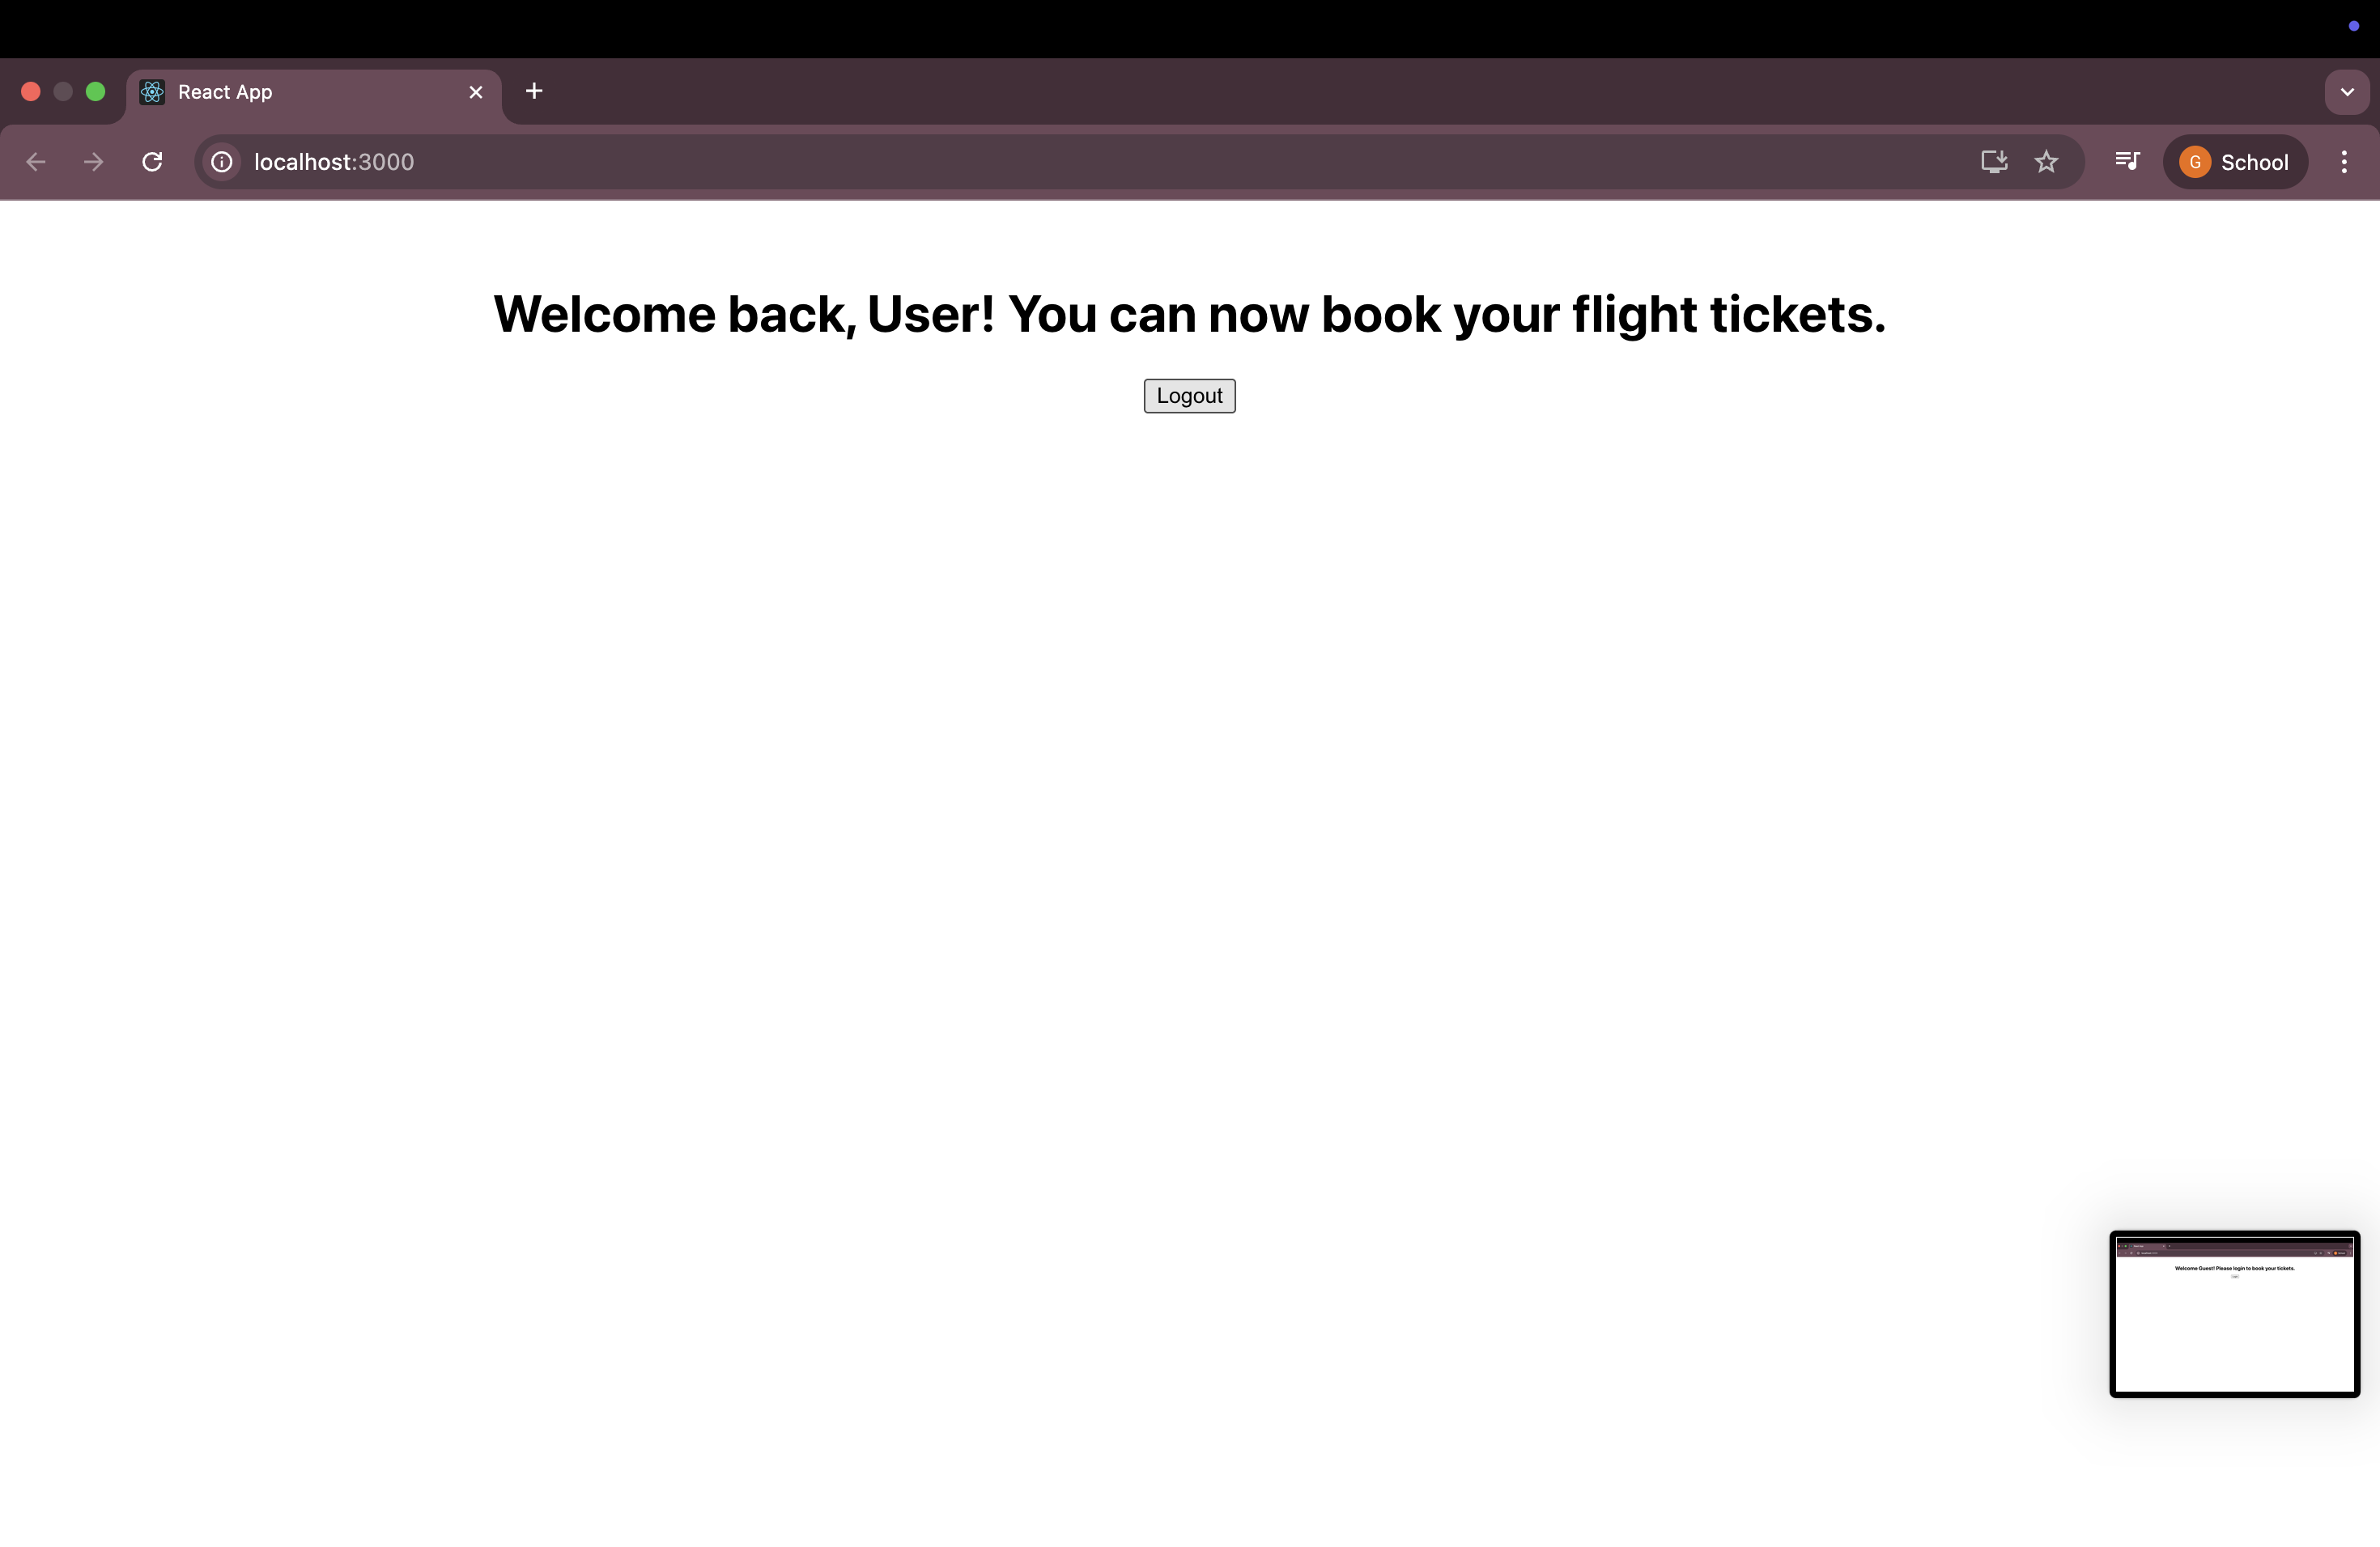

Task: 13. ReactJS-HOL
Objectives
Explain various ways of conditional rendering:
React allows us to show or hide components based on logic. Common ways include:
- if/else: Used inside functions to return different JSX.
- Ternary Operator: condition ? <TrueComponent /> : <FalseComponent />
- Logical AND (&&): condition && <Component /> shows the component only if condition is true.
- Switch Statement: For multiple matching conditions, used inside a render method.
Explain how to render multiple components:
We can return multiple components from one parent using:
- A wrapper like <div> or <React.Fragment>
- Returning an array of components (rare)
Example:
return (
<div>
<Header />
<MainContent />
<Footer />
</div>
);
Define list component:
A list component is a reusable component that displays multiple similar elements (like a list of books, users, etc.). It uses map() to loop through data and return JSX for each item.
Explain about keys in React applications:
- Keys help React identify and track each item uniquely in a list.
- They must be unique and stable (preferably use id).
- Keys improve performance and avoid unnecessary re-rendering.
Example:
items.map(item => <li key={item.id}>{item.name}</li>)
Explain how to extract components with keys:
When building a list, we can pass each item to a child component and use a key:
books.map(book => <BookItem key={book.id} book={book} />);
Here, BookItem is a component that receives a single book and displays it.
Explain React map, map() function:
- The map() function in React is used to create dynamic JSX from data.
- It loops through arrays and returns a component for each element.
Example:
const bookItems = books.map(book => (
<div key={book.id}>
<h3>{book.bname}</h3>
<p>{book.price}</p>
</div>
));
This makes UI updates dynamic and based on real-time data.
Step 1: Create the React App
Open VS Code terminal and run:
npx create-react-app bloggerapp
cd bloggerapp
npm start

Step 2: Create book data file
Inside the src folder, create a new file named data.js and paste:
export const books = [
{ id: 101, bname: 'Master React', price: 670 },
{ id: 102, bname: 'Deep Dive into Angular 11', price: 800 },
{ id: 103, bname: 'Mongo Essentials', price: 450 }
];

Step 3: Create CourseDetails.js
import React from 'react';

function CourseDetails() {
return (
<div>
<h1>Course Details</h1>
<ul>
<li>Angular - 4/5/2021</li>
<li>React - 6/5/2021</li>
</ul>
</div>
);
}

export default CourseDetails;

Step 4: Create BookDetails.js
import React from 'react';

function BookDetails(props) {
const bookList = props.books.map((book) => (
<div key={book.id}>
<h3>{book.bname}</h3>
<h4>{book.price}</h4>
</div>
));

return (
<div>
<h1>Book Details</h1>
{bookList}
</div>
);
}

export default BookDetails;

Step 5: Create BlogDetails.js
import React from 'react';

function BlogDetails() {
return (
<div>
<h1>Blog Details</h1>
<h3>React Learning</h3>
<p>Welcome to learning React!</p>
<h3>Installation</h3>
<p>You can install React from npm.</p>
</div>
);
}

export default BlogDetails;

Step 6: Update App.js
Replace all content in src/App.js with:
import React from 'react';
import './App.css';
import CourseDetails from './CourseDetails';
import BookDetails from './BookDetails';
import BlogDetails from './BlogDetails';
import { books } from './data';

function App() {
return (
<div className="box">
<div className="left">
<CourseDetails />
</div>
<div className="middle">
<BookDetails books={books} />
</div>
<div className="right">
<BlogDetails />
</div>
</div>
);
}

export default App;

Step 7: Add styling to App.css
Replace all content in src/App.css with:
.box {
display: flex;
justify-content: space-around;
text-align: center;
margin-top: 30px;
}

.left, .middle, .right {
border-left: 2px solid green;
padding: 20px;
flex: 1;
}

Expected Output:
- Three columns displayed side-by-side
- Course details on the left
- Book list (using .map) in center
- Blog section on the right

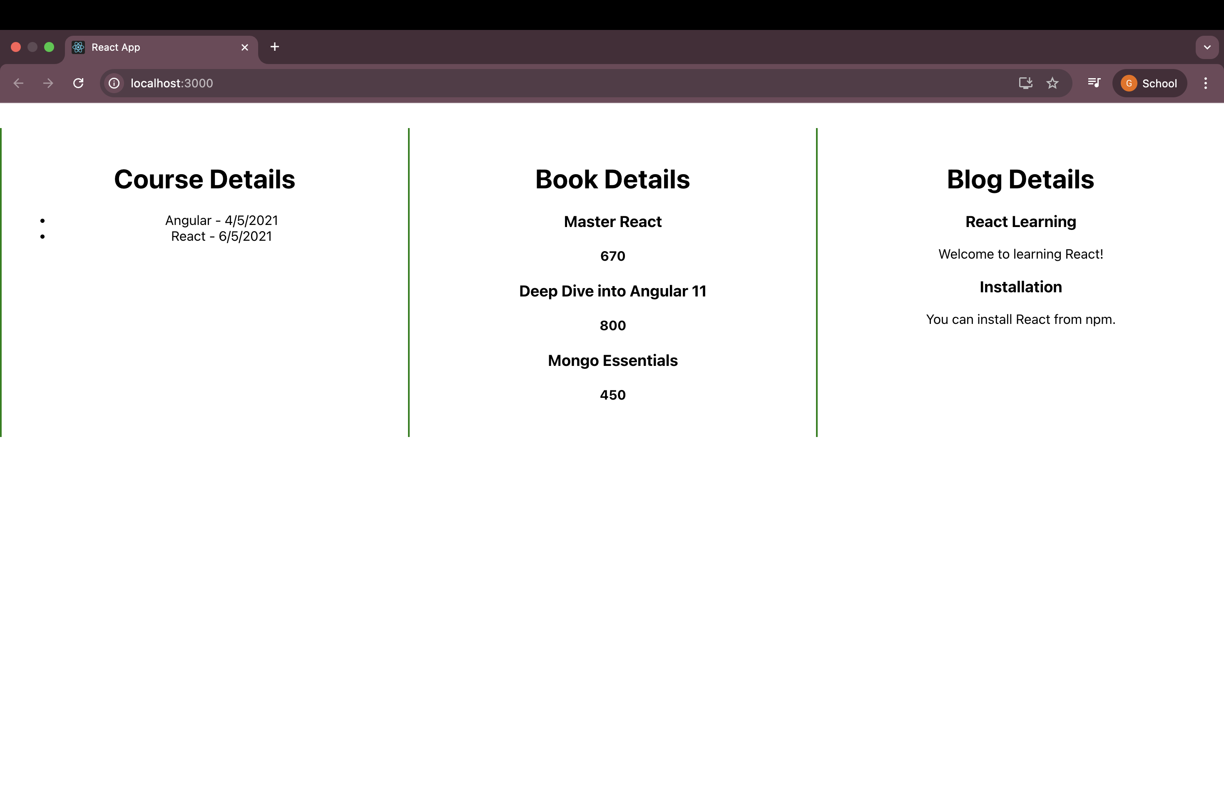
Output:

