<PSZT> Project 1: Memetic algorithm  
documentation

1. **Authors:**

Christian Konopczyński  
Wojciech Maciejewski

1. **Assignment interpretation:**

We modify the evolutionary algorithm from the slide to create memetic algorithm. Algorithm is created with versatility in mind (any fitness function, mutation method, crossover method, etc.). For local optimizer we use gradient descent. Implementation in Python.

1. **Author input:**

Christian Konopczyński –μ+λ mutation, documentation, local optimizer, tests  
Wojciech Maciejewski –1+1 mutation, evolutionary algorithm implementation, local optimizer, tests

1. **Important project decisions:**

* deciding on versatile algorithm implementation
* choice of implemented methods – mainly gradient descent for local optimizer

1. **Tools and libraries:**

* Visual Studio Code
* Spyder
* Git
* NumPy
* standard Python libraries: math, sys, random

1. **Thesis and objectives of research:**

We compare evolutionary algorithm before and after implementing additional optimization making the algorithm memetic. Our expectations might be summarized like this:

- Memetic algorithm required more time for each epoch (iteration)

- Memetic algorithm, thanks to local optimizer, will reach maximum or value close to maximum in a smaller number of epochs (iterations) than evolutionary algorithm

1. **Experimentation results:**

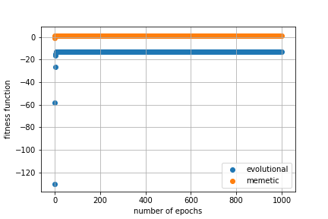

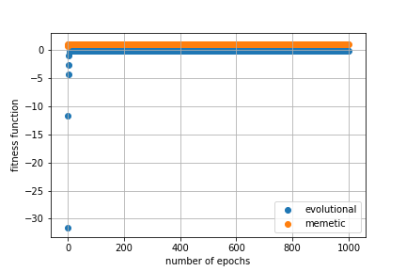

It is noticeable that memetic algorithm converges faster on the optimum and finds points in closer proximity to it.

1. **Result discussion:**

In general, memetic algorithm is better for considerable amount of problems but isn’t suited to every each of them since gradient descent can only be used for differentiable functions and gradient must be known. Also, each epoch takes longer because of taken optimizing steps. The learning rate must be adjusted separately for each case.

Because of that evolutionary algorithm has the advantage of being more flexible and being possible to use for wider scope of problems.

1. **Conclusions:**

In most cases memetic algorithm should be used over the evolutionary algorithm if possible since it’s better at finding local optimums.