TicTacToe by Norbi&Laci

We created a basic TicTacToe game on a fix 3x3 play area.
It is 95% playable for now.
- we can win in the game
- it shows whose turn is now
- asks for coordinates to input
- shows help message if wrong data inputed
- has a basic but nice 2d graphical background
- clears the terminal while playing, only shows game progress
- 95% playable, because yet game not stopping when game field is full, and noone won.

Planned progress:
- AI
- Extendable board
- Colored game
- Functional code creation

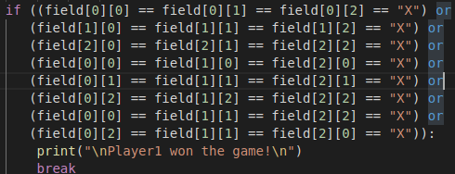
Example codec what and why we want to start working with functions:

