# Overall Approach and Process

Steps:

* Created a Jupyter notebook / Python to extract the raw data
* Divided the initial dataset in to subsets (tables)
* Imported the tables into Tableau
* Created joins/relationships
* Created visualizations
* Created this user guide/report

# User guide

## Dashboard #1

### Select the first dashboard

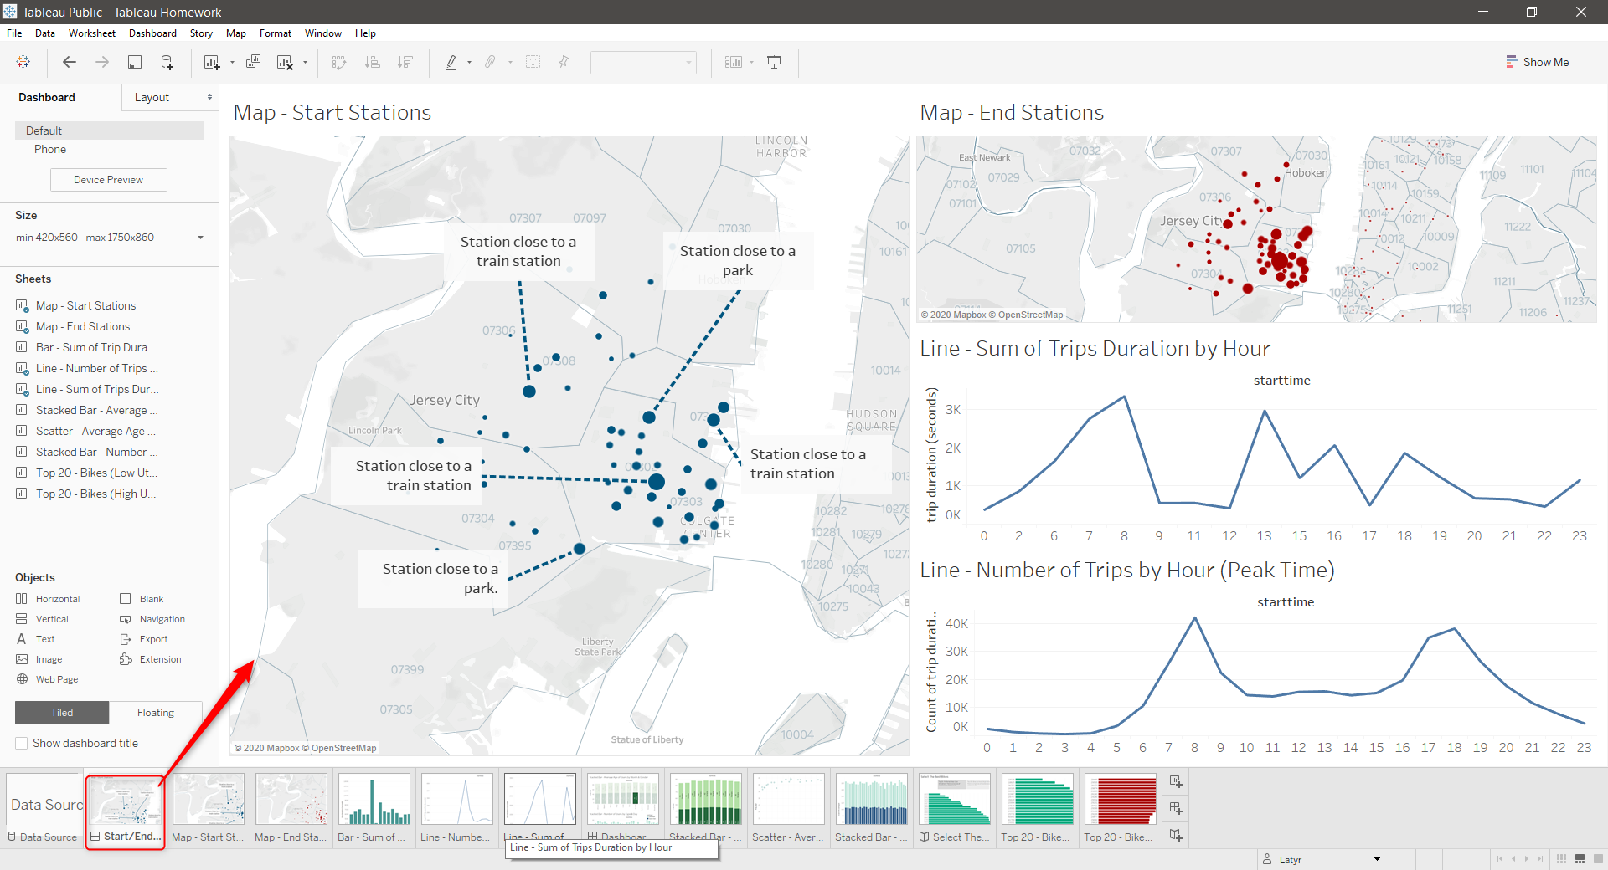

### Hover a Station to show the tooltip

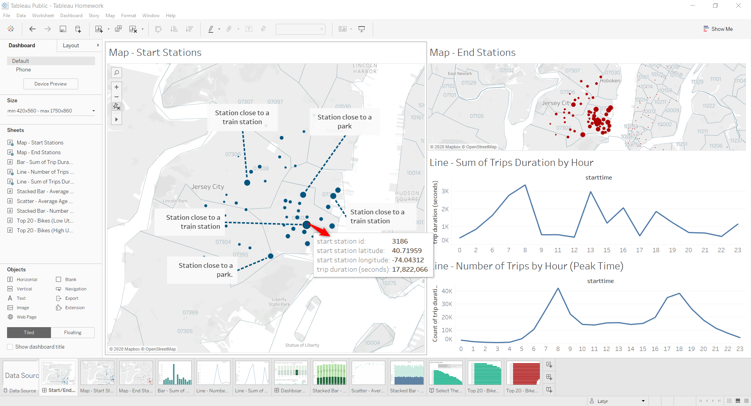

### Click on the station to filter remaining charts

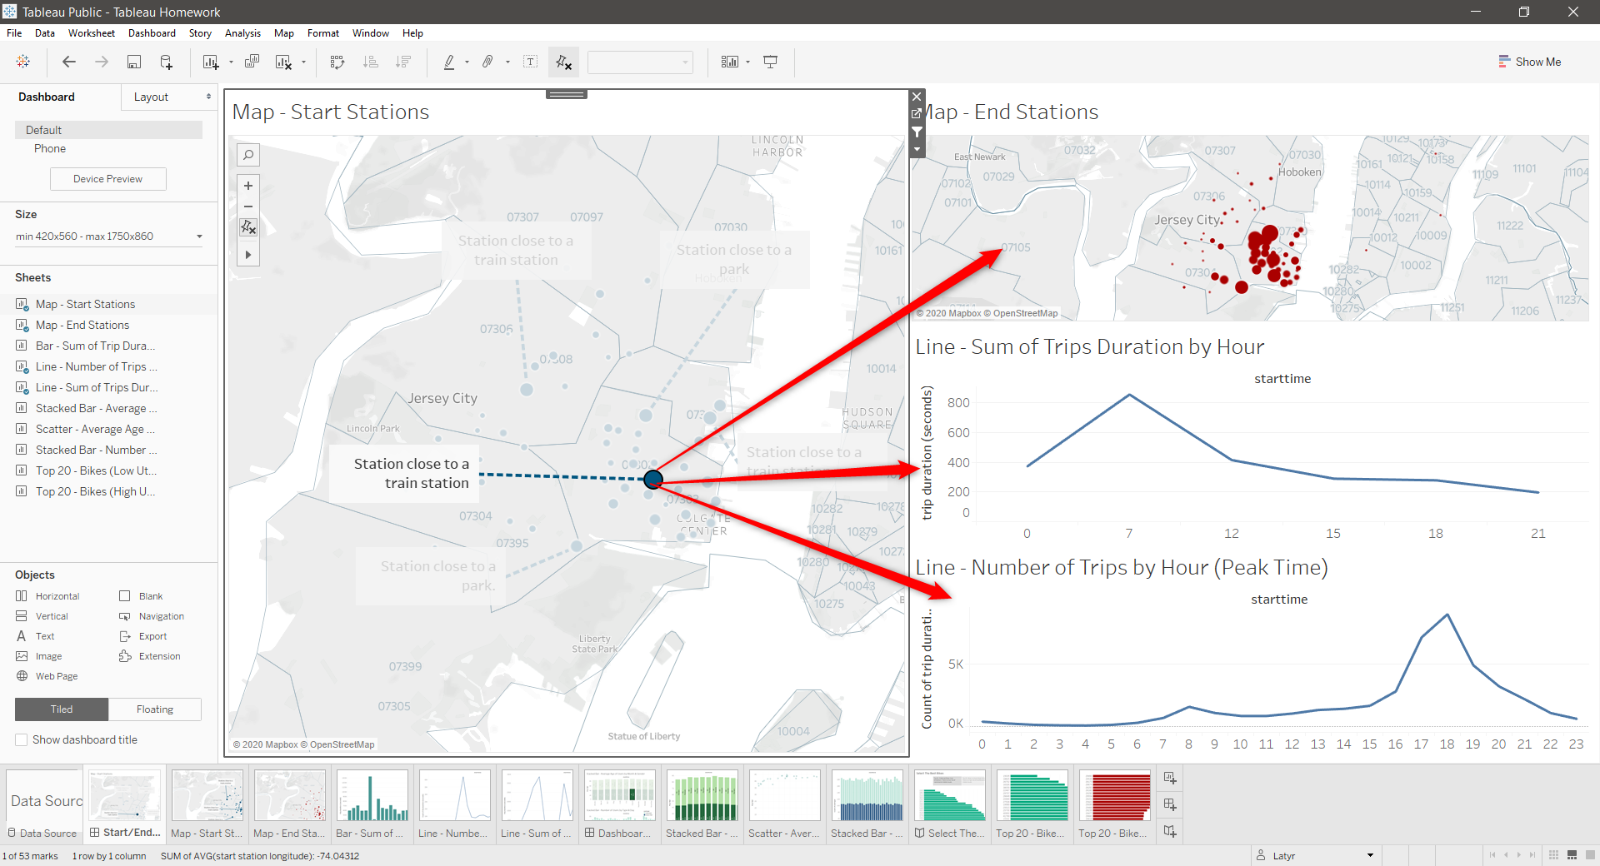

## Dashboard #2

### Select the 2nd dashboard

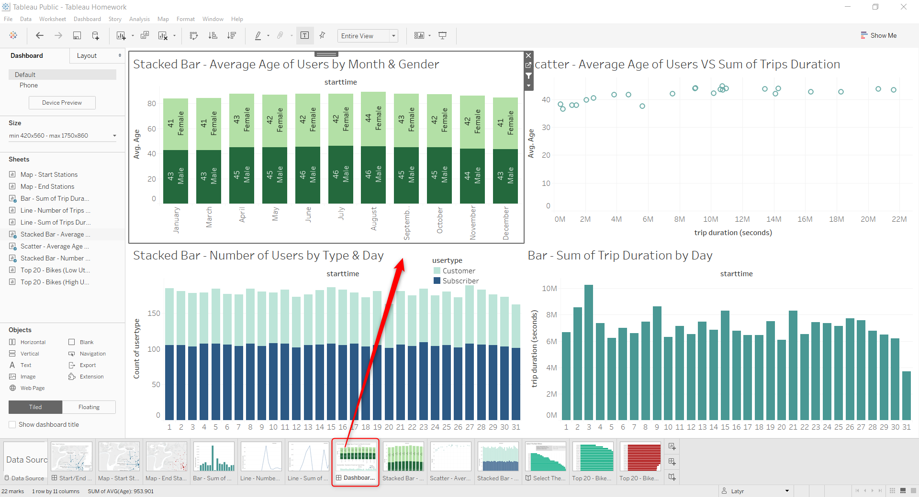

### Click on a bar, first bar chart to filter the remaining charts

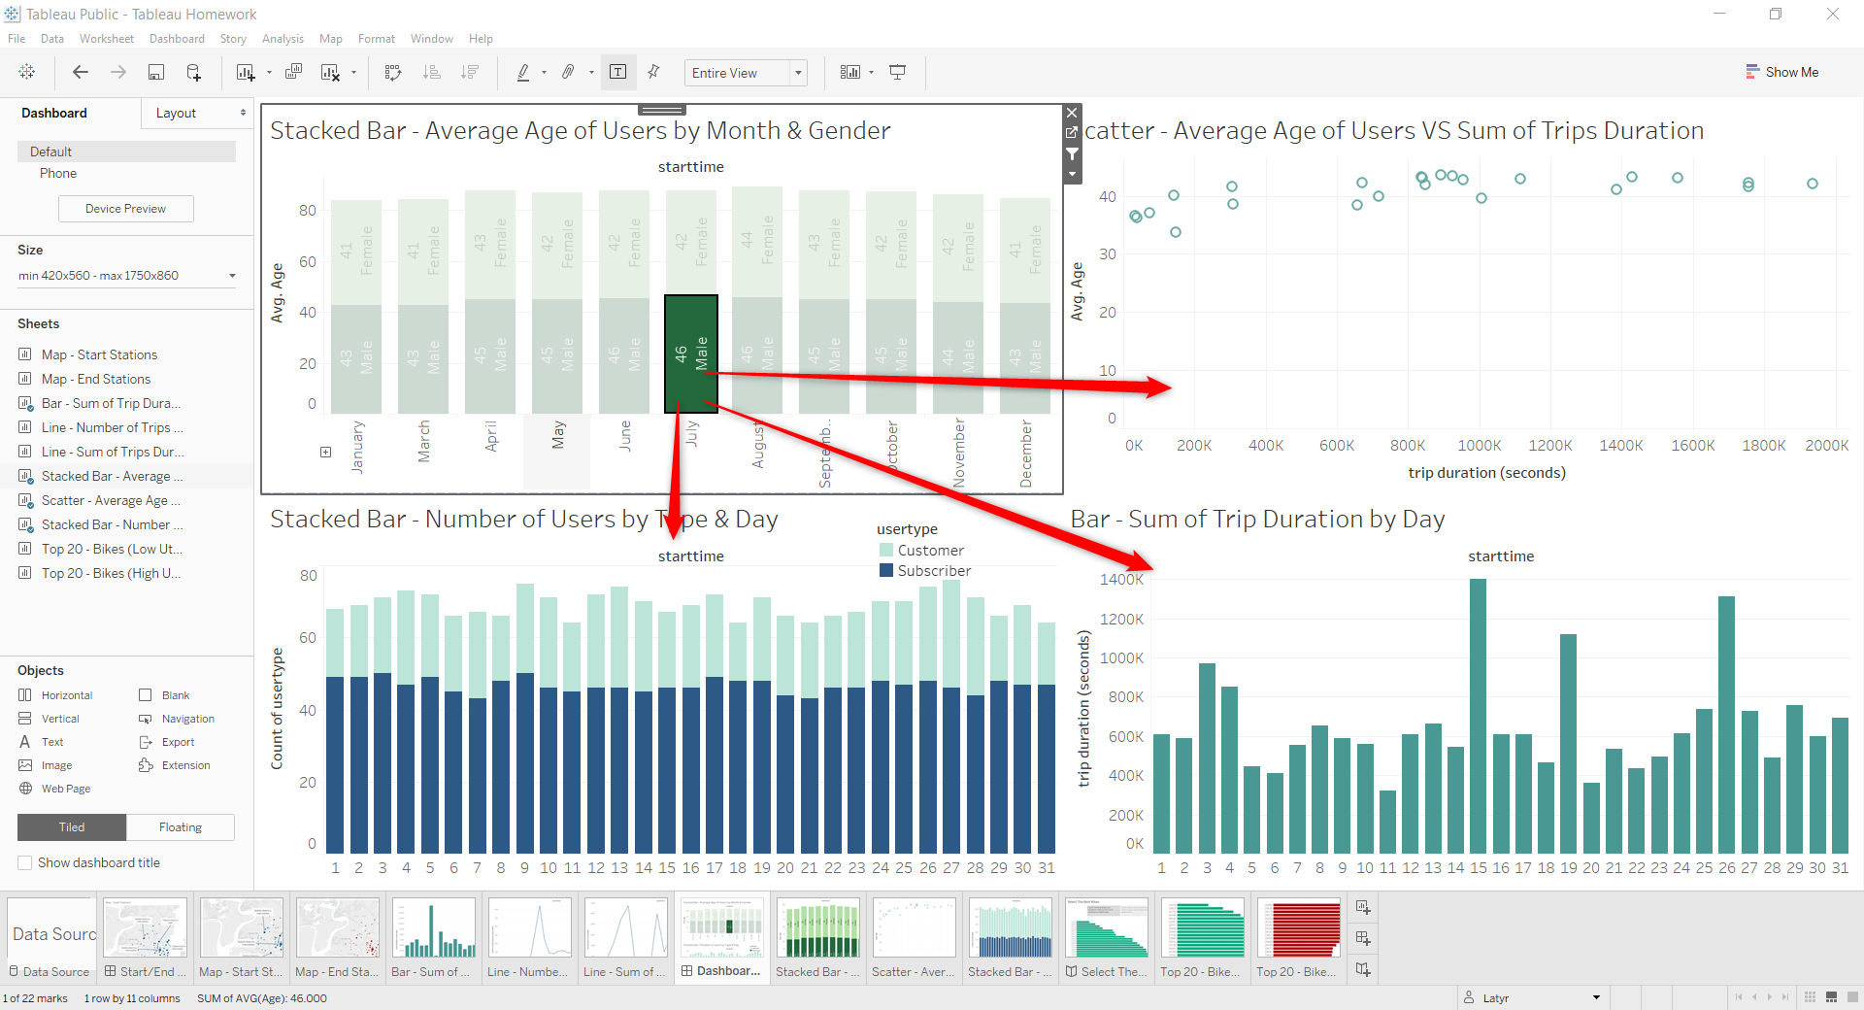

## Story

### Open the Story

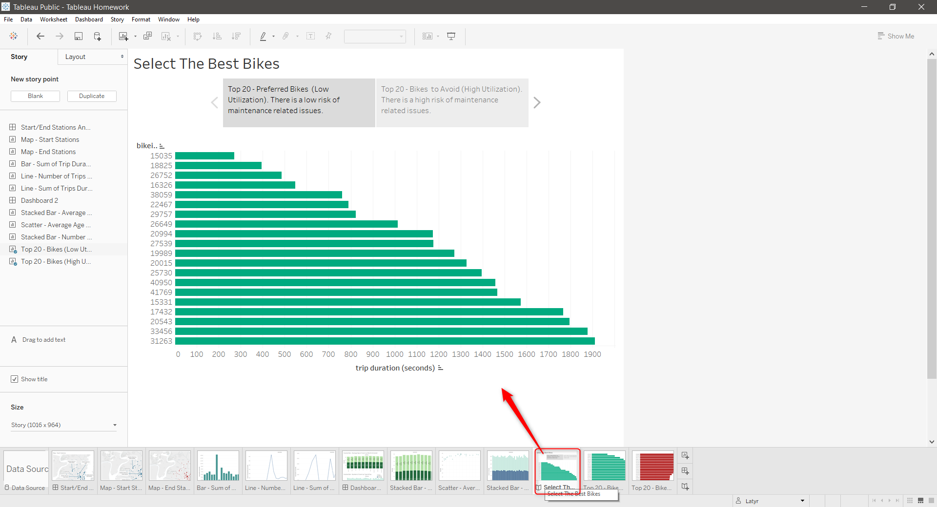

### Show the next chart

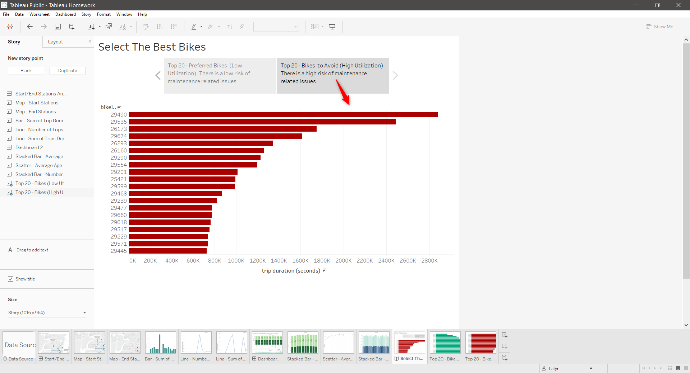

# Report & Conclusions

## Two unexpected observations

### Start Stations map and End Stations map show a similar patterns/sizes

This is confusing as it could mean that a user starts its trip a station and ends it at the same station.

But By looking at closer to the maps and the Peak Time, it appears that most users use those bikes around 8:00 am and 6:00 pm. That indicates that people are going to work or coming back from their offices.

Additionally, most stations with a high traffic are located next to a train station, which suggest that the use the bikes between that same station and their homes. The train being a complementary means of transportation to reach the office.

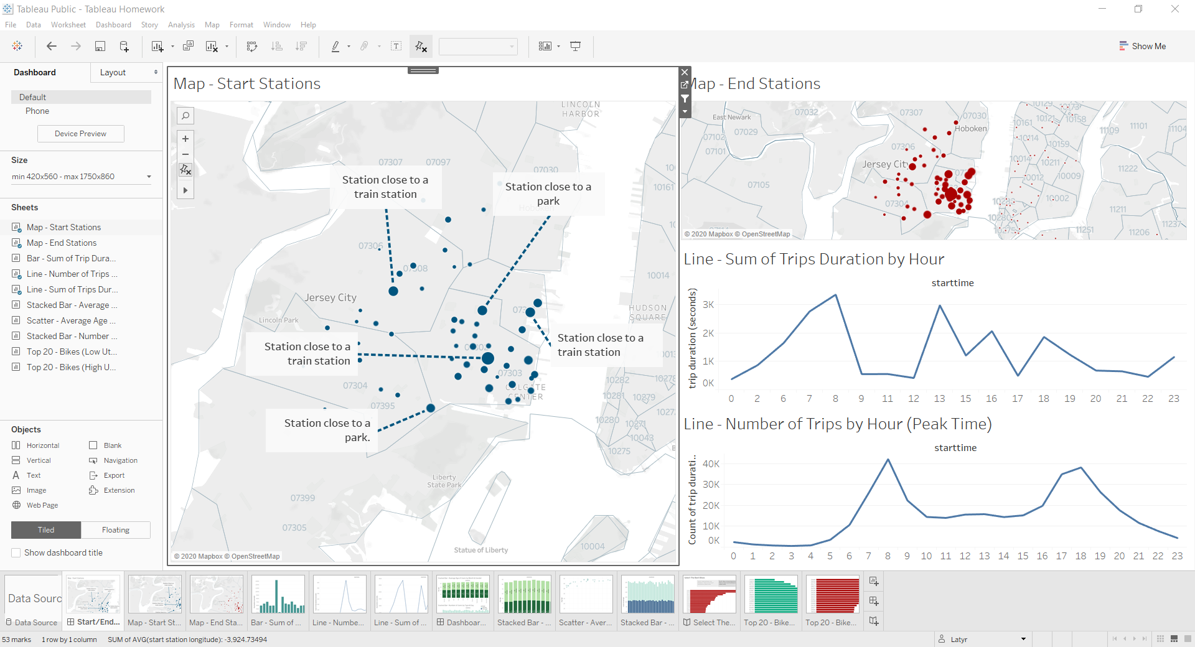

### The Average age of users is over 40

One would think that “young” people (between 20 and 30) are more like to enjoy biking or outdoor activities. But the chart shows that the average user age is over 40. Also the older the user is, the longer the trip duration. That could mean that user may not only bike to go to work but also do it as a hobby. Which is why many users are customers (do not have any subscription).

