UNIT II

Software Requirement Specification
Fundamental problem of s/w engineering is the problem of scale.
In the early days of s/w development, emphasis was on coding and design and little importance was given to s/w requirement.
As system grew more complex, the goal of entire system could not be decided easily. Hence the need for a more rigorous requirement phase comes. Now for large s/w system requirement analysis is most difficult and intractable activity. S/w project is initiated by the client needs. In the beginning these needs are in the minds of various people in the client organization. The analyst has to identify the requirement by talking to their people and understanding their needs.

Software Requirement
IEEE defines a requirement as ::
- A condition of capability needed by a user to solve a problem or achieve an objective
- A condition or capability that must be met or processed by a system to satisfy a contract, standard, specification or other formally imposed document
In s/w requirements we are dealing with requirements of the proposed system.
SRS is a document that completely describes what the proposed s/w should do without describing how the s/w will do it.
Basic goal of requirement phase is to produce the SRS which describes the complete external behavior of the proposed software.
Request for change can be made even after the requirement phase is done and the SRS is produced. Requirement changes are a fact of file for most complex system.
Changing requirements is a continuous irritant for s/w developers and frequently leads to bitterness between client and developers. Though many changes come due to the changing needs of clients, many of the changes request have their origin in incorrect interpretations or specification of requirements. These errors come in SRS largely due to requirement phase not been done thoroughly by the client and the requirement analysis not performing the task rigorously.

Need for SRS
The origin of most s/w system is in the need of a client who either wants to automate an existing manual system or devices a new s/w system. It is created by developers. Finally the completed system will be used by the end user. Thus there are three major parties interested in a new system :
- Client
- User
- Developer
Problem is that the client usually does not understand s/w or s/w development process and the developer often does not understand the client’s problem and application areas. This causes a communication gap between the parties involved in the development project. Basic purpose of SRS is to bridge this communication gap. SRS is the medium through which the client and user needs are accurately specified. SRS is helping the client understand their own needs.
in the development project. Basic purpose of SRS is to bridge this communication gap. SRS is the medium through which the client and user needs are accurately specified. SRS is helping the client understand their own needs.
Main advantages of SRS
- An SRS establishes the basis for agreement between the client and supplier or what the s/w product will do.
- Through SRS the client clearly describes what it expects from supplier and developer clearly understand what capabilities to build in s/w
- An SRS provides a reference for validation of final product. Without a proper SRS, there is no way a client can determine if the s/w being delivered is what was ordered and there is no way the developer can convince the client that the entire requirements have been fulfilled.
- High quality SRS is a prerequisite to high quality s/w. Quality of SRS has an important effect on cost of the project.
- A high quality SRS reduce the development cost.
Requirement Process
It is the sequence of activities that need to be performed in the requirement phase and that culminate in producing a high quality document containing the SRS. The requirement phase typically consists of 3 basic activities::
- Problem or requirement analysis
- Requirement specification
- Requirement validation
Problem analysis starts with some general “statement of need” or a high level “problem statement”. During analysis the problem domain and the environment are modeled in an effort to understand the system behavior, constraints on the system, its input and output.
In requirement specification the focus is on clearly specifying the requirements in a document. Issues, such as representation, specification languages and tools are addressed during this activity.
Validation focus on what has been specified in the SRS is indeed all the requirements of the s/w and making sure that the SRS is of good quality.
Problem Analysis
Analysis issues :
Three basic approach to problem analysis::
- Informal Approach-> Based on structured communication/interaction
- Conceptual Modeling-> Based on approach
- Prototyping
Structured Analysis:
Data flow diagram
Data dictionary
Other modeling approach
SADT
PSL/PSA: Problem Statement Language
RSL/REVS: Requirement Statement Language/Requirement Engineering Validation System
E-R Modeling:
Prototyping::Two approaches to prototyping:
- Throwaway::It is constructed with the idea that it will be discarded after analysis is complete.
- Evolutionary::It is built with the idea that it will eventually be converted into final system.
Characteristics of SRS::
- Correct
- Complete
- Unambiguous
- Verifiable
- Consistent
- Ranked for importance and/or stability
- Modifiable
- Traceable
Components of an SRS
- Functionality
- Performance
- Design constraints imposed on an implementation
- External interfaces
Validation
Development of s/w starts with the requirement document which is also used to determine eventually whether or not the delivered s/w system is acceptable.
Due to nature of the requirement specification phase there is a lot of room for misunderstanding and committing error and it is quite possible that the requirements specification does not accurately represent the client needs.
Basic goal of requirement validation activity is to ensure that the SRS reflect the actual requirements accurately and clearly.
Following errors occur in SRS:
- Omission::In these types of error, some user requirements are simple and not included in the SRS. Omitted requirement may be related to the behavior of the system and its performance. It directly affects the external completely of the SRS.
- Inconsistency::It can be due to contradiction with the requirement of the client or with the environment in which the system will operate.
- Incorrect Fact::When some fact recorded in the SRS is not correct,
- Ambiguity::When there are some requirement that have multiple meaning, that is, their interpretation is not required.

Software Process Models
- A simple representation of s/w process presented from specific perspective
- Examples of process perspective are
- Workflow perspective-sequence of activities
- Data flow perspective-information flow
- Role/action perspective-who does what
- Generic process models
- Waterfall
- Iterative development
- Component based s/w engineering

Waterfall Model
Also referred to as Linear Sequential Model, this is the most common and classic of life cycle models. It is very simple to understand and use. In this model, each phase must be completed in it is entirely before the next phase can begin. At the end of each phase, a review takes place to determine if the project is on right path and whether or not to continue or discard the project. Unlike the general model, phases do not overlap in a waterfall model.
This model encompasses the following activity:
System/information engineering and modeling:: S/w is always part of large system (or business),work begins by establishing requirements for all system elements and then allocating some subset of these requirements to s/w. This system view is essential when s/w must interact with other elements such as h/w, people and databases. System engineering and analysis encompass requirements gathering at the system level with a small amount of top level design and analysis. Information engineering encompasses requirements gathering at the strategic business level and at the business area level.

Requirement
Design
Implementation and Unit testing
Integration and Software Testing
Operation

Waterfall Model
S/w requirement analysis::The requirements gathering process is intensified and focused specially on software. To understand the natures of programs to be built, the s/w engineer (“analyst”) must understand the information domain for the s/w as well as required function, behavior, performance and interface. Requirements are for both the system and the s/w are documented and reviewed with the customer.
Design:: S/w design is actually a multistep process that focuses on four distinct attributes of a program: data structure, s/w architecture, interface representations and procedural (algorithmic ) details. The design translates requirements into a representation of the s/w that can be assessed for quality before coding begins. Like requirements, the design is documented and becomes part of s/w configuration.
Code Generation:: The design must be translated into a machine-readable form. The code generation step performs this task. If design is performed in a detailed manner, code generation can be accomplished mechanistically.
Testing:: Once code has been generated, program testing begins. The testing process focuses on the logical internals of the software, ensuring that all the statements have been tested, and on the functional externals; i.e. conducting tests to uncover errors and ensure that defined input will produce actual results that agree with required results.
Advantages
- Simple and easy to use.
- Easy to manage due to the rigidity of the model-each phase has specific deliverables and a review process.
- Phases are processed and complete one at a time
- Works well for smaller projects where requirements are very well understood.
Disadvantages
- Adjusting scope during the life cycle can kill a project
- No working s/w is produced until late during the life cycle
- High amounts of risk and uncertainty
- Poor model for complex and object-oriented projects
- Poor mode for long and ongoing projects
- Poor model where requirements are at a moderate to high risk of changing

Prototyping Model

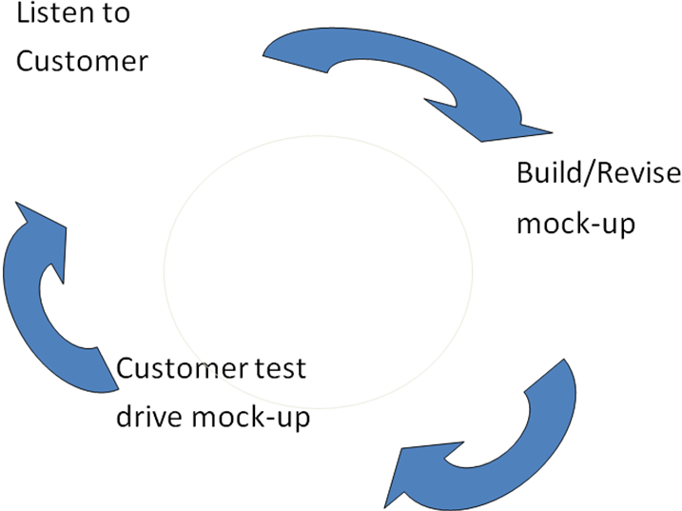

- Customer may not specify complete requirements at beginning
- Developer may be unsure of the software product he had made
Prototyping
  - Quick design (prototype) is prepared and evaluated by customer
  - Serves as mechanism for identifying software requirements
Problems :
- Sometimes customer sees it as a working version and when told about that
it is to be rebuilt to achieve high quality, demands that few fixes should be applied to prototype to make it a working product.
- Developer often makes compromises on O/S and prog. languages while
building prototype. After some time, they become familiar with these
choices and they became integral part of the system.

RAD Model

- Works on 4GT
- Rapid Application Development (RAD) is an incremental software development process model that emphasises a very short development cycle.
- RAD is used primarily for information systems applications, the RAD approach encompasses the following phases:

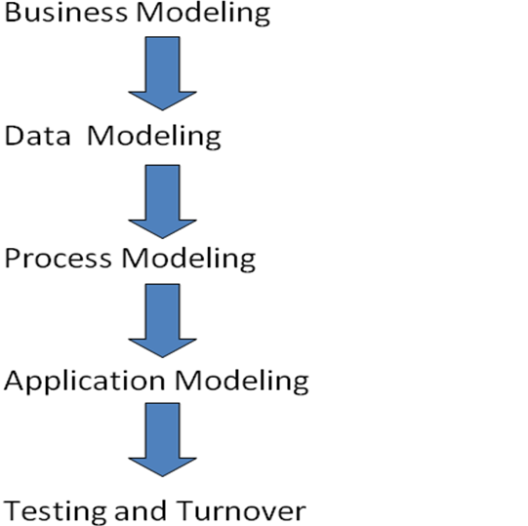
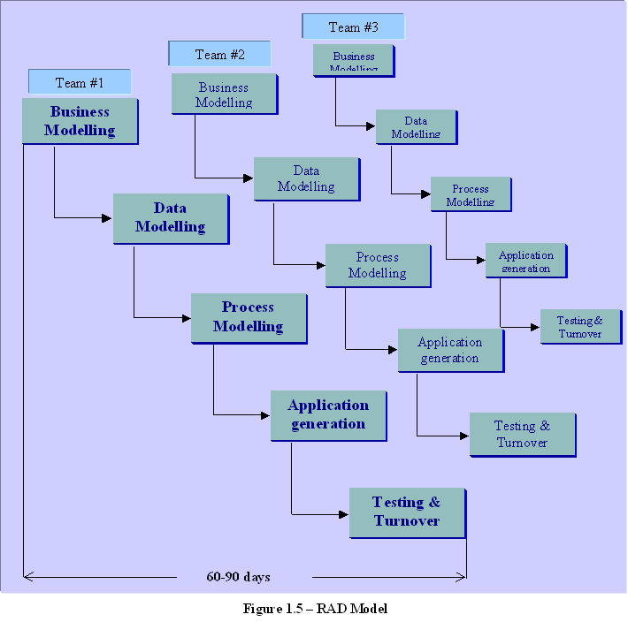

Business modeling
The information flow among business functions is modeled in a way that answers the following questions:
What information drives the business process?
What information is generated?
Who generates it?
Where does the information go?
Who processes it?

Data modeling
The information flow defined as part of the business modeling phase is refined into a set of data objects that are needed to support the business. The characteristics (called attributes) of each object are identified and the relationships between these objects are defined.

Process modeling
The data objects defined in the data-modeling phase are transformed to achieve the information flow necessary to implement a business function. Processing descriptions are created for adding, modifying, deleting, or retrieving a data object.

Application generation
RAD assumes the use of the RAD fourth generation techniques and tools like VB, VC++, Delphi etc rather than creating software using conventional third generation programming languages. The RAD works to reuse existing program components (when possible) or create reusable components (when necessary). In all cases, automated tools are used to facilitate construction of the software.

Testing and turnover
Since the RAD process emphasizes reuse, many of the program components have already been tested. This minimizes the testing and development time.
If a business application can be modularized so that each major function can be completed within the development cycle then it is a candidate for the RAD model. In this case, each team can be assigned a model, which is then integrated to form a whole.

Problems with RAD Model
- requires team members who are committed to rapid-fire activities
- for systems that cannot be properly modularized, building the components necessary for RAD will be problematic.
- when building new applications and technical risks are high, RAD is not appropriate.
- for large but scalable projects, RAD requires sufficient human resources to create right number of teams.
Evolutionary development Models

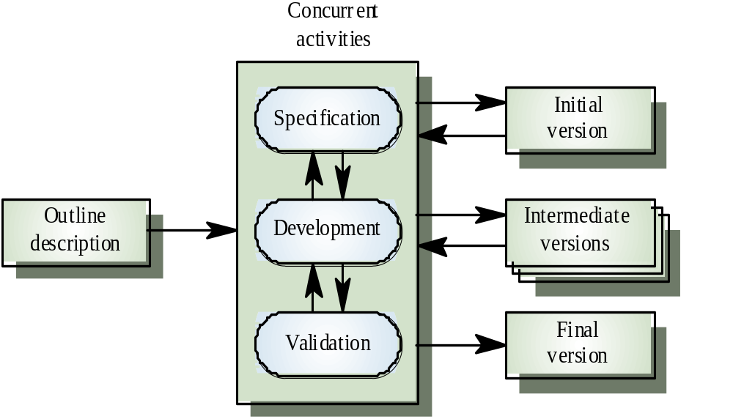

- Potential problems
  - Lack of process visibility
  - Final version/prototype is often poorly structured
  - Special skills (e.g., in languages for rapid prototyping) may be required
- Applicability
  - For small or medium-size interactive systems
  - For parts of large systems (e.g., the user interface)
  - For short-lifetime systems (in case of exploratory development)

Incremental Model

- Combines element of the linear sequential model and iterative nature of prototyping.
- Each linear sequence produces a “increment” which is deliverable.
- First increment is called a core product where basic requirements are addressed, but many supplementary features remain undelivered.
- Every increment is used and evaluated by customer.
- Next increment meets the additional features and functionality identified in previous increment.
- Process is repeated until a complete product is produced.
- Particularly useful when staffing is unavailable for complete implementation by the deadline.
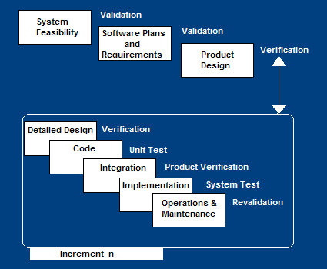

Advantages
- Useful functionality is delivered with each increment, so customers derive value early.
- Early increments act as a prototype to help elicit requirements for later increments.
- Lower risk of overall project failure
- The highest priority system services tend to receive the most testing.
- Develop high-risk or major functions first
- Each release delivers an operational product
- Customer can respond to each build
- Uses “divide and conquer” breakdown of tasks
- Lowers initial delivery cost
- Initial product delivery is faster
- Customers get important functionality early
- Risk of changing requirements is reduced
Disadvantages
- Requires good planning and design
- Requires early definition of a complete and fully functional system to allow for the definition of increments
- Well-defined module interfaces are required (some will be developed long before others)
- Total cost of the complete system is not lower

Spiral Model

- Objectives: functionality, performance, hardware/software interface, critical success factors, etc.
- Alternatives: build, reuse, buy, sub-contract, etc.
- Constraints: cost, schedule, interface, etc.
- Study alternatives relative to objectives and constraints
- Identify risks (lack of experience, new technology, tight schedules, poor process, etc.
- Resolve risks (evaluate if money could be lost by continuing system development
- Typical activites:
  - Create a design
  - Review design
  - Develop code
  - Inspect code
  - Test product
- Typical activities
  - Develop project plan
  - Develop configuration management plan
  - Develop a test plan
  - Develop an installation plan
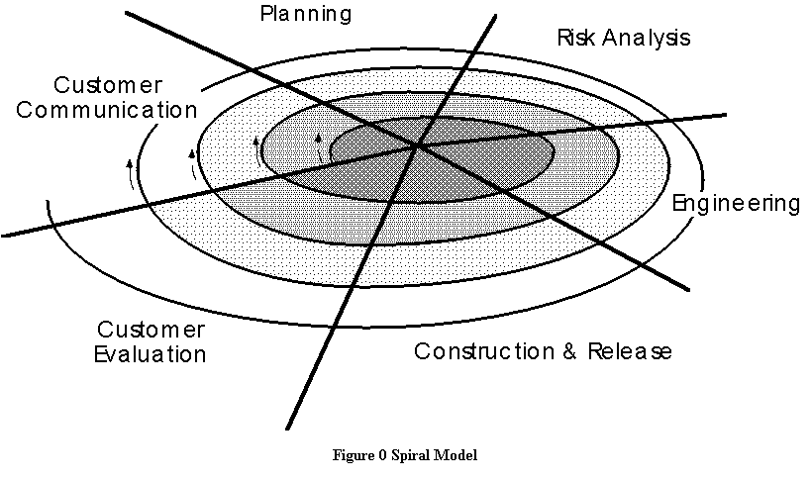
Advantages
- Provides early indication of insurmountable risks, without much cost
- Users see the system early because of rapid prototyping tools
- Critical high-risk functions are developed first
- The design does not have to be perfect
- Users can be closely tied to all lifecycle steps
- Early and frequent feedback from users
- Cumulative costs assessed frequently
Disadvantages
- Time spent for evaluating risks too large for small or low-risk projects
- Time spent planning, resetting objectives, doing risk analysis and prototyping may be excessive
- The model is complex
- Risk assessment expertise is required
- Spiral may continue indefinitely
- Developers must be reassigned during non-development phase activities
- May be hard to define objective, verifiable milestones that indicate readiness to proceed through the next iteration

Task regions in spiral model :
- Customer Communication
- Planning
- Risk Analysis
- Engineering
- Construction and Release
- Customer Evaluation

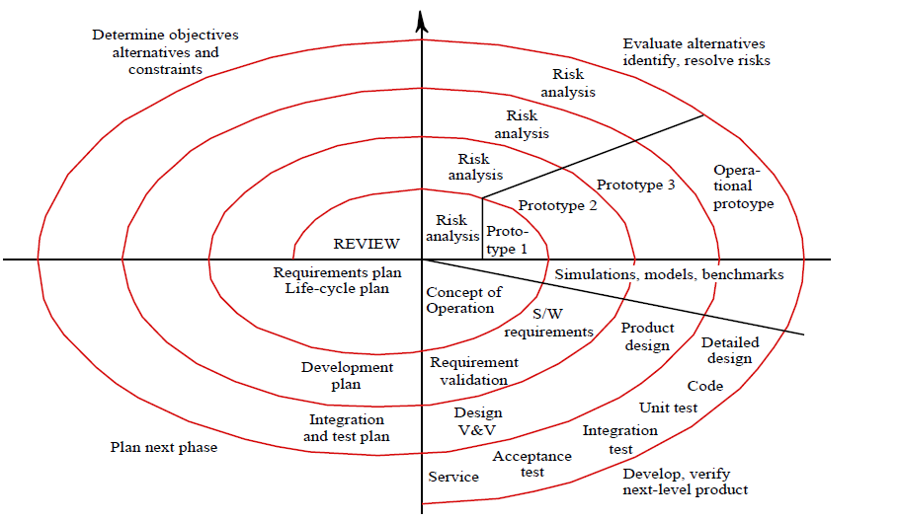
- Unlike classical process models that end when software is delivered, the spiral model can be adapted to apply throughout the life of the computer software.
WINWIN Spiral Model

In an ideal context, the developer simply asks the customer what is required and the customer provides sufficient detail to proceed. Unfortunately, this rarely happens. In reality, the customer and the developer enter into a process of negotiation.
The best negotiation strive for a “win-win” situation. The customer wins by getting the product that satisfies the majority of the customer’s needs and the developer wins by working to realistic and achievable budgets and deadlines.

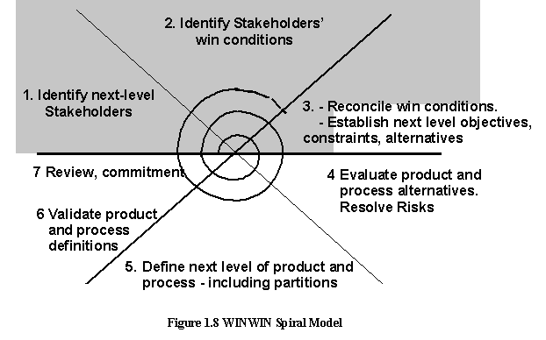
Activities in model :

- Identify next-level stakeholders’
- Identify stakeholders’ win conditions
- Reconcile win conditions and establish next-level objectives, constraints and objectives
- Evaluate process and product alternatives and resolve risks
- Define next level of product and process
- Validate product and process definitions
- review and comment

Function Oriented Design
Design is the first step in moving from the problem domain to solution domain.
It is a bridge between requirement specification and the final solution for satisfying the requirements
Goal of the design process is to produce a model on representation of a system, which can be used later to build that system.
Produced model is called Design of the System
It is a blueprint or plan of a solution for the system.
A system can be considered to be a set of components with clearly defined manners to produce some service or behavior for its environment.
In s/w system component is an s/w module. Design process for s/w system often has two levels::
- At first level, the focus is on deciding which modules are needed for the system, the specification of these modules and how the modules should be interconnected. It is called System Design or Top-Level design
- Internal design of the modules or how the specifications of the module can be satisfied is decided. This design level often called Detailed Design or Logic Design
Detailed design essentially expands the system design to contain a more detailed description of the processing logic and data structure so that the design is sufficiently complete for coding.
Since the detailed design is an extension of system design. System design control the major structured characteristics of system. System design has a major impact on testability and modifiability of a system and it impacts its efficiency.
Design Methodology
It is a systematic approach to creating a design by applying a set of techniques and guidelines. Most design methodologies focus on the system design. Most current design methodologies essentially offer a net of guidelines that can be used by the developer to design a system.
The input to the design phase is the specifications for the system to be designed. The output of the top-level design phase is the architectural design or the system design for the s/w system to be built. This can be produced with or without design methodology.
Design can be object oriented or function oriented. In function oriented design, the design consists of module definition, with each module supporting a functional abstraction. In object oriented design the module in the design represent data abstraction.
Purpose of design phase is to specify the components for this transformation function, so that each component is also a transformation function.
Basic output of the system design phase is the definition of all the major data structure in the system, all major modules of the system and how the modules interact with each other.
Design Principles:
Design of a system is correct if a system built according to the design satisfy the requirement of that system.
Goal during the design phase is to produce correct design. The goal of design phase is to find the best possible design within the limitations imposed by the requirements and physical and social environment in which the system will operate. To evaluate a design, some properties and criteria need to be specified that can be used for evaluation.
A design should clearly be verifiable, complete and traceable the two most important properties that concern designers are efficiency and simplicity.
Efficiency of any system is concerned with the proper use of scare resources by the system. The need for efficiency arises due to cost consideration. In computer system, the resources that are most often considered for efficiency one processor type and memory. An efficient system is one that consumes less processor time and requires less memory.
Simplicity::It is the most important quality criteria for s/w system. Maintenance of s/w is usually quite expensive. Maintainability of s/w is one of the goals. Design of a system is one of the most important factors affecting the maintainability of system.
During maintenance, maintainer has a thorough understanding of the different module of the system, how they are interconnected and how modifying one will affect the other.
A simple and understandable design will go a long way in making the job of the maintainer easier.
The principles that can be used in design are the same as those used in problem analysis. Methods are also similar because in both analysis and design a model is being constructed.
There are some fundamental differences:
- In problem analysis, a model of problem domain is constructed, while in design model for solution domain is created.
- In problem analysis, the analyst has limited degree of freedom in selecting the model as the problem is given and modeling has to represent it. In design, the designer has great deal of freedom in deciding the models; the designer is creating a model for the system that will be the basis for building the system.
- In design system depend on model, while in problem analysis the model depends on system.
- Basic aim of modeling in problem analysis is to understand while basic aim of modeling in design is to optimize.

Role of management in s/w development
Proper management is an integral part of s/w development. A large s/w development project involves many people working for a long period of time. A development process typically partitions the problem of developing s/w into a set of phases. To meet the cost, quality and schedule objectives and resources have to be properly allocated to each activity for the project and progress of different activities has to be monitored and corrective action taken, if needed all these activities are parts of the project management process.
A development process does not specify following, so project management is necessary.
- How to allocate resources to the different activities in the process
- Schedule for the activities
- How to divide the work within the phase
- How to ensure that phase is being done properly
- What is the risk for project and how to migrate them
The focus of the management process is on issue like planning a project, estimating resources and schedule and monitoring the project. For large project, a proper management process is essential for success.
Phases of management process
The activities in the management process for a project can be grouped broadly in to 3 phases::
- Planning::
Project management begins with planning, which is perhaps the single largest responsibility of the project management. The goal of this phase is to develop a plan for s/w development following which the objectives of the project can be met successfully and efficiently. During planning the major activities are::
- Cost estimation
- Schedule and milestone determination
- Project staffing
- Quality control plans
- Controlling and monitoring plans
In the cost and schedule estimation, the total time needed for successful completion of the project is estimated. In addition, cost and schedule for the different activities of the development process to be used are also estimated. A plan also provides methods for handling change and methods for monitoring a project. Project planning is undoubtedly the single and most important management activity and the output of this forms the basis of monitoring and control.
- Monitoring and control::
Project monitoring and control phase of the management process is the longest in terms of duration; it encompasses most of the development process. It includes all the activities the project, management has to perform while the development is going on to ensure that project objectives are met and the development proceeds according to the development plan.

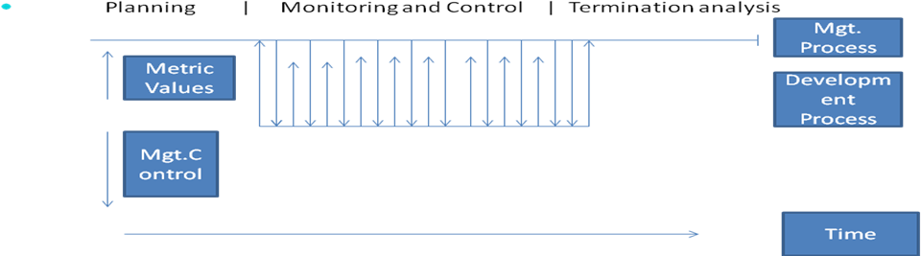
Monitoring a development process requires proper information about the project; such information is typically obtained by the management process from the development process. The implementation of the development process model should be such that each step in development process produces information that the management process needs for that step i.e. development process provides the management process needs.
- Termination analysis::
Termination analysis is performed when the development process is over. The basic reason for performing termination analysis is to provide information about the development process. The data about the project is also needed to analyze the process. For these reasons, the termination analysis phase is needed.
Role of Metrics and Measurement
Matrix is used for effective project management. Objective data is needed for this s/w matrix is used. S/w metrics are quantifiable measure and that could be used to measure different characteristics of a s/w system or the s/w development process. A number of metrics have been proposed to quantity things like the size, complexity and reliability of a s/w product. There are two types of metrics are used for s/w development:
- Product metrics
- Process metrics
Product metrics are used to quantify characteristic of the project being developed. Process metrics are used to quantify the characteristics of the process being used to develop the s/w.
Intricately tied to metrics is measurement. Metrics provide the scale for quantifying qualities, qualifying characteristics of the given s/w. An analogy in the physical world and that centimeter is the metric of length, but to determine the length of a given rod, one must measure it some means like measuring tape. The measurement methods must be objective and should produce the same result independent of the measure.
Values for some metrics can be directly measured; others might have to be deduced by other measurement. If the metrics is not measured directly, it is called metrics indirect. Some factors like many s/w qualifying parameters cannot be measured directly. Metrics measures productivity, cost and resource requirement effectiveness of quality assurance measure. For effective monitoring the management need to get information about the project.
- How far it has progressed?
- How much development has taken place?
- How far behind schedule it is?
- The quality of the development
- The decisions can be made about the project
In metrics measurement and models go together. Metrics provide a quantification of some property. Measurement provides the actual value for the metrics and models are needed to get the value for the metrics that cannot be measured directly.
For estimating, models are needed. A model is a relationship of the predicted variable that other variables that can be measured i.e. if there is some metrics of interest which cannot be measured directly, then we build models to estimate the metrics value based on the value of some other metrics that we can measure. The model may be determined based on empirical data or it may be analytic. Building a model is an issue that concerns process management.

Basic Principle of Design
- Problem partitioning and hierarchy: When solving a small problem, the entire problem can be tackled at once. The complexity of large problem and the limitation of human minds do not allow a large problem to be treated as huge monoliths. For large problem solving basic principle is divided into smaller pieces so that each piece can be conquered separately. For s/w design, therefore, the goal is to divide the problem into manageably small piece that can be solved separately. It is this restriction of being able to solve each part separately that makes dividing into pieces a complex task that many methodologies for the system design aim to address. Basic strategy behind this is that if the pieces of a problem are solvable separately, the cost of solving the entire problem is more than the sum of the cost of solving all pieces. However, the different pieces cannot be entirely independent of each other as they together form the system. The different pieces have to co-operate and communicate to solve the larger problem. This communication adds complexity, which arises due to partitioning and may not have existed in the original problem. As the number of components increase, the cost of partitioning together with cost of this added complexity may become more than the saving achieved by partitioning. If a module A is independent of module B then we can modify A without introducing any unanticipated side effects in B. Total independence of modules of one system is not possible, but the design process should support as much independence as possible between modules. Problem partitioning, which is essential for solving a complex problem leads to hierarchies in design.
- Abstraction: It is powerful concept and is used in all engineering disciplines. It is total that permits a designer to consider a component at an abstract level without worrying about the details of the implementation of the component. It describes the external behavior of that component without bothering with the internal details of the implementation of the component. It describes the external behavior of the component without bothering the internal details that produce that behavior. It is essential for problem partitioning. Partitioning is the exercise in determining the component of system. Their component are not isolated from each other, designer has to specify how a component interact with other component. If the designer has to understand the details of the other component to determine their external behavior, the purpose of partitioning and isolating a component from other stands defeated. To allow the designer to concentrate on one component at a time, abstraction of other component is used. Abstraction is used for existing component as well as component that are being designed. It plays an important role in the maintenance phase. To modify a system, the first step is to understand what the system does and how. Using abstraction the behavior of the entire system can be understood. During the design process, abstraction is used in reverse manner than in the process of understanding a system.
There are two abstraction mechanisms for s/w systems::
- Functional Abstraction:: A module is specified by the function it performs. Eg.->A module to compute the log of a value can be abstractly represented by the function log. Similarly, a module to sort an input array can be represented by the specification of sorting. It is the basis of partitioning in function oriented approach. When the problem is being partitioned, the overall transformation function for the system is partitioned into smaller function that comprises the system function.
- Data Abstraction:: Operations are required from a data object, depending on the object and the environment in which it is used.

Modularity: Real power of partitioning comes if a system is partitioned into modules so that modules are solvable and modifiable separately. It will be even better if the modules are also separately ` compactable. A system is considered modular if it consists of discreet components so that each component has minimal impact on other component.
Modularity helps in system debugging- isolating the system problem to a component is easier if the system is modular, in system repair changing a part of system is easy.
For modularity, each module need to support a well defined abstraction and have a class interface through which it can interact with other module.

Top-Down and Bottom-Up Strategies
A system consists of component. It is hierarchy of components. To design such a hierarchy there are two possible approach::
- Top-Down:: It starts from highest level component of the hierarchy and proceeds through the lower level. It starts by identifying the major components of the system, decomposing them into lower level components until the desired level of details is achieved. This method often results in some form of stepwise refinement. Starting from abstract design, in each step the design is refined to more concrete level, until a level where no more refinement is needed is reached and the design can be implemented directly. It is suitable only if the specification of system is clearly known.
- Bottom-Up:: It starts with the lowest level component of the hierarchy and proceeds through progressively higher level to top level components. It starts with designing the most basic components and proceeds to higher level components that use these lower level components. This method works with layer of abstraction. It is more useful when a system is to be built from an existing system.
Definition of system/software design
- Design is a meaningful representation of something that is to be built.
- It can be traced to a customer’s requirements and at the same time assessed for quality against a set of predefined criteria for “good” design.
- According to Stevens:”Software Design is the process of inventing and selecting programs that meet the objectives for software systems.
- Input includes an understanding of the following:
  - Requirement
  - Environmental constraints
  - Design criteria
  - Output of the design effort is composed of the following:
    - Architecture design
    - Specification
    - Definitions
Design Objectives/Properties
- Correctness :should be correct and satisfy the requirement of the system.
- Verifiability: it should be verified for correctness.
- Completeness: all the relevant data structure modules, external interfaces and module interconnections are specified.
- Traceability: the entire design element must be traceable to the requirements.
- Efficiency: is concerned with the proper use of scarce resources.
- Simplicity: The most important criteria is the quality of software system.
Design Principles
- Problem partitioning: large problem can be solved ,the basic principle is time-tested principle of “Divide and Conquer”. It can be divided into two categories:
        - Horizontal Partitioning
        - Vertical Partitioning
Horizontal partitioning
  - It defines separate branches of modular hierarchy for each major program function.
    - Software that is easier to test.
    - Software that is easier to maintain.
    - Software that is easier to extend.
    - Propagation of fewer side effects.
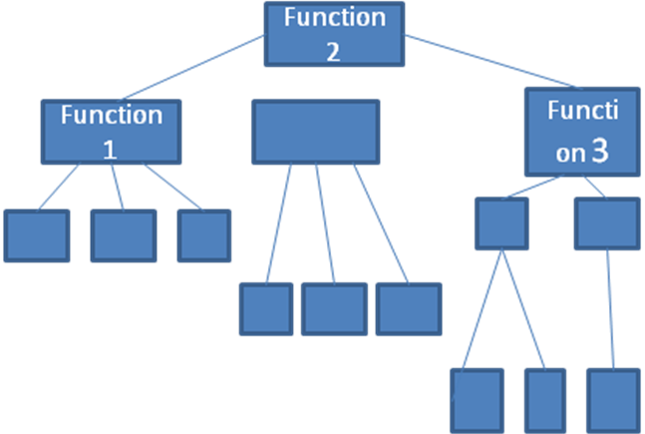
Vertical partitioning
  - Vertical partitioning: also called factoring, suggests that control and work should be distributed from top-down in the program me structure.
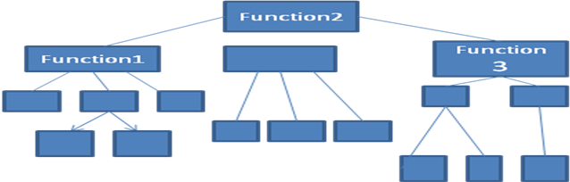
Coupling :
- Coupling is a measure of interconnection among modules in a software structure.
- The coupling between two modules indicates the degree of interdependence between them.
  - Highly Coupled: When the modules are highly dependent on each other then they are called highly-coupled.
  - Loosely Coupled:When the modules are depend on each other but the interconnection among them is weak.
  - Uncoupled:When the different modules have no interconnection among them.

Factors affecting Coupling
- The various factors affecting coupling between modules are as follows:

 | Interface Complexity | Type of Connection | Type of Communication
Low | Simple Obvious | To module by name | Data
High | Complicated Obscure | To internal elements | Control Hybrid

Types of Coupling
Data Coupling | Best
Stamp Coupling
Control Coupling
External Coupling
Common Coupling
Content Coupling | (Worst)

- Data Coupling: Two modules are data coupled ,if they communicate using an elementary data item that is passed as a parameter between the two.
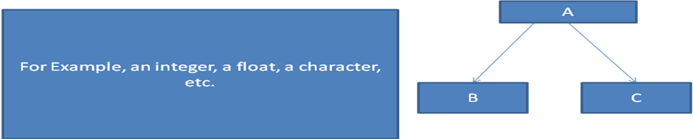
- Stamp Coupling: Two modules are stamp copled, if they communicate using a composite data item such a record, structure, object etc.
  - When module passes non-global data structure or entire structure to another module,they are said to be stamp coupled.
- Control Coupling: exist between two modules, if data from one module is used to direct the order of instruction execution in another.
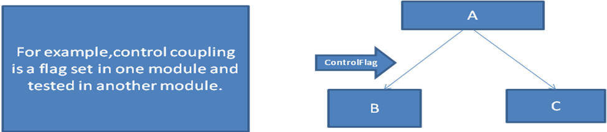
- External Coupling: It occurs when module are tired to an environment external to software.It is essential but should be limited to a small number of modules with structure.
- Common Coupling: Two modules are common coupled, if they share some global data items.
- Content Coupling: exist between two modules,if their code is shared,it means when one module directly refer to the inner workings of another module.

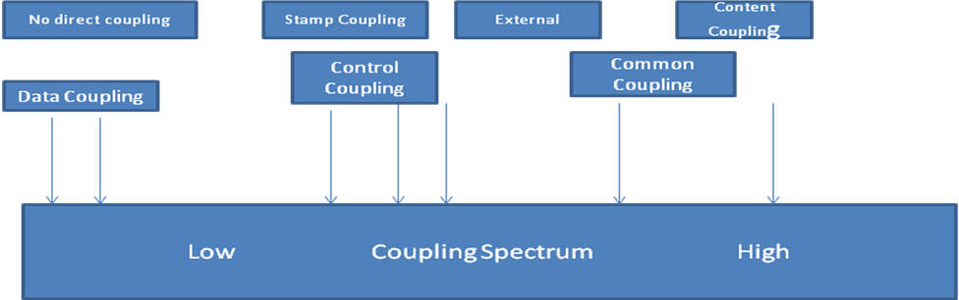

Cohesion
- Cohesion is a natural extension of information hiding concept.
- Cohesion I s a measure of the relative functional strength of a module.
- A cohesive module performs a single task within a software procedure ,requiring little interaction with procedures being performed in other parts of a program.
- A strongly cohesive module implements functionality that is related to one feature of the solution and requires little or no interaction with other module.
- This is shown in diagram……………….in the next slide…..
Cohesion-strength
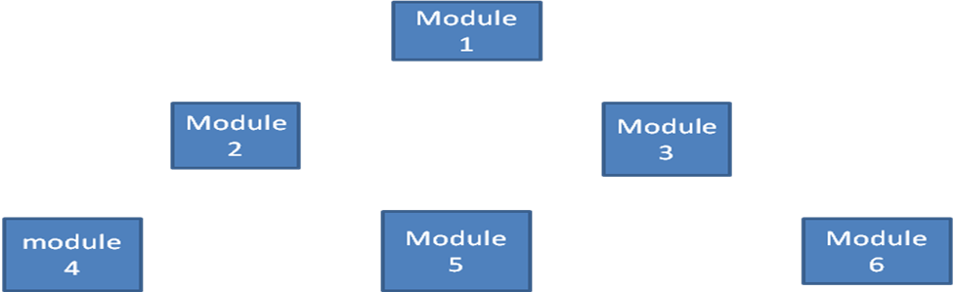

Types of cohesion
Functional Cohesion | Best(High)
Sequential Cohesion
Communicational Cohesion
Procedural Cohesion
Temporal Cohesion
Logical Cohesion
Coincidental Cohesion | Worst (low)

Functional Cohesion:
- It is said to exit if different elements of a module cooperate to achieve a single function .
FUNCTION A Part 1
FUNCTION A Part 2
FUNCTION A Part 3



Sequential cohesion
- A module is said to possess sequential cohesion, if the element of a module form the parts of a sequence ,where the output from one element of the sequence is input to the next.
FUNCTION A
FUNCTION B
FUNCTION C

Communicational Cohesion:
- All the functions of the module refer to or update the same data structure.


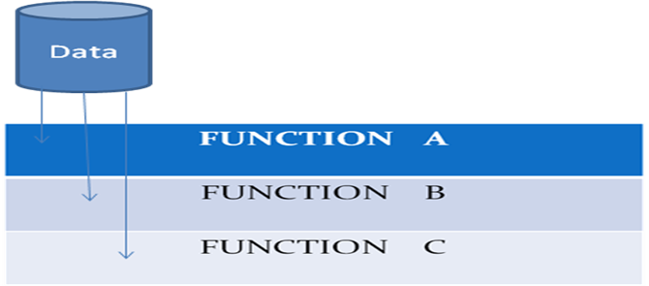

Procedural Cohesion
- All the set of function of the module are all part of a procedure in which certain sequence of steps has to be carried out for achieving an objective.

FUNCTION A
FUNCTION B
FUNCTION C

Temporal Cohesion:
- When a module contains functions that are related by the fact that all the functions must be executed in the same time span is said to be exhibit temporal cohesion.
TIME TO
TIME TO+A
TIME TO+2A

Logical cohesion
- All elements of the module perform similar operation.
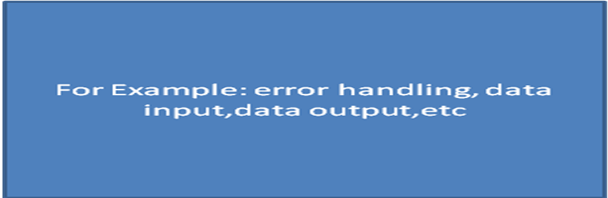

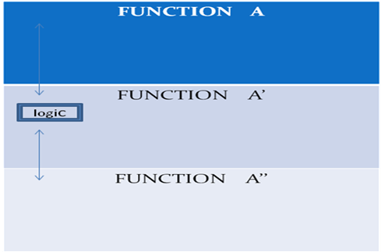

Coincidental Cohesion
- It performs a set of task that relate to each other very loosely.
- The module contains a random collection of function.
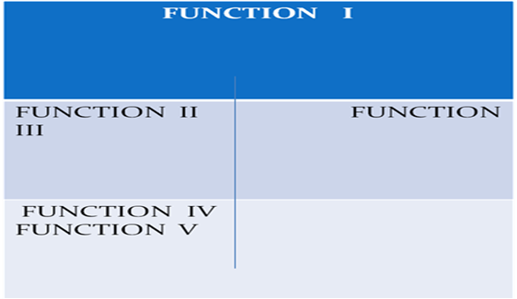

Functional Versus object-oriented approach
Functional Approach | Object oriented Approach
- The basic abstraction which are given to the user are real world functions  For Example: sort,merge,track,display,etc | - The basic abstraction are not the real world functions but the data abstraction where the real world entities are represented .  For example picture, machine, radar system, customer, student, employee, etc. e:
2.Functions are grouped together by which a higher –level function is obtained.  For example: SA/SD | 2.The function are grouped together on the basis of data they operate on like in class person,function display are made member function to operate on its data members .  For Example: person name, age
In this approach ,the state information is often represented in a centralized shared memory . | 3. In this approach, the state information is not represented in a centralized shared memory but is implemented /distributed among the object s of the system.

Design Specification :
- It address different aspect of design model and is completed as the designer refines his representation of the software .
  - Data Design:-Which includes data structure , any external file structures, and a cross reference that connects data objects to specific files are all defined .
  - Architectural Design :-indicates how the program architecture has been derived from any model .Structure chart are used to represent a module hierarchy.
- Interface Design:-indicates the design of external and internal program interfaces along with a detailed design of the human/machine interface is described.
- Procedural Design:-specifies components separately addressable elements of software such as subroutines, function or procedures in form of english language processing narratives.
Requirements of Design Specification :
- The purpose of the cross-reference is:

  - To establish that all requirements are satisfied by the software design.
  - To indicate which components are critical to the implementation of specific requirements.
System Objective:
System Objective | Human-machine interface
Major Software requirements design | Specification and design
Constraints, limitation | External interface design
Data design | Interfaces to external/system
Data object and resultant data | Internal design rule
Structure | Processing narrative
File and database structures | Interface description
External file structure | Design language description
Logical Structure | Modules used
Access method | Data structures used
Global data | Comments
File and data cross-reference | Requirement cross-reference

Verification for design
- The output of the system design phase, like the output of the other phases in the development process , should be verified before proceedings with the activities of the next phase .
- There are two approaches to verification .
-behavior of the product to see whether the product performs as expected .
-analyzing the product.
Monitoring and Control for Design
- It specifies what are needed to meet the cost ,quality and schedule objectives.
- Monitoring obtain information from development process and exerts the required control over it.
Diagram of Phases of project Management
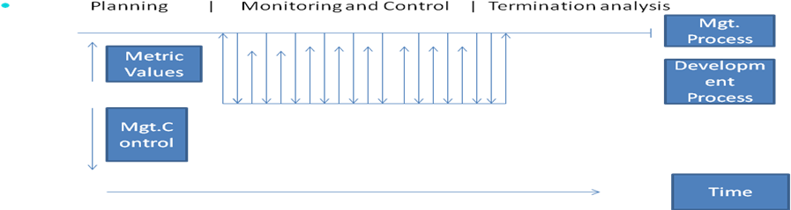
- They check sensors providing information about the system ‘s environment and take action depending on the sensors reading.
- It takes action when some exceptional sensor value is detected.
- Control system continuously control hardware actuators depending on the value of associated sensors.
- When a sensor detects the presence of an intruder, the system automatically calls the local police and, using a voice synthesizer, reports the location of the alarm.

For Example,
A burglar alarm system is to be implemented for a building. This uses several different types of sensor. These include movement detectors in individual rooms, window sensors on ground floor windows, which detect if a window has been broken, and door sensors, which detects door opening on corridor doors . There are fifty window sensors, 30 doors sensors and 200 movement detectors in the system.

Component level design::
- Also called procedural design.
- It occurs after DATA, ARCHITECTURAL and INTERFACE designs have been established.
- The intent is to translate the design model into operational software
- It is possible to represent the component level design using a programming language.
- Since the level of abstraction of the existing design model is relatively high while that of operational program is low, so the translation can be challenging and cause subtle errors that may be difficult to find and correct at later stages of software process.
- The program is hence created using design model as a guide.
- Alternatively, the procedural design can be represented using some intermediate representations (eg. graphical, tabular or text based) that can be easily translated into source code
Work product: The procedural design for each component, represented in graphical, tabular or text based notation is primary work product produced during component level design
How to ensure that design is accurate?
A design walkthrough or inspection is conducted. The design is examined to determine whether data-structures, interfaces, processing sequences and logical conditions are correct and will produce the appropriate data or control transformation allocated to the component during earlier design steps.

Structured Programming:
What are Constructs?
- In 1960 Dijkstra proposed the use of a set of constrained logical CONSTRUCTS from which any program can be formed.
- The constructs emphasized “maintenance of functional domain”.
- Each construct has a predictable logical structure, was entered at the top and exited at the bottom, enabling the reader to follow the procedural flow more easily.
Fundamental Constructs for Structural Programming
- The constructs are sequence, condition and repetition
- Sequence implements processing steps that are essential in the specification of any algorithm.
- Condition provides the facility for selected processing based on some logical occurrence.
- Repetition allows for looping
- The structured constructs were proposed to limit the procedural design of software to a small number of predictable operations.
- The structured constructs are logical chunks that allow a reader to recognize procedural elements of a module, rather than reading the design or code line by line.
- Understanding is enhanced when readily recognizable logical patterns are encountered.
GRAPHICAL DESIGN NOTATION:
- Graphical tools, such as the flowchart or box diagram, provide useful pictorial patterns that readily depict procedural detail.
- However, if graphical tools are misused, the wrong picture may lead to the wrong software.
Flowchart
- Sequence is represented as two processing boxes connected by a line of control.
- Condition is depicted as a decision diamond that if true, causes then-pat processing to occur and if false, invokes else part processing.
- Repetition is represented using two slightly different forms:
  - The do-while tests a condition and executes a loop task repetitively as long as the condition holds true.
  - A repeat until executes the loop task first, then tests the condition and repeats the task until the condition fails.
- The structured constructs may be nested with in on another
Sequence
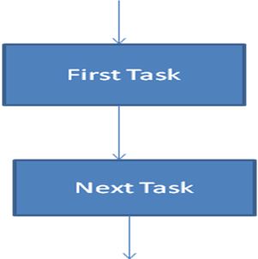

If-Then-Else

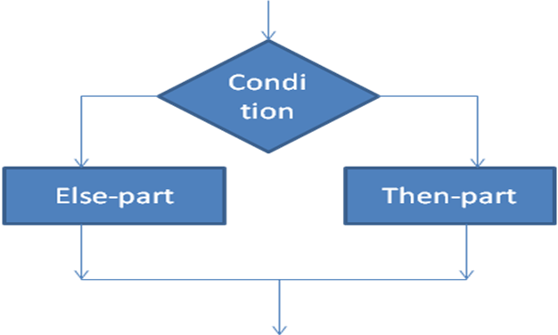
SELECTION
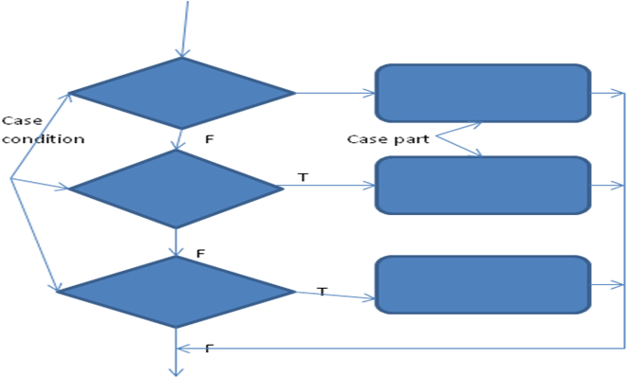
REPETITION
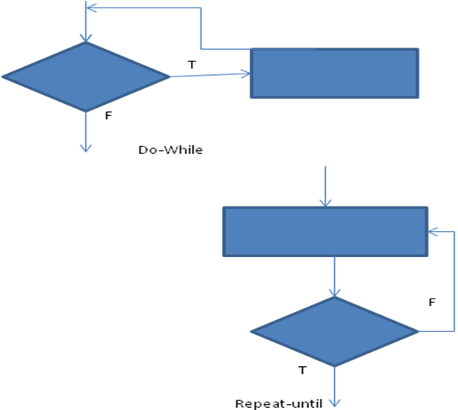
- The dogmatic use of only the structured constructs can introduce inefficiency when an escape from a set of nested loop or nested conditions is required
- The designer is hence left with two options:
  - Procedural representation is redesigned so that the “escape branch” is not required at a nested location in a flow of control
  - The structured constructs are violated in a controlled manner ie. A constrained branch out of the nested flow is designed.
- Option 1 is the ideal approach but option 2 can be accommodated without violating the spirit of structured programming
Box Diagram
- It evolved from a desire to develop a procedural design representation that would not allow violation of the structured constructs.
- Also called Nassi-Shneiderman charts, N-S charts or Chapin charts
Characteristics of Box Diagram
- Functional domain (ie. the scope of repetition or if-then-else ) is well defined and clearly visible as a pictorial representation
- Arbitrary transfer of control is impossible
- The scope of local and/or global data can be easily determined
- Recursion is easy to represent
Sequence
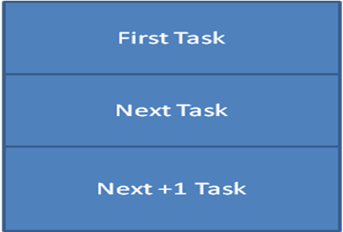
If-Then-Else

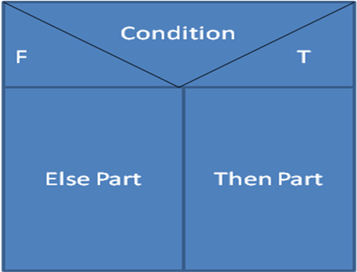

Repetition
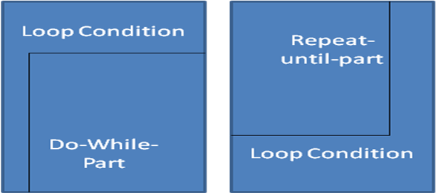

SELECTION
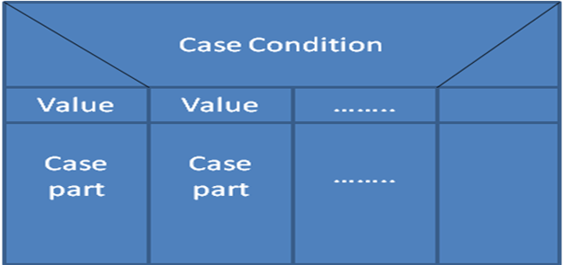

- The fundamental element of the diagram is a box
- To represent a sequence, two boxes are connected bottom to top
- To represent if-then-else a condition box is followed by a then-part and else-part box
- Repetition is depicted with a bounding pattern that encloses the process (do-while part or repeat-until part) to be repeated
- Selection is represented using the graphical form
- Like flowchart, a box diagram is layered on multiple pages as processing elements are refined
TABULAR DESIGN NOTATION
- In many s/w applications, a module may be required to evaluate a complex combination of conditions and select appropriate actions based on these conditions.
- Decision tables provide a notation that translates actions and conditions into tabular form
- The table is difficult to misinterpret and may even be used as machine readable input to a table driven algorithm
- The decision table can be effectively used to supplement other procedural design notation
STEPS TO DEVELOP A DECISION TABLE
- List all actions that can be associated with a specific procedure (or module)
- List all conditions (or decision made) during execution of the procedure
- Associate specific sets of conditions with specific actions, eliminating impossible combinations of conditions; alternatively, develop every possible permutation of conditions
- Define rules by indicating what action(s) occurs for a set of conditions
PROGRAM DESIGN LANGUAGE (PDL)
- Also called structured English or pseudocode
- Is a pidgin language in that it uses the vocabulary of one language (ie. English) and the overall syntax of another (ie. a structured programming language)
- The PDL is different from a real programming language in the sense that it uses the narrative text embedded directly within PDL structure
- The PDL cannot thus be compiled (not yet)
- PDL tools exist to translate PDL into a programming language “skeleton” and/or a graphical representation (eg. a flowchart) of design.
- These tools also produce nesting maps, a design operation index, cross reference tables and a variety of other information
COMPARISION OF DESIGN NOTATION
- Design notation should lead to a procedural representation that is easy to understand and review.
- The notation should enhance “code to” ability so that code becomes a natural by-product of design
- Design representation must be easily maintainable so that design always represents the program correctly
Attributes of Design Notation
- Modularity: Design notation should support the development of modular s/w and provide a means for interface specification
- Overall Simplicity: Design notations should be relatively simple to learn, relatively easy to use and generally easy to learn
- Ease of editing: The procedural design may require modification as the s/w process proceeds. The ease with which a design representation can be edited can help facilitate each s/w engineering task
- Machine Readability: Notation that can be input directly into a computer based development system offers significant benefits.
- Maintainability: S/w maintenance is the most costly phase of the s/w life cycle. Maintenance of the s/w configuration nearly always means maintenance of procedural design representation.
- Structural Enforcement: Design notations that enforce the use of only the structured constructs promotes good practice.
- Automatic Processing: A procedural design contains information that can be processed to give designer new or better insights into the correctness and quality of a design. Such insights can be enhanced with reports provided via s/w design tools
- Data Representation: The ability to represent local and global data is an essential element of component level design. Ideally, design notation should represent such data directly.
- Logic Verification: Automatic verification of design logic is a goal that is paramount during s/w testing. Notation that enhances the ability to verify logic greatly improves testing adequacy.
FOURTH GENERATION TECHNIQUES: 4GT
INTRODUCTION
- The term 4Gt encompasses a broad array of s/w tools that have one thing in common.
- Each tool enables the s/w engineer to specify the characteristics of s/w at high level.
- The tool then automatically generates source code based on the developer’s specification.
- The 4GT paradigm for s/w engineering focuses on the ability to specify s/w using specialized language forms or a graphic notation that describes the problem to be solved in terms that the customer can understand.
S/W ENVIRONMENT THAT SUPPORT 4GT
- Non-procedural languages for database query
- Report generation
- Data manipulation
- Screen interaction and definition
- Code generation of HTML and similar languages used for web-site creation using advanced s/w tools
MORE ABOUT 4GT
- Modern 4GT environments have been extended to address most s/w application categories
- 4Gt begins with a requirement gathering step
- For small applications it may be possible to move directly from requirements gathering step to implementation using a non-procedural 4GL or a model composed of graphical icons
- For larger efforts it is necessary to develop a design strategy for the system
- The use of 4GT without design (for large projects) will cause the same difficulties (poor quality, poor maintainability, poor customer acceptance)
- Implementation using a 4GL enables the s/w developer to represent desired results in a manner that leads to automatic generation of code to create those results
- To transform a 4GL implementation into a product, the developer must conduct thorough testing, develop meaningful documentation and perform all other solution integration activities that are required in other s/w engineering paradigms
ADVANTAGES
- The use of 4GT is a viable approach for many different application areas. Coupled with computer-aided s/w engineering tools and code generators, 4GT offers a credible solution to many s/w problems
- Data collected from companies that use 4GT indicate that the time required to produce s/w is greatly reduced for small and intermediate applications that the amount of design and analysis for small applications is also reduced
DISADVANTAGE
- The use of 4GT for large s/w development efforts demands as much or more analysis, design and testing (s/w engineering activities) to achieve substantial time savings that result from the elimination of coding
Unit-2

Questions asked in UPTU Examinations

2006-07

Attempt any 4 parts:

- What are the primary differences between a model oriented specification method and a property-oriented specification method?
- Enumerate the different types of coupling that might exist between two modules
- What do you understand by layered software design? What are advantages of layered design?
- What do you mean by balancing a DFD? Illustrate your answer with a suitable example.
- What is the significance of Design Reviews? Make a list of items that can be used as a checklist for carrying out design reviews.
- What do you understand by term encapsulation in the context of software design? How does data abstraction help in reducing the coupling in design solution?

2007-08

Attempt any 4 parts:

- Draw data flow diagram for library management system. Clearly describe the working of the system.
- Describe spiral model in detail. What are the limitations of such a model?
- What is software development life cycle? Discuss the generic waterfall model.
- List advantages of software requirement specification. Describe the desirable characteristics of a good software requirement specification.
- Explain various types of coupling and define module coupling.

2008-09

Attempt any 2 parts:

- What do you mean by functional requirements, non-functional requirements and domain requirements? List the above various requirements for any hospital.
- Write short notes on the following:
  - Coupling and cohesion
  - Top-down and bottom-up design
- Define the following:
  - Software architecture
  - Fourth generation techniques for software design

