**Web Programming (CW 1)**

**Submitted by Zafar Iqbal**

WampServer

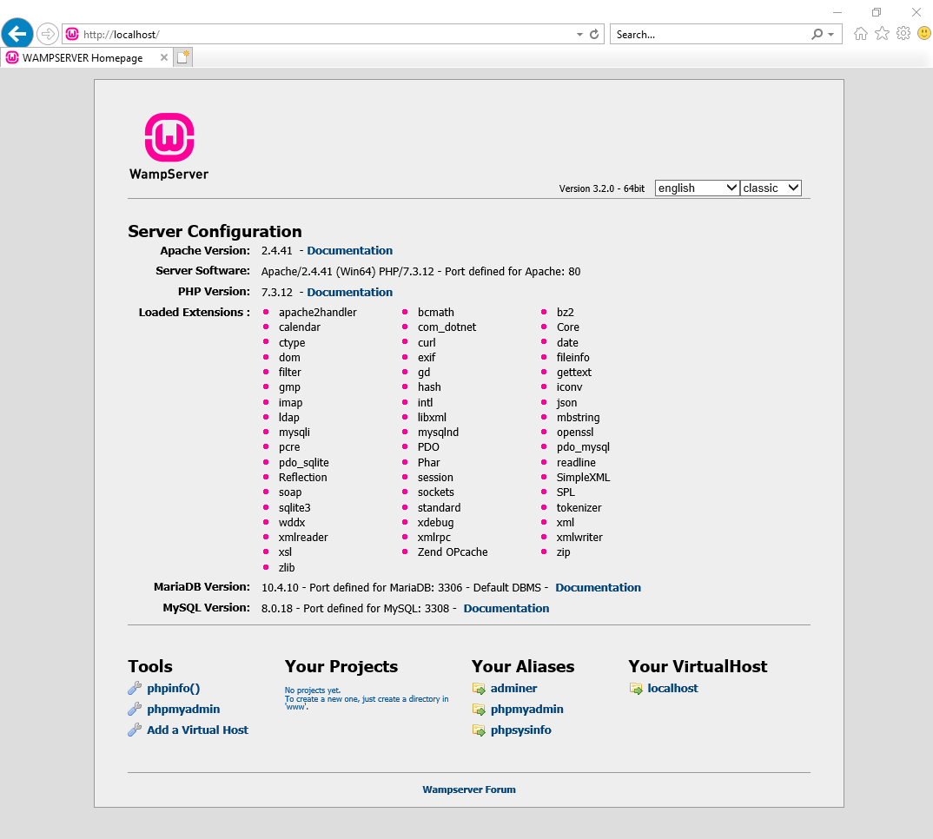

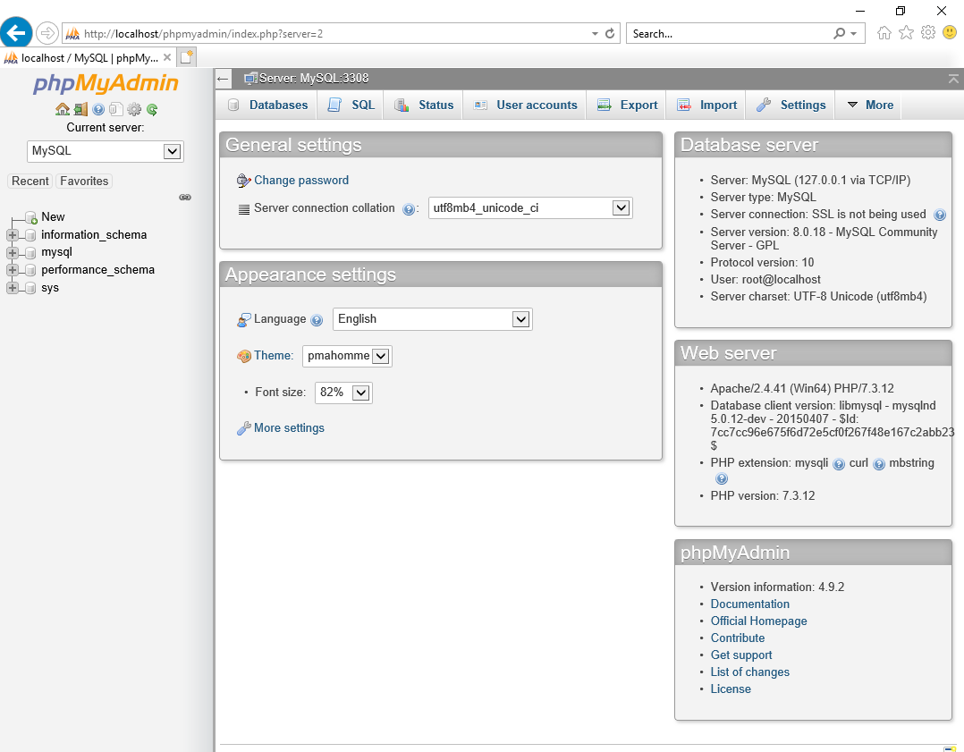

Created database and a table in it.

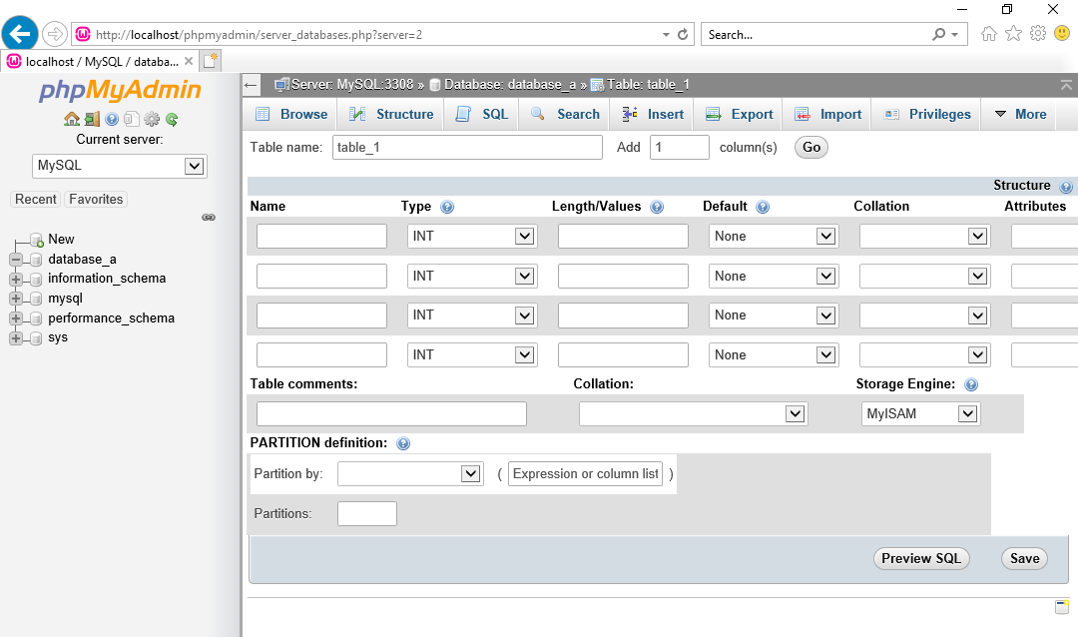

HTML PAGE (index2.phd)

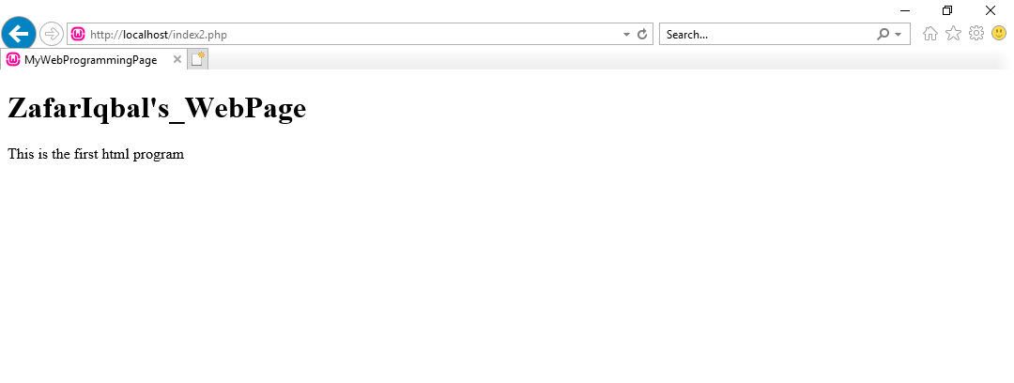

Got full access to Codd server. Everything works perfectly

