**Project Title: Unleashing The Potential Of Our Youth: A Student Performance Analysis**

**Faculty Mentor:** Sashi Kanth Beta

**Team Id:**LTVIP2023TMID08025

**Team size:**04

**Team Leader:**Latchupatula Jyotshna

**Team Members:** Koppala Dhana Laxmi

Kinthada Chaitrika

Maharaju Devi

**Data Analytics:**

Data analytics is a multidisciplinary field that employs a wide range of analysis techniques, including math, statistics, and computer science, to draw insights from data sets. Data analytics is a broad term that includes everything from simply analysing data to theorizing ways of collecting data and creating the frameworks needed to store it.

**Data Analyst?**

Data analyst is a broad term for someone paid to analyse data and create insights that viewers can act on. Skilled data analysts are some of the most sought-after professionals in the world.

Because demand is strong and the supply of people who can do this job well is limited, data analysts command higher-than-average salaries and perks, even at the entry level.

Data analyst jobs can be found throughout a diverse mix of companies and industries. Some top jobs in data analysis involve using data to make investment decisions, target customers, assess risks, or decide on capital allocations.

**Key Takeways:**

The role of the data analyst has become increasingly important since the early 2000s, with employment opportunities in industries ranging from [finance](https://www.investopedia.com/how-to-change-careers-to-a-financial-sector-job-5200345) to marketing to social media.

In addition to knowing your way around computers, data analysts must also be well-versed in statistical methods and models.

Big data and machine learning are among the cutting-edge applications of data analysis.

**Student Performance Analysis:**

A country's growth is strongly measured by quality of its education system. Education sector, across the globe has witnessed sea change in its functioning. Today it is recognized as an industry and like any other industry it is facing challenges, the major challenges of higher education being decrease in students' success rate and their leaving a course without completion.

Analysing student work is an essential part of teaching. Teachers assign, collect and examine student work all the time to assess student learning and to revise and improve teaching. Ongoing assessment of student learning allows teachers to engage in continuous quality improvement of their courses. Many factors can influence a student's performance, including the influence of the parents' educational background, test preparation and so on.

The dataset contains the marks secured by 1000 students from a school. This project analyses and correlates student performance with different attributes. The analysis aims to understand the influence of important factors such as parental level of education, the status of test preparation course etc. on the performance of the students in the exams.

**Business Requirements of Student performance Analysis :**

Business requirement of student performance analysis refers to the need of educational institutions or organizations to gather, analyse, and use data on students' academic performance to improve teaching and learning outcomes. This process involves collecting, analysing, and interpreting data on various aspects of student performance such as test scores, attendance, behavioural patterns, and demographic information. The business requirement of student performance analysis is crucial for educational institutions to provide high-quality teaching and learning outcomes and improve student success. The ultimate goal is to gain insights and improve performance through data visualization techniques.

**Literature Survey:**

A literature survey for Student Performance Analysis involves reviewing academic articles, and other sources related to the analytics of Students Performance. Researchers and practitioners in the field are exploring new methods and tools to improve teaching and learning outcomes and provide more personalized learning experiences for individual students. The analysis can provide a comprehensive understanding of the significance, challenges, and opportunities associated with Student Performance.

**Social Or Business Impact :**

Social Impact: It have a positive social impact by improving student outcomes, promoting equity in education, and increasing transparency and accountability in the education system.

Business Model/Impact: It have a significant impact on businesses and educational institutions, as it provides valuable insights into student learning and helps improve teaching, increasing efficiency, and promoting competitiveness.

**Project Flow:**

To accomplish this, we have to complete all the activities listed below,

* Define Problem / Problem Understanding
  + Specify the business problem
  + Business requirements
  + Literature Survey
  + Social or Business Impact.
* Data Collection & Extraction from Database
  + Collect the dataset,
* Prepare the Data for Visualization
* Data Visualizations
  + No of Unique Visualizations
* Dashboard
  + Responsive and Design of Dashboard
* Story
  + No of Scenes of Story
* Report
  + No of Visualization with detail information
* Performance Testing
  + Utilization of Data Filters
  + No of Calculation Fields
  + No of Visualizations/ Graphs
* Web Integration
  + Dashboard, Report and Story embed with UI With Flask

**Data Collection & Extraction From Database:**

Data collection is the process of gathering and measuring information on variables of interest, in an established systematic fashion that enables one to answer stated research questions, test hypotheses, and evaluate outcomes and generate insights from the data.

**Understanding the Data:**

Data contains all the meta information regarding the columns described in the CSV files. The name of file is StudentPerformance.csv

Description for StudentPerformance.csv:

The file StudentPerformance.csv contains 1000 rows. Each row corresponds to an individual student with details and marks in respective subjects. The columns are:

Categorical columns are:

Gender: Male or Female

Race/ethnicity: 5 groups, from group A to group E

Parental level of education: from high school to a master’s degree

lunch: free/reduced or standard.

Numerical Columns are:

Math score: out of 100

Reading score: out of 100

Writing score: out of 100

**Data Preparation:**

Data modules are containers that describe data and rules for combining and shaping data to prepare it for analysis and visualization in IBM Cognos Analytics. Data module sources. Data modules can be based on data servers, packages, uploaded files, data sets, and other data modules

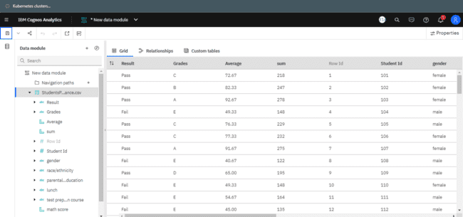

**No Of Unique Visualizations:**

The number of unique visualizations that can be created with a given dataset. Some common types of visualizations that can be used to analyse the Literacy include bar charts, line charts, heat maps, scatter plots, pie charts, Maps etc. These visualizations can be used to compare and analyze students  performance base on number of diffrent parameters.

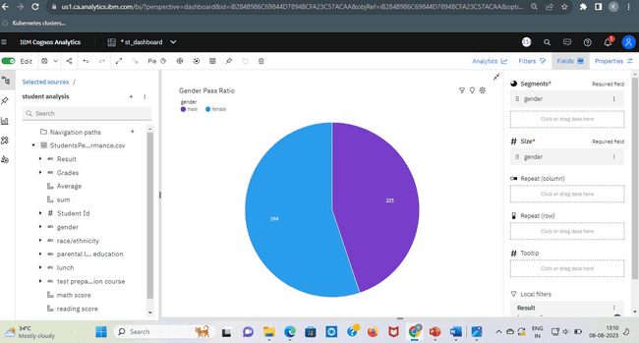

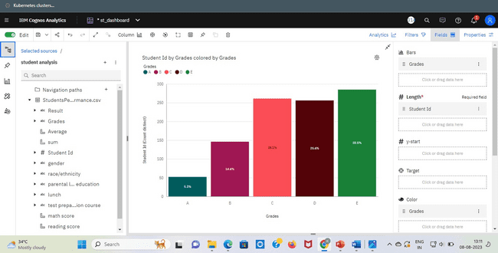

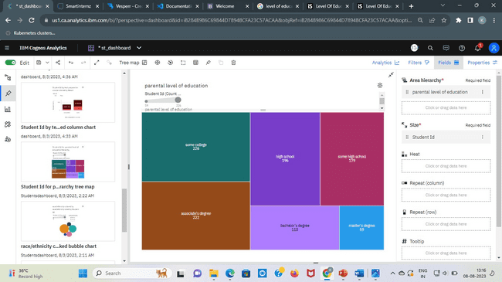

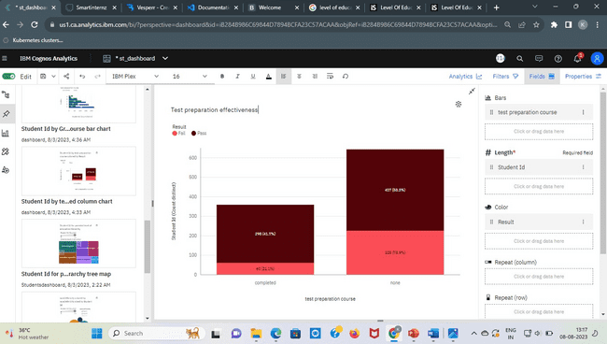

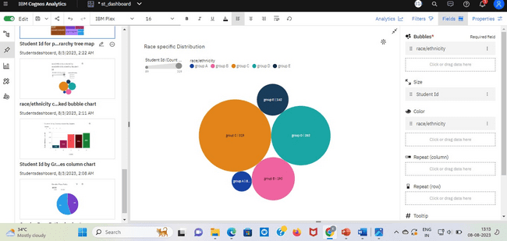

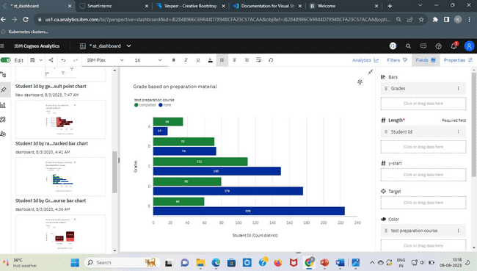

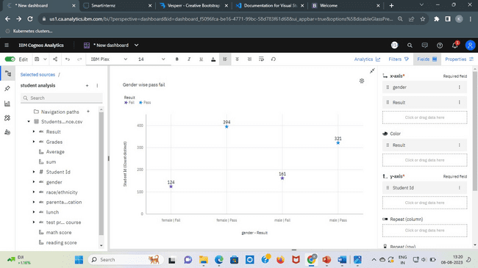

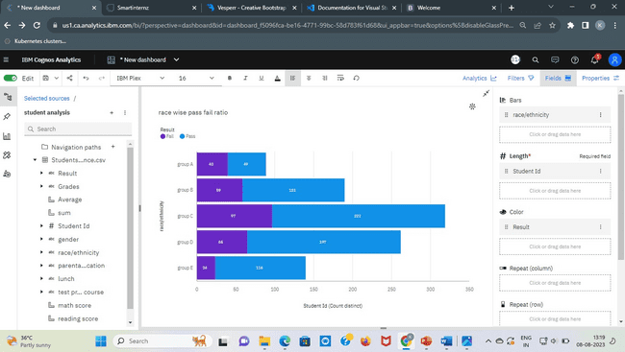

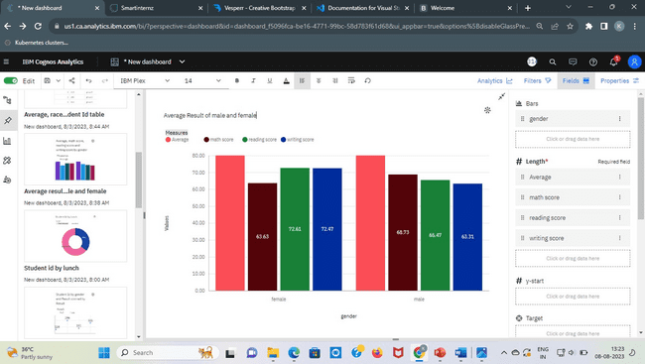

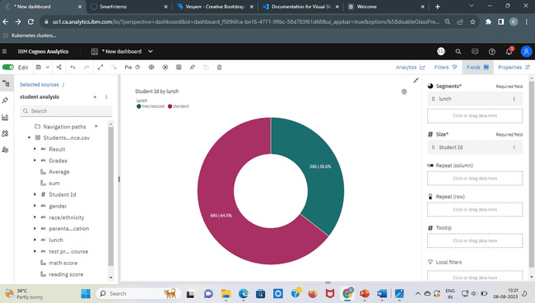

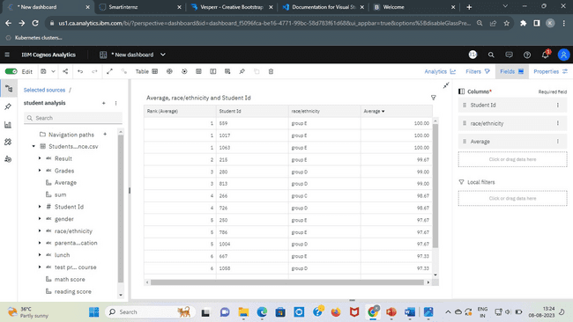

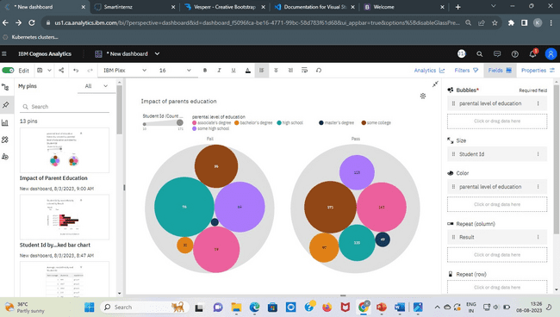

**Responsive And Design Of Dashboard:**

The responsiveness and design of a dashboard for Data-Driven insights on Student Performance is crucial to ensure that the information is easily understandable and actionable. Key considerations for designing a responsive and effective dashboard include user-centered design, clear and concise information, interactivity, data-driven approach, accessibility, customization, and security. The goal is to create a dashboard that is user-friendly, interactive, and data-driven, providing actionable insights.

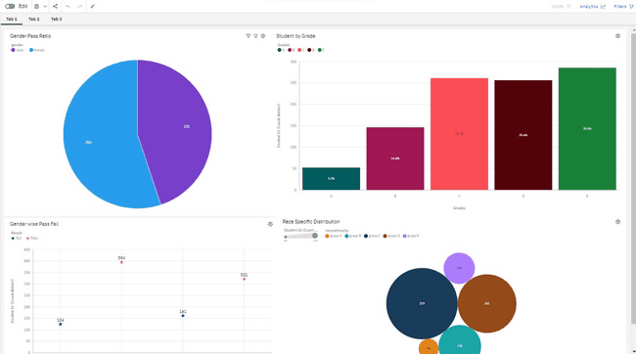

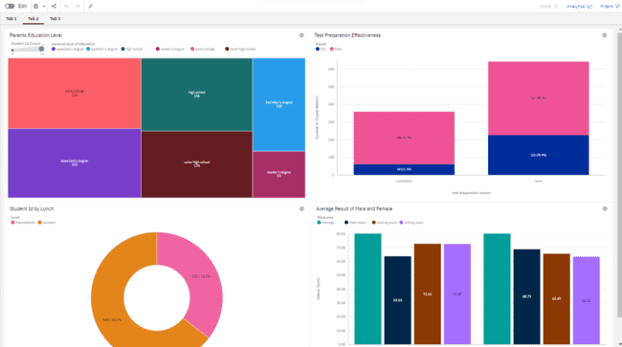

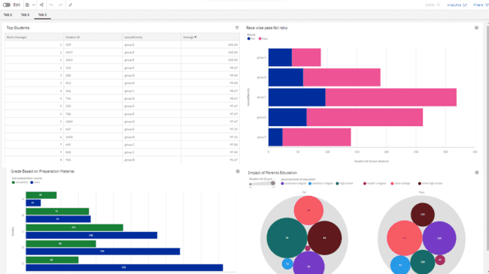

**Story:**

A data story is a way of presenting data and analysis in a narrative format, with the goal of making the information more engaging and easier to understand. A data story typically includes a clear introduction that sets the stage and explains the context for the data, a body that presents the data and analysis in a logical and systematic way, and a conclusion that summarizes the key findings and highlights their implications. Data stories can be told using a variety of mediums, such as reports, presentations, interactive visualizations, and videos.



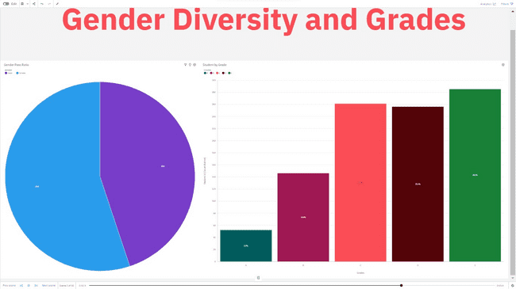

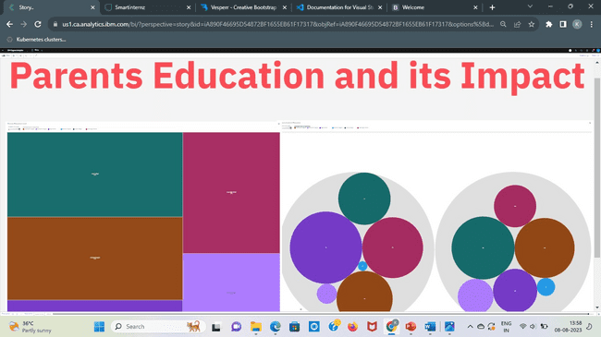

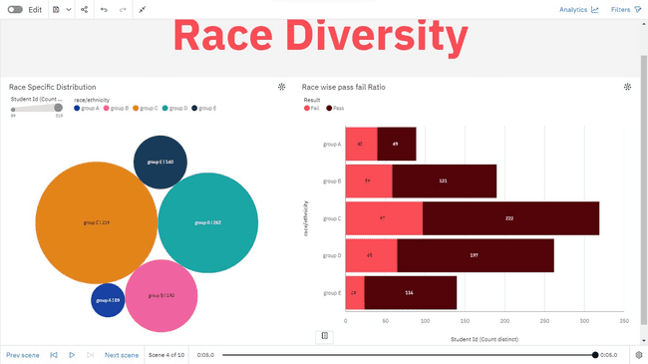

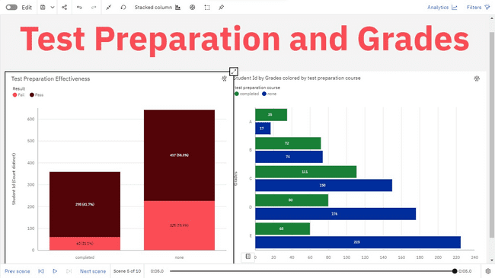

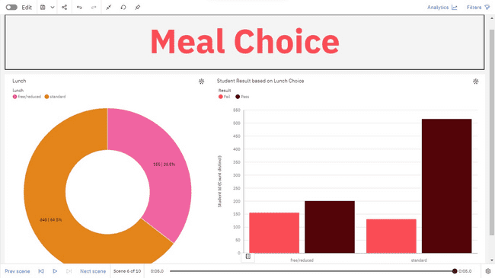

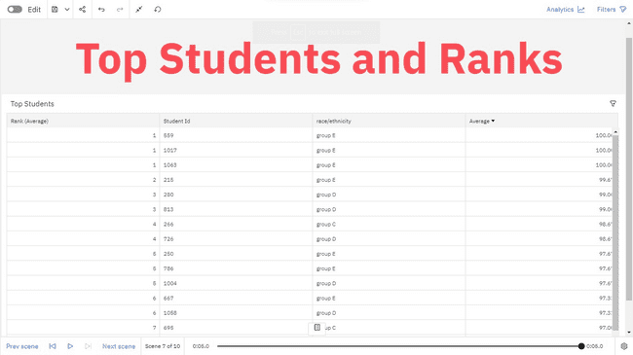

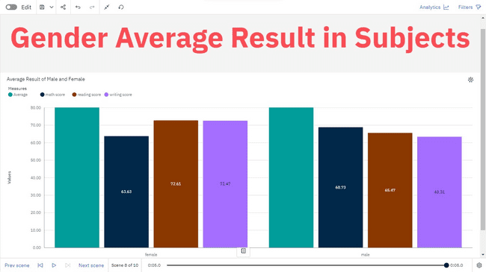

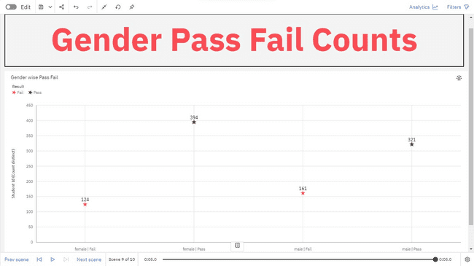

**Report:**

A report in data analytics typically involves analysing and interpreting data to draw insights and conclusions that can inform business decisions or address research questions. The report usually includes a summary of the data analysis process, including the methods and tools used, as well as the findings and recommendations based on the analysis. The report should begin with an executive summary, which provides a brief overview of the main findings and recommendations. The introduction should provide background information on the problem or research question being addressed and the data sources used.

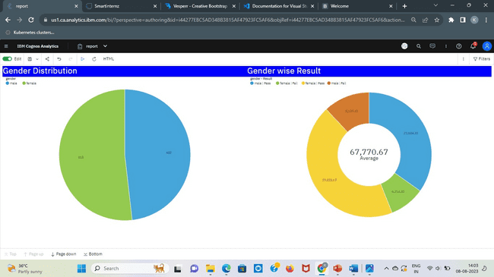

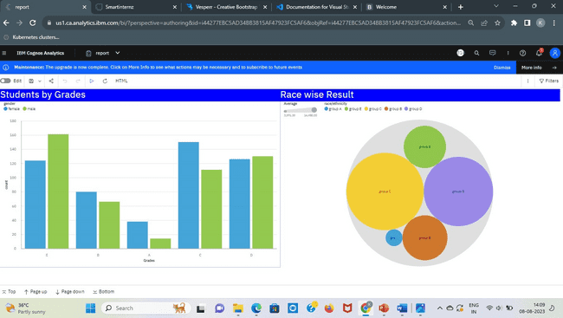

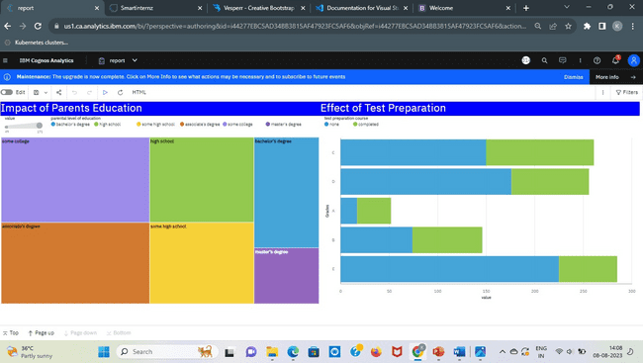

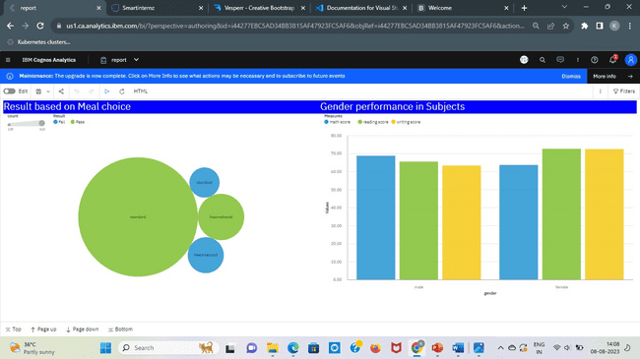

### Web Integration

Publishing helps us to track and monitor key performance metrics, to communicate results and progress. help a publisher stay informed, make better decisions, and communicate their performance to others.

**Publishing dashboard, report & story.**

Step 1: Go to Dashboard, report & /story, click on share button on the top.



