TESTING AND RUNNING EXCHANGE PROGRAM
Date: 7th April 2026

- Make sure Docker Desktop is running and any previous containers relating to A3 are deleted, otherwise looking something like this:
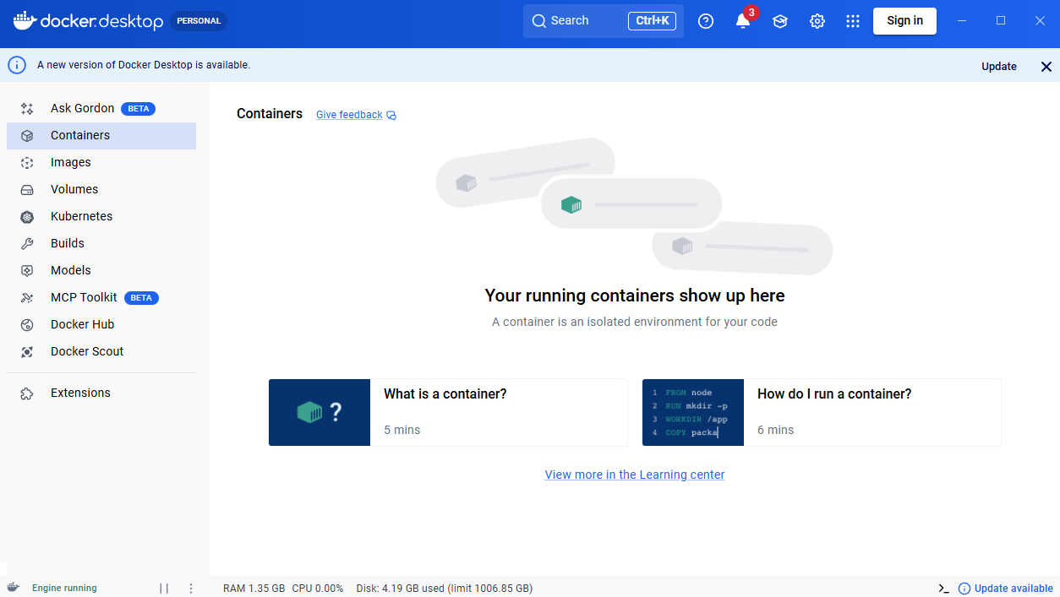

- Open PowerShell from within “ALL_SERVICES”
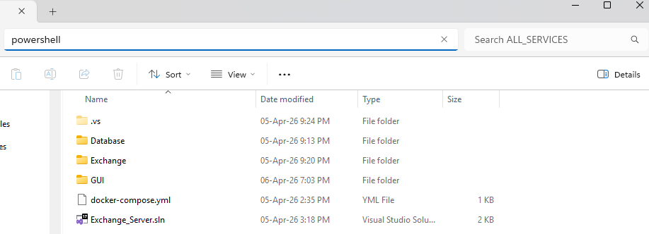

- Build docker using docker-compose up –build (because we need to build fresh builds)
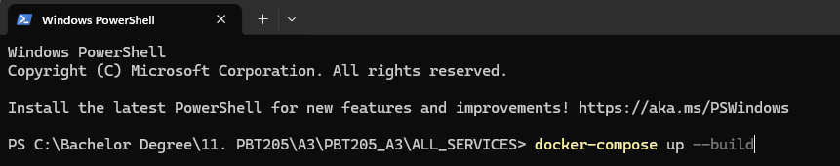

- After a while exchange will be running and will look something like this:
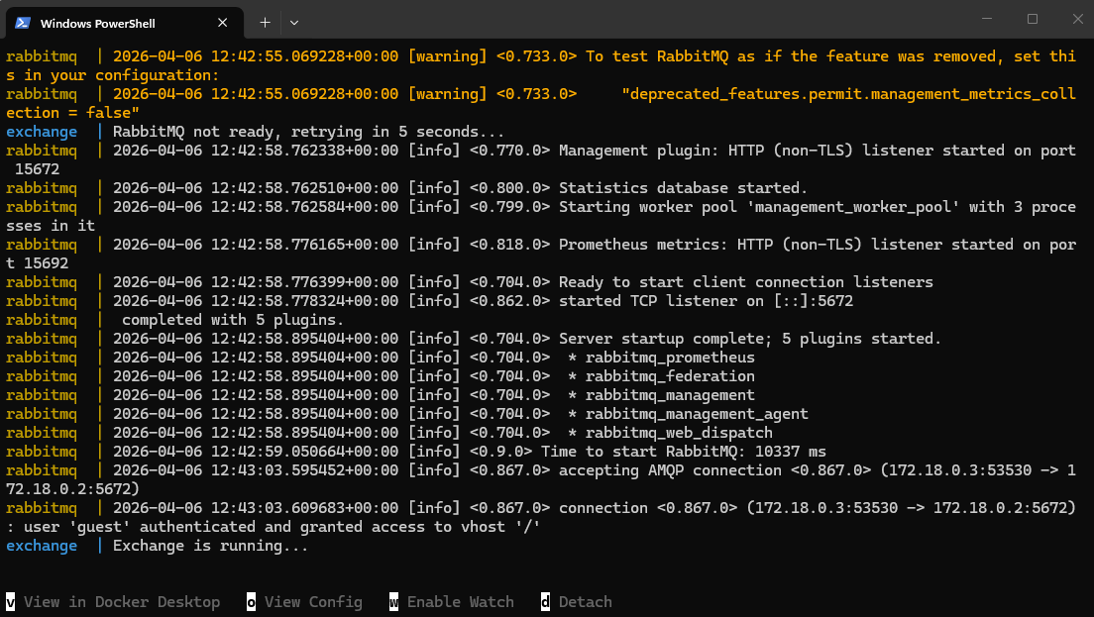

- Go to RabbitMQ, login using “guest” as username and password: http://localhost:15672/#/queues
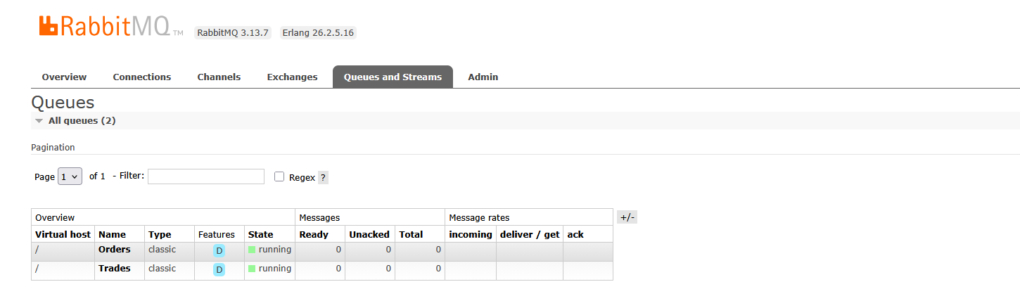
We should be able to see queues “Orders” and “Trades” which are created during the docker build (these are setup from C# exchange)

- Navigate to the “TradePublisher” folder where the C# TradePublisher solution resides:
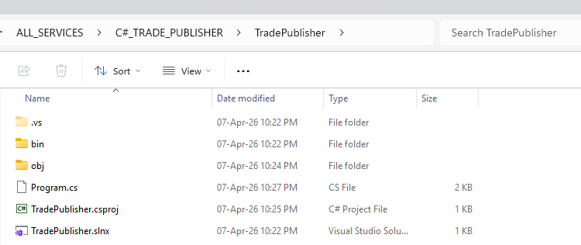

- Open PowerShell and type dotnet run
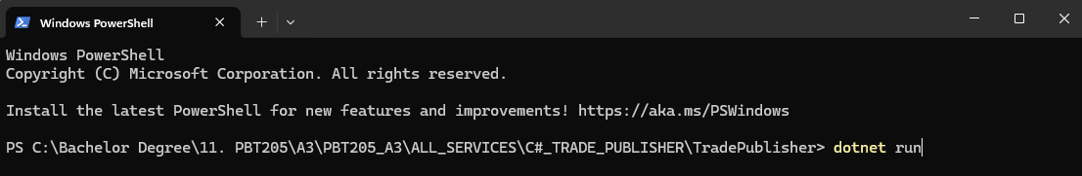

At this point the TradePublisher should open, we can leave it running in the background, it will automatically publish trades when they happen and print them here. It should look like this for now:

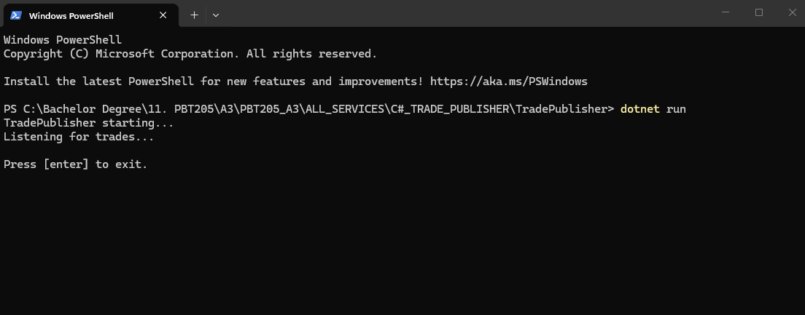

- Navigate to the “GUI” folder and run a second instance of PowerShell from here:
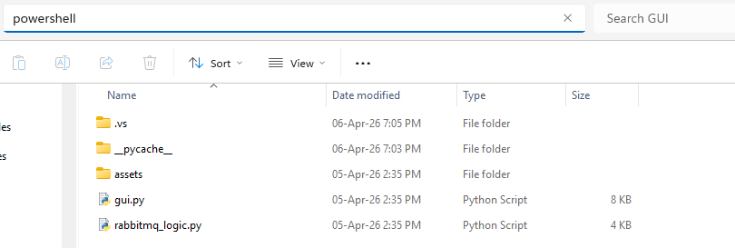

- Run python python gui.py
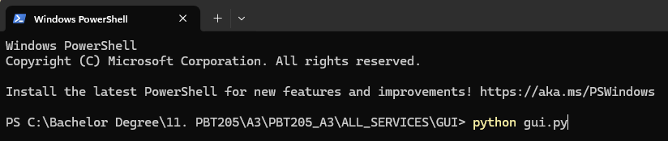

- If all of the above worked you should get the GUI which currently looks like this:
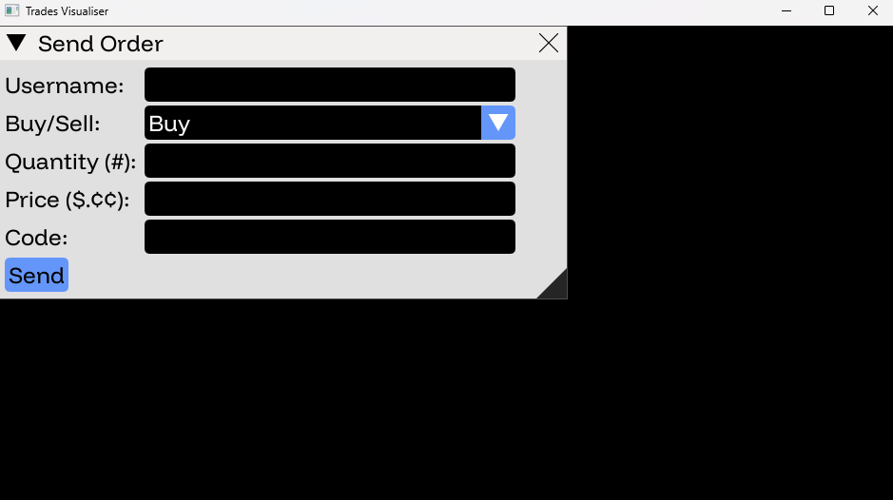

- The database in Docker is synchronizing to the database here: \Database\Trading.db
- If you have SQLite you can query the DB and confirm it has a number of BUY & SELL orders pre-loaded
- Enter in a corresponding order to make a trade, which will appear in the TradePublisher:

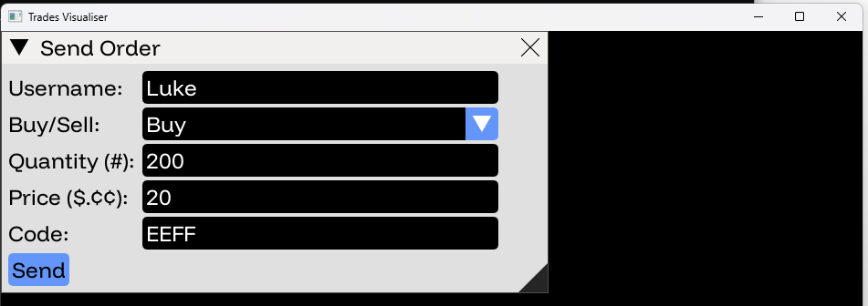

Trade is published here:
