[Home](http://www.amsgh.com/) http://www.amsgh.com/templates/ausdrill_master/assets/img/breadcrumbs.png [Our Business](http://www.amsgh.com/amsgh-our-business/amsgh-about-us.html) http://www.amsgh.com/templates/ausdrill_master/assets/img/breadcrumbs.png Safety



SAFETY

WE TAKE THE BUSINESS OF WORKING SAFELY ACROSS EVERY ASPECT OF OUR  OPERATIONS VERY SERIOUSLY – IT’S AN INTEGRAL PART OF OUR BUSINESS, AND THE CULTURE OF OUR PARENT COMPANY, AUSDRILL.

**We put safety on top of the agenda**

African Mining Services is a safely conscious mining contracting entity committed to maintaining the highest standards of HS&E in the industry in order to eliminate conditions and incidents that could result in personal injury, ill health or damage to the environment.

We are committed to taking all possible steps to ensure the safety and health of all persons working in the workplace and prevent damage to company property, equipment and the environment.

Our management ensure that supervisors and employees understand their specific responsibilities for HS&E and that all site activities are carried out in accordance with Mines Regulations and any other relevant HS&E requirements.

We are committed to effective training so that each employee can develop skills in an efficient and safe manner.

Our employees share responsibility with management in ensuring the safety and well-being of themselves and other persons in the workplace and ensuring that no-one is allowed to work in an unsafe situation or in an unsafe manner. It is essential that all dangerous situations are identified and isolated. Immediate supervision, along with management, are made aware immediately.

**Continually improving our record in health and safety onsite**

We are committed to

* Continual improvement of workplace health and safety in partnership with employees and sub-contractors.
* Regular identification of hazards, risk assessment and risk control in order to identify all issues of HS&E concern and thereby establish objectives, targets and strategies for their management.
* Building a team attitude and approach to safety and training and promotes fluid interaction between staff and employees where all matters of HS&E are concerned.

[Home](http://www.amsgh.com/) http://www.amsgh.com/templates/ausdrill_master/assets/img/breadcrumbs.png [Our Business](http://www.amsgh.com/amsgh-our-business/amsgh-about-us.html) http://www.amsgh.com/templates/ausdrill_master/assets/img/breadcrumbs.png Suppliers



SUPPLIERS

WE COVER THE FULL SCOPE OF THE PROCUREMENT LIFE CYCLE, WITH MORE THAN 85% OF ALL PURCHASES BEING DONE IN THE LOCAL REGION, FROM LOCAL SUPPLIERS

**Becoming a Supplier**

When sourcing high quality goods and services we value companies with the following qualities:

* Excellent safety record
* Cost efficiency
* Financial viability
* Competitive pricing
* Customer focus
* Innovative business solutions
* 24hr Technical Support

To register as a potential supplier, forward your company details, products and services to [procurement@amsgh.com](mailto:procurement@amsgh.com).

Companies must be willing to adhere to the African Mining Services procurement principles and operate under our specific trading terms and conditions which can be found here.

**African Mining Services Procurement Procedures Outline**

* The role of the Procurement function within the African Mining Services Group and the way we want to operate
* The expectations and commitments between Procurement and its internal customers;
* The expectations between Procurement and suppliers; and
* African Mining Services expectations of its own employees and contractors.

African Mining Services Procurement Procedures cover the full scope of the procurement cycle including:

* obtaining global and local sources of supply and initiating requests for goods and services;
* obtaining quotations covering pricing and availability from suppliers
* placing orders for goods or services; and
* authoring payments to suppliers.

African Mining Services Procurement Procedures have been written to ensure that all procurement related activities are conducted with transparency and are understood by all key stakeholders. This document complements the internal AMS Group Procurement policies and guidelines.

African Mining Services Procurement Procedures are intended to have broad application across the AMS Group and apply to the Procurement function as well as individual businesses in the acquisition of goods and/or services.

**Terms and Conditions**

By accepting this purchase order, you are agreeing to accept our Standard Terms and Conditions located on our company website.

If you do not have access to the internet, please let your purchasing officer know and they will send you a copy.

[Home](http://www.amsgh.com/) http://www.amsgh.com/templates/ausdrill_master/assets/img/breadcrumbs.png [Our Business](http://www.amsgh.com/amsgh-our-business/amsgh-about-us.html) http://www.amsgh.com/templates/ausdrill_master/assets/img/breadcrumbs.png Policies



POLICIES

WE ARE COMMITTED TO PROVIDING COHERENT, CONCISE AND OPEN POLICY DOCUMENTATION COVERING A RANGE OF WORKPLACE PROCEDURES, TO ENSURE A COHESIVE OPERATING CODE FOR ALL EMPLOYEES AT EACH WORK SITE.

**Our Policies**

|  |  |  |
| --- | --- | --- |
| **Title** |  |  |
| Environmental Policy | [English](http://www.amsgh.com/images/files/Environmental_Policy_AMSG_Jan_2018.pdf) | [French](http://www.amsgh.com/images/files/Environmental_Policy_AMSG_Jan_2018_French.pdf) |
| Injury Management Policy | [English](http://www.amsgh.com/images/files/Injury_Management_Policy_AMSG_Jan_2018.pdf) | [French](http://www.amsgh.com/images/files/Injury_Management_Policy_AMSG_Jan_2018_French.pdf) |
| Safety and Health Policy | [English](http://www.amsgh.com/images/files/Safety_and_Health_Policy_AMSG_Jan_2018.pdf) | [French](http://www.amsgh.com/images/files/Safety_and_Health_Policy_AMSG_Jan_2018_French.pdf) |
| Quality Policy | [English](http://www.amsgh.com/images/files/Quality_Policy_AMSG_Jan_2018.pdf) | [French](http://www.amsgh.com/images/files/Quality_Policy_AMSG_Jan_2018_French.pdf) |
| Training Policy | [English](http://www.amsgh.com/images/files/Training_Policy_AMSG_Jan_2018.pdf) | [French](http://www.amsgh.com/images/files/Training_Policy_AMSG_Jan_2018_French.pdf) |
| Mission Statement | [English](http://www.amsgh.com/images/files/Mission_Statement_Policy_AMSG_Jan_2018.pdf) | [French](http://www.amsgh.com/images/files/Mission_Statement_Policy_AMSG_Jan_2018_French.pdf) |
| HIV/AIDS Policy | [English](http://www.amsgh.com/images/files/HIV_AIDS_Policy_AMSG_Jan_2018.pdf) | [French](http://www.amsgh.com/images/files/HIV_AIDS_Policy_AMSG_Jan_2018_French.pdf) |

Hire Equipment : African Mining Services

[Home](http://www.amsgh.com/) http://www.amsgh.com/templates/ausdrill_master/assets/img/breadcrumbs.png [Our Services](http://www.amsgh.com/amsgh-our-services/amsgh-overview.html) http://www.amsgh.com/templates/ausdrill_master/assets/img/breadcrumbs.png Hire Equipment



HIRE EQUIPMENT

ADMIT IT – YOU DIDN’T WANT TO END UP HERE, NOW TO FIND A RELIABLE CONTRACTOR THAT WILL DELIVER YOUR REQUIREMENTS SAFELY AND COST EFFECTIVELY. HERE WE ARE, READY TO GO.

As your hire equipment contractor of choice, we will achieve your goals for you for the price quoted, as we understand all aspects of equipment hire challenges in Africa and have recently put in place an internal resource to assist with the growing needs of the equipment hire business.

We will be further developing this part of our website soon - we will keep you updated.

[Home](http://www.amsgh.com/) http://www.amsgh.com/templates/ausdrill_master/assets/img/breadcrumbs.png [Our Services](http://www.amsgh.com/amsgh-our-services/amsgh-overview.html) http://www.amsgh.com/templates/ausdrill_master/assets/img/breadcrumbs.png Load and Haul



LOAD AND HAUL

WHY SPEND YOUR MONEY DOING WHAT WE DO BEST? BY OUTSOURCING YOUR LOAD AND HAUL OPERATIONS TO AMS YOU CAN SPEND YOUR MONEY WHERE IT SERVES YOU BEST, IN PROCESSING. AMS OWNS, OPERATES AND MAINTAINS A LARGE MODERN MINING FLEET THAT CAN CATER FOR YOUR REQUIREMENTS.

As your load and haul contractor, AMS will ensure your material is moved in conjunction with your mine plan safely and efficiently so you can concentrate on the rest of your business. We will have the equipment already, or, with our close relationship with existing OEM's in the regions we operate in, we can provide fleet to meet your requirements in a timely manner.

With a large fleet in addition to our range excavators, dump trucks and other heavy plant, you can leave the earthmoving to us, knowing that we’ll get the job completed safely, on time and within budget.

[Home](http://www.amsgh.com/) http://www.amsgh.com/templates/ausdrill_master/assets/img/breadcrumbs.png [Our Services](http://www.amsgh.com/amsgh-our-services/amsgh-overview.html) http://www.amsgh.com/templates/ausdrill_master/assets/img/breadcrumbs.png Grade Control



GRADE CONTROL

WE RECOGNIZE THAT THERE CAN BE NO WEAK LINKS IN THE LIFECYCLE OF YOUR MINING OPERATION AND OUR ACCESS TO HIGH QUALITY GRADE CONTROL RIGS BUILT BY AUSDRILL SETS US APART FROM THE REST. WE ARE ABLE TO PERFORM IN-PIT REVERSE CIRCULATION (RC), GRADE CONTROL (GC) DRILLING AND SAMPLING WITH OUR FLEET OF TRACK MOUNTED RIGS, THE RIGS DESIGNED TO PROVIDE HIGH QUALITY SAMPLE WITH INCREASED LEVEL OF EFFICIENCY AND ACCURACY, AN ESSENTIAL STEP TOWARDS YOUR MINES OPTIMUM OPERATIONAL CAPABILITY.

We recognize that safety, sample quality and productivities are of paramount importance for our clients' grade control programs.

Grade Control drilling is primarily a quality control function. Focusing on productivities will not come at the cost of quality samples.

We perform in-pit reverse circulation grade control drilling and sampling utilizing a fleet of track-mounted Schramm and Rock Commander machines. These machines are designed to provide a high quality sample with increased levels of safety, efficiency and accuracy.

Our purpose built Rock Commander Grade control machines offer the following safety benefits:

* Ground level servicing
* Ground level cyclone cleaning
* Deadman functions - drilling and tramming operation
* Fire suppression system - 3 activation points
* Emergency shut down system - 3 activation points

We are able to provide specific sampling systems suited to our clients' needs.

[Home](http://www.amsgh.com/) http://www.amsgh.com/templates/ausdrill_master/assets/img/breadcrumbs.png [Our Services](http://www.amsgh.com/amsgh-our-services/amsgh-overview.html) http://www.amsgh.com/templates/ausdrill_master/assets/img/breadcrumbs.png Exploration Drilling



EXPLORATION DRILLING

WE HAVE ONE OF THE MOST DIVERSE EXPLORATION DRILLING FLEETS IN AFRICA, ENSURING THAT WHEN YOU'RE READY TO EXPLORE NEW GROUND, WE ARE THE PARTNER OF CHOICE.

AMS has assembled a fleet of exploration rigs, built to our own specifications – because we know what’s needed in the challenging conditions of Africa. The equipment on board ensures that we can meet whatver your needs, wherever your site is located. Capable, competitive, reliable and supported by a modern reliable support fleet, the drilling just won't stop.

Our fleet includes DRA 1200 and KL 900 multi purpose machines, schramm, KL 150 and our DRA 160 equivalent. Add to the mix DRA 800 diamond drills and big air with boosters for those looking at deeper and dryer RC holes, our fleet covers all bases when it comes to exploration drilling in West Africa.

[Home](http://www.amsgh.com/) http://www.amsgh.com/templates/ausdrill_master/assets/img/breadcrumbs.png [Our Services](http://www.amsgh.com/amsgh-our-services/amsgh-overview.html) http://www.amsgh.com/templates/ausdrill_master/assets/img/breadcrumbs.png Mobile Crushing



MOBILE CRUSHING

AMS NOT ONLY MOVES YOUR MATERIAL, WE CAN CRUSH IT ALSO. BY OUT-SOURCING YOUR CRUSHING AND SCREENING TO AMS, YOU GET YOUR MATERIAL HOW YOU NEED IT AND WHEN YOU WANT IT.

In the past few years, AMS has gathered experience in mobile crushing and screening to ensure we can complete your project requirements ahead of time. Mobile crushing is becoming a standard requirement on most projects, so start your planning early when talking mining contracts with the company that can do it all.

[Home](http://www.amsgh.com/) http://www.amsgh.com/templates/ausdrill_master/assets/img/breadcrumbs.png [Our Services](http://www.amsgh.com/amsgh-our-services/amsgh-overview.html) http://www.amsgh.com/templates/ausdrill_master/assets/img/breadcrumbs.png Pit Dewatering



PIT DEWATERING

WATER IS GENERALLY THE BIGGEST DISRUPTION BETWEEN YOU AND YOUR COMMODITY. AMS CAN HELP YOU WITH THAT DISRUPTION.

AMS has moved a significant amount of water in Africa to ensure mining operations can be carried out safely and effectively, with a vast range of dewatering equipment available for your operation. Do not underestimate the ability of water to disrupt your operations. AMS can provide cost effective solutions to enable safe and productive mining operations to continue.

# Gold CIL process

Cyanidation ---carbon adsorption process is the most widely used in gold cyanide extraction process . The principle in brief is the carbon could adsorb liquid gold from cyanide solution . In 1970s , with the research and establishment of adsorption of carbon loaded with gold and the recovery of carbon discharge gold , make recycle the carbon and reduce the cost , and easy to process the gold ore with low grade .

###### **Introduction**

**Application**

The gold CIL process is mainly used in the oxide ore which has low grade of silver , its more economize and has more benefit .

**Process introduction**

CIL process is mainly include : decontaminate , concentrate before leaching , leaching and adsorption , desorption and electrowinning , hydrometallurgy ,  regeneration of activated carbon ， tailings filting , waste water treatement and so on .

1、Decontaminate impurity ：remove the impurity like the bits of mood before cyanide adsorption , avoid the bits of mood adsorb the gold from slurry , avoid the bits of mood block the carbon separator .

2、Concentrate before leaching , usually to reach a suitable leaching concentrate , the slurry should be dewatered through the thickener before leaching , the concentration could influence the leaching time and influence the float of activated carbon .

3、Leaching and adsorption : put the slurry after decontaminated and concentrated into the high-efficiency leaching tank , there are 5-8 tanks normally , add cyanide solution into the former two tanks , add activated carbon into the other five tanks , activated carbon adsorb gold become the loaded gold carbon , the loaded gold carbon lift into the lifting screen by air lifter ,  the lifting screen separate activated carbon and slurry .

4、Desorption and electrowinning :  the desorption of activated carbon and electrowinning the liquid gold are completed in a closed system ， in a high temperature and high pressure , activated gold carbon after desorption and electrowinning become gold pulp and barren carbon . Main equipment including : desorption column , acide tank , heater , filter , desorption tank , electrowinning tank and so on .

5、Smelting : after acide washing and decontaminate , gold ingot will be smelted . With the method of hydrometallurgy , the gold grade could be 99.99%.

6、Application of the regenerated activated carbon : the activated carbon after desorption make acide washing to remove the carbonate accumulate , after times of using that need heating activated to regenerate the carbon , then for recycling .  Main equipment including activated carbon regenerated tank , water quench tank , fine carbon separate screen .

Yantai Jinpeng Mining Mining Machinery is the professional manufacturer of mining equipment , product with high quality .

**Auto Centering Vibrating Screen**

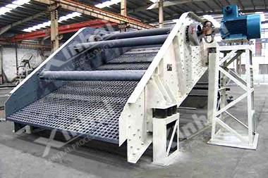

**Product Introduction**

A traditional and widely using vibrating screen

**Capacity**

20～300t/h

**Product Improvements**

Elastic location limit part is made of Yantai Group wear-resistant rubber

Adopting the new patent technology: a seat type vibrating screen lifting device, Patent No. 201120562516.7

**Linear Vibrating Screen**

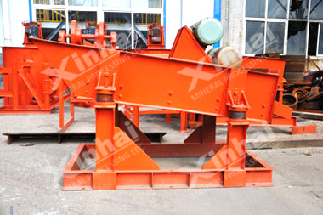

**Product introduction**

A vibrating screen that screen box takes reciprocating movement along the directional linear, is used for fine screening.

**Capacity**

20～300t/h

**Product improvement**

Screen angle is adjustable

Vibrating motor as vibration exciter, low energy consumption

**Round Vibrating Screen(YA)**

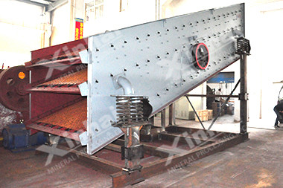

**Product Introduction**

A kind of advanced vibrating screen with circular motion

**Capacity**

80～1700t/h

**Product Improvement**

Ring groove rivets connection, plate type screen box, advanced structure, strong and durable

Vibration exciter with eccentric shaft and eccentric block, high screening efficiency, large capacity

**Jaw Crusher**

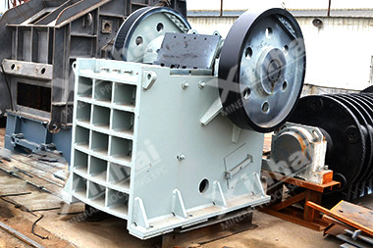

**Product Introduction**

Yantai Group jaw crusher with high production capacity, large reduction ratio and high crushing efficiency

**Production capacity**

0.5~700t/h

**Product Improvement**

Yantai Group improves the traditional specification of crushing chamber by adopting high speed swing jaw and cambered jaw plate.

**Hammer Crusher**

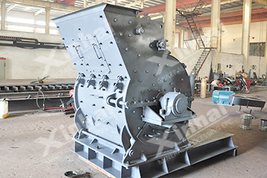

**Product Introduction**

Hammer crusher is a kind of equipment with high production capacity, large reduction ratio and high crushing efficiency

**Production Capacity**

5～75t/h

**Product Improvement**

High-speed hammer impacts materials to crush materials. There are two ways of crushing (Wet and dry)

**Hydraulic Cone Crusher**

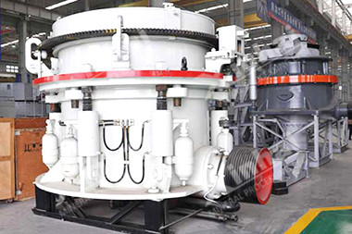

**Product Introduction**

Hydraulic cone crusher is a kind of crushing equipment

**Production Capacity**

5～750t/h

**Product Improvement**

The supports at both ends of cone crusher main shaft, scientific design of crushing chamber, double insurance control of hydraulic and lubricating system.

Working principle

Hydraulic cone crusher consists of frame, transmission, hollow eccentric shaft, bowl-shaped bearing, crushing cone, springs and hydraulic pressure station for adjusting discharge opening. During operation, motor drives eccentric shaft shell to rotate through a horizontal axle and a pair of bevel gear. The axle of crushing cone swings with the force of eccentric shaft shell so that the surface of the crushing wall is close to the roll mortar wall from time to time. In this way, the ores and rocks will be pressed and crooked and crushed.

# Mobile crushing and screening equipment

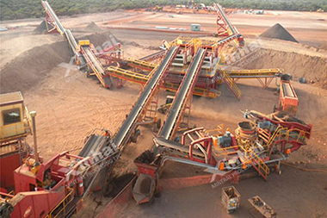

**Introduction**

High flexibility upon transportation, whereas low cost upon comprehensive use.

**Effective Volume**

100-2000t/d

**Product Improvement**

Yantai Group mobile crushing and screening equipment consists of three types: semi-mobile, tire movable type and crawler type. The machines comes with the power source and is highly adaptable. It also have the characteristics of low body and easy to transport and handling.

##### Introduction

**Energy Saving Ball Mill**

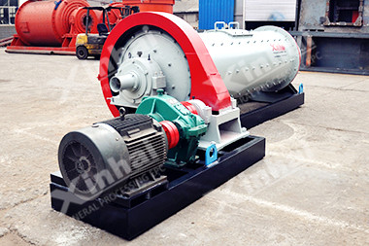

**Product Introduction**

A high efficiency and energy saving ball mill with rolling bearing

**Capacity**

Up to 160t/h

**Product Improvement**

[Cylindrical energy saving grid ball mill](http://www.ytmachines.com/product_3_8.html) is lined grooved ring plate which increases the contact surface of ball and ore and strengthens the grinding.

**Rod Mill**

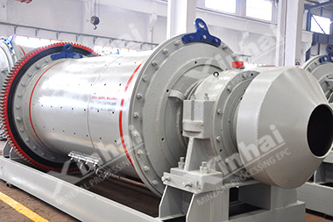

**Product Introduction**

A grinding equipment with steel rod as medium

**Capacity**

0.62～250t/h

**Product Improvement**

Yantai Group **rod mills** include overflow rod mill, end peripheral discharge rod mill and center peripheral discharge rod mill, which could meet different requirement.

**Grid Type Ball Mill**

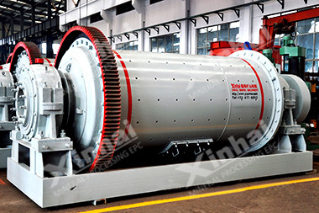

**Introduction**

A traditional ball mill with discharging grid

**Diameter of cylinder**

900mm～4500mm

**Products improvement**

[Wet type grid ball mill](http://www.ytmachines.com/product_3_10.html) is lined with Yantai Group wear-resistant rubber sheet with excellent wear resistance, long service life and convenient maintenance

**Overflow Type Ball Mill**

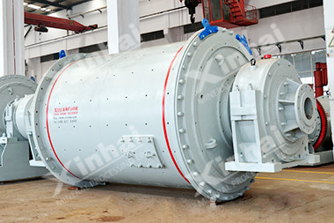

**Introduction**

A ball mill with simple structure

**Capacity**

0.17～170t/h

**Product improvement**

[Wet type overflow ball mill](http://www.ytmachines.com/product_3_11.html) is lined with Yantai Group wear-resistant rubber sheet with excellent wear resistance, long service life and convenient maintenance

**Autogenous Mill**

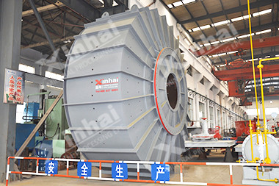

**Product Introduction**

A wet autogenous mill that materials as grinding media

**Feeding Particle Size**

200-350mm

**Product improvement**

[High-efficiency autogenous mill](http://www.ytmachines.com/product_3_80.html) can realize the second and third stage crushing and screening, and part or all crushing and grinding of rod mill or ball mil. Low power consumption, no dust pollution, less auxiliary equipment, easy production automation, and stable particle size.

**Cylinder Energy-Saving Overflow Ball Mill**

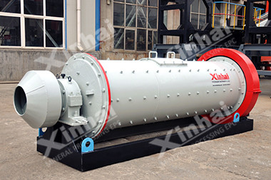

**Product Introduction**

A overflow ball mill with rolling bearings, high efficiency and energy saving

**Capacity**

Up to 160t/h

**Product Improvement**

20-30%. Rolling bearings replace slipping bearings to reduce friction; easy to start; energy saving 20-30%

**Raymond Mill**

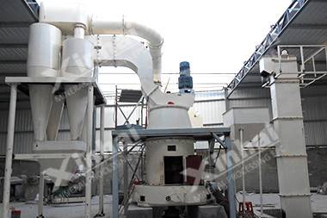

**Introduction**

Raymond Mill has a strong performance of becoming a complete set with a production system independently.

**Feed Size**

25-35mm

**Capacity**

3-22T/h

**Product improvement**

All important parts of [raymond mill](http://www.ytmachines.com/product_3_85.html" \t "_blank) are made of high quality steel, and all wear-resistant parts are made of high-performance wearresistant materials. The whole machine has high wear resistance and reliable operation.

**Leaching Agitation Tank**

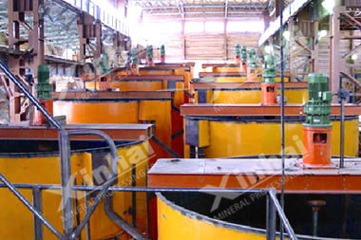

**Product Introduction**

Leaching agitaion tank is a leaching equipment for cyanide leaching by referring the USA technical design

**Effective Volume**

6-395m3

**Product Improvement**

Leaching agitation tank for gold extraction with double impeller, uniform mixing, low energy consumption; the impeller coated by rubber, long service life; multi points to give gas, uniform inflation

**Air Lifter**

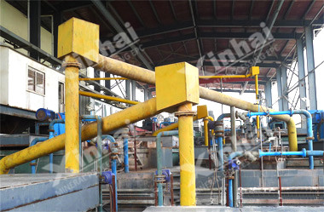

**Product Introduction**

A slurry transporting equipment by compressed air

**Lifting Head**

3-5m

**Product Feature**

No moving part

**Carbon Screen**

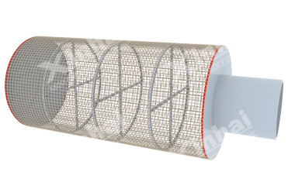

**Product Introduction**

An equipment for separation of carbon and slurry

**Frame diameter**

100-500mm

**Product Application**

In the cyaniding carbon pulp plant, it is used to screen activated carbon in the leaching tank.

**Desorption Electrolysis System**

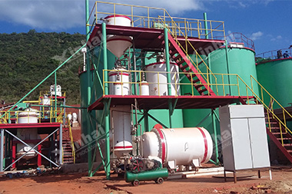

**Product Introduction**

Desorption electrolysis system obtains gold mud from carbon by desorption and electrowinning

**Gold Loaded Carbon Content**

≥3.5kg/t

**Product Structure**

Desorption electrolysis system consists of electrolysis equipment including desorption column and the electrodeposition tank

**Washing Thickener**

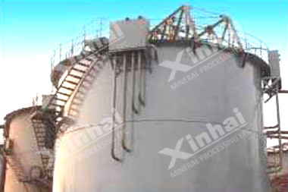

**Product Introduction**

Washing thickener for solid-liquid separation of gold leaching liquid

**Capacity**

10-250t/d

**Product Features**

1, Countercurrent washing, large capacity and high washing efficiency

2, Small area taken

3, Stable production and convenient operation

**Zinc Powder Displacement Device**

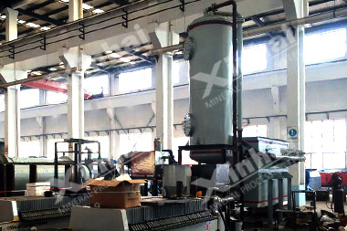

**Product Introduction**

A system extracts gold from pregnant solution by zinc powder

**Capacity**

≤1200m3/d

**Product Constitution**

Zinc powder displacement process is composed of pregnant solution purification, deoxidation and zinc powder filtering replacement

**Pendulum Feeder**

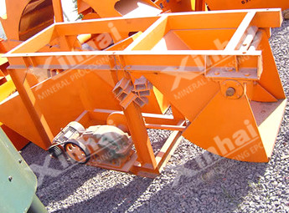

**Product Introduction**

A feeder with periodic reciprocating motion for fine particles

**Capacity**

4.5~25t/h

**Product Improvement**

Worm gear reducer, compact structure, reliable sealing device

**Chute Feeder**

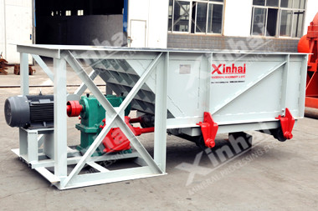

**Product Introduction**

A periodic and reciprocating feeding machine for large bulk materials

**Capacity**

10~90t/h

**Product Improvement**

According to user requirements, the motor can be changed to the speed adjustment motor to adjust the feeding volume.

**ZSW Vibrating Feeder**

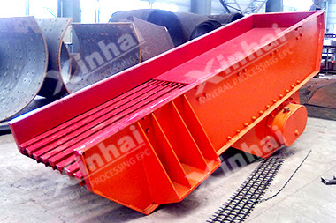

**Product Introduction**

A mechanical vibrating feeding equipment with rough screening function

**Capacity**

96~560t/h

**Product Improvement**

1、Baseboard of feeding tank adopts “Blind plate + screen” to pre-screen the small block materials

2、Double eccentric shaft vibrator

**Electromagnetic Vibrating Feeder**

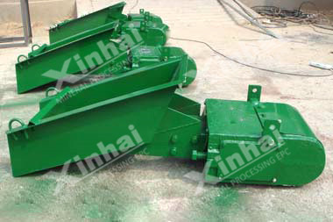

**Product Introduction**

A feeder with simple structure and suitable for non-sticky materials

**Capacity**

7~1700t/h

**Product Improvement**

1、Transporting materials relying on electromagnetic vibrating

2、Stepless adjustment feeding